Mono TFT Support in Graphics Manager 02

INDEX

1 INTRODUCTION 2
2 PURPOSE 2
3 REQUIREMENTS 2
4 1/2/4 BPP RENDERING - DESIGN & FEATURES: 2
5 DESIGN FLOW- MIGRATION FROM GFX01 to GFX02 7
6 DATA STRUCTURES APPENDED IN GFX02 10
7 MONO TFT PLATFORM SPECIFIC FEATURES 13
8 LIMITATIONS 13
9 REVISION HISTORY 13

INTRODUCTION
This document provides an overview of the changes done in graphics manager 02 to support mono TFT Platform. The Mono TFT Platform facilitates rendering of 1, 2 and 4BPP display.

PURPOSE
To capture the design and flow of operation for mono TFT Platform support. To brief about the rendering of 1/2/4 BPP TFT displays.

REQUIREMENTS

The general mono TFT Platform requirements:

- Graphics manager 01 tool and driver doesn’t support animation. IGDT tool and Graphics manager 02 supports animation. Hence to satisfy the animation related requirements
- Graphics manager 02 should support rendering of 1/2/4 BPP TFT displays.
- All functionalities and features provided in existing Graphics Manager 01 should be made available in graphics manager 02.
- A separate Platform named “MONO_TFT” should be designed in Graphics manager 02 to meet the above requirements.
- The IGDT Tool should also support design and code generation for 1/2/4 BPP TFT displays.

1/2/4 BPP RENDERING - DESIGN & FEATURES:

Graphics Manager 01 currently supports the rendering of 1/2/4 BPP TFT displays.
The folder structure shown below:

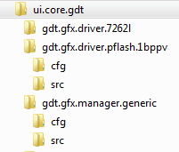

The file system includes:

Gfx Mgr 01:
\ui.core.gdt\ gdt.gfx.manager.generic\src\ hmi_gfx_manager.c
\ui.core.gdt\ gdt.gfx.manager.generic\src\ hmi_gfx_manager.h

Gfx Driver 01:
\ui.core.gdt\ gdt.gfx.driver.pflash.1bppv\src\ hmi_gfx_driver.c
\ui.core.gdt\ gdt.gfx.driver.pflash.1bppv\src\ hmi_gfx_ driver.h

Configuration for Gfx Mgr 01:
\ui.core.gdt\ gdt.gfx.manager.generic\cfg\ hmi_gfx_mgr_app.$cfg
\ui.core.gdt\ gdt.gfx.driver.pflash.1bppv\cfg\ hmi_gfx_ driver.$cfg

DATA PACKING METHODS:

1/2/4 BPP rendering achieved using two types of data packing methods.
- Horizontal Packing
- Vertical Packing
The packing method need to be set in GDT tool.

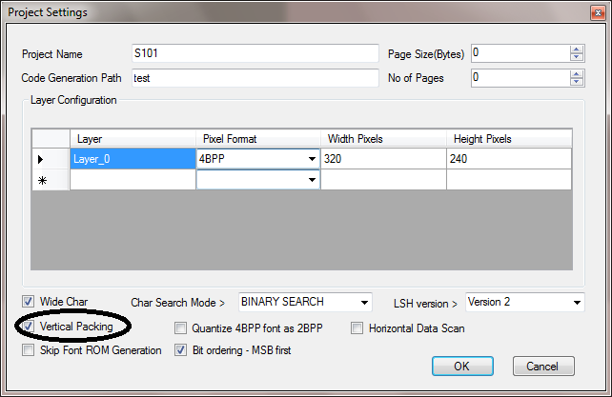

HORIZONTAL PACKING
Bytes of data will be packed horizontally and filled vertically.
E.g.: 1BPP
Image size – 16(W) * 8(H) -> Total Pixels – 16*8 = 128 pixels

 | Width - 16 pixels
Height  8 pixels | Pix1 | Pix2 | Pix3 | Pix4 | Pix5 | Pix6 | Pix7 | Pix8 | ….Pix16
Height  8 pixels | Pix17 | Pix18 | Pix19 | Pix20 | Pix21 | Pix22 | Pix23 | Pix24 | ….Pix32
Height  8 pixels | Pix33 | Pix34 | Pix35 | Pix36 | Pix37 | Pix38 | Pix39 | Pix40 | ….Pix48
Height  8 pixels | Pix49 | Pix50 | Pix51 | Pix52 | Pix53 | Pix54 | Pix55 | Pix56 | ….Pix64
Height  8 pixels | Pix65 | Pix66 | Pix67 | Pix68 | Pix69 | Pix70 | Pix71 | Pix72 | ….Pix80
Height  8 pixels | Pix81 | Pix82 | Pix83 | Pix84 | Pix85 | Pix86 | Pix87 | Pix88 | ….Pix96
Height  8 pixels | Pix97 | Pix98 | Pix99 | Pix100 | Pix101 | Pix102 | Pix103 | Pix104 | ….Pix112
Height  8 pixels | Pix113 | Pix114 | Pix115 | Pix116 | Pix117 | Pix118 | Pix119 | Pix120 | ….Pix128

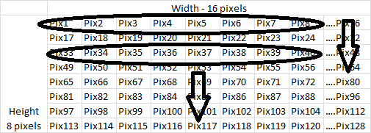

1BPP image data array size will be 128 bits → 128/8 = 16 bytes
UINT8 Image data array = {Data1, Data2, Data3…Data16}
Data1 =
{
Pix1 | Pix2 | Pix3 | Pix4 | Pix5 | Pix6 | Pix7 | Pix8
}
Data2 =
{
Pix17 | Pix18 | Pix19 | Pix20 | Pix21 | Pix22 | Pix23 | Pix24
}
Data3 =
{
Pix33 | Pix34 | Pix35 | Pix36 | Pix37 | Pix38 | Pix39 | Pix40
}
Data4 =
{
Pix49 | Pix50 | Pix51 | Pix52 | Pix53 | Pix54 | Pix55 | Pix56
}
.
.
Data9 =
{
Pix8 | Pix9 | Pix10 | Pix11 | Pix12 | Pix13 | Pix14 | Pix15
}
Data10 =
{
Pix25 | Pix26 | Pix27 | Pix28 | Pix29 | Pix30 | Pix31 | Pix32
}
.
Data16 =
{
Pix121 | Pix122 | Pix123 | Pix124 | Pix125 | Pix126 | Pix127 | Pix128
}

2BPP image data array size will be 128 * 2 = 256 bits → 256/8 = 32 bytes
UINT8 Image data array = {Data1, Data2, Data3…Data32}
Data1 =
{
Pix1 | Pix2 | Pix3 | Pix4
}
Data2 =
{
Pix17 | Pix18 | Pix19 | Pix20
}

4BPP image data array size will be 128 * 4 = 512 bits → 512/8 = 64 bytes
UINT8 Image data array = {Data1, Data2, Data3…Data64}
Data1 =
{
Pix1 | Pix2
}
Data2 =
{
Pix17 | Pix18
}

VERTICAL PACKING
Bytes of data will be packed vertically and filled horizontally.
E.g.: 1BPP
Image size – 16(W) * 8(H) -> Total Pixels – 16*8 = 128 pixels

 | Width - 16 pixels
Height  8 pixels | Pix1 | Pix2 | Pix3 | Pix4 | Pix5 | Pix6 | Pix7 | Pix8 | ….Pix16
Height  8 pixels | Pix17 | Pix18 | Pix19 | Pix20 | Pix21 | Pix22 | Pix23 | Pix24 | ….Pix32
Height  8 pixels | Pix33 | Pix34 | Pix35 | Pix36 | Pix37 | Pix38 | Pix39 | Pix40 | ….Pix48
Height  8 pixels | Pix49 | Pix50 | Pix51 | Pix52 | Pix53 | Pix54 | Pix55 | Pix56 | ….Pix64
Height  8 pixels | Pix65 | Pix66 | Pix67 | Pix68 | Pix69 | Pix70 | Pix71 | Pix72 | ….Pix80
Height  8 pixels | Pix81 | Pix82 | Pix83 | Pix84 | Pix85 | Pix86 | Pix87 | Pix88 | ….Pix96
Height  8 pixels | Pix97 | Pix98 | Pix99 | Pix100 | Pix101 | Pix102 | Pix103 | Pix104 | ….Pix112
Height  8 pixels | Pix113 | Pix114 | Pix115 | Pix116 | Pix117 | Pix118 | Pix119 | Pix120 | ….Pix128

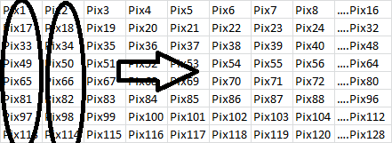

1BPP image data array size will be 128 bits → 128/8 = 16 bytes
UINT8 Image data array = {Data1, Data2, Data3…Data16}
Data1 =
{
Pix1 | Pix17 | Pix33 | Pix49 | Pix65 | Pix81 | Pix97 | Pix113
}
Data2 =
{
Pix2 | Pix18 | Pix34 | Pix50 | Pix66 | Pix82 | Pix98 | Pix114
}
Data3 =
{
Pix3 | Pix19 | Pix35 | Pix51 | Pix67 | Pix83 | Pix99 | Pix115
}
.
.
Data16 =
{
Pix16 | Pix32 | Pix48 | Pix64 | Pix80 | Pix96 | Pix112 | Pix128
}

2BPP image data array size will be 128 * 2 = 256 bits → 256/8 = 32 bytes
UINT8 Image data array = {Data1, Data2, Data3…Data32}
Data1 =
{
Pix1 | Pix17 | Pix33 | Pix49
}
Data2 =
{
Pix2 | Pix18 | Pix34 | Pix50
}

4BPP image data array size will be 128 * 4 = 512 bits → 512/8 = 64 bytes
UINT8 Image data array = {Data1, Data2, Data3…Data64}
Data1 =
{
Pix1 | Pix17
}
Data2 =
{
Pix2 | Pix18
}

MAJOR FEATURES SUPPORTED IN GFX MGR 01

- Color Transparency support for images.
- Scroll support.
- Dynamic screen priority change.
- Dynamic properties of element can be change.
- Text rendering on grey background.
- Group font selection.

For 4BPP alone:

- Alpha blending.
- Image blending.

DESIGN FLOW- MIGRATION FROM GFX01 to GFX02

The Mono TFT Platform file system includes below newly added files in ui.core.gdt\hmi_gfx_manager.02\src\:

\ui.core.gdt\hmi.gfx.manager.02\src\hmi_gfx_mgr02_monolib.c
\ui.core.gdt\hmi.gfx.manager.02\src\hmi_gfx_mgr02_monolib.h
\ui.core.gdt\hmi.gfx.manager.02\src\hmi_gfx_driver_cp_image.inc

BUILD FLOW:
hmi_gfx_mgr02_
if.c

hmi_gfx_mgr02_
layout.c

hmi_gfx_mgr02_
generic.c

hmi_gfx_mgr02_monolib.c

DESIGN DECISIONS:

- The API and functionalities provided in hmi_gfx_manager.c and hmi_gfx_manager.h files will be provided through hmi_gfx_mgr02_if.c and hmi_gfx_mgr02_layout.c files.
- The features covered in hmi_gfx_driver.c and hmi_gfx_driver.h file are now integrated in hmi_gfx_mgr02_monolib.c file.
- The IGDT tool will be now made compatible to VGDT xml.
- The IGDT tool generated files mapping are mentioned below:

hmi_gfx_mgr_data.rom | hmi_gfx_mgr02_config.dat
hmi_gfx_mgr_cfg.h | hmi_gfx_mgr02_cfg.h
hmi_gfx_mgr_font.h | hmi_gfx_mgr02_font.h
hmi_gfx_mgr_font.rom | Individual font.c files

- Animation related tool generated files are hmi_gfx_anim_engine_data.rom, hmi_gfx_anim_engine_cfg.h.

API MAPPING FROM 01 TO 02:

Mapping Between Graphics Manager 01 and 02 API
Graphics Manager 01 API | Graphics Manager 02 API
GfxManagerSendEvent(ScreenID, GFX_REMOVE_SCREEN_EV) | hmi_gfx_mgr02_if_set_screen(GFX_MGR02_SCR_ELEM_ID ,FALSE)
GfxManagerSendEvent(ScreenID, GFX_ADD_SCREEN_EV) | hmi_gfx_mgr02_if_set_screen(GFX_MGR02_SCR_ELEM_ID ,TRUE)
GfxManagerSendEvent(DYN_BITMAPS_INDEX, index) | hmi_gfx_mgr02_if_select_dimage(GFX_MGR02_DIMG_ELEM_ID, index)
GfxManagerSendEvent(DYN_WIDGET_INDEX, index) | hmi_gfx_mgr02_if_select_dwidget(GFX_MGR02_DWDG_ELEM_ID, index)
GfxManagerSendEvent(DYN_XY_BITMAPS, x) | hmi_gfx_mgr02_if_set_obj_pos_x(GFX_MGR02_ANIM_ELEM_ID,x)
GfxManagerSendEvent(DYN_XY_BITMAPS, y) | hmi_gfx_mgr02_if_set_obj_pos_y(GFX_MGR02_ANIM_ELEM_ID,y)
GfxManagerSendEvent(DYN_XY_BITMAPS, alpha) | hmi_gfx_mgr02_if_set_obj_alpha(GFX_MGR02_ANIM_ELEM_ID,alpha)
GfxManagerSendEvent(DYN_XY_DIMAGES, x) | hmi_gfx_mgr02_if_set_obj_pos_x(GFX_MGR02_ANIM_ELEM_ID,x)
GfxManagerSendEvent(DYN_XY_DIMAGES, y) | hmi_gfx_mgr02_if_set_obj_pos_y(GFX_MGR02_ANIM_ELEM_ID,y)
GfxManagerSendEvent(DYN_XY_TEXTS, x) | hmi_gfx_mgr02_if_set_obj_pos_x(GFX_MGR02_ANIM_ELEM_ID,x)
GfxManagerSendEvent(DYN_XY_TEXTS, y) | hmi_gfx_mgr02_if_set_obj_pos_y(GFX_MGR02_ANIM_ELEM_ID,y)
GfxManagerSendEvent(DYN_XY_TEXTS, alpha) | hmi_gfx_mgr02_if_set_obj_alpha(GFX_MGR02_ANIM_ELEM_ID,alpha)
GfxManagerSendEvent(DYN_XY_TEXTS, color) | hmi_gfx_mgr02_if_set_obj_fg_color(GFX_MGR02_ANIM_ELEM_ID,color)
GfxManagerSendEvent(DYN_FILL_SCREENS, x) | hmi_gfx_mgr02_if_set_obj_pos_x(GFX_MGR02_ANIM_ELEM_ID,x)
GfxManagerSendEvent(DYN_FILL_SCREENS, y) | hmi_gfx_mgr02_if_set_obj_pos_y(GFX_MGR02_ANIM_ELEM_ID,y)
GfxManagerSendEvent(DYN_FILL_SCREENS, width) | hmi_gfx_mgr02_if_set_obj_dim_w(DYN_FILL_SCREENS,width)
GfxManagerSendEvent(DYN_FILL_SCREENS, height) | hmi_gfx_mgr02_if_set_obj_dim_h(DYN_FILL_SCREENS,height)
GfxManagerSendEvent(DYN_FILL_SCREENS, alpha) | hmi_gfx_mgr02_if_set_obj_alpha(GFX_MGR02_ANIM_ELEM_ID,alpha)
GfxManagerSendEvent(DYNAMIC_CLIP_WIDGETS, clipx) | hmi_gfx_mgr02_if_set_obj_hclip(GFX_MGR02_ANIM_ELEM_ID,clipx)
GfxManagerSendEvent(DYNAMIC_CLIP_WIDGETS, clipy) | hmi_gfx_mgr02_if_set_obj_vclip(GFX_MGR02_ANIM_ELEM_ID,clipy)
GfxManagerSendEvent(DYNAMIC_CLIP_WIDGETS, clipwidth) | hmi_gfx_mgr02_if_set_obj_hclip(GFX_MGR02_ANIM_ELEM_ID,clipwidth)
GfxManagerSendEvent(DYNAMIC_CLIP_WIDGETS, clipheight) | hmi_gfx_mgr02_if_set_obj_vclip(GFX_MGR02_ANIM_ELEM_ID,clipheight)
GfxManagerSendEvent(DYNAMIC_CLIP_WIDGETS, alpha) | hmi_gfx_mgr02_if_set_obj_alpha(GFX_MGR02_ANIM_ELEM_ID,alpha)
GfxManagerSendEvent(DYN_TEXTS_SCROLL, scrollpixel) | hmi_gfx_mgr02_if_set_text_scroll_parameter(GFX_MGR02_ANIM_ELEM_ID,scrollpixel)
GfxManagerSendText(DYN_TEXTS, string) | hmi_gfx_mgr02_if_set_text(GFX_MGR02_DTEXT_ID, string)
GfxManagerGetEvent(DYN_XY_BITMAPS, x) | hmi_gfx_mgr02_if_get_obj_pos(GFX_MGR02_ANIM_ELEM_ID,pos)
GfxManagerGetEvent(DYN_XY_BITMAPS, y) | hmi_gfx_mgr02_if_get_obj_pos(GFX_MGR02_ANIM_ELEM_ID,pos)
GfxManagerGetEvent(DYN_XY_DIMAGES, x) | hmi_gfx_mgr02_if_get_obj_pos(GFX_MGR02_ANIM_ELEM_ID,pos)
GfxManagerGetEvent(DYN_XY_DIMAGES, y) | hmi_gfx_mgr02_if_get_obj_pos(GFX_MGR02_ANIM_ELEM_ID,pos)
GfxManagerGetEvent(DYN_XY_TEXTS, x) | hmi_gfx_mgr02_if_get_obj_pos(GFX_MGR02_ANIM_ELEM_ID,pos)
GfxManagerGetEvent(DYN_XY_TEXTS, y) | hmi_gfx_mgr02_if_get_obj_pos(GFX_MGR02_ANIM_ELEM_ID,pos)
GfxManagerGetEvent(DYN_FILL_SCREENS, x) | hmi_gfx_mgr02_if_get_obj_pos(GFX_MGR02_ANIM_ELEM_ID,pos)
GfxManagerGetEvent(DYN_FILL_SCREENS, y) | hmi_gfx_mgr02_if_get_obj_pos(GFX_MGR02_ANIM_ELEM_ID,pos)
GfxManagerGetEvent(DYN_FILL_SCREENS, width) | hmi_gfx_mgr02_if_get_obj_dim(GFX_MGR02_ANIM_ELEM_ID,dim)
GfxManagerGetEvent(DYN_FILL_SCREENS, height) | hmi_gfx_mgr02_if_get_obj_dim(GFX_MGR02_ANIM_ELEM_ID,dim)
GfxManagerGetTextFitWidth(element, GFX_TEXT_WIDTH_INFO_DEF_T * p_txt_info_S) | hmi_gfx_mgr02_if_get_text_width(GFX_MGR02_DTEXT_ID p_elem_id,  GFX_MGR02_TEXT_WIDTH_INFO * p_text_info)
GfxManagerSetDefaultProperties(GFX_ELEMENT_ID_T p_element) | hmi_gfx_mgr02_if_set_obj_default_properties(GFX_MGR02_ANIM_ELEM_ID p_elem_id)
GfxManagerSelectGroupFontIndex(GFX_ELEMENT_ID_T p_font_id, GFX_ELEMENT_DATA_T p_selection_index) | hmi_gfx_mgr02_if_select_gfont_index(UINT32 p_font_id, UINT32 p_selection_index, UINT32 p_right2left)
GfxManagerSetDynScreenPriority(GFX_ELEMENT_ID_T p_element, GFX_ELEMENT_DATA_T p_data, UINT8 p_priority) | hmi_gfx_mgr02_if_set_screen_dyn_priority(GFX_MGR02_SCR_ELEM_ID p_elem_id,  UINT32 p_show, UINT8 priority)
GfxManagerSetScreenDynPosition(GFX_ELEMENT_ID_T p_element, GFX_SIZE_X_T p_pos_x, GFX_SIZE_Y_T p_pos_y) | hmi_gfx_mgr02_if_set_obj_pos(GFX_MGR02_ANIM_ELEM_ID,pos)

DATA STRUCTURES APPENDED IN GFX02

Macros:

Configuration from TOOL:

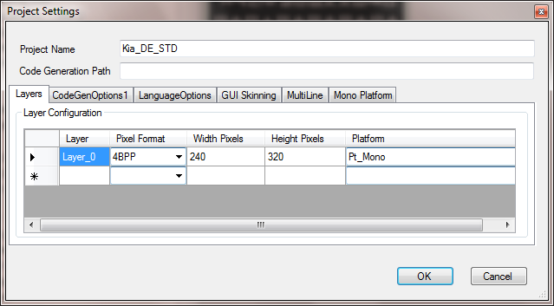
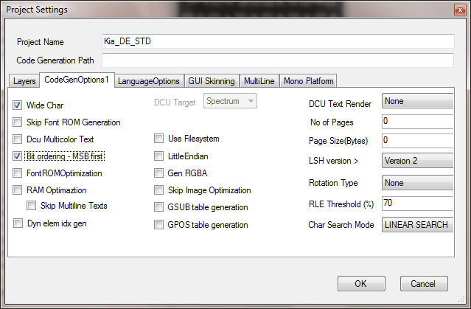

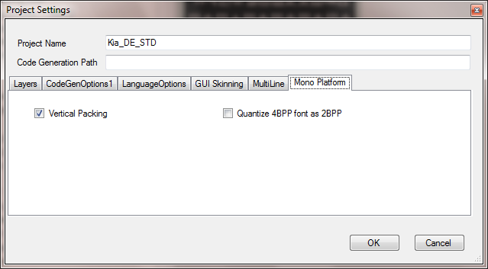

Enumerated Data Type and typedefs:

Content additions and modifications in hmi_gfx_mgr02_types.h

#if (GFX_MGR02_PIX_FORMAT == GFX_MGR02_PIX_FORMAT_1BPP)
#define GFX_MGR02_PIX_FORMAT_ALPHA 0x01
#define GFX_MGR02_PIX_ALPHA_SHFT 0x01
#define GFX_MGR02_PIX_MAX_COLOR 0x01
#elif (GFX_MGR02_PIX_FORMAT == GFX_MGR02_PIX_FORMAT_2BPP)
#define GFX_MGR02_PIX_FORMAT_ALPHA 0x03
#define GFX_MGR02_PIX_ALPHA_SHFT 0x02
#define GFX_MGR02_PIX_MAX_COLOR 0x03
#elif (GFX_MGR02_PIX_FORMAT == GFX_MGR02_PIX_FORMAT_4BPP)
#define GFX_MGR02_PIX_FORMAT_ALPHA 0x0F
#define GFX_MGR02_PIX_ALPHA_SHFT 0x04
#define GFX_MGR02_PIX_MAX_COLOR 0x0F
#else
#define GFX_MGR02_PIX_FORMAT_ALPHA 0xFF
#define GFX_MGR02_PIX_ALPHA_SHFT 0x08
#define GFX_MGR02_PIX_MAX_COLOR 0xFF
#endif

#define GFX_MGR02_MONO_NORMAL (14)
#define GFX_MGR02_MONO_TRANSPARENT (15)
#define GFX_MGR02_MAX_BPP (16)

Global Variables:

Content additions and modifications in hmi_gfx_mgr02_types.h

#if defined(GFX_MGR02_MONOTFT)
#define YES 1
#define NO 0

typedef struct
{
UINT16 lcd_xsize; /* lcd_xsize of layer */
UINT16 lcd_ysize; /* lcd_ysize of layer */
UINT16 lcd_bytes_per_row;
UINT16 lcd_bytes_per_col;
UINT16 lcd_size_mul_factor;
UINT8 lcd_pmask;
}GFX_MGR02_PIXEL_DEF_T;
#endif

Content additions and modifications in hmi_gfx_mgr02_defs.h

#define GFX_MGR02_PLATFORM_MON ((UINT32)(0x00500000))

TOOL GENERATED DATA

#define GFX_MGR02_MONOTFT
#define GFX_MGR02_HOR_PACKING (1)
#define GFX_MGR02_BIT_ORDER_LSB_FIRST (0)

MONO TFT PLATFORM SPECIFIC FEATURES
The following features are specific to mono TFT Platform.

- Image Types
  - Options like Image blending can be applied only for transparent images.

- Horizontal Scroll
  - Scroll can be achieved by invoking the API hmi_gfx_mgr02_if_set_text_scroll_parameter(GFX_MGR02_ANIM_ELEM_ID,scrollpixel).

LIMITATIONS

- Only animations like MAL, Color and Alpha will be supported. All other animations are not supported.

REVISION HISTORY

Version | Section | Date | Cdsid | Nature of change
1.0 | All |  | adevi | Initial Version

