Mono TFT Platform User Guide

INDEX

1 INTRODUCTION 2
2 API USAGE- MIGRATION FROM GFX01 to GFX02 2
3 CONFIGURATION 4

INTRODUCTION
This document provides an overview of the API changes and the configuration changes that needs to be done to support mono TFT Platform.

API USAGE- MIGRATION FROM GFX01 to GFX02

API MAPPING FROM 01 TO 02:

Mapping Between Graphics Manager 01 and 02 API
Graphics Manager 01 API | Graphics Manager 02 API
GfxManagerSendEvent(ScreenID, GFX_REMOVE_SCREEN_EV) | hmi_gfx_mgr02_if_set_screen(GFX_MGR02_SCR_ELEM_ID ,FALSE)
GfxManagerSendEvent(ScreenID, GFX_ADD_SCREEN_EV) | hmi_gfx_mgr02_if_set_screen(GFX_MGR02_SCR_ELEM_ID ,TRUE)
GfxManagerSendEvent(DYN_BITMAPS_INDEX, index) | hmi_gfx_mgr02_if_select_dimage(GFX_MGR02_DIMG_ELEM_ID, index)
GfxManagerSendEvent(DYN_WIDGET_INDEX, index) | hmi_gfx_mgr02_if_select_dwidget(GFX_MGR02_DWDG_ELEM_ID, index)
GfxManagerSendEvent(DYN_XY_BITMAPS, x) | hmi_gfx_mgr02_if_set_obj_pos_x(GFX_MGR02_ANIM_ELEM_ID,x)
GfxManagerSendEvent(DYN_XY_BITMAPS, y) | hmi_gfx_mgr02_if_set_obj_pos_y(GFX_MGR02_ANIM_ELEM_ID,y)
GfxManagerSendEvent(DYN_XY_BITMAPS, alpha) | hmi_gfx_mgr02_if_set_obj_alpha(GFX_MGR02_ANIM_ELEM_ID,alpha)
GfxManagerSendEvent(DYN_XY_DIMAGES, x) | hmi_gfx_mgr02_if_set_obj_pos_x(GFX_MGR02_ANIM_ELEM_ID,x)
GfxManagerSendEvent(DYN_XY_DIMAGES, y) | hmi_gfx_mgr02_if_set_obj_pos_y(GFX_MGR02_ANIM_ELEM_ID,y)
GfxManagerSendEvent(DYN_XY_TEXTS, x) | hmi_gfx_mgr02_if_set_obj_pos_x(GFX_MGR02_ANIM_ELEM_ID,x)
GfxManagerSendEvent(DYN_XY_TEXTS, y) | hmi_gfx_mgr02_if_set_obj_pos_y(GFX_MGR02_ANIM_ELEM_ID,y)
GfxManagerSendEvent(DYN_XY_TEXTS, alpha) | hmi_gfx_mgr02_if_set_obj_alpha(GFX_MGR02_ANIM_ELEM_ID,alpha)
GfxManagerSendEvent(DYN_XY_TEXTS, color) | hmi_gfx_mgr02_if_set_obj_fg_color(GFX_MGR02_ANIM_ELEM_ID,color)
GfxManagerSendEvent(DYN_FILL_SCREENS, x) | hmi_gfx_mgr02_if_set_obj_pos_x(GFX_MGR02_ANIM_ELEM_ID,x)
GfxManagerSendEvent(DYN_FILL_SCREENS, y) | hmi_gfx_mgr02_if_set_obj_pos_y(GFX_MGR02_ANIM_ELEM_ID,y)
GfxManagerSendEvent(DYN_FILL_SCREENS, width) | hmi_gfx_mgr02_if_set_obj_dim_w(DYN_FILL_SCREENS,width)
GfxManagerSendEvent(DYN_FILL_SCREENS, height) | hmi_gfx_mgr02_if_set_obj_dim_h(DYN_FILL_SCREENS,height)
GfxManagerSendEvent(DYN_FILL_SCREENS, alpha) | hmi_gfx_mgr02_if_set_obj_alpha(GFX_MGR02_ANIM_ELEM_ID,alpha)
GfxManagerSendEvent(DYNAMIC_CLIP_WIDGETS, clipx) | hmi_gfx_mgr02_if_set_obj_hclip(GFX_MGR02_ANIM_ELEM_ID,clipx)
GfxManagerSendEvent(DYNAMIC_CLIP_WIDGETS, clipy) | hmi_gfx_mgr02_if_set_obj_vclip(GFX_MGR02_ANIM_ELEM_ID,clipy)
GfxManagerSendEvent(DYNAMIC_CLIP_WIDGETS, clipwidth) | hmi_gfx_mgr02_if_set_obj_hclip(GFX_MGR02_ANIM_ELEM_ID,clipwidth)
GfxManagerSendEvent(DYNAMIC_CLIP_WIDGETS, clipheight) | hmi_gfx_mgr02_if_set_obj_vclip(GFX_MGR02_ANIM_ELEM_ID,clipheight)
GfxManagerSendEvent(DYNAMIC_CLIP_WIDGETS, alpha) | hmi_gfx_mgr02_if_set_obj_alpha(GFX_MGR02_ANIM_ELEM_ID,alpha)
GfxManagerSendEvent(DYN_TEXTS_SCROLL, scrollpixel) | hmi_gfx_mgr02_if_set_text_scroll_parameter(GFX_MGR02_ANIM_ELEM_ID,scrollpixel)
GfxManagerSendText(DYN_TEXTS, string) | hmi_gfx_mgr02_if_set_text(GFX_MGR02_DTEXT_ID, string)
GfxManagerGetEvent(DYN_XY_BITMAPS, x) | hmi_gfx_mgr02_if_get_obj_pos(GFX_MGR02_ANIM_ELEM_ID,pos)
GfxManagerGetEvent(DYN_XY_BITMAPS, y) | hmi_gfx_mgr02_if_get_obj_pos(GFX_MGR02_ANIM_ELEM_ID,pos)
GfxManagerGetEvent(DYN_XY_DIMAGES, x) | hmi_gfx_mgr02_if_get_obj_pos(GFX_MGR02_ANIM_ELEM_ID,pos)
GfxManagerGetEvent(DYN_XY_DIMAGES, y) | hmi_gfx_mgr02_if_get_obj_pos(GFX_MGR02_ANIM_ELEM_ID,pos)
GfxManagerGetEvent(DYN_XY_TEXTS, x) | hmi_gfx_mgr02_if_get_obj_pos(GFX_MGR02_ANIM_ELEM_ID,pos)
GfxManagerGetEvent(DYN_XY_TEXTS, y) | hmi_gfx_mgr02_if_get_obj_pos(GFX_MGR02_ANIM_ELEM_ID,pos)
GfxManagerGetEvent(DYN_FILL_SCREENS, x) | hmi_gfx_mgr02_if_get_obj_pos(GFX_MGR02_ANIM_ELEM_ID,pos)
GfxManagerGetEvent(DYN_FILL_SCREENS, y) | hmi_gfx_mgr02_if_get_obj_pos(GFX_MGR02_ANIM_ELEM_ID,pos)
GfxManagerGetEvent(DYN_FILL_SCREENS, width) | hmi_gfx_mgr02_if_get_obj_dim(GFX_MGR02_ANIM_ELEM_ID,dim)
GfxManagerGetEvent(DYN_FILL_SCREENS, height) | hmi_gfx_mgr02_if_get_obj_dim(GFX_MGR02_ANIM_ELEM_ID,dim)
GfxManagerGetTextFitWidth(element, GFX_TEXT_WIDTH_INFO_DEF_T * p_txt_info_S) | hmi_gfx_mgr02_if_get_text_width(GFX_MGR02_DTEXT_ID p_elem_id,  GFX_MGR02_TEXT_WIDTH_INFO * p_text_info)
GfxManagerSetDefaultProperties(GFX_ELEMENT_ID_T p_element) | hmi_gfx_mgr02_if_set_obj_default_properties(GFX_MGR02_ANIM_ELEM_ID p_elem_id)
GfxManagerSelectGroupFontIndex(GFX_ELEMENT_ID_T p_font_id, GFX_ELEMENT_DATA_T p_selection_index) | hmi_gfx_mgr02_if_select_gfont_index(UINT32 p_font_id, UINT32 p_selection_index, UINT32 p_right2left)
GfxManagerSetDynScreenPriority(GFX_ELEMENT_ID_T p_element, GFX_ELEMENT_DATA_T p_data, UINT8 p_priority) | hmi_gfx_mgr02_if_set_screen_dyn_priority(GFX_MGR02_SCR_ELEM_ID p_elem_id,  UINT32 p_show, UINT8 priority)
GfxManagerSetScreenDynPosition(GFX_ELEMENT_ID_T p_element, GFX_SIZE_X_T p_pos_x, GFX_SIZE_Y_T p_pos_y) | hmi_gfx_mgr02_if_set_obj_pos(GFX_MGR02_ANIM_ELEM_ID,pos)

CONFIGURATION

Macros:

Configuration from TOOL:

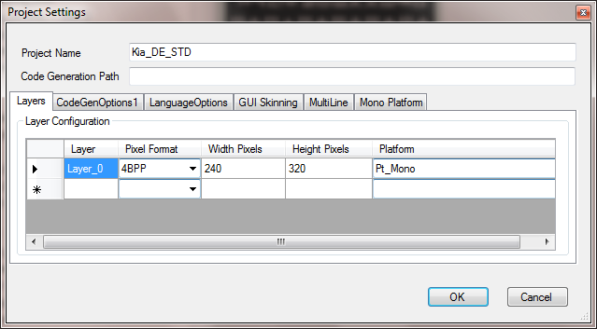
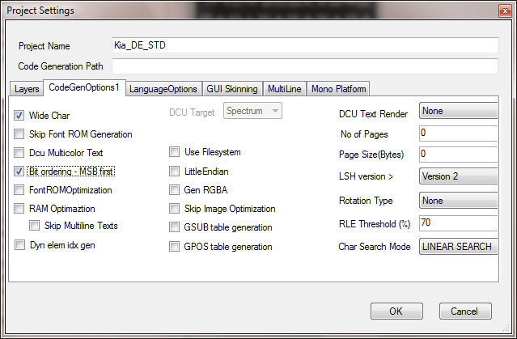

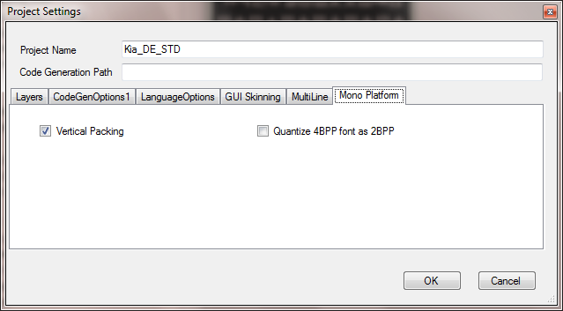

TOOL GENERATED DATA SPECIFIC TO MONO PLATFORM

#define GFX_MGR02_MONOTFT
#define GFX_MGR02_HOR_PACKING (1)
#define GFX_MGR02_BIT_ORDER_LSB_FIRST (0)

SAMPLE CONFIGURATIONS IN hmi_gfx_mgr02.cfg:

/* ---------------- MONO TFT PLATFORM CONFIGURATIONS ----------------------------------*/
#define GFX_MGR02_SOFTWARE_FB_SIZE LCD_L1_BYTES_PER_COLOUMN*GFX_MGR02_LAYERS_MAX_WIDTH
#define GFX_MGR02_SOFTWARE_FB_ADDRESS (UINT32)&l_mono_fb_U8A
#define GFX_MGR02_LCD_UPDATE(fb_pointer) HMI_GFX_MGR_BUF_Gfx_Build_Update(fb_pointer)
#define GFX_MGR02_DRIVER_SINGLE_FB
#define GFX_ROTATED_DISPLAY NO
/* ------------------------------------------------------------------------------------*/

The macro GFX_MGR02_LCD_UPDATE(fb_pointer) ensures the transfer of content from frame buffer to the TFT which needs to be handled by the users.

ANIMATIONS SUPPORTED

Only the below animations are supported for Mono Platform.

- Moving along line.
- Moving alpha.
- Changing color.

Other animations listed in IGDT tool is currently not supported for Mono Platform.

