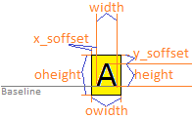

Shows how a character data metrics are generated.
typedef struct  {  SINT8 x_soffset;  SINT8 x_eoffset;  SINT8 y_soffset;  UINT8 owidth;  UINT8 width;  UINT8 height;  UINT8 const * fdata;  }GFX_MGR02_FONT_CHAR_CONFIG; | typedef struct  {  SINT8 x_soffset;  SINT8 y_soffset;  UINT8 width;  UINT8 height;  UINT8 owidth;  UINT8 oheight;  }GFX_MGR02_FONT_CHAR_METRICS;

