Graphics Design Tool
Software Design Specification



Visteon Corporation

PROPRIETARY AND CONFIDENTIAL

This document contains information that is proprietary to Visteon Corporation. Recipients of the document shall not duplicate, use or disclose information contained herein, in whole or in part, for other than company purposes.

Table of contents
1.1 Graphics Design Tool 4
1.1.1 Development Environment Information 4
1.1.1.1 Directory Structure 5
1.1.2 Designer 5
1.1.2.1 XML file format 7
1.1.2.2 GUI Design 7
1.1.2.2.1 GUI 7
1.1.2.2.2 Tree View 7
1.1.2.2.3 Element Manipulation 8
1.1.2.3 Use Cases 9
1.1.2.3.1 Project Creation 9
2. Revision History 9

Graphics Design Tool
Graphics Design Tool provides raster based graphics display design and code generation functionality. At the moment the tool is supporting code generation for Yukawa VDC (RGB565 and ARGB4444), Kepler DCU and 1BPP LCD displays. Graphics Designing Tool consists of following major software blocks.
- Graphics Designer (gfx_viewer_win32.exe)
- XML project file parser (gfx_coder_prj_parser.dll)
- Coder Generator (gfx_coder.dll)
Graphics Designer and the Parser components are common between all the supported platforms. Conditional compilation switches are used to select platform specific behavior for the common components. Currently Yukawa and 1BPP has a single coder component and Kepler has its coder component.
This document provides an overall structure of the GDT tool software components. Detailed information can be found from the source code directly in the form of comments. So use this document as a starting point. Also have a look at the tool help document to understand the functionalities supported by it.

Development Environment Information
GDT tool is developed using the Microsoft Visual Studio and utilizes the .NET framework to achieve the required functionality. Following is the detailed information of the development tools and its version.
Microsoft Visual Studio 2008 Version 9.0.21022.8 RTM
Microsoft .NET Framework Version 3.5
Installed Edition: VC Express
Microsoft Visual C++ 2008 91909-152-0000052-60632
Microsoft Visual C++ 2008

So before start working on modifying the GDT, you should install MS VC++ 2008 and .NET frame work 3.5 or higher on your PC. .NET framework can be downloaded free from http://download.microsoft.com/download/6/0/f/60fc5854-3cb8-4892-b6db-bd4f42510f28/dotnetfx35.exe
GDT Tool user guide is developed using IBE SOFTWARE HelpNDoc tool. This tool would be required to modify the .hnd HelpNDoc project files and to generate the .chm files for the GDT.
This design documentation uses iGrafx FlowCharter 2000 Professional for creating some of the diagrams.

Directory Structure
GDT tool is maintained under the sw_methods_tools VOB and organized under the following directory structure.
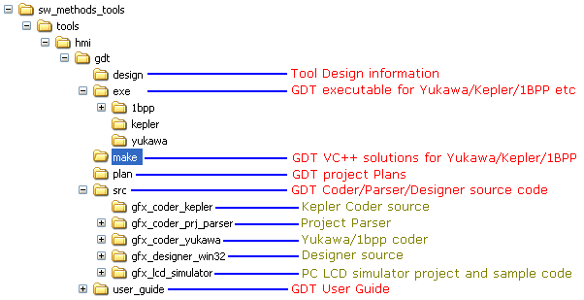

VC++ solution files are located under the make folder. There are separate solution files for each platform. Each solution has platform specific preprocessor directives defined so that the common designer and parser are configured properly for the platform. So when you try to work on the GDT open the appropriate solution in the VC++ 2008 IDE.
Each of the supported solutions will generate the output executables and dll files under a platform specific folder in the exe directory. For example the 1bpp platform will generate its output inside .\exe\1bpp. Basically the following files are generated once the solution is rebuilt.
- gfx_viewer_win32.exe
- gfx_coder_prj_parser.dll
- gfx_coder.dll
Source code for the three software blocks are located inside the src folder. gfx_designer_win32 folder contains the source code for the Graphics Designer block. gfx_coder_prj_parser folder contains the source code for the XML project file parser block. gfx_coder_yukawa folder contains the source code for the 1BPP and Yukawa platform Coder Generator block. gfx_coder_kepler folder contains the source code for the Kepler platform Coder Generator block. gfx_lcd_simulator folder inside the src directory contains source code and VC 6.0 project to create a simulated LCD display in the PC environment. This will be useful while creating PC based simulations when GDT is used as a development tool.

Graphics Designer
GDT designer tool is developed based on the following requirements
- Need to support creation of Project.
- Need to support project specific settings storage/edit.
- Need to support saving project information as an XML file and reopening the same file.
- Present the project as a Tree view to the user and provide ability to add/remove graphics elements to the tree view.
  - Support screen element.
  - Support element groups (Widgets)
  - Support Text element.
  - Support Image element.
  - Support Fillscreen element.
  - Support Font element.
- Provide a property window for editing an elements property.
- Update property information based on selection in Treeview.
- Provide a Graphics viewer where the screen or element will be rendered. This will provide a realtime view/appearance of the screen/element selected to the user.
Based on the above basic requirements, a GUI has been derived for the GDT as below.
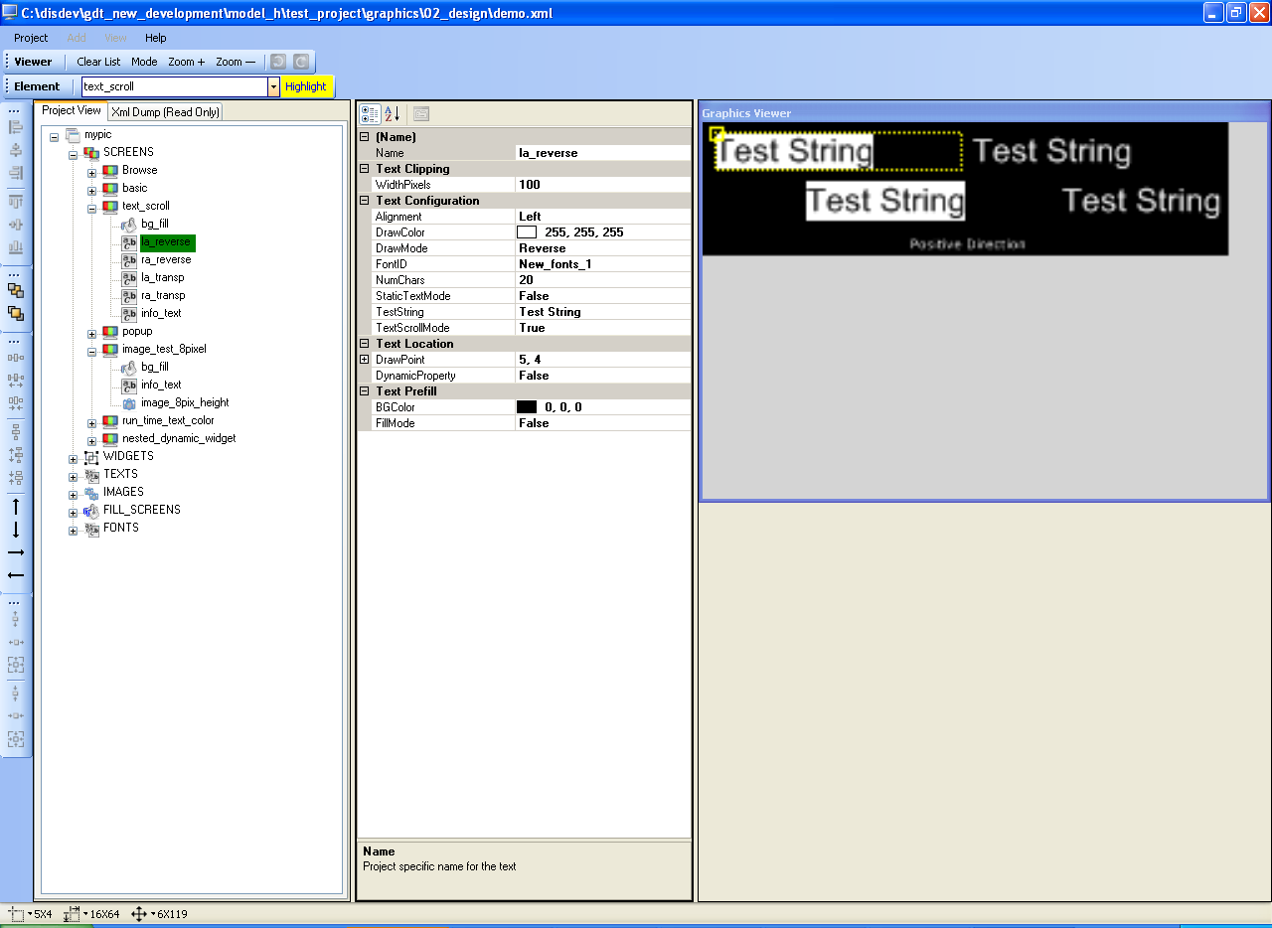
Left side window shows the Project in a tree view, middle window shows the selected elements property and the right side window shows the selected screen/elements rendering view.

XML file format
Based on the requirements laid out for the tool an XML file format is being created. In the XML file each element will be a parent node and its properties will be considered as child nodes. This way the entire project will be represented as a treeview. The XML file format is defined in the gdt_xml_file_format.xls file located in the design folder.

Compiler Switches
ALIGNED_ELEMENT_GROUPS_NEEDED | :
CLIPPED_ELEMENT_GROUPS_NEEDED | :
STATIC_TEXT_NEEDED | :
MULTI_LINE_TEXT_NEEDED | :
SUPPORT_INDEPENDANT_ELEMENT_PROPERTY | :
SCROLABLE_TEXT_NEEDED | :
KEPLER_PLATFORM | :
GDT_VERSION_1BPP_ONLY | :

Key Dictionary Data
GDT uses Dictionary data to store the information related elements used in the project. These dictionaries allows us easily locate the element and perform actions on to the elements such as rename, copy, delete etc. Following table list the key dictionary data used by GDT.
static Dictionary<String ^, TreeNode ^> ^ project_xml_element_cache; | : | This dictionary stores element name as Key and the elements Node address as the Value in the Key-Value pair. This list is updated as and when a new element is added to the ProjXmlTreeView. This dictionary helps in easily locating an element in the ProjXmlTreeView.
static Dictionary<String ^, TreeNode ^> ^ project_user_element_cache; | : | This dictionary stores element name as Key and the elements Node address as the Value in the Key-Value pair. This list is updated as and when a new element is added to the ProjUserTreeView. This dictionary helps in easily locating an element in the ProjUserTreeView.
static Dictionary<String ^, List<TreeNode ^>^> ^ xml_element_use_list_db; | : | This dictionary stores an element name and a list of TreeNode address where the element is being used with respect to the ProjXmlTreeView. For example if a text element "text_abc" is used in screen "screen_1" and widget "widget_1" then this dictionary will have a key for text element "text_abc" and the value for it will be a TreeNode pointer List of size two where  List[0] will contain pointer to the TreeNode corresponding to element "screen_1"  List[1] will contain pointer to the TreeNode corresponding to element "widget_1".  This dictionary will help us to find all the TreeNodes where a particular element is being used. This way it will be easy to perform rename or delete operation on an element because we will know where exactly they are used and we only need to look at those nodes and not the entire treeview.
static Dictionary<String ^, List<TreeNode ^>^> ^ user_element_use_list_db; | : | This dictionary functionality is same as xml_element_use_list_db and the only difference is it is for ProjUserTreeView.
static Dictionary<String ^, String ^> ^ project_user_removed_element_cache; | : | When ever user creates a new element GDT automatically generates a name with suffix "_N". where N can be 1, 2, 3, .. etc. But when the user deletes or renames an auto generated element name, this dictionary will be updated with the auto generated name. And this dictionary will be used to reuse the name again.  For example if the user adds a new screen for the first time GDT will name it as "New_screens_1". Now if the user renames it as "my_first_screen", the project_user_removed_element_cache dictionary will be updated to add "New_screens_1". Now if the user adds another screen, the auto generated name will not be "New_screens_2" because logic will look at the project_user_removed_element_cache to see if a name is present and will use "New_screens_1" for the second screen.

Design
Following diagram shows hierarchical representation of GDT software components and associated source files.
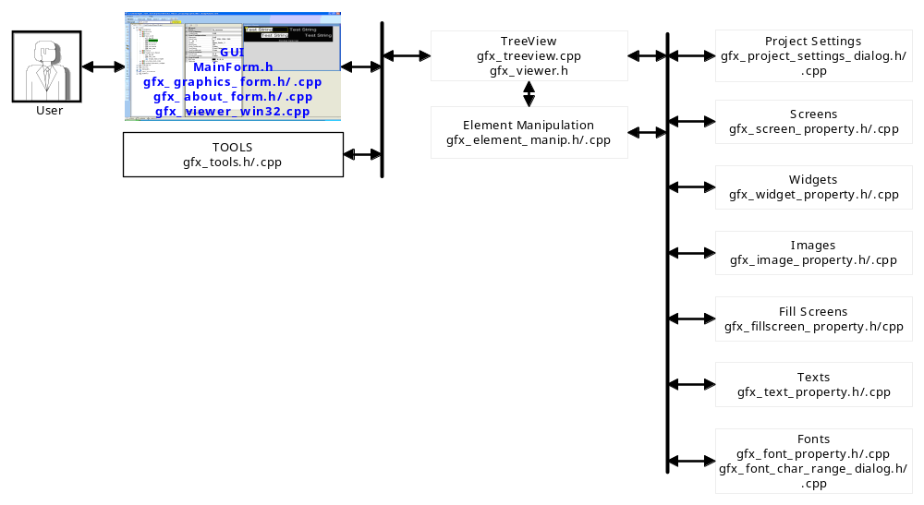
All of the GDT designer source files are located inside \sw_methods_tools\tools\hmi\gdt\src\gfx_designer_win32 folder. Following sections will cover each of the software components in detail.

GUI
Main entry point of the application is located inside MainForm.h. All the user triggers are handled through here. Mainform.h defines the MainForm class which creates the GDT GUI. It also creates a number of key data which is used by the GDT program.

Tree View
The .NET TreeView class has some limitation as they don't support multiple element selection. So the Treeview class is inherited to add the multiple section functionality to it. The new class is named as TreeViewMS and is available in gfx_viewer.h. TreeViewMS implements multi-element selection with the Shift or Ctrl key combinations. The list selected elements is available through NodeList element (List<TreeNode ^> ^ NodeList).

Since each element is having a number of properties associated to it, showing an exact replica of XML tree will be a lot of information to the user. So in order to minimize the complexity only the elements are shown in the tree view (ProjectView tab). In order to do this, two tree view is maintained by the GDT. One is the ProjUserTreeView and other is the ProjXmlTreeView. ProjUserTreeView will have only the elements where as ProjXmlTreeView will have elements as well as its child property nodes as well. Following table shows the difference.

ProjUserTreeView | ProjXmlTreeView
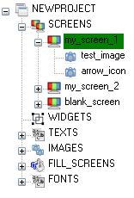 | 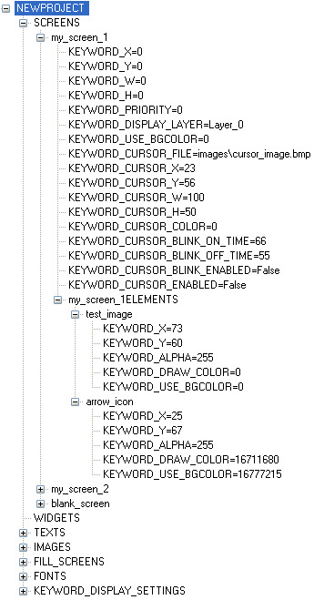
Even though the complexity w.r.t the user is reduced, this brings additional complexity to the tool since now the tool need to make sure that both the trees are synchronized. I.e. for example if an elements gets added, then both the tree should reflect this.

Basically the TreeView handles the following events
- Drag and Drop
- Auto Scroll Up/Down when dragging an item above/below the viewing area.
- Left mouse click to select an element. When an element is selected, the MainForm::app_main_form->Selected_Elem_CBox->Text is updated with the selected element name to trigger a refresh of the viewer window and then the property window is refreshed with new element's property.
- Right mouse click to open up the context menu associated to the element type. All the required context menu is created in tree_view_context_menu and are enabled/disabled based on the element type and its property.
- Events associated to the context menu strip.
- Mouse double click to edit the element name.
gfx_treeview.cpp file contains all the event handlers for the ProjUserTreeView.

In the ProjUserTreeView, for each of the Node following naming strategy is followed. The Name property is used to store the element type string. Element type string can be on of the entry in lc_keywords[] array (MainForm.h). Text property is used to store the elements name. For example, in the case of a TreeNode ^ mynode,
mynode->Name will represent the element type
mynode->Text will represent the element name (This will be the one visible to the user).

For the ProjXmlTreeView, following naming strategy is followed.
- If the node is a property node (does not have any child nodes) then, the Name property will store the property value and the Text property will store <property keyword> + "=" + <property value>. Property keyword can be one of the entry from lc_keywords[] array (MainForm.h).
- If the node is not a property node, then only the Text property will be used to store the element name.

Element naming also follows certain set of rules such as
- Name shall be unique. (Refer ChangeElementName() in gfx_element_manip.cpp)
- Name shall not contain any special symbols. (Refer CheckElementName() in gfx_viewer.h)

Element Manipulation
This component provides following functionalities
- Adding new element.
- Removing existing element.
- Renaming element.
- Copy an existing element in to a group (widget, screen or dynamic image).
- Trigger to reload the property and refresh the property grid.
The component implementation is done in the gfx_element_manip.cpp and gfx_element_manip.h files. This component is a generic component which handles for all the type of elements (Screen/Widget/Image/Fillscreen/Text/Font). The individual element specific handling is implemented in its respective components.

Project Settings

Screens

Widgets

Images

FillScreens

Texts

Fonts

Use Cases

Project Creation

Move an Element in to a Widget/Screen

Delete an Element

Save the Project

XML project file parser

Compiler Switches

ALIGNED_ELEMENT_GROUPS_NEEDED | :
CLIPPED_ELEMENT_GROUPS_NEEDED | :
STATIC_TEXT_NEEDED | :
MULTI_LINE_TEXT_NEEDED | :
SUPPORT_INDEPENDANT_ELEMENT_PROPERTY | :
SCROLABLE_TEXT_NEEDED | :
NEED_EXTENDED_CHAR_SET_SUPPORT | :
KEPLER_PLATFORM | :
GDT_VERSION_1BPP_ONLY | :

Coder Generator

Compiler Switches
ALIGNED_ELEMENT_GROUPS_NEEDED | :
CLIPPED_ELEMENT_GROUPS_NEEDED | :
STATIC_TEXT_NEEDED | :
MULTI_LINE_TEXT_NEEDED | :
SUPPORT_INDEPENDANT_ELEMENT_PROPERTY | :
SCROLABLE_TEXT_NEEDED | :
GENERATE_DTEXT_INIT_TABLE_ROM | :
RGB888TO565_USE_MSBITS_FOR_R_AND_B | :
KEPLER_PLATFORM | :
GDT_VERSION_1BPP_ONLY | :

Use Cases

Scrolling Text Handling
When the user selects a dynamic text as scrollable, the coder will set the property GFX_TEXT_PROPERTY_SCROLABLE for the text and adds two bytes at the end of its allocated string data memory to hold the scroll offset. The graphics library build text function will access these two bytes as a signed 16bit variable to calculate the start offset for the string.

Char0 | Char1 | …. | CharN | NULL | Scroll Offset Byte 1 | Scroll Offset Byte 1

Revision History

Rev # | cdsid | Date | Reason
0.1 | emanoj1 | 04-Jan-2010 | Creation

