

Driver Information

GDG03 Programmer’s Guide

Revision 1.5

Dec 10, 2012

Visteon Corporation
DI Core Software Group

Table of Contents
1 Introduction 3
1.1 Purpose 3
1.2 Definitions and Acronyms 3
1.3 References 4
2 Package File List 4
3 Target Architecture 6
4 GDG03 Functional Description 7
4.1 Basic Architecture 7
4.2 Graphics Manager Implementation 8
4.3 Graphic Display Types 8
4.3.1 Bitmap Display Types 8
4.3.2 Tile Display Types 11
4.3.3 Text Display Types 13
4.3.4 Widget Display Types 13
5 Graphics Manager API 15
5.1 Extending the API 15
5.2 Integrating the EOL 15
5.3 Integrating the QSPI checksum 15
5.4 User Interface layer 16
6 Scheduling 17
7 Error Handling 18
8 Freescale Library Files 18
9 Configuration 18
10 Installation Procedure 21
11 Shutdown and Startup Procedure 23
11.1 Startup Procedure After Cold/Warm/Wakeup 23
11.2 Normal Shutdown Procedure 23
11.3 Emergency Shutdown Procedure 23
11.4 Startup Procedure After Shutdown 24
11.5 Important Metrics 24
12 Presentation Scheduling 25
13 PC Simulation 25
14 Recommended Practices 25
Appendix A – Change History 27

Introduction

Purpose
In 2008, Freescale introduced the MPC560xS family of 32-bit microcontrollers based on their Power Architecture. These microcontrollers are targeted at automotive applications that incorporate a thin-film transistor (TFT) display and are capable of driving the TFT directly. This eliminates the need for an external IC to do this work, which leads to overall lower product cost.

These micros also incorporate a novel approach to TFT display control called a Display Control Unit (DCU). The DCU blends data from 16 different layers (including a cursor and video input) to generate a display. Software need only specify the content of each layer and DMAs are used to fetch the content with little to no CPU overhead.

The three micros in this family are the MPC5602S, MPC5604S, and MPC5606S. As is typical for micros in a family, they are basically the same but vary in the number of peripherals supported and in the RAM / FLASH size. The focus of this document will be on the MPC5606S which is a 48K RAM / 160K graphics RAM / 1MB Flash part and is known as the Spectrum and the MPC56xxS which is a 64K / 1MB ( 512 K) graphics RAM / 2MB Flash part Rainbow (Rainbow lite). It has an e200z0h CPU core.

The Spectrum/Rainbow microcontroller and supporting bookshelf hardware and software are collectively known as the Kepler platform. The purpose of this document is to describe the operation and integration of the GDG03 (GFX MANAGER 02) code package which has been written to manage all graphics on Kepler platforms.

The GDG03 code package works in conjunction with the Graphics Development Tool (GDT) which is a PC-based utility to generate all the graphical content of a product. In other words, the GDT generates the actual pixel data and data structures to define how to combine graphics into actual screens, and this code package issues the proper commands to dynamically build the screens using the DCU when the software is running in the Spectrum / rainbow micro.

Before attempting to use this code package, you should familiarize yourself with the documents referenced in section 1.3 as they provide necessary background to understand the details provided here.

Definitions and Acronyms
BPP Bits Per Pixel
CLUT Color Look Up Table
COP Computer Operating Properly
DCU Display Control Unit
DI Driver Information
DMS Display Manager Subsystem
DMA Direct Memory Access
FPS Frames Per Second
GDT Graphics Development Tool
IC Integrated Circuit or Instrument Cluster
IDE Integrated Development Environment
MCU Microcontroller Unit
QSPI Quad Serial Peripheral Interface
RAM Random Access Memory
RGB Red Green Blue
RLE Run Length Encoding
ROM Read Only Memory
TFT Thin Film Transistor
VOB Versioned Object Base

References
- Kepler Software Architecture documentation (kepler_sw_arch.doc) in ClearCase “sw_architecture \ driver_information \ platforms \ Kepler \ 05_product \ design”.
- MPC5606S Microcontroller Reference Manual (MPC5606SRM 8-11-09.pdf), available in Smart Folder “FS MPC56xx (Spectrum/Rainbow)”.
- GDT Tool User Guide in ClearCase “sw_methods_tools \ tools \ hmi \ gdt \ user_guide”.
- Kepler GDT Framework Specification (kepler_gdt_framework.doc) in ClearCase “sw_methods_tools\ tools \ hmi \ simulation_framework \ kepler”
- Kepler GDG02 change proposal (KeplerGraphicsProposal.ppt) in Clearcase “sw_hmi_ss\hmi_gfx_manager_02\06_documentation\specs”
- GDG03 Programmer’s Guide (this document) in ClearCase “sw_hmi_ss\hmi_gfx_manager_02\ 06_documentation”.

Package File List
The GDG03 package consists of the following source code files written and maintained by Visteon and few files are written by freescale. These files are available in ClearCase “sw_hmi_ss\hmi_gfx_manager_02 \03_code\ src”.

File | Description
dcu.c | Low level DCU interface layer.
dma.c | Low level DMA driver.
dmahandler.c | High level DMA manager. Not currently used.
fontlibrary.c | Font building routines.
graphics.c | Graphic object manipulation routines (copy, rotate, scale, etc).
hmi_gfx_mgr02.c | High level graphics manager.
hmi_gfx_mgr02_binarysearch.c | Internal to the gdg03 package.
hmi_gfx_mgr02_driver.c | Low level graphics library functions. Internal to gdg03 package.
hmi_gfx_mgr02_if.c | Internal to the gdg03 package.
hmi_gfx_mgr02_if_chart.c | Internal to the gdg03 package.
hmi_gfx_mgr02_if_chart.h | Internal to the gdg03 package.
hmi_gfx_mgr02_if_model_autocode.c | Internal to the gdg03 package.
hmi_gfx_mgr02_if_model_autocode.h | Internal to the gdg03 package.
hmi_gfx_mgr02_image_data.$c | Sample image data file. Use this file as a template to create the image data file for your product (hmi_gfx_mgr02_image_data.c).
hmi_gfx_mgr02_mem.c | Internal to the gdg03 package.
qspi.c | Quad-SPI driver.
qspi_chksum.c | Internal to the gdg03 package.

HMI GFX MANAGER 02 package has a public folder where the interface functions to the application are available.
File | Description
hmi_gfx_mgr02_if.h | Interface file for the application.

HMI GFX MANAGER 02 package has a private folder where the interface functions used in the hmi gfx manager internally.
File | Description
common.h | Dummy header file created just so the Freescale library will compile.
dcu.h | Low level DCU interfaces.
dma.h | Private header file.
dmahandler.h | Private header file.
fontlibrary.h | Private header file.
GALLO.h | Currently Not used.
graphics.h | Private header file.
hmi_gfx_mgr02.h | Private header file.
hmi_gfx_mgr02_binarysearch.h | Private header file.
hmi_gfx_mgr02_driver.h | Public header file. This shall be used to configure the Interrupt vector for DCU isr.
hmi_gfx_mgr02_mem.h | Private header file.
hmi_gfx_mgr02_priv.h | Private header file.
hmi_gfx_mgr02_types.h | Private header file.
jdp.h | Dummy header file created just so the Freescale library will compile.
ports.h | Dummy header file created just so the Freescale library will compile.
qspi.h | Private header file.
qspi_chksum.h | Internal to the gdg03 package.

GDG03 package also uses the following configuration files that are used in conjunction with the GDT tool. These files are available in ClearCase “sw_hmi_ss\hmi_gfx_manager_02\03_code\cfg\”.

hmi_gfx_mgr02$.cfg | Sample configuration file. Use this file as a template to create the configuration file for your product (hmi_gfx_mgr02.cfg).
hmi_gfx_mgr02_clut_table$.cfg | Sample configuration file. Use this file as a template to create the configuration file for your product (hmi_gfx_mgr02_clut_table.cfg).
hmi_gfx_mgr02_font$.cfg | Sample configuration file. Use this file as a template to create the configuration file for your product (hmi_gfx_mgr02_font.cfg)
qspi$.cfg | Sample configuration file. Use this file as a template to create the configuration file for your product (qspi.cfg)

Target Architecture
This package has been specifically written to work on the Kepler platform. It will not work on any other platform. Prior to attempting to use this code package, the software developer must read and understand the Kepler Software Architecture documentation that is referenced in section 1.3.

GDG03 Functional Description

Basic Architecture
The basic architecture of the GDG03 package is shown in figure 1.
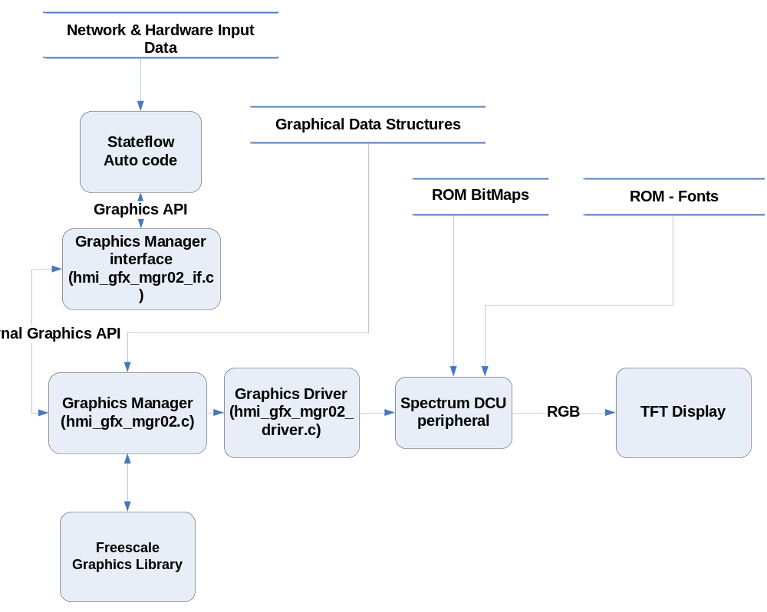

Figure 1 – GDG03 Architecture

Some of the information in the above diagram is for clarity, because GDG03 technically only consists of the Graphics Manager (hmi_gfx_mgr02.c), Visteon Graphics Library (hmi_gfx_mgr02_driver.c) and Freescale Graphics Library. For completeness.

The GDG03 package allows the application code to update the contents of a graphical display by executing API functions to build and control the content of the DCU “layers”. These API functions are translated by the Graphics Manager into function calls to the Visteon Graphics Library, and/or Freescale Graphics Library. These function calls ultimately write to the DCU registers to control the RGB signals that will be sent to the TFT display.

As documented in the Kepler Software Architecture documentation, the DCU supports 16 layers. Each layer can contain a graphics object. The application code issues a series of “build layer” commands to turn on these layers to build the contents of a screen.

The graphics objects that can be displayed in a layer are: bitmaps, tiles, alpha maps, text, and widgets. Data structures are used by the manager to retrieve specific information about each of these types. These data structures are auto-generated using the GDT (Graphics Development Tool). Details on each of these types can be found in the following sections. Details on the GDT can be found by following the links in the references section (section 1.3).

Section 5 provides a listing of all of the API functions and details of their usage.

Graphics Manager Implementation
The graphics manager executes during the interrupt that marks the start of the vertical blanking period of the display. This is the period of time during which it is safe to update CLUTs, use the DMA to build font text, widgets etc. Graphics manager doesn’t allow application layer before it completes the previous build request.

When the graphics manager executes, it will check a queue for commands. This queue is basically data in a data structure that is filled each time the HMI logic calls one of the API functions. The data in the structure is processed accordingly during the graphics manager execution. In most cases, the processing involves executing functions provided by the Visteon Graphics Library, or Freescale Graphics Library. These functions generally result in writes to the registers contained within the DCU peripheral and ultimately affect the contents of the display.
Graphics manager is designed such a way that all static elements of the selected screen will be automatically built when the application requests to build the screen. Application shall update the commands for dynamic elements and animation elements property changes alone. Application doesn’t have any provision to update or change the non-animation elements.

Graphic Display Types
As previously mentioned, the graphics objects that can be displayed in a layer are: bitmaps, tiles, alpha maps, text, and widgets which falls either animation element or non-animation element. The following sections provide some basic information on each type, with some simple examples of how to display each in a layer. More specific information is available in section 5.0.

Bitmap Display Types
A bitmap is a series of pixels and the associated color information. The pixel information may contain the color information (i.e. 16BPP or higher types) or be derived via a CLUT (i.e. 8BPP or lower types).
There two different types of bit maps are available in the design Dynamic and static bit maps, These 2 types can be configured as Animation / non-Animation elements. Application cannot change the properties of the Non- animation elements; only animation element properties can be changed by the application.

The following example illustrates how the application code uses the GDG03 package to display an Animation elements and Non-animation elements for static images and dynamic images.

Some considerations with respect to bitmaps / CLUTs:

- There is a limit to the number of CLUTs that can be loaded into CLUT RAM because the size of the CLUT RAM is limited. This means that while design time the application must make an effort to communize CLUTs across bitmaps and minimize their sizes. The GDT tool has much of this capability built into it.
- gfx manager handles the clut loading in two different ways one static loading and the other dynamic loading. This is compilation time select option based on the CLUT size gfx manager enables the Static/ Dynamic type loading.
  - Static loading takes place when the total CLUT size of the design is lesser than the available CLUT size in the micro (Spectrum/ Rainbow) selected. This will be loaded when gfx manager gets initialized.
  - Dynamic loading takes place when the total CLUT size is greater than the available CLUT size in the micro.
- While design time if the bit map needs to change during run time it is recommended to use the Animation image type.

If Application wants to build a different CLUT than the design time on application shall use
hmi_gfx_mgr02_if_set_obj_clut(GFX_MGR02_ANIM_ELEM_ID, UINT32 p_clut_id).

Static Image

Non Animation element:

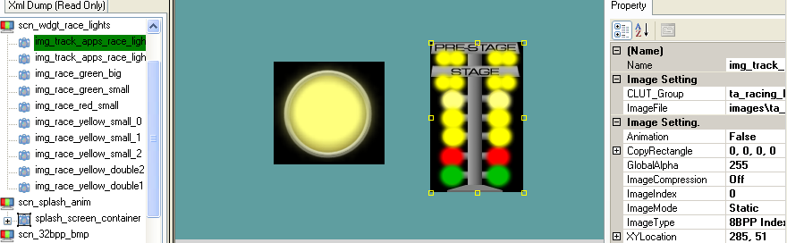

In the above shown picture the image img_track_apps_race_lights_tree is a static image and Non-Animation element. hmi_gfx_mgr02 doesn’t allow changing the image properties (X, Y position, and alpha, Clipping …) for this element. Upon selection of the screen gfx manager collects the static image property and builds the element. Application need not to do any calls to set this type of elements.
Example
hmi_gfx_mgr02_if_set_screen (GFX_SCN_WDGT_RACE_LIGHTS, 1); will automatically take care of building the image img_track_apps_race_lights_tree.

Animation Element:

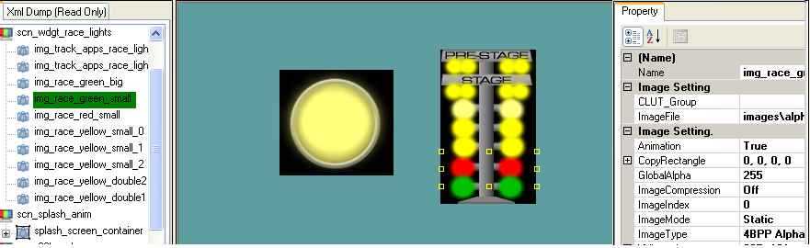

In above shown picture the image img_race_green_small is a static element and its animation property is set. Gfx manager sets the default properties which are set in the data structure; it is application responsibility to set required setting by invoking appropriate API’s to set properties of the elements.

- hmi_gfx_mgr02_if_set_obj_clut(GFX_MGR02_ANIM_ELEM_ID, UINT32 p_clut_id)
- hmi_gfx_mgr02_if_set_obj_blend(GFX_MGR02_ANIM_ELEM_ID, GFX_MGR02_BLEND_DATA)
- hmi_gfx_mgr02_if_set_obj_fg_color(GFX_MGR02_ANIM_ELEM_ID p_elem_id, UINT32 p_color)
- hmi_gfx_mgr02_if_set_obj_bg_color(GFX_MGR02_ANIM_ELEM_ID p_elem_id, UINT32 p_color)
- hmi_gfx_mgr02_if_set_obj_fill_color(GFX_MGR02_ANIM_ELEM_ID p_elem_id, UINT32 p_color)
- hmi_gfx_mgr02_if_set_obj_vclip(GFX_MGR02_ANIM_ELEM_ID, GFX_MGR02_VCLIP_DATA)
- hmi_gfx_mgr02_if_set_obj_pos_x(GFX_MGR02_ANIM_ELEM_ID, SINT16 p_pos_x)
- hmi_gfx_mgr02_if_set_obj_pos_y(GFX_MGR02_ANIM_ELEM_ID, SINT16 p_pos_y)

Dynamic Image

Non animation element:
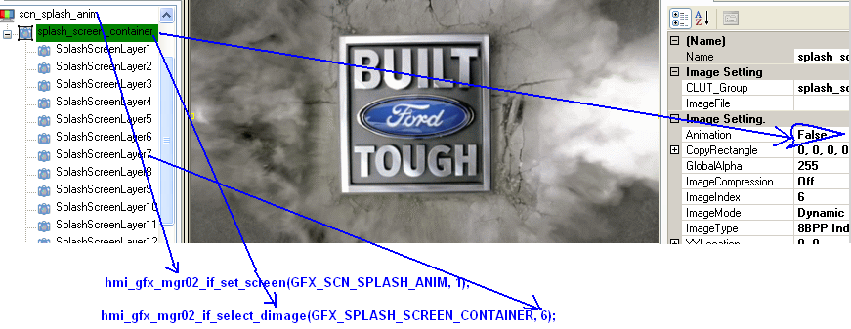
In above shown picture splash_screen_container is the dynamic element and its animation settings are disabled. Application has to set the appropriate image index to the dynamic image by using the below API. If the child elements of the dynamic image are non-animation elements gfx manager doesn’t allow changing any property of the element.

API.
- hmi_gfx_mgr02_if_select_dimage(GFX_MGR02_DIMG_ELEM_ID, p_index)

Animation element:
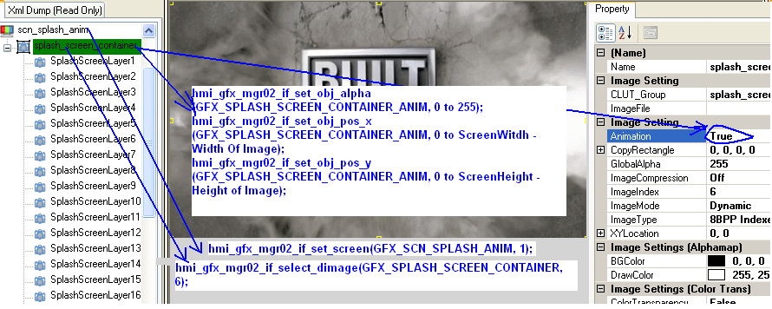

After selecting the Dynamic image application can change the animation properties of the selected element just by changing the Dynamic element Anim ID. This is same as the Static image animation element.

API’s to use:
- hmi_gfx_mgr02_if_select_dimage(GFX_MGR02_DIMG_ELEM_ID, p_index)
- hmi_gfx_mgr02_if_set_obj_clut(GFX_MGR02_ANIM_ELEM_ID, UINT32 p_clut_id)
- hmi_gfx_mgr02_if_set_obj_blend(GFX_MGR02_ANIM_ELEM_ID, GFX_MGR02_BLEND_DATA)
- hmi_gfx_mgr02_if_set_obj_fg_color(GFX_MGR02_ANIM_ELEM_ID p_elem_id, UINT32 p_color)
- hmi_gfx_mgr02_if_set_obj_bg_color(GFX_MGR02_ANIM_ELEM_ID p_elem_id, UINT32 p_color)
- hmi_gfx_mgr02_if_set_obj_fill_color(GFX_MGR02_ANIM_ELEM_ID p_elem_id, UINT32 p_color)
- hmi_gfx_mgr02_if_set_obj_vclip(GFX_MGR02_ANIM_ELEM_ID, GFX_MGR02_VCLIP_DATA)
- hmi_gfx_mgr02_if_set_obj_pos_x(GFX_MGR02_ANIM_ELEM_ID, SINT16 p_pos_x)
- hmi_gfx_mgr02_if_set_obj_pos_y(GFX_MGR02_ANIM_ELEM_ID, SINT16 p_pos_y)

Tile Display Types
A tile is a bitmap that is repeated multiple times in a window of variable size.

The following example illustrates how the application code uses the GDG03 package to display a tile of an 8BPP bitmap on the display.
Building Tile Element:
Steps:
- Create the tile element under the FILL_SCREENS.
- Set the tile element properties as required from Fill Settings in the GDT tool.
  - Animantion (True → To Have animation on tile element, False → For Normal)
  - Fill Color → Color as required.
  - FillMode → Normal / Tiling
  - FillRectangle → Tile image x, y and width, height properties.
- Set the image which is needed tiling.
Example shown below:
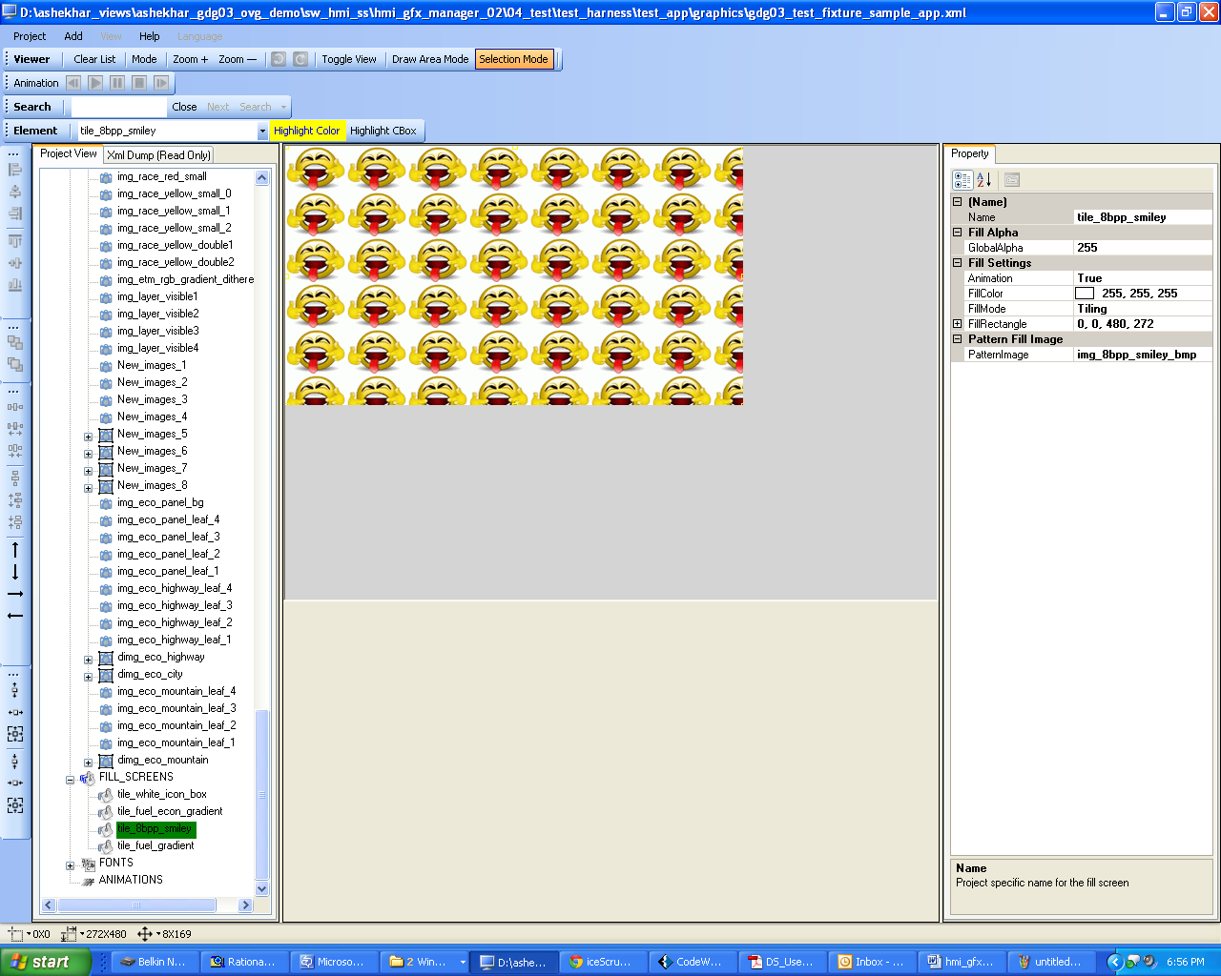

Non Animation element:

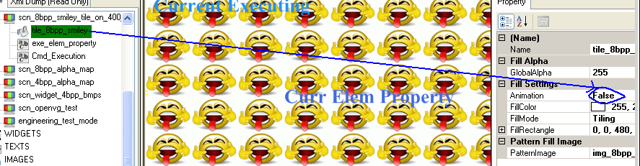

Gfx manager builds the non-animation tiles when application selects the tile element screens. hmi_gfx_mgr02_if_set_screen (GFX_SCN_8BPP_SMILEY_TILE_ON_400…, 1)

Animation element:
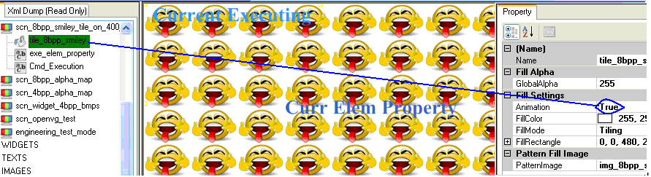

API’s to set tiling properties
hmi_gfx_mgr02_if_set_obj_tile(GFX_MGR02_ANIM_ELEM_ID, GFX_MGR02_TILE_DATA)

Text Display Types
A text I/O is a series of ASCII or UNICODE characters that the application code wishes to display. The Freescale library provides functions to build the text I/O, character by character, using a DMA or the CPU. The characters are built by copying the character pixel map into a RAM buffer that is allocated to hold all of the text. This RAM buffer is treated like any other graphics object and put into a layer. The character pixel map is retrieved from a “font file” that is generated by GDT and/or the Freescale font utility. This font file is stored in either internal or external flash ROM at the lead software engineer’s discretion.

There are two types of text I/Os: static and dynamic. The name “static” implies that the text cannot be changed after it is built. The difference between the two types is determined during the build process.

After the initialization, if the text is static, the text characters in the data structures generated by GDT will be used to build the text. This text cannot be changed during run time.

After the initialization, if the text is dynamic, no text will be put into the display buffer. In order to see text in the buffer, the application would use the API functions to update text to the desired values. Generally, it is expected that dynamic text will be used to display text that you want to build but that may have different starting values. For example, your odometer text would be dynamic because you would want it to start with the latest odo value and not “000000” every time it is displayed.

Once a layer that contains text is no longer required, it is imperative that the application code use the “set text with NULL string” using the API function hmi_gfx_mgr02_if_set_text (Element_Id, String) or The text can be set using the SID by hmi_gfx_mgr02_if_set_sid(GFX_MGR02_DTEXT_ID p_elem_id, LANG_SID_T p_sid).

- hmi_gfx_mgr02_if_set_text(Element_Id, L”WELCOME”);

After text has been built in a layer, the API provides functions to change the text contents.

Some considerations with respect to text:

- Text can have 1, 2, 4, or 8 bits of anti-aliasing. You can choose this when designing the project in GDT. Text of 1 or 2 bits will be rendered using the CPU, meaning that it will block while the characters are being copied from flash to RAM. Text of 4 or 8 bits uses the DMA to copy characters, which does not block other software from running. For this reason, it is recommended to use 4 or 8 bits (which look nicer anyway) unless you do not have enough flash ROM space.
- 1 or 2 bit text cannot be in alpha map format, so a color lookup table must be created and loaded similar to the way it is done with bitmaps. You can also choose to have 4 or 8 bit text with an associated color lookup table. Generally, however, 4 or 8 bit text should be done with alpha data and would then function the same as an alpha map.

Widget Display Types
A widget is a combination of different graphic objects and/or text in RAM, and is easier to understand by examining the group of icons shown below.



You could implement this with 6 different bitmap layers (one for each icon), and not use any RAM. However, you may not have enough layers to do this. Using a widget, you can combine all these bitmaps into one RAM block and then use just one layer to display it.

Widgets can also consist of two or more lines of text, or any combination of text and bitmaps. The example below is a widget of three lines of centered text with a blue foreground color and yellow background color.



In GDT design application can generate dynamic / static widgets.
When the graphics manager executes this command, it will allocate enough RAM memory to hold all of the graphic objects, and then initialize that RAM to a default value. At this point, the widget would be ready for display although there would be nothing in it. You would use the “update widget” command to show the various graphic objects within the widget at which point they would become visible.

Widgets are very powerful in that you can have many graphics objects and text in them located at many different locations. The number of objects and the number of locations is not required to be the same.

Please note that the BPP and encoding of each graphics object and text in a widget must be the same. This is because each widget is put into its own layer and there is only one BPP and encoding per layer. For example, if you were implementing the widget shown above with three lines of text and six arrows, you would most likely want to do this in 4BPP alpha map format because this is the best for viewing text. Therefore, the arrow bitmaps would need to be converted to 4BPP alpha map format as well prior to use in the widget.

Additionally, for a widget with multiple lines of text, all lines must have the same attributes. For example, if the first line of text in the widget is horizontal, left-justified, Arial 10-point, then all lines of text in the widget must have the same properties. Although GDT will allow you to set the properties differently, it will ignore the attributes for the other lines of text and generate all data structures using just the attributes from the first line of text.

The following example illustrates how the application code uses the GDG03 package to display a widget on the display.

Static widgets:
Application need not to invoke any API’s calls to build the static widget. Once application selects the screen which contains the static widget gfx manager starts building the static widget. Application has to select the screen that contains the static widgets.
The static widgets can further have 2 different types Animation or Non-Animation.
Application cannot change any property of the Non-Animation element.
For Animation element application change the x, y coordinates of the widgets and the Vertical clipping of widgets, alpha properties can be changed during runtime.
API’s
- hmi_gfx_mgr02_if_set_obj_clut(GFX_MGR02_ANIM_ELEM_ID, UINT32 p_clut_id)
- hmi_gfx_mgr02_if_set_obj_blend(GFX_MGR02_ANIM_ELEM_ID, GFX_MGR02_BLEND_DATA)
- hmi_gfx_mgr02_if_set_obj_fg_color(GFX_MGR02_ANIM_ELEM_ID p_elem_id, UINT32 p_color)
- hmi_gfx_mgr02_if_set_obj_bg_color(GFX_MGR02_ANIM_ELEM_ID p_elem_id, UINT32 p_color)
- hmi_gfx_mgr02_if_set_obj_fill_color(GFX_MGR02_ANIM_ELEM_ID p_elem_id, UINT32 p_color)
- hmi_gfx_mgr02_if_set_obj_vclip(GFX_MGR02_ANIM_ELEM_ID, GFX_MGR02_VCLIP_DATA)
- hmi_gfx_mgr02_if_set_obj_pos_x(GFX_MGR02_ANIM_ELEM_ID, SINT16 p_pos_x)
- hmi_gfx_mgr02_if_set_obj_pos_y(GFX_MGR02_ANIM_ELEM_ID, SINT16 p_pos_y)

Dynamic widgets:
Dynamic widget contains the set of static widgets application need to select the child static widget while building the dynamic widget screen. API to select the child static widget.
- hmi_gfx_mgr02_if_select_dwidget(GFX_MGR02_DWDG_ELEM_ID, UINT32 p_index);

Dynamic widget can also be configured as Animation element or Non-Animation element. All API’s used for the static widget are applicable after selecting the child static widget from the dynamic widget.

Graphics Manager API
The API provides the interface between the HMI logic and the graphics manager.
Where applicable, API commands have a parameter which specifies the Element IDs in which the command should be executed. Based on the screen priorities manager decide which DCU layer shall be used. If layers are not available it automatically frees layers required for the high priority screens, so user need not to worry about the DCU layer management.

Extending the API

Integrating the EOL
Conditional switch HMI_GFX_MGR02_ENABLE_DCU_TEST shall be defined in the hmi_gfx_mgr02.cfg file to enable the EOL interface.
Two options are provided to perform the EOL test for the TFT LCD. First one is just to check the manufacturer’s Color bar test pattern. With this DCU displays a test pattern consisting of vertical bands of programmable color. API’s provided for this is hmi_gfx_mgr02_init_for_EOL_mode(UINT8 enable_test_pattern) to enable the test pattern application shall pass the param as 1. The second approach is user specified test pattern which was designed as per the program specific to perform this user shall enable the compilation macro HMI_GFX_MGR02_ENABLE_DCU_TEST and invoke the above mentioned function with parameter as 0, which shall do all necessary initializations for the DCU. Once the DCU is initialized user shall set the screen using the hmi_gfx_mgr02_set_screen (ScreenID, enable) and followed by the hmi_gfx_mgr02_build_screen ().

Integrating the QSPI checksum
QSPI check sum support is added with conditional compilation switch (HMI_GFX_MGR02_CALC_QSPI_CHKSUM) to check the data consistency in QSPI FLASH memory. This function gets executes in the interrupt level when ever the graphics manager completes the graphics rendering.

In order to start the QSPI check sum initially application shall invoke the
qspi_checksum_start function from the qspi_chksum.c the interface is provided in the qspi_chksum.h file. This routine consumes 2.926 milli seconds to complete one block on rainbow Lite, and 5.264 milli seconds to complete in Spectrum.

qspi_checksum_is_completed function is provided to know the completion of the qspi checksum requested earlier. Based on this application can perform another iteration if required. The return parameter for this function is TRUE when checksum calculation is completed. The return parameter for this function is FALSE when checksum calculation is not completed.

qspi_checksum_ok is provided to know the qspi flash status.
All above mentioned function prototypes are available in the qspi_chksum.h header file.The return parameter for this function is TRUE when checksum is correct. The return parameter for this function is FALSE when checksum is not correct.

qspi_checksum_Calculator is provided to calculate the checksum in a single shot. The calculated checksum is the return parameter.

qspi_checksum_process_next_block is provided to calculate the current block checksum.

The macro used to specify the total number of bytes per block in KB is BYTES_PER_BLOCK. It can be configured as per requirement.

The recommented bytes to configure is 2KB.

For example:
#define BYTES_PER_BLOCK (2048ul)

The external flash device starting address is to be specified in the product.mic file. The macro to be included for this is ACTUAL_EXTERNAL_FLASH_ROM_START_ADDR.

The external flash device ending address is also to be specified in the product.mic file. The macro to be included for this is ACTUAL_EXTERNAL_FLASH_ROM_END_ADDR.

For example
#define ACTUAL_EXTERNAL_FLASH_ROM_START_ADDR 0x70000000uL
#define ACTUAL_EXTERNAL_FLASH_ROM_END_ADDR 0x70FFFFFFuL

User Interface layer
In order enable the user interface layer the user type image shall be added to the screen as place holder for the element to be built by the gfx manager. As this image is building by the user rest of the parameters are not required at this stage.
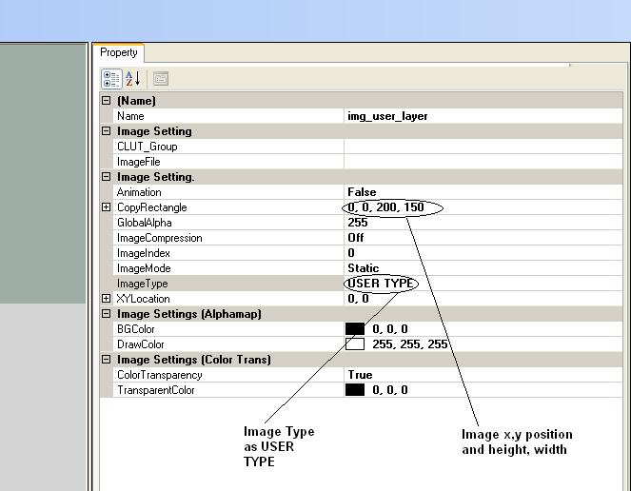

User layer shall be built in the GRAM, user shall configure the gram in such a way that at any point of the time the required gram size shall not be more than available gram size.
GDT generates the function proto types which shall get triggered by the gfx manager while allocating the layer (gfx_xxxxx_get_user_layer_area_cb(GFX_MGR02_ELEMENT_AREA *, GFX_MGR02_USER_IMAGE_DATA_T *)), in this user shall fill the details like element start x, y, end x, y, transparency, position of the element. Another callback shall be triggered by the manager layer while pre-rendering the graphics this is the place holder where the user layer shall build and pass the layer information (gfx_xxxxx_render_user_layer_element_cb(struct DCU_LAYER_tag *
, struct DCU_FG_tag *))
The final callback gets triggered once the layer information is passed to the DCU, once gfx_xxxxx_user_layer_render_complete_cb(void) callback indicates the rendered gram is allocated to the DCU layers this should never change. Currently double buffer concept is used for gram, text, widgets are built by manager in the gram, the sharing of the gram shall be configured such a way that half of gram shall be used to build the complete layers, rest of the gram is used to rebuild the for the next cycle as per the requirement.

Scheduling
As previously described, the graphics manager executes in an interrupt that triggers at the start of the vertical blanking period of the display. No explicit scheduling of graphics manager tasks is needed outside of ensuring that the interrupt is enabled and the proper interrupt service routine installed in IVECTORS.CFG.

Error Handling
The graphics manager does not have success / failure return codes. If the design and coding of the project is properly done, i.e. you are not doing something like exceeding the 160K graphics RAM boundary or trying to put things in an invalid layer value, then return codes are not needed.

If the graphics manager does encounter an error when executing, it will simply abandon the current function. This means that if you are incorrectly building a layer, the manager will ignore the request and the layer will not be displayed. This will be an indication that you have done something wrong and a defect search will be warranted.

Freescale Library Files
The Freescale library files are managed by the graphics manager and the application code does not explicitly need to execute functions therein unless extending the API as described in section 5.3.

Configuration
This section provides details on configuring GDG03. Many details are included in the various sample CFG files, and as such everything is not necessarily repeated here. Only important items or items require more detail appear here.

Configuring hmi_gfx_mgr02_driver.C:
Configure hmi_gfx_mgr02_driver.C by starting with the sample hmi_gfx_mgr02$.CFG file and modifying it per your needs. With this file, you can enable/disable and set the TFT register settings. Most of the items here are self-explanatory and straight-forward and not repeated here with one exception:
/*
** If you are using the Sharp LQ042 display connected to the DCU, you
** can #define the "GFX_MGR02_USE_SHARP_LQ042" macro and a display setup
** function called "hmi_gfx_mgr02_driver_SetupLQ042()" will be conditionally compiled
** in and executed when appropriate.
**
** If you #define the "GFX_MGR02_USE_SHARP_LQ042" macro, a subset of
** the display timing parameters can be adjusted by configuring
** the macros shown below. These parameters are described in detail
** in the comments in "hmi_gfx_mgr02_driver_SetupLQ042()".
** The key to configuring the timing is to ensure that the frames
** per second (FPS) update rate of the display is fast enough to meet
** your customer requirements and stays within the tolerance of the
** display itself.
**
** If you are not using that display(s) or would like different
** timing parameters, comment out "GFX_MGR02_USE_SHARP_LQ042" and
** define "GFX_MGR02_PROD_SPEC_DISPLAY_SETUP()" as a function to setup
** whatever display(s) you are using and use "hmi_gfx_mgr02_driver_SetupLQ042()"
** as an example of what you need to do.
*/
/*
** The below configuration is to select the Sharp LQ042 display or another display.
** If Sharp LQ042 display is selected, then define the GFX_MGR02_USE_SHARP_LQ042
** otherwise comment this and add a function to initialise the TFT LCD display.
*/
#define GFX_MGR02_USE_SHARP_LQ042
#define GFX_MGR02_PROD_SPEC_DISPLAY_SETUP ()
#define SHARP_LQ042_BACK_PORCH_HORIZONTAL 112
#define SHARP_LQ042_PULSE_WIDTH_HORIZONTAL 5
#define SHARP_LQ042_FRONT_PORCH_HORIZONTAL 2
#define SHARP_LQ042_BACK_PORCH_VERTICAL 29
#define SHARP_LQ042_PULSE_WIDTH_VERTICAL 2
#define SHARP_LQ042_FRONT_PORCH_VERTICAL 2
#define SHARP_LQ042_DIV_RATIO 0x0B
#define GFX_MGR02_PROD_SPEC_DISPLAY_SETUP()
/*
** GFX_MGR02_DONOT_REBUILD_UNCHANGED_ELEMENT - define this macro to enable
** gfx02 to perform an element changed check and based that decide whether
** to build the element again or not. If the element is not changed then
** the gfx02 will copy from the already built buffer to the new buffer rather
** than rebuilding it again.
*/
#define GFX_MGR02_DONOT_REBUILD_UNCHANGED_ELEMENT
/*
** Specify the handler for the presentation task of application.
** graphics manager will invoke this handler at the rate set for
** hmi_gfx_mgr02_if_KSTimedTask(). Application shall invoke the
** graphics manager API's in hmi_gfx_mgr02_if.h only with in the
** context of GFX_MGR02_IF_APP_PRESENTATION_TASK()
*/
#define GFX_MGR02_IF_APP_PRESENTATION_TASK()
/*
** Define the 32-bit default background color. Any area of the display that
** does not have an active pixel will be set to this color, and it will be
** blended with other layers if those layers have selected the alpha
** blending option. This is the value that will be set at cold/warm/wakeup
** initialization.
**
** The MS 8-bits are ignored, the next 8-bits are the R value, then the G
** value, then the B value.
**
** Some examples:
** 0x00000000 black
** 0x00FFFFFF white
** 0x00404040 mid-gray
** 0x00FF7FFF pink
**
** The macro "GFX_MGR02_DEFAULT_BACKGROUND_COLOR" selects the background
** color for the DCU.
*/
#define GFX_MGR02_DEFAULT_BACKGROUND_COLOR 0x00000000
/*
** Define the HMI_GFX_MGR02_DYNAMIC_CLUT_LOAD_SUPPORT_NEEDED macro
** if Dynamic CLUT loading is required. The dynamic CLUT
** loading is must if image/ text CLUT size is more than the available CLUT size. And optional if the image /text CLUT size is lesser than available CLUT size.
** If the below macro not defined the CLUT will get loads during the startup, and during the building the Layer just gets mapped to the address of the CLUT mem.
*/
/*
** #define HMI_GFX_MGR02_DYNAMIC_CLUT_LOAD_SUPPORT_NEEDED
*/
#ifndef HMI_STRNLEN
#define HMI_STRNLEN(x, y) HMI_STRLEN(x)
#endif
/*
** Specify a default character to be used when a character in text
** string is not present in the font database.
*/
#define GFX_MGR02_DEFAULT_CHAR (0)
/*
** To perform qspi checksum enable the HMI_GFX_MGR02_CALC_QSPI_CHKSUM macro.
** Specify ACTUAL_EXTERNAL_FLASH_ROM_START_ADDR to the QSPI flash start address
** Specify ACTUAL_EXTERNAL_FLASH_ROM_END_ADDR to the QSPI flash end address in the
** product.mic file.
**
*/
/*
** #define HMI_GFX_MGR02_CALC_QSPI_CHKSUM
*/
#ifdef HMI_GFX_MGR02_CALC_QSPI_CHKSUM
/* Total number of bytes per block in KB*/
/* Currently it is configured for 2KB it can be configured as per requirement */
#define BYTES_PER_BLOCK (16384ul)
#endif
/*
** To enable the engineering test mode to test without the GDT design enable
** below macro definition.
** #define HMI_GFX_MGR02_ENABLE_DCU_TEST
*/
/*
** To enable the end of line Display test enable the
** HMI_GFX_MGR02_ENABLE_DCU_TEST.
*/
By default, the hmi_gfx_mgr02_driver.C code will assume it is connected to a Sharp LQ042 display (480x272 pixels) with a Spectrum micro running at 64MHz, as this is the target display for the Kepler platform. The default configuration enables the display at ~30 FPS. If you are using a different display or would prefer a different FPS, you can use this configuration item to change it. Regardless, it is highly recommended that you review the comments in the “hmi_gfx_mgr02_driver_SetupLQ042 ()” function and understand the different parameters that are under your control.
Creating GDG03_IMAGE_DATA.C:
If using the GDT tool to generate your graphics and graphical data structures, you will need to create hmi_gfx_mgr02_image_data.C to specify whether graphic data is placed in internal memory or external flash memory. The method to do this is well documented in the sample hmi_gfx_mgr02_image_data$.C. Review the comments in detail to determine the best configuration for your product. If you have enough internal memory, it is best to place your graphic data there as there are no bandwidth issues accessing internal memory. If you run out, you must carefully choose which items to place in external memory as there are bandwidth limitations when accessing this memory (see the Kepler Software Architecture document for more details).

Installation Procedure
Installing the GDG03 package requires the following steps.
Installing GDG03:
- Locate hmi_gfx_mgr02_if_KSColdInit, hmi_gfx_mgr02_if_KSWarmInit, hmi_gfx_mgr02_if_KSWakeUp, hmi_gfx_mgr02_if_KSSleep, hmi_gfx_mgr02_if_TimedTask, hmi_gfx_mgr02_if_shutdown, in hmi_gfx_mgr02_if.c, hmi_gfx_mgr02_if_chart.c file and place them into the proper list in SCHED.CFG.
- Configure the hmi_gfx_mgr02_if_KSTimedTask in SCHED.CFG as a timed task. The rate configured for this task affects both the periodicity of the task configured in GFX_MGR02_IF_APP_PRESENTATION_TASK() and error in its scheduling. Refer Presentation Scheduling section for more info.
- hmi_gfx_mgr02_if_shutdown will disable the DCU and puts the graphics manager in shutdown state. Needs to be called when an abnormal condition is detected and the TFT shall not be driven (Refer Shutdown and Startup Procedure for more info).
- hmi_gfx_mgr02_if_TimedTask rate depends on how frequent the application wants to update the contents. When the graphics manager is idle a call to hmi_gfx_mgr02_if_TimedTask will schedule the animation/presentation task and if there are any commands issued then graphics manager will change it state to building state. The graphics manager will require 2 vsync signals to complete building and return to idle state again. During the building state any call made to hmi_gfx_mgr02_if_TimedTask are ignored, in other way the calls are processed only when the idle state is active. If the TFT refresh rate is 60Hz, for 2vsync it will take 33.33mSec. So if you need to achieve a 33mSec refresh rate you could either run the task at next highest possible rate such as 34mSec or at lower interval such as 2/4mSec.
- hmi_gfx_mgr02_if_start needs to be called when the application is ready to drive the display such as the QSPI and TFT power up sequence is completed and it is now ready to start the display refresh. This function will perform the DCU initialization, enables the DCU and puts the graphics manager in active state. (Refer Shutdown and Startup Procedure for more info)
- Application presentations shall run through the GFX_MGR02_IF_APP_PRESENTATION_TASK(), graphics manager expects that the data does not gets modified while it is building the screen content. The GFX_MGR02_IF_APP_PRESENTATION_TASK() handles this by making sure that it does not schedules your presentation tasks when the hmi_gfx mgr02 is busy.
- Graphics_Task, Graphics_Task_Done are covered by the package itself.
- Create the “hmi_gfx_mgr02.cfg” files to meet your product requirements using the sample configuration files provided with the package (“hmi_gfx_mgr02.cfg $.cfg”)
- For Kepler Spectrum/Rainbow platforms follow the additional configurations
- Include “hmi_gfx_mgr02_driver.h” & #include "hmi_gfx_mgr02_dcu.h" in IVECTORS.CFG and define the following entries: The priority is shown for illustration purpose only. Make sure that VS_BLANK interrupt is setup to have a higher priority as this interrupt is used to program the DCU registers. Any latency may lead to error in register programming and visible effects in display.
  - #define DCU0_VS_BLANK hmi_gfx_mgr02_driver_dcu_isr
#define DCU0_VS_BLANK_PRIORITY 14
  - #define RLE_INT hmi_gfx_mgr02_rle_isr
  - #define RLE_INT_PRIORITY 14
- Integrate the infrastructure.core.mppd\dma.handler.driver package. Please note that the eDMA ISR used by graphics manager may generate back to back interrupt requests, so its priority has to be kept as low as possible so that other high priority interrupts such as gauge, can has no impact.
  - Configure the dma.driver.cfg to include a maximum of two dma channels for graphics manager
  - First channel is for eDMA operations and the second one is required only if hardware RLE decoding support is required
  - If RLE support is used then make sure that dma.driver.cfg is configured in such way that the “HW Channel Number = Priority value”. This is due to a limitation within the software implementation for RLE decoding. For example the DMA_CH_PARAMETERS entry should look something like this { 0 , 0}, { 1 , 1}, ....
  - Now the HW Channel Number reserved for graphics manager has to be correctly configured against GFX_MGR02_DMA_CHANNEL & GFX_MGR02_DMA_RLE_READ_CHANNEL configurations inside hmi_gfx_mgr02.cfg
  - Please make sure that eDMA error isr is also correctly hooked to the eDMA driver.
- For rainbow platform, Integrate freescale openvg drivers if openvg support is required. In ivectors.cfg following isr configuration has to be made
  - #define GFX2D_IRQ_0 kgsl_intr_isr
  - #define GFX2D_IRQ_0_PRIORITY 14
- Integrate the infrastructure QSPI package (infrastructure.core.mpc56xx\qspi01.mpc560xs) as per the corresponding guide
- Add statements in your build scripts files to compile and link the (.c) files listed in the Package File List section of this document.
- Create the “hmi_gfx_mgr02_clut_table.cfg” file to meet your product requirements using the sample configuration file provided with the GDT tool (“hmi_gfx_mgr02_clut_table.cfg $.cfg”).
- Create a file called “hmi_gfx_mgr02_image_data.c” using the sample file provided with the GDT tool (“hmi_gfx_mgr02_image_data.c $.c”) and do the following:
- In this file, copy all of the “#include” statements that are in the “hmi_gfx_mgr02_code_gen.txt” file that GDT generates. These “#include” statements are for all the image data that GDT generates. You must choose whether to put this data in internal flash memory or external QSPI flash memory.
- For data that you want in internal memory, no action is necessary because by default the data will be in internal memory.
- For data that you want in external memory, use the appropriate #pragmas. An example of what this might look like is:
#pragma push
#pragma section "QSPI0_FLASH"
__declspec(section "QSPI0_FLASH")
#include "base_bg.dat"
__declspec(section "QSPI0_FLASH")
#include "middle_n_scrollbar.dat"
#pragma pop
Initially, this file is cumbersome to create. Thereafter, however, you only need to modify to add/remove data and/or move data from internal to external memory and vice versa.
- Add statements in your build scripts files to compile and link “hmi_gfx_mgr02_image_data.c” and all of the (.c) files created by the GDT tool when you autogenerate code.

Shutdown and Startup Procedure
Since the Graphics manager uses external devices such as TFT, QSPI memory and DDR and DI Kernel graphics task, it is important to perform a shutdown and startup sequence to make sure that a proper operation can be guaranteed. Following sections provide details about the Startup and Shutdown sequence to be followed for the graphics manager.

Startup Procedure After Cold/Warm/Wakeup
After every Cold, Warm or Wakeup initialization, the graphics manager will be put in to the SHUTDOWN state. In this state DCU will be in disabled state and presentation will not be scheduled by graphics manager. In order to start the graphics manager display build and refresh functionality application must put the graphics manager in to NORMAL mode. Application software must call hmi_gfx_mgr02_if_start() after Cold, Warm or Wakeup initialization is completed and all the devices that the graphics manager might access are initialized. These devices include eDMA, QSPI memory, DDR memory and TFT.

Please note that the above procedure is only valid after a Cold/Warm/Wakeup initialization. For startup of graphics manager after a user initiated shutdown, please refer the following sections.

Normal Shutdown Procedure
Normal Shutdown can be initiated at any time by calling,
hmi_gfx_mgr02_if_shutdown(GFX_MGR02_SHUTDOWN_NORMAL);

This function will initiate the NORMAL shutdown procedure and will return immediately. The shutdown procedure will be executed after the completing the currently active build process if any (i.e. after completing the graphics task, if it was running when the normal shutdown was initiated).

Important Information: - There is no guarantee that the shutdown process will be completed in the hmi_gfx_mgr02_if_shutdown (GFX_MGR02_SHUTDOWN_NORMAL) call. The shutdown process will be completed only after the currently running graphics task finishes. So if the application software wants to perform DCU, eDMA, TFT, QSPI or DDR shutdown in the normal procedure, then after making the call to hmi_gfx_mgr02_if_shutdown(GFX_MGR02_SHUTDOWN_NORMAL) it shall poll the hmi_gfx_mgr02_if_is_ready_to_sleep() function. Once this function returns TRUE then it means the graphics manager entered shutdown state and is now safe to shutdown TFT, QSPI and DDR and disable DCU.

hmi_gfx_mgr02_if_shutdown(GFX_MGR02_SHUTDOWN_NORMAL);
……………….
………………..
Do_polling() until shutdown is complete and ready to sleep is set-----
if (hmi_gfx_mgr02_if_is_ready_to_sleep() != FALSE)
{
hmi_gfx_mgr02_if_disable_dcu();
…..
Shutdown TFT, eDMA, DDR, QSPI etc.
}

Emergency Shutdown Procedure
Emergency shutdown procedure provides a provision to shut down the graphics manager as quickly as possible. This can be initiated at any time, even from an ISR routine, by calling hmi_gfx_mgr02_if_shutdown(GFX_MGR02_SHUTDOWN_EMERGENCY). This function will perform the following actions before returning
- Cancels the ongoing DMA operations
- Set a Shutdown Flag
After the call is returned the application can shutdown the DCU, TFT, QSPI and DDR. Graphics manager will initiate to finish the graphics task by aborting the ongoing activity from its hmi_gfx_mgr02_if_KSTimedTask() context.

Startup Procedure After Shutdown
After performing either a Normal or Emergency shutdown procedure during normal operation, to start the graphics manager again the application shall follow the below procedure,
- Poll the hmi_gfx_mgr02_if_is_ready_to_sleep() function and wait until it returns TRUE
- Application software must ensure all the devices that the graphics manager might access are initialized at this point. These devices include QSPI memory, DDR memory and TFT.
- If hmi_gfx_mgr02_if_shutdown is/can get triggered from a ISR, then disable the specific ISR which might make a call to hmi_gfx_mgr02_if_shutdown() and then call hmi_gfx_mgr02_if_start(). It is not necessary to perform a global interrupt disable.
- Invoke hmi_gfx_mgr02_if_enable_dcu();
- This will enable the DCU and TFT control signals are emitted.
- Now the disabled ISR if any can be enabled again.

It is important to execute the hmi_gfx_mgr02_if_start() from a critical section, if the hmi_gfx_mgr02_if_shutdown() function can get called from an ISR. If you don’t then there is a possibility that the DCU disabled by hmi_gfx_mgr02_if_shutdown() can get enabled again by the hmi_gfx_mgr02_if_start().

Important Metrics
Function Name |  | Typical Execution Time
hmi_gfx_mgr02_if_shutdown(GFX_MGR02_SHUTDOWN_EMERGENCY) | : | TBD
hmi_gfx_mgr02_if_start() | : | TBD

Sample Implementation
To be updated based on the implementation in P55x for future reference.

Presentation Scheduling
The graphics manager schedules the GFX_MGR02_IF_APP_PRESENTATION_TASK when it is in idle state and if hmi_gfx_mgr02_if_KSTimedTask is triggered. Now once the presentation task is scheduled, the graphics manager will start the building procedure and puts the state to busy. The state will be changed back to IDLE only after the building process gets finished. It can happen from 0 to 2*VBlank ISR time. i.e. if your display is configured to have a 60fps refresh in DCU, then building time can be 0 to 33.33mSec. So if you configure the hmi_gfx_mgr02_if_KSTimedTask to 32mSec in sched.cfg then there can be up to 32mSec error in scheduling the GFX_MGR02_IF_APP_PRESENTATION_TASK

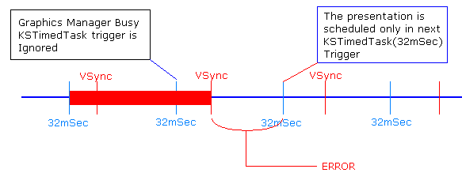

The error can be reduced by scheduling the hmi_gfx_mgr02_if_KSTimedTask at a faster rate such as 4mSec. This will make sure that there is only 4mSec error in triggering the presentation task after the graphics manager becomes Idle. Regardless of the hmi_gfx_mgr02_if_KSTimedTask rate, the GFX_MGR02_IF_APP_PRESENTATION_TASK will be scheduled at a minimum rate of (2 * Vsync) time. E.g, for a 60fps TFT configuration it will be 33.33mSec minimum.
Added 2 macros in hmi_gfx_mgr02.cfg file to have run the presentation at equal intervals.
- GFX_MGR02_IF_APP_PRESENTATION_RATE → This shall be configured as per the program specific refresh rate, Gfx manager triggers the presentation task at this rate.
- GFX_MGR02_IF_TASK_RATE → Application shall set this value as configured in sched for the hmi_gfx_mgr02_if_KSTimedTask.

PC Simulation
A simulation environment using Visual Studio is available in ClearCase. You can use this environment to simulate your code on the PC. This is useful when you don’t have actual hardware to test on or when you would like to review something with the customer. Details on the simulation can be found in the “Kepler GDT Framework Specification” referred to in section 1.3.

Recommended Practices
The following practices are recommended when using the GDG03 package.

- Verify that all displays in your product are displayed correctly.

- There is no way to check a CLUT table once it is loaded into CLUT RAM to ensure that its data has not been corrupted. It is not expected that data will ever become corrupted.

Appendix A – Change History
Version (date) | Description of Changes (author)
Revision 1.0 (4/04/2012) | First version based on a draft that was reviewed in detail by E Manoj. (Shekhar A)
Revision 1.1 (24/May/2012) | Updated the version after file split.
Revision 1.2 (2-July-2012) | Updated for the qspi_chksum and EOL mode interface updates. Section 6, 7
Revision 1.3 (2-July-2012) | Updated for the qspi_chksum. Section 7
Revision 1.4 (22-Nov-2012) | Updated Installation Procedure section 10.
Revision 1.5 (10-Dec-2012) | Added section 11 Shutdown and Startup Procedure and section 12 Presentation Scheduling
Revision 1.6 (10-Dec-2012) | Section 11 updated based on review meeting with P55x team.

