

Graphics Display Generator
GDG-03
Software Design Specification

Revision 1.3

CDIS-SDS-GDG-03

ISSUE DATE: January 24, 2012

Visteon Technical and Services Center
DI Core Software Group

Table of Contents
1 Scope of the Design 3
1.1 Purpose 3
1.2 Definitions 3
1.3 Boundaries 3
1.4 Environment 4
2 Scope of Design 5
3 Design Constraints/Decisions 6
4 High Level Design 7
4.1 Architectural components 10
4.2 Interrupt Design 10
4.3 Architectural component interfaces 10
4.4 Operating Modes 12
4.5 Components Designed for Reuse 12
4.6 Components Used from the Bookshelf 12
5 Detailed Design 12
5.1 Data Design 13
5.1.1 Data Structures 13
5.2 Layout Manager 23
5.3 Layer Manager 25
5.4 Driver 25
6 Change History 25

Scope of the Design

Purpose
The purpose of this document is to describe the design of the GDG-03 package. Additional information, which may be considered an extended part of the design description, can be found in the GDG-03 Programmer's Guide and the GDG-03 package source files (it is recommended that the Programmer's Guide be read before reading this document).

Definitions
CDIS Core Driver Information Software
CLUT Color LookUp Table
COP Computer Operating Properly
DCU Display Control Unit
DIS Driver Information Software
DFD Data Flow Diagram
DMA Direct Memory Access
GDG Graphics Display Generator
GDT Graphics Design Tool
GRAM Graphics RAM
LCD Liquid Crystal Display
OS Operating System
SRS Software Requirements Specification
TFT Thin Film Transistor

Boundaries
The GDG-03 package interacts with the following software components that are "external" to the GDG-03 package.

- Application display client tasks. Client tasks use the GDG-03 public interfaces to write GRAM and DCU layers to display information (text strings, bitmaps, etc.) to a pixilated TFT display.

- The DI Kernel operating system. The DI Kernel provides scheduling of GDG-03 initialization functions, DCU Interrupt, DMA interrupt.

- The Freescale graphics library. The GDG-03 package uses functions provided by the Freescale graphics library to display text, bitmaps, draw lines, etc. The GDG-03 package does not directly write to pixels – this is done by functions in the Freescale library.

All public interfaces provided by the GDG-03 package begin with the prefix " hmi_gfx_mgr02_" and can be found in the " hmi_gfx_mgr02_driver.h" file.

Environment
The GDG-03 package was designed to work with any operating system as it doesn’t need any os task. This package separated into 2 parts one to handle the all application requests through a function call and prepares and updates the local virtual copies of the DCU layers as the complete driver runs on the ISR the minimal time bandwidth is available @ driver level, second part is the driver this handles 1 interrupt to transfer the images, text to the TFT through the GRAM and DCU engine in the available VS_BLANK period.

Scope of Design
The Graphics Display Generator is a device driver to control the TFT devices through the DCU engine. Application requests the GDG manager which display items shall be built based on the current mode of the application GDG manager shall handle the API interfaces to build / refresh the display items on the TFT module. There is a tight couple between the GDT and the GDG03 the data structures are built such a way that the display items shall be identified based on the data generated by the GDT. GDG Manager manages all interfaces to application; GDG 03 Driver handles the updating the Graphics RAM (GRAM) and configuring the DCU engine to handle the TFT display layers.

The Context diagram from the SRS is included here for reference. The external interfaces to the software are illustrated here.

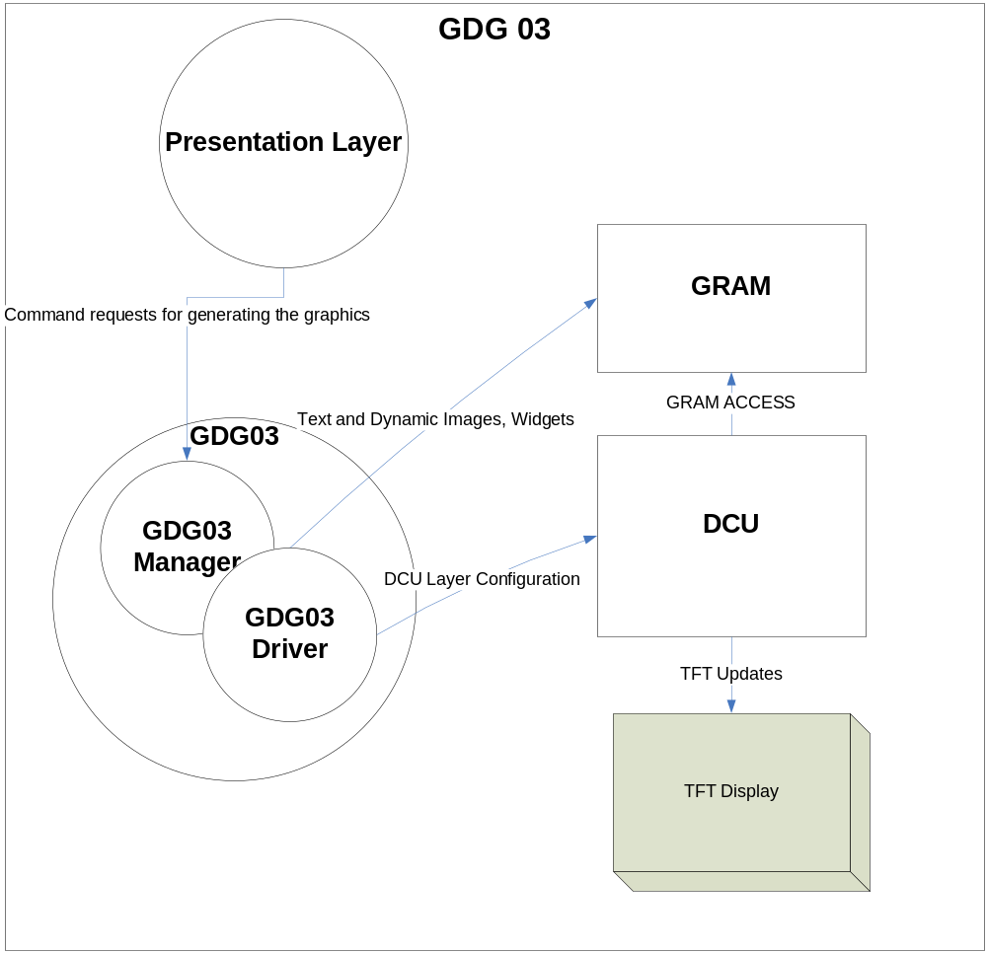
Figure 1 Context Diagram

Design Constraints/Decisions
The GDG-03 package was developed per the following.
- The GDG-03 package software is designed for the DI Core Bookshelf for Kepler platform.

- The GDG-03 package software is designed to work with the DI Kernel Operating System, but could be used with other real time scheduling systems (as described above).

- The software design adheres to the following design standards, procedures and recommendations:

Bookshelf Process Activities SW-TLR-CK01
Software Design Process SW-ES-P-01
Software Implementation Process SW-IMP-PC-01
Software Coding Standard SW-IMP-SD-01

- The standard device driver used by the GDG-03 package is the Freescale graphics library.
- DCU engine has only 2.09 milliseconds time for the application to update the graphics images or text for display, once the DCU layers configured the data shall be transferred to the TFT display, some times the available application time is not sufficient to complete the image, text updating in GRAM, to avoid this decided to use the virtual DCU layers to copy all screen images and text once the complete data is transferred virtual layers shall be copied to the actual DCU layers. Once all data transferred to the DCU layers those layers shall be enabled to reflect the screen complete changes without any flicker in display.
- Allocation of GRAM is decided such a way that for available number of screens the priority of the screens shall be decided at design time and the maximum GRAM required for the screen priority shall be allocated.
- When a screen is newly added, the entire content of the screen shall come together. If there are items to be built in GRAM then this means building them all and then finally programming the DCU.
- If a screen is replaced with another one, the existing screen content to be retained until new screen contents are built fully.
- In an active screen if any item is changed, then changed item needs to be build in background and updated.
- Based on the GDT design if the CLUT RAM size is greater than the available CLUT RAM, CLUT shall be loaded dynamically for the active DCU layers. If the CLUT required is lesser than the available CLUT RAM, gdg03 loads all CLUT ram at startup to reduce the CLUT loading over head.

High Level Design

Presentation
State
Building
State
Application
Presentation
Functions
GDG03 CORE
GDG03
Interfaces (API)
Control Data
GDG03 IF
Presentation Tick
1
2
3
DONE
4
Normal Tasks
Graphics Task (background)

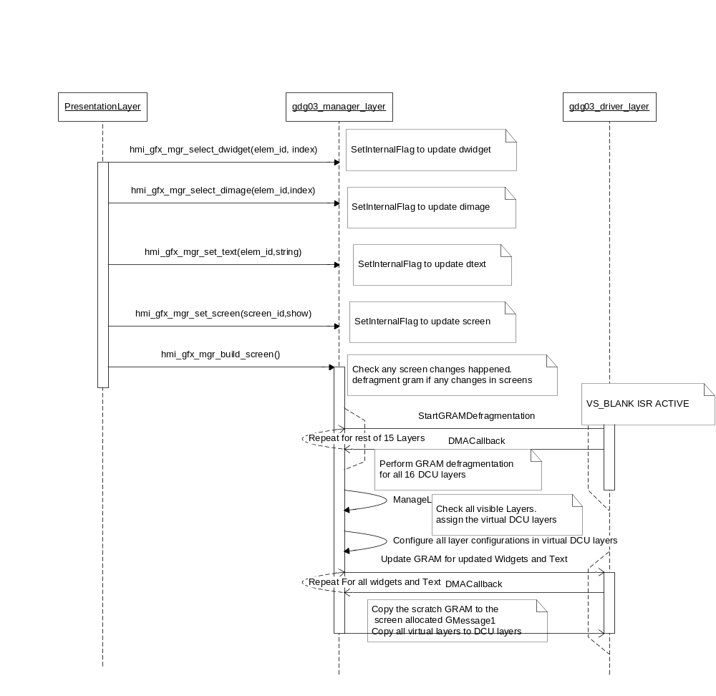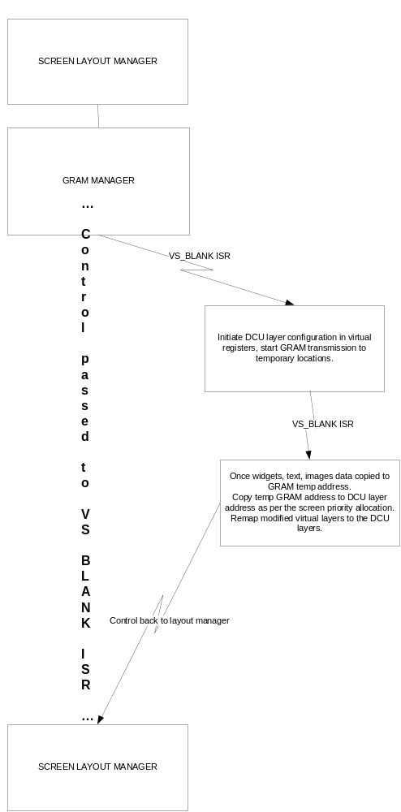

Architectural components
The major parts of the architecture of the GDG-03 package, which can be viewed as architectural components, are as follows:

- Initialization functions. These functions perform initialization under warm initialization, cold initialization, and wakeup scenarios (these functions are called by the DI Kernel at the appropriate point in time). These functions perform initialization to prepare for accepting channel control and display generation commands from display client tasks.

- The GDG-03 Manager. The manager processes all the Presentation layer's requests and handles the virtual layers to further process and transfer the images data to the TFT. All external interfaces handled in manager are provided in the Programmer's Guide.

- GDG03 Driver. Here all display information to be displayed on TFT shall be framed into the layers and passes the control to the DCU engine to control the TFT display.

- GDT Tool generated files.

Interrupt Design
The GDG-03 package has 1 ISR.
- DCU ISR
DCU layers shall be updated in this VS BLANK period only.

Architectural component interfaces
DCU is capable of copying the static image data from the flash memory to the TFT. For the Dynamic Text and the Widgets a common GRAM is used in which the Text information and widget images shall be copied into the GRAM and assigned this pointer to the DCU layers for further processing, All image data is the global data which is in the Flash memory. GDG03 provides the global functions to set the screens designed in the GDT based on the application requirement.
Component provides the following API functions to application to build the screens, text, widgets, and images as per the application requirement.

- hmi_gfx_mgr02_if_KSColdInit: Component cold init routine which initializes the internal RAM variables and sets the component to default state.
- hmi_gfx_mgr02_if_KSWarmInit: Warm init routine.
- hmi_gfx_mgr02_if_KSWakeUp: Wake Up routine.
- hmi_gfx_mgr02_if_KSSleep: Sleep routine disables the qspi and DCU.
- hmi_gfx_mgr02_if_presentation_task: Initializes the graphics task.
- hmi_gfx_mgr02_if_set_screen: This shall be used to select the screen to be shown or hide.
Ex: hmi_gfx_mgr02_set_screen (screen_id, Show/Hide);

- hmi_gfx_mgr02_if_set_text: Sets the text value for dynamic text element.
Ex: hmi_gfx_mgr02_set_text(DText_elem_id, L“Text…..”);

- hmi_gfx_mgr02_if_set_sid: Sets the text value for the Dynamic text element based on the sid value.

- hmi_gfx_mgr02_if_select_dwidget: Sets the selection index of the dynamic widget.
Ex: hmi_gfx_mgr02_select_dwidget(DWIDGET_Element, ListIndex)

- hmi_gfx_mgr02_if_select_dimage: This shall be used to set the index in the Dynamic Image element.

- hmi_gfx_mgr02_if_set_obj_clut: Sets the CLUT index for the requested element. The CLUT can be only if the element type is other than the Dynamic Image, Dynamic Widget or property type is dynamic.

- hmi_gfx_mgr02_if_set_obj_tile: This shall be used to change the tile properties of the dynamic elements.

- hmi_gfx_mgr02_if_set_obj_blend: This shall be used to change the blending properties of the screen elements dynamically for animations.

- hmi_gfx_mgr02_if_set_obj_alpha: Sets the alpha component to the requested animation element.

- hmi_gfx_mgr02_if_set_obj_fg_color: This shall be used to change the fore ground color of the screen element. If the fore ground color is different than design time color.

- hmi_gfx_mgr02_if_set_obj_bg_color: This shall be used to change the back ground color of the screen element. If the back ground color is different than design time color.

- hmi_gfx_mgr02_if_set_obj_vclip: This shall be used to change the animation elements vertical clipping properties.

- hmi_gfx_mgr02_if_set_obj_pos_x: This API shall be used to change the x coordinates of the animation / widget animation elements. Note: make sure that the x coordinate shall be with in the range of the parent widget.

- hmi_gfx_mgr02_if_set_obj_pos_y: This API shall be used to change the y coordinates of the animation / widget animation elements. Note: make sure that the y coordinate shall be with in the range of the parent widget.

- hmi_gfx_mgr02_if_get_obj_pos: This API shall be used to get the x, y coordinates of the animation/widget animation elements. Note: make sure that the y coordinate shall be with in the range of the parent widget.

Operating Modes
The GDG-03 package does not contain any internal operating modes. The package shall function in any application mode as long as the appropriate GDG-03 functions are called and scheduled. It is up to the application using the GDG-03 package to call package functions in the appropriate modes.

Components Designed for Reuse
All the internal components (as described above) of the GDG-03 package shall be placed on the DI HMI core bookshelf from reuse across multiple applications.

Components Used from the Bookshelf
The GDG-03 package is a standalone package – technically it does not reuse any bookshelf packages, but it does interface to the Freescale graphics library (which is stored on the bookshelf).

Detailed Design
Gdg03 package is internally maintained as 3 layers which are called as layer manager, layout manager and the DCU driver.

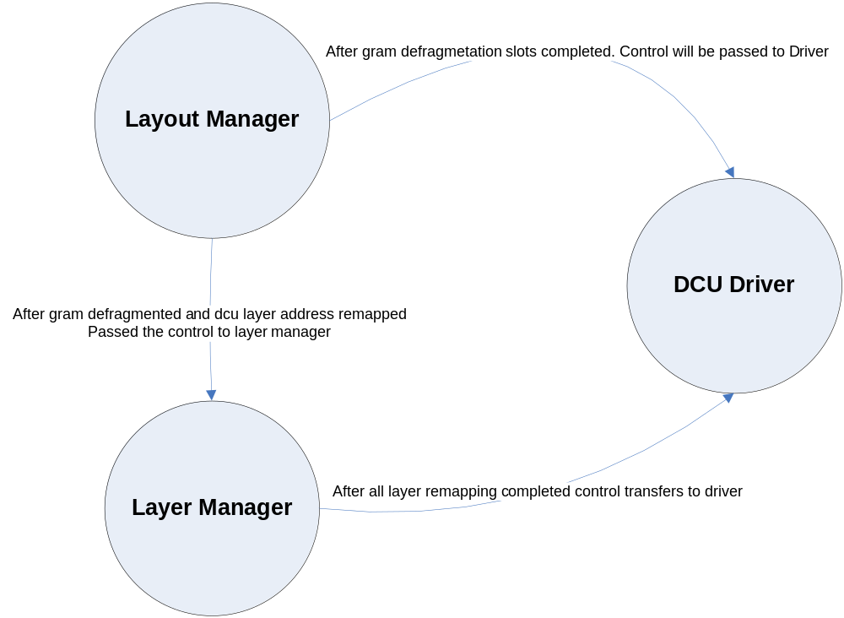

Data Design

Data Structures

GFX_MGR02_SCREEN_T
This section shows how the different data is linked and need to be interpreted.

GFX_MGR02_SCREEN_T is the root structure to hold a screen. It points to a GFX_MGR02_ELEM_LIST_T. GFX_MGR02_ELEM_LIST_T holds the information on how many elements are part of the group and a pointer to an array of element list (GFX_MGR02_ELEM_LIST_T).
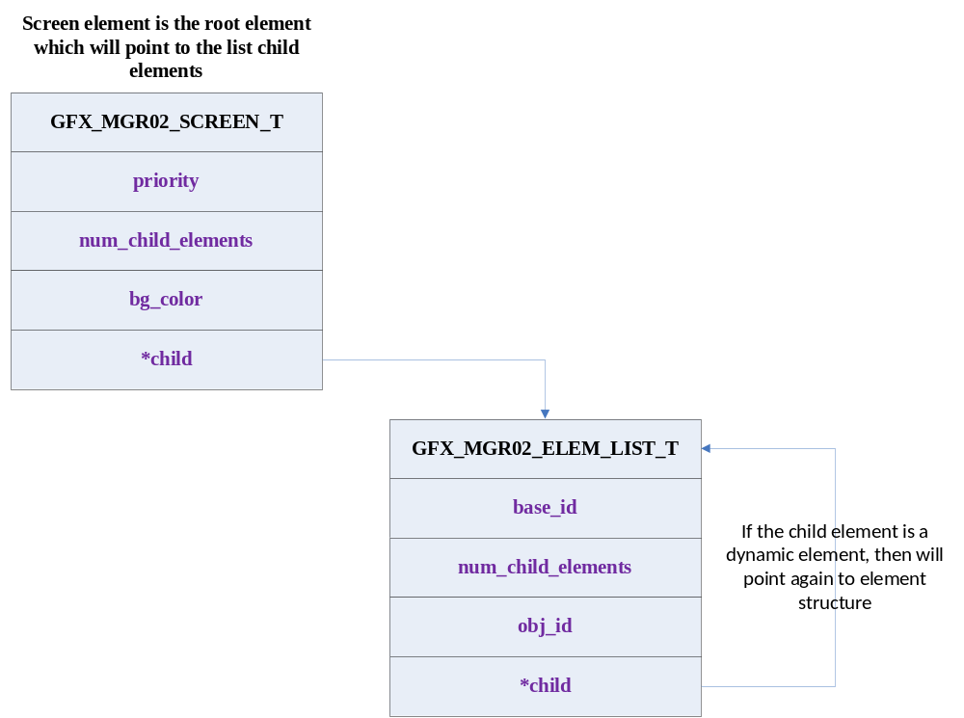

GFX_MGR02_ELEM_LIST_T holds the identifier information regarding an element.
They are
base_id | : | Base ID is an index in to an array which contains base properties for an element. There are two base arrays one for Text element and another of Image element
num_child_elements | : | Specifies number of child elements present in the screen.
obj_id | : | Object id holds several information.  It points to the elements local property array  It holds the type of the element  It holds information on whether an element has dynamic property or static property  These information are bit encoded in to the 32bit obj_id as below  Bit0-23 – is the index in to the local property array. This array depends on obj type and dynamic property of element. Possible values are  GFX_MGR02_TYPE_SWIDGET – 0  GFX_MGR02_TYPE_DWIDGET - 1  GFX_MGR02_TYPE_SIMAGE – 2  GFX_MGR02_TYPE_DIMAGE – 3  GFX_MGR02_TYPE_STEXT - 4  GFX_MGR02_TYPE_DTEXT - 5  GFX_MGR02_TYPE_TILE - 6  GFX_MGR02_TYPE_USER_LAYER - 7  8-15 are unspecified as of now  Bit24-27 – is the object type. This is used to identify the right local property table for the element type.  Bit 28 – Specifies the dynamic property True(1) or False(0). Dynamic elements will have separate RAM based local property table. So this bit is used to identify the right property table.  Bit 29 – Specifies whether element is part of a widget True(1) or False(0). If the element is part of a widget then its local property table will be different than when an element is not part of widget. So this is used to index in to the right table.
*child | : | If the element is another widget or dynamic element then this points to the element structure which holds information about its child elements.

If the object type is determined as GFX_MGR02_TYPE_SWIDGET or GFX_MGR02_TYPE_SIMAGE or GFX_MGR02_TYPE_TILE then the base_id will be an index in to following array.
static GFX_MGR02_IMAGE_T const l_image_layer_def_S[GFX_MGR02_NUM_OF_IMAGE_LAYERS]

If the object type is determined as GFX_MGR02_TYPE_STEXT or GFX_MGR02_TYPE_DTEXT then the base_id will be an index in to following array.
static GFX_MGR02_TEXT_T const l_text_layer_def_S[GFX_MGR02_NUM_OF_TEXT_LAYERS]

Local Property table selection:-

OBJ_TYPE | WDG ELEMENT | DYN PROPERTY | Property Table
GFX_MGR02_TYPE_SWIDGET | 0 | 0 | GFX_MGR02_STATIC_PROP_DATA
GFX_MGR02_TYPE_SWIDGET | 0 | 1 | GFX_MGR02_ELEM_PROP_DATA
GFX_MGR02_TYPE_SWIDGET | 1 | 0 | GFX_MGR02_LOC_DATA
GFX_MGR02_TYPE_SWIDGET | 1 | 1 | GFX_MGR02_WIDGET_ELEM_DATA

OBJ_TYPE | WDG ELEMENT | DYN PROPERTY | Property Table
GFX_MGR02_TYPE_DWIDGET | 0 | 0 | GFX_MGR02_STATIC_PROP_DATA
GFX_MGR02_TYPE_DWIDGET | 0 | 1 | GFX_MGR02_ELEM_PROP_DATA
GFX_MGR02_TYPE_DWIDGET | 1 | 0 | GFX_MGR02_LOC_DATA
GFX_MGR02_TYPE_DWIDGET | 1 | 1 | GFX_MGR02_WIDGET_ELEM_DATA

OBJ_TYPE | WDG ELEMENT | DYN PROPERTY | Property Table
GFX_MGR02_TYPE_SIMAGE | 0 | 0 | GFX_MGR02_IMAGE_T GFX_MGR02_STATIC_PROP_DATA  GFX_MGR02_BLEND_DATA  GFX_MGR02_ELEM_COLOR_TILE_DATA
GFX_MGR02_TYPE_SIMAGE | 0 | 1 | GFX_MGR02_IMAGE_T GFX_MGR02_ELEM_PROP_DATA
GFX_MGR02_TYPE_SIMAGE | 1 | 0 | GFX_MGR02_IMAGE_T GFX_MGR02_STATIC_PROP_DATA  GFX_MGR02_BLEND_DATA  GFX_MGR02_ELEM_COLOR_TILE_DATA
GFX_MGR02_TYPE_SIMAGE | 1 | 1 | GFX_MGR02_IMAGE_T GFX_MGR02_ELEM_PROP_DATA

OBJ_TYPE | WDG ELEMENT | DYN PROPERTY | Property Table
GFX_MGR02_TYPE_DIMAGE | 0 | 0 | GFX_MGR02_IMAGE_T GFX_MGR02_STATIC_PROP_DATA  GFX_MGR02_BLEND_DATA  GFX_MGR02_ELEM_COLOR_TILE_DATA
GFX_MGR02_TYPE_DIMAGE | 0 | 1 | GFX_MGR02_IMAGE_T GFX_MGR02_ELEM_PROP_DATA
GFX_MGR02_TYPE_DIMAGE | 1 | 0 | GFX_MGR02_IMAGE_T GFX_MGR02_STATIC_PROP_DATA  GFX_MGR02_BLEND_DATA  GFX_MGR02_ELEM_COLOR_TILE_DATA
GFX_MGR02_TYPE_DIMAGE | 1 | 1 | GFX_MGR02_IMAGE_T GFX_MGR02_ELEM_PROP_DATA

OBJ_TYPE | WDG ELEMENT | DYN PROPERTY | Property Table
GFX_MGR02_TYPE_STEXT | 0 | 0 | GFX_MGR02_TEXT_T  GFX_MGR02_LOC_DATA
GFX_MGR02_TYPE_STEXT | 0 | 1 | GFX_MGR02_TEXT_T  GFX_MGR02_LOC_DATA
GFX_MGR02_TYPE_STEXT | 1 | 0 | GFX_MGR02_TEXT_T  GFX_MGR02_LOC_DATA
GFX_MGR02_TYPE_STEXT | 1 | 1 | GFX_MGR02_TEXT_T  GFX_MGR02_LOC_DATA

OBJ_TYPE | WDG ELEMENT | DYN PROPERTY | Property Table
GFX_MGR02_TYPE_DTEXT | 0 | 0 | GFX_MGR02_TEXT_T  GFX_MGR02_LOC_DATA
GFX_MGR02_TYPE_DTEXT | 0 | 1 | GFX_MGR02_TEXT_T  GFX_MGR02_LOC_DATA
GFX_MGR02_TYPE_DTEXT | 1 | 0 | GFX_MGR02_TEXT_T  GFX_MGR02_WIDGET_ELEM_DATA
GFX_MGR02_TYPE_DTEXT | 1 | 1 | GFX_MGR02_TEXT_T  GFX_MGR02_WIDGET_ELEM_DATA

OBJ_TYPE | WDG ELEMENT | DYN PROPERTY | Property Table
GFX_MGR02_TYPE_TILE | 0 | 0 | GFX_MGR02_IMAGE_T GFX_MGR02_STATIC_PROP_DATA  GFX_MGR02_BLEND_DATA  GFX_MGR02_ELEM_COLOR_TILE_DATA
GFX_MGR02_TYPE_TILE | 0 | 1 | GFX_MGR02_IMAGE_T GFX_MGR02_ELEM_PROP_DATA
GFX_MGR02_TYPE_TILE | 1 | 0 | GFX_MGR02_IMAGE_T GFX_MGR02_STATIC_PROP_DATA  GFX_MGR02_BLEND_DATA  GFX_MGR02_ELEM_COLOR_TILE_DATA
GFX_MGR02_TYPE_TILE | 1 | 1 | GFX_MGR02_IMAGE_T GFX_MGR02_ELEM_PROP_DATA

OBJ_TYPE | WDG ELEMENT | DYN PROPERTY | Property Table
GFX_MGR02_TYPE_USER_LAYER | 0 | 0 | None.

GFX_MGR02_IMAGE_T structure holds the width, height and the color encoding of the image or widget. This has the visible area offset index which gives the unprinted area in the widget.

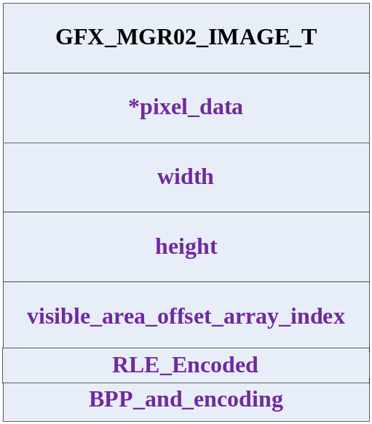

*pixel_data | : | This holds the starting address of the image pixel data.
width | : | Width of the image.
height | : | Height of the image.
visible_area_offset_array_index | : | This holds the free area in the widget area.
RLE_Encoded | : | This holds whether image is RLE encoded.  0 → RAW Image data  1 → RLE Encoded image data
BPP_and_encoding | : | Holds the image type and provides the encoding format for the element. Possible BPP encoding are  GFX_MGR02_1BPP 0  GFX_MGR02_2BPP 1  GFX_MGR02_4BPP 2  GFX_MGR02_8BPP 3  GFX_MGR02_16BPP_RGB565 4  GFX_MGR02_24BPP 5  GFX_MGR02_32BPP 6  GFX_MGR02_4BPP_TRANSPARENCY 7  GFX_MGR02_8BPP_TRANSPARENCY 8  GFX_MGR02_4BPP_LUMINANCE 9  GFX_MGR02_8BPP_LUMINANCE 10  GFX_MGR02_16BPP_ARGB1555 11  GFX_MGR02_16BPP_ARGB4444 12  GFX_MGR02_16BPP_APAL8 13

GFX_MGR02_TEXT_T holds the Text element properties like Font, width, height, encoding, justification, orientation of the text and also the index of the starting. The index points to the l_dynamic_text_buffer incase the TEXT is dynamic text otherwise index of the string array of lc_static_text_buffer.

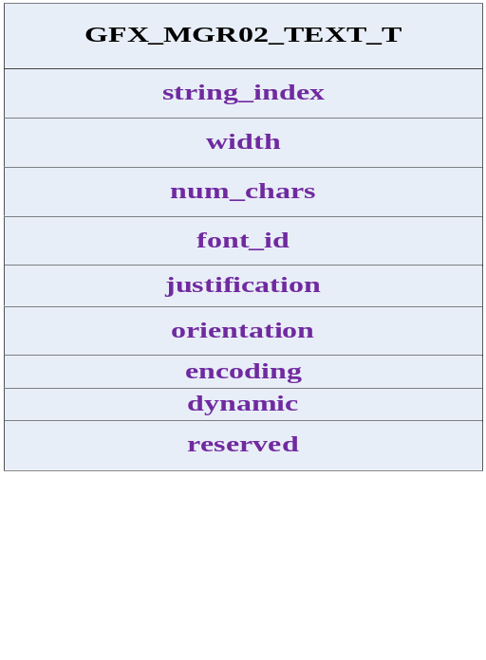

string_index | : | Address of the string to be displayed.
width | : | Width of the element.
num_chars | : | Gives the number of characters in the string.
font_id | : | Index to the font table array of Font_FontType. Font_type holds the character encoding, height of the character, format of the char. Possible formats are  FONT_8BPP 0  FONT_4BPP 1  FONT_2BPP 2  FONT_1BPP 3  While applying to the layer this needs to be converted to the layer encoding format which is BPP_and_encoding.
justification | : | Text justification whether text to be displayed Centre, Left, or Right.
orientation | : | Orientation indicates the display format whether it is in vertical or horizontal position.
encoding | : | This indicates the Character coding (ASCII or UNICODE).
dynamic | : | Flag to identify the string is of type dynamic or static.

GFX_MGR02_STATIC_PROP_DATA structure holds the static element display properties

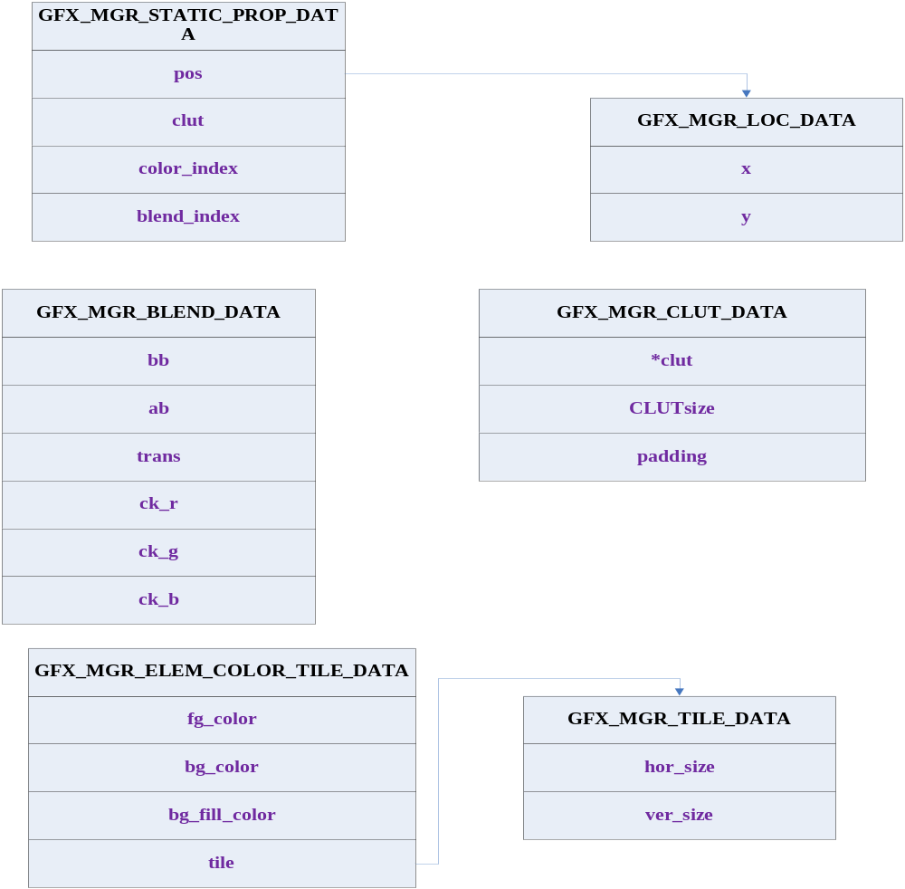

pos | : | This indicates the x, y origin points of the element with respective to the x, y origin points of the screen.
clut | : | This is the index from the CLUT look up table (GFX_MGR02_CLUT_DATA) to get the element CLUT to be loaded into the CLUT RAM.
color_index | : | Index to the color component array list of the GFX_MGR02_ELEM_COLOR_TILE_DATA. Needs to fetch the fore ground, back ground, tile, back ground fill color information of the element.
blend_index | : | This is the index of the blending or chroma keying structure GFX_MGR02_BLEND_DATA array.

GFX_MGR02_ELEM_PROP_DATA holds the dynamic image or widget element properties as shown below diagram. This holds all properties of the elements as this can be changed during run time for the animations.
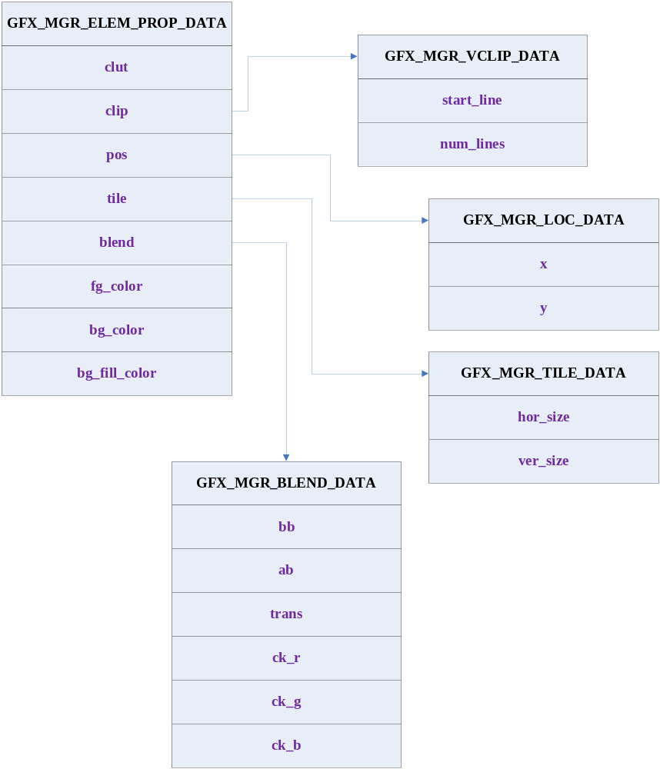

clut | : | This is the index from the CLUT look up table (GFX_MGR02_CLUT_DATA) to get the element CLUT to be loaded into the CLUT RAM.
clip | : | This holds the information for the image or widget clipping; this holds the starting line and number of lines to be clipped.
pos | : | This holds the starting x, y coordinates of the dynamic element.
tile | : | Tile information width and the height of the element to be tiled.
blend | : | Blending information of the element.
bg_color | : | Back ground color of the dynamic element.
fg_color | : | Fore ground color of the dynamic element.
bg_fill_color | : | Back ground fill color for the dynamic element.

Layout Manager
Layout manager separated into two operations 1 managing the GRAM the second is managing the Virtual DCU layers. The double buffering concept is used to effectively use the GRAM and DCU layers.
GRAM is managed such a way that complete GRAM is allocated to the 16 actual DCU layers and 16 virtual layers (If the layer needed GRAM) and swapped between top down and bottom up approach. In the below mentioned diagram 3 layers needs the GRAM and there is change in the 7th DCU layer, now the GRAM allocation for the 7th layer is assigned from the bottom address of the GRAM i.e. from 0x60000000 + size of GRAM. And the size of the image i.e. if image needs 124 KB for widget the start address of the 7th virtual layer shall be 0x60061000 and it goes up to 0x6007FFFF, since there is change in the higher layer the lower layer (15th layer) GRAM is copied to 0x60041000 to 0x60060FFF. In the next iteration 7th layer shall allocated with 0x60001000 to 0x6001FFFF and swapping for the 15th layer from 0x60041000 to 0x60020000 and so on.
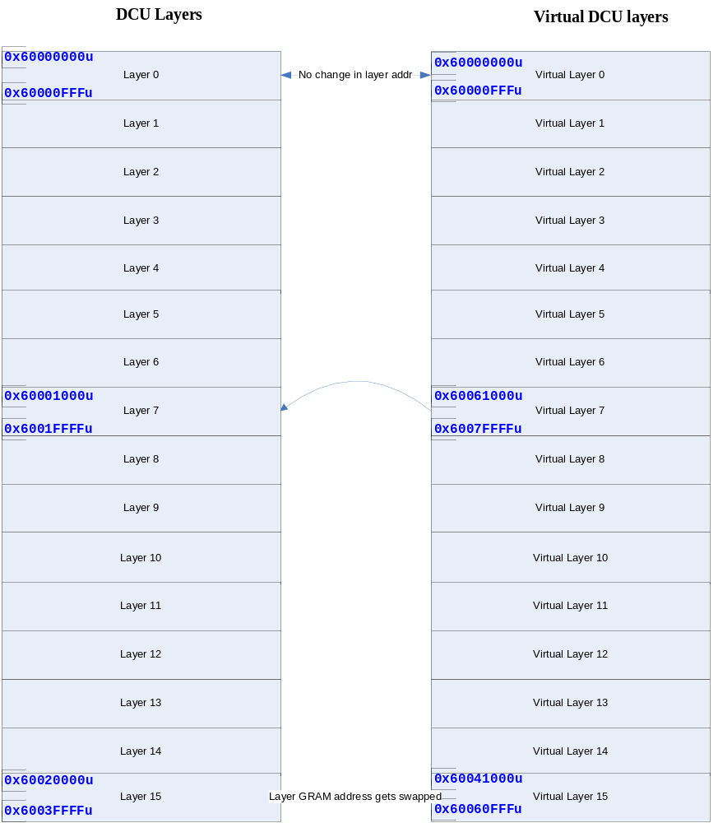

All user actions shall be queued and once the build screen command is called layout manager starts building the changed elements in the virtual DCU layers if the DCU layer requires the GRAM then layout manager computes the offset of the GRAM required for the DCU layer as explained above and copies un changed DCU layer GRAM to the new offsets this operation is called as pre-render, once all the layers are mapped to virtual layers the control shall be passed to the Layer manager.

Layer Manager
All active screens shall be processed based on the screen priority and element priority and shall be mapped to the dcu virtual layers. Once all layers are mapped the control shall be passed to the driver to build the screen layers one after another based on the priority. Shall update the Text, widget information in the gram.
Once all GRAM data transfer is completed Virtual DCU layer shall be mapped to the actual DCU layers.

Driver
All virtual DCU layers shall copy to the actual DCU layers and the control shall be released for the further user requests. This executes in the VS BLANK ISR.

Change History

Version (date) | Description of Changes (author)
Revision1.0  (Jan 27, 2012) | First version. (ashekhar)
Revision 1.1 (Feb 27, 2012) | Re Designed for the double buffering concept.
Revision 1.2 (May 10, 2012) | Removed old interfaces and updated with all public accessible interfaces.
Revision 1.3 (July 18, 2012) | Added RLE Encoding, User Layer

