Layer allocation logic for the DCU target

For DCU target, the layer allocation starts with topmost element in the high priority active screen to the bottommost element in the lowest priority active screen.

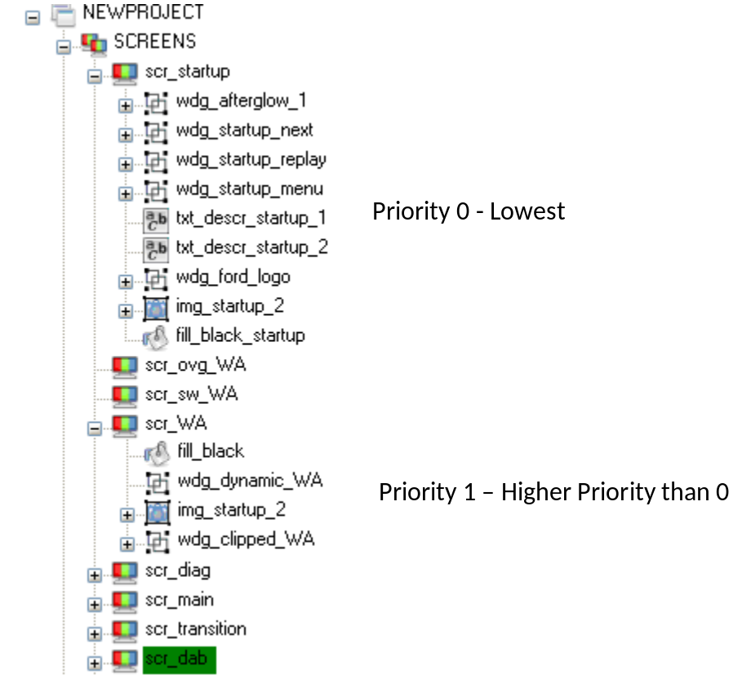

Assume that we have scr_startup (priority 0) and scr_WA(priority1) are active currently. Now in this case the layer allocation will be happening from wdg_clipped_WA to fill_black, then from fill_black_startup to finally wdg_afterglow_1.
For GDT heigher number means high priority and an element’s position lower in the tree view means its on top of previous element. For example scr_startup element txt_descr_start_1 is lower than wdg_startup_menu, so txt_descr_start_1 will be topmost compared to wdg_startup_menu

Normal Layer allocation process:-

The layer allocation process starts with highest priority topmost element and its then goes to a virtual layer array l_gfx_virtual_layer[]. The virtual layer array is of the same size as the number of layers available in the DCU. Now the first element goes in to it by default provided that it is visible. Visible means its alpha is > 0 and it is within the TFT panel area.

When the layer management routine takes the next element, its goes in to the virtual array if it is not completely hidden by the element above it.

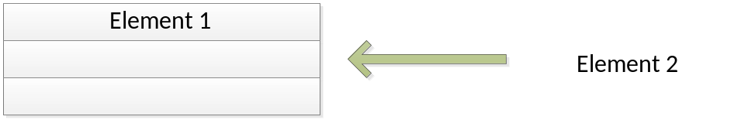

i.e element 2 goes in to the virtual layer array if its fully or partially visible. In case it is completely beneath element1 or if its alpha is 0 or if it is outside the TFT area then it doesn’t go in to the virtual layer array.

This process goes until we reach end of the virtual layer array. Once we reach end, then we reset the current location to start of the array. This means next elements if they are visible, they replace the highest priority visible elements.
By this method at the end of the process we will have N visible layer which are from low priority to high priority. If number of DCU layers are 16, then N will be 16. And if we are ending up having > 16 visible elements by any chance then we will display only the 16low priority elements out of it.

Example case 1 : DCU layer = 16, number of visible elements = 4
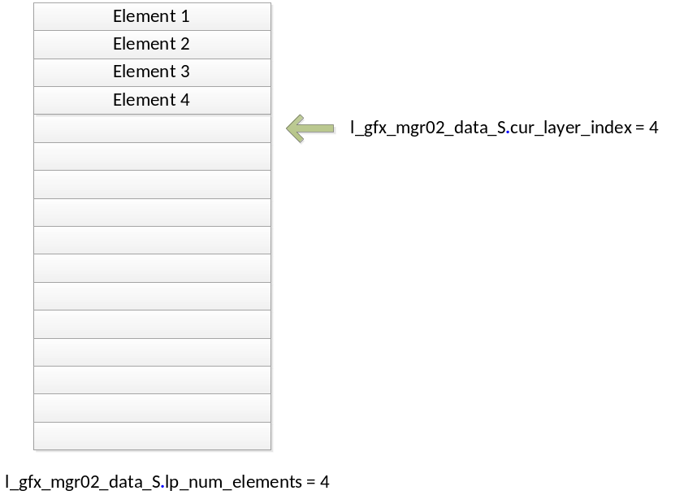
In this case the allocation will start from index 0 of the virtual layer array and gets filled until index 3. After the end of the process the l_gfx_mgr02_data_S.cur_layer_index will be having a value of 4 indicating that the layers are available from (4-3) index 3 to index 0. The number of elements are loaded in to l_gfx_mgr02_data_S.lp_num_elements which will be 4 in this case.

Example case 2 : DCU layer = 16, number of visible elements = 19
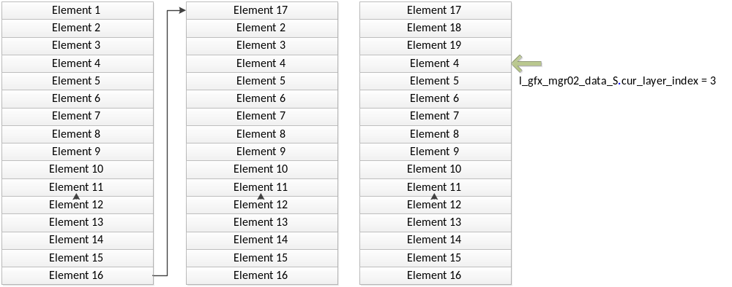
In this case after the first 16hiest priority elements fill in the index reset back to 0, and next 3 elements replaces the highest priority elements 1, 2 and 3. After the process
l_gfx_mgr02_data_S.cur_layer_index = 3 and
l_gfx_mgr02_data_S.lp_num_elements = 16

This means that the layer mapping routine needs to read the first layer from index (l_gfx_mgr02_data_S.cur_layer_index-1) which is index 2 back word till index 0. When it reaches index 0 it would have read 3 layers. Now reset the index to (num_dcu_layers-1) which is 15 and start reading backwords until the reset of the 13 layers are read or till we reach index 3.

HP Layer allocation process:
With the above process the draw back is that we cannot guarantee the highest priority contents are getting displayed. But this can be overcome by a having a different process which gets enabled by defining GFX_MGR02_RESERVE_LAYERS_FOR_HIGH_PRIORITY_SCREEN.

When this is defined, the layer allocation process happens in two stages. First stage runs for the highest active priority screen alone and fills the virtual layer array with visible elements. The process is the same as the one described above. After the process we will have the following data updated
l_gfx_mgr02_data_S.cur_layer_index and l_gfx_mgr02_data_S.hp_num_elements

In stage two, runs only if the l_gfx_mgr02_data_S.hp_num_elements < number of DCU layers. i.e if there is space available in the virtual layer array. The stage two is also runs same as the above process but it will work with in the free slots available after the stage1.

For example if we take the same example of 19 layers, and assuming that the hyigh priority screen has 5 visible elements. Then the stage 1 will utilize the 5 slots in the virtual layer array.

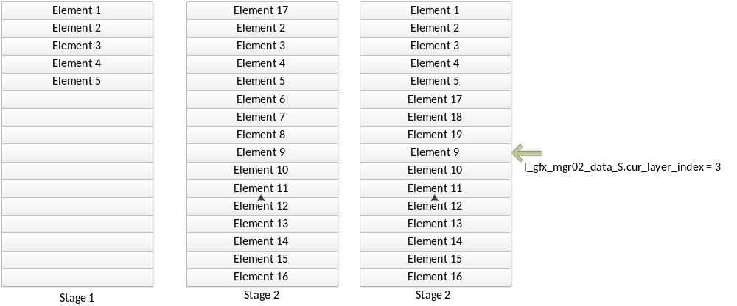

Following variable will be updated to after stage 1.

l_gfx_mgr02_data_S.cur_layer_index = 5
l_gfx_mgr02_data_S.hp_num_elements = 5

Before starting stage2, the current layer index for the HP elements is saved in to
l_gfx_mgr02_data_S.start_layer_index = l_gfx_mgr02_data_S.cur_layer_index

So after stage 2, start_layer_index will indicate the starting point for low priority array.

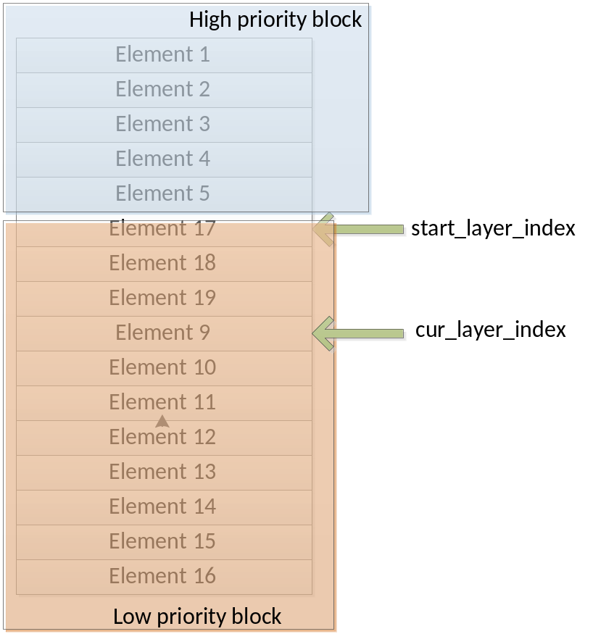

The hmi_gfx_mgr02_vblank_isr() utilizes the above information to map the virtual layers to DCU layers.

