GDT Theme Folder image files details extract utility:

The figure given below shows the main window of this utility developed for B515 team to extract the image files details in theme folders recursively.

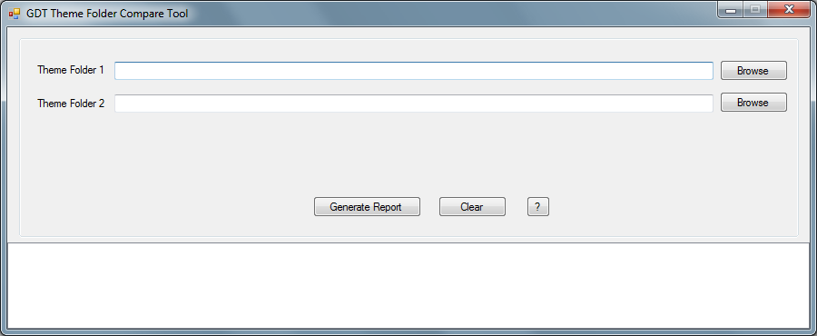

Limitations:

Extracts details of *.bmp, *.png, *.jpg and *.jpeg files only.
Extracts Width and Height only.

Usage:

- Select the theme folders using Browse buttons or paste the folder path in corresponding text boxes.
- Click Generate Report button.
- It will take some time to generate the report and the status will be updated in bottom text box.
- Once code generated, please check the given theme folders and locate the files “ImageFilesDimensions.csv”.

Example:
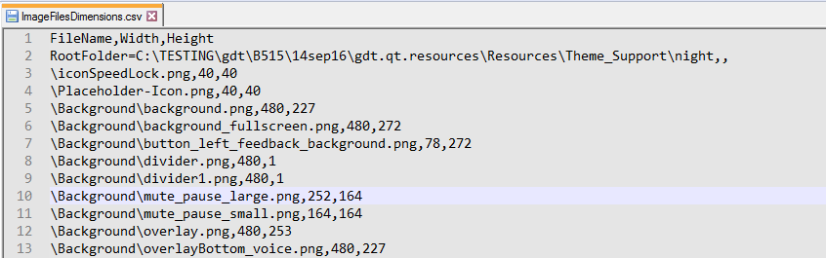

This utility will be useful to compare the image details of theme folders, if we use Theme feature in GDT.

Use any text compare tools like Beyond Compare to compare the *.csv files generated.

The tool and Source code are attached below. Use Visual Studio 2008 Express or above to open the project.

RTC Item: (Source code archived in RTC task also)
Utility Tool for B515: Create a tool compare the image files in two different folders (693911)

