Drawing Area Object



Version 1.1

HMI
Visteon Technical and Services Centre
Chennai, India

Table of Contents

1. Introduction
2. AltiaEx API Interface Functions

3. How DAO is implemented in JLR cluster

4. DAO in GDGO3 Environment

1. Introduction

Purpose

This document will explain about the overview of Drawing area object used in ALTIA.

What is Drawing Area Object

The drawing area object allows you to have external graphics code draw within
Rectangular area of an Altia design.
The external Graphics code be in any of the following forms
- Handwritten code that wrote using the Drawing Area “s AltiaEx API
- Graphics Code written in Machine’s native Window API

When we can use DAO

- When you have existing graphics code that we like to incorporate into an altia design
- The code can be ported to a drawing area AltiaEx Api if portability is required to run on different graphics systems
- Existing graphics code can be left in the Native Window API and modified to work with Drawing object
(or)
- if we use Altia as designing tool and if we are not able to have some images/pictures, we can update the custom graphics code to meet that need

How DAO works

It works both in Altia design and Deep Screen Generated Code

Using Altia Design :-

For Altia design and runtime, the code must be linked with the help of Shared DLL
So it can run in the same address space.

Shared DLL or Library is linked to the drawing area “s API using altia.ex.Lib

Using Deep Screen:-

The code is directly linked to the generated code – No Shared DLL or Library

Instead the code for the deep screen version of the AltiaEx API library is simply a component of the Deep Screen generated code

Although the implementation of Altia API is different between Design and Deep Screen
The interface is the same .No User Impact.

2. AltiaEx API Interface Functions

The AltiaEx API provides an interface between external code and Altia Design/Deep Screen..

2.1 AltiaExinitialise :-

When defining a DAO within Altia, the user must give an initialization method name that the Altia will call on startup to make the link between the application draw function dedicated to the DAO instance involved, and the graphic framework. This initialization function will be called with the DAO unique integer identifier as parameter.

This function is not called by your code, instead Altia will call this function to initialize the altiaEx library. Since data is passed between Altia and the library, a version number is included to verify that the library and Altia are compatible

When the DAO initialization function is called by Altia, the application layer is responsible for registering four callbacks to handle to following events:

  - Redraw
  - Resize
  - Close
  - Show

2.2 Int altiaRegCallBack (int obj id,int Callbktype ,AltiaDACall BkFunc func)

This function lets you register one of your functions as a call back function. Altia will then call this function when it needs the client code to do certain things like redraw. You pass in the object ID of the Drawing Area object, the type of callback, and the function to call. This function will return 1 if the object ID was found, otherwise it will return 0.

2.3 Types of Callback

ALTIA_REDRAW_CALLBACK

void (*AltiaDARedrawFunc) (int objId, void *win, void *dc, int left, int top, int right, int bottom, int x, int y, int xoff, int yoff, AltiaEx_Transformer_type *trans)

This function will be called when Altia needs the drawing area to be redrawn.

objId The object ID of the Drawing Area.
Win The window ID that Altia wants the code to draw into.

Dc The device context is provided for convenience and it is not required to be used

left, top, The redraw area relative to the top left corner of the screen. This is the part of right, screen that needs to be re-drawn. Use the (x,y) parameters to convert this
bottom region to DAO coordinates

x, y Where the top left corner of the drawing area is located relative to the top left
corner of the screen.

xoff, yoff These will be zero if the window ID is a real window. If the win-dow ID refers to a bitmap, then these values are the amount that the location parameters were changed to compensate for the size difference between the window and the bitmap. When Altia double buffers, the bitmap it draws into might not be the same size as the Altia window. Altia modifies the x, y, left, bottom, and right parameters to allow for this size change. If you are drawing to a window that is overlaying the drawing area, you can remove this adjustment by subtracting out xoff and yoff from these values.

Trans The transformation matrix only needs to be applied if you want to support drawing to a scaled or rotated drawing area.

ALTIA_RESIZE_CALLBACK

This function will be called when the width or height of the drawing area changes as a result of the built in animations in the Drawing Area having been changed.

int (*AltiaDAResizeFunc) (int objId, int width, int height)

objId The object ID of the Drawing Area that was resized.

width, height The new width and height of the object.

ALTIA_CLOSE_CALLBACK

This function will be called when a drawing area object is being deleted.

int (*AltiaDACloseFunc) (int objId)

objId The object ID of the Drawing Area that is being deleted.

ALTIA_EVENT_CALLBACK

This function will be called when the Drawing Area object has gotten a mouse, keyboard, or timer event If the Drawing Area object in the design has a stimulus area defined for keyboard and/or mouse then that object will be called when those events occur. Timer events will arrive if your external code has defined any system timers

void (*AltiaDAEventFunc) (int objId, void *win, AltiaEx_InputEvent_type *event)

objId The object ID of the Drawing Area.
win Window ID of the window receiving the event.
event Pointer to the event.

ALTIA_SHOW_CALLBACK
This function will be called when the Drawing Area object has been hidden or shown or placed in the cut buffer via a cut edit operation.

Void (*AltiaDAShowFunc) (int objId, int showFlag)

ObjId The object ID of the Drawing Area being shown or hidden.
show Flag 1 if the object is to be shown, 0 if it is to be hidden.

2.4 AltiaExGetInfo

int altiaExGetInfo(int objId, void *win, int *x, int *y, int *width, int *height)

This function allows you to query a Drawing Area object. Pass in the object ID of the Drawing Area you want to query and the function returns the other parameters. The window ID, X, and Y might differ from the values set to the Redraw Callback function and the redraw values.

Obj Id The object ID of the Drawing Area.
Win The window ID that Altia wants the code to draw into.
x,y Returned X,Y position
Width, Returned Width and Height
Height

2.5) int altiaExUpdate (int objid, int left,int top,int right,Int bottom)
This function is called when a part of Drawing area object needs to be redrawn.
This function will lead to the redraw callback being called to do the drawing

Objid The objected of the Drawing area

Left,
Top,
Bottom, Redraw Area relative to the top corner of the Screen
Right

2.6 int altiaExRouteText(char *eventName, const char *string)

Call this function when you want to change an animation string within Altia.

2.7 int altiaExRouteConnectionValue(char *connectionName, double value)

Call this function when you want to change animation values in other objects that are connected to this object’s connection.

2.8 int altiaExRouteConnectionText(char *connectionName, const char string)

Call this function when you want to change animation values in other objects that are connected to this object’s connection. And those animation are strings.

2.9 int altiaExellipseDraw()

Call this function when you want to draw an ellipse or circle within an drawing area object

3.0 int altiaExRectdraw()

Call this function when we want to draw an rectangle within the drawing area object
Including the background of the drawing area object

3.1 int altiaExLineDraw()

Call this function when we want to draw a line or series of connected lines within a drawing area object

3.2 int altiaExArcDraw()

Call this function when you want to draw an arc within an drawing area object

3.3 int altiaExPolygonDraw()

Call this function when you want to draw a polygon within drawing area object

3.4 int altiaExLabelDraw()

Call this function when you want to draw a text string within an drawing area object

3.5 int altiaExCreateRastor()

The function creates a bitmap that can be later displayed within the drawing area object

3.6 int altiaExRasterDraw()

Call this function when you want to draw a bitmap within an drawing area object

4. DAO Creation and Integrating:
Steps to create the DAO in Altia
1. Create the DAO object
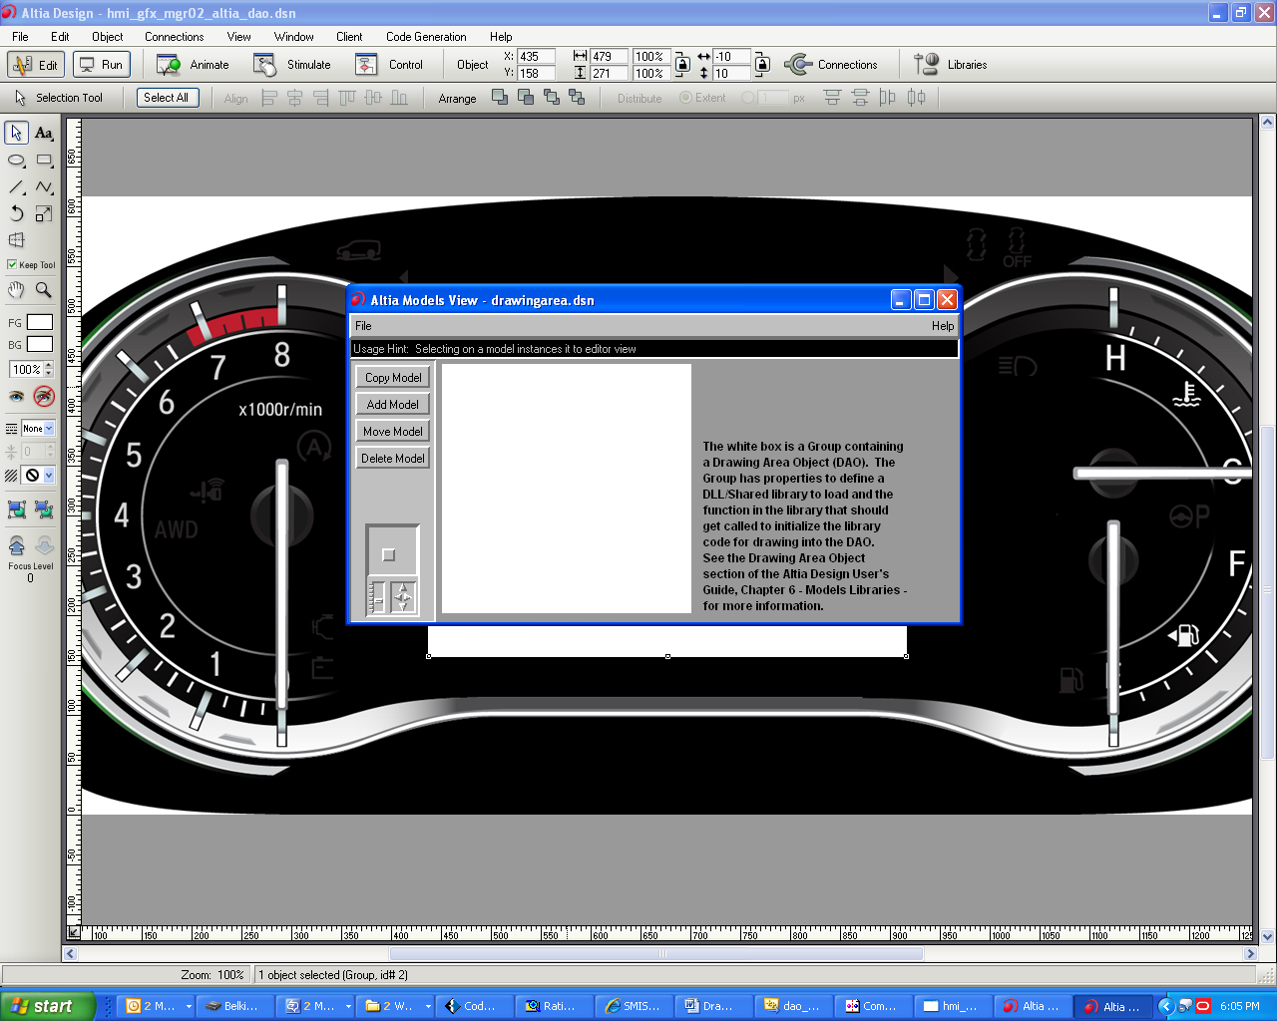
Select the DAO object from the Altia library
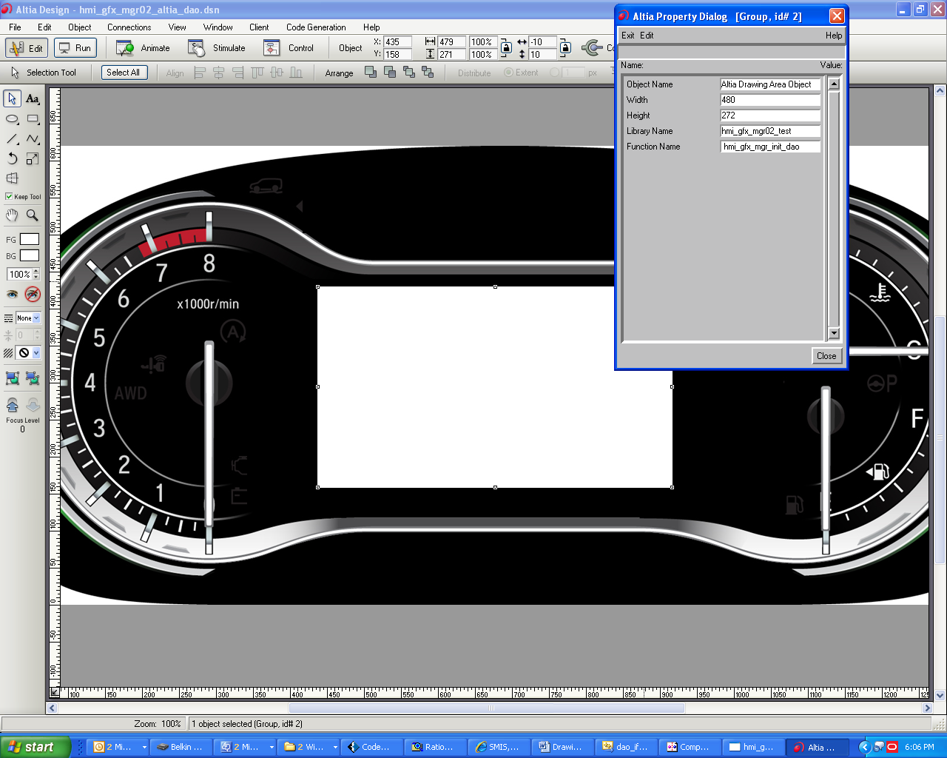
Edit the DAO properties Width, Height, Library Name, Function Name
Width → DAO object width
Height → DAO object Height
Library Name → This is the shared library need to implement for integration.
Function Name → Altia invokes this function at startup, while dll implementation need ensure that the name provided in Altia and DLL file is same. In this file all callbacks shall be registered. ALT_REDRAW_CALLBACK, ALT_RESIZE_CALLBACK, ALT_CLOSE_CALLBACK, ALT_SHOW_CALLBACK, ALT_EVENT_CALLBACK
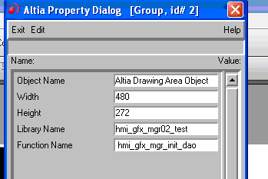

5. DAO in GDGO3 Environment

Create a solution with 2 projects.
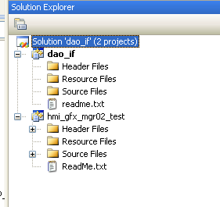
- With Configuration Type (Makefile)
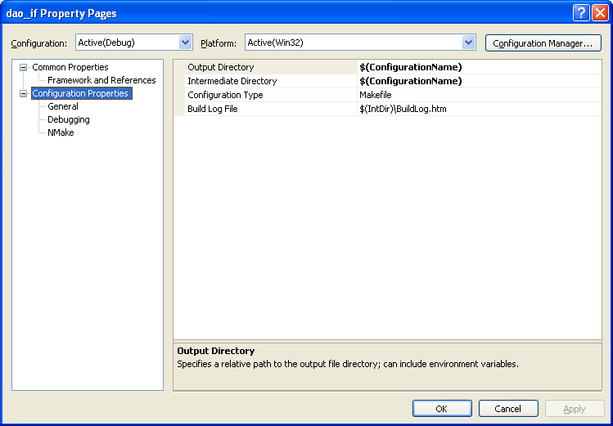
Add the altia generated batch file in Build command Line, ReBuild,… as shown below.
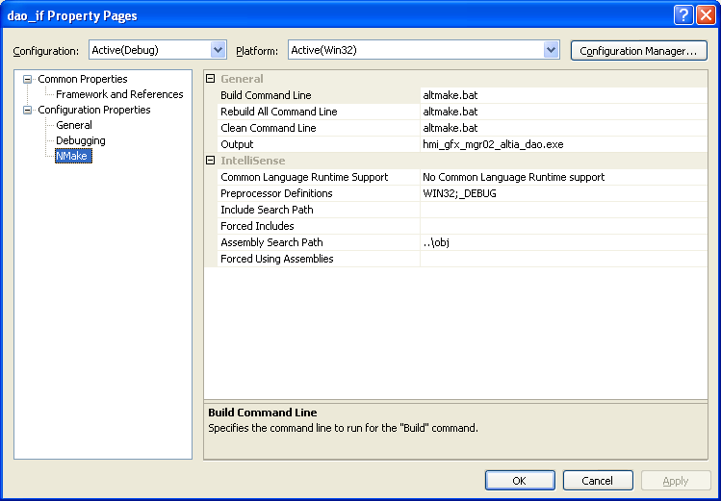

- Create 2nd project with Static Library option with Library name same as mentioned
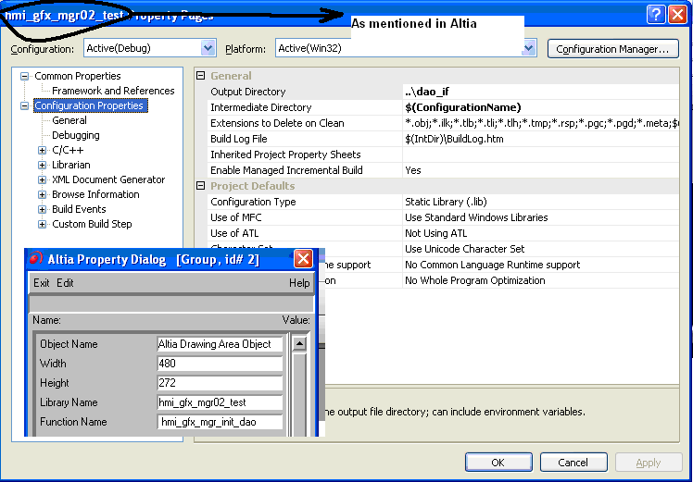

- Implement the Callback functions

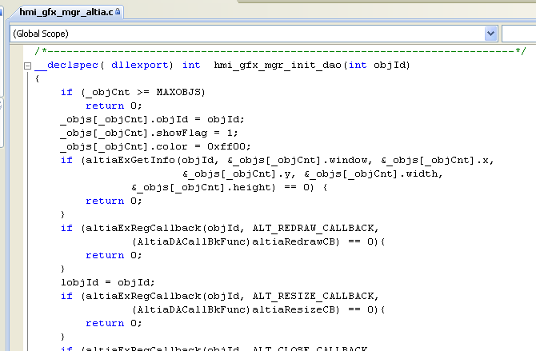

6. Generating Executable
Edit the generated Altia make file (altmake.mk) to add the hmi_gfx_mgr02_test.lib in DLLLIBS. Attached example files.
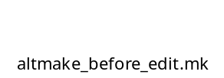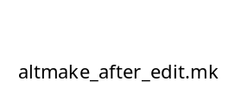
Build the complete solution.

