

DI Graphical Display Generator Package
(GDG-03)

Software Requirements Specification

Revision 1.1

CDIS-SRS-GDG-03

ISSUE DATE: November 17, 2011
Revision Date: July 18, 2012

Visteon Corporation
DI Core Software

1. Introduction 3
1.1. Purpose and Scope 3
1.2. References 3
1.3. Acronyms and Abbreviations 3
1.4. Definitions 3
1.5. Document Overview 3
2. Overall Description 4
3. Software Requirements 4
3.1. Operating Modes 4
3.2. Constraints 5
3.3. Feature 5
3.4. Configurations Items 7
3.5. Special Safety Related Requirements 7
3.6. Regulatory Requirements 7
3.7. Diagnostic Requirements 7
3.8. Manufacturing Requirements 7
3.9. Derived Requirements 7
3.10. Other Requirements 7
4. Traceability 8
5. Revision History 8
6. Originator of this Document 8

Introduction

Purpose and Scope
This Software Requirements Specification (SRS) captures the requirements for the DI GDG-03 (HMI GFX MANAGER 02) core Graphics Display Generator package (GDG-03). This document contains the high-level requirements that will be used to design, implement, and test the software.
To keep the interfaces simple and hiding the platform/DCU related info to the clients.

References

[1] Software Development Process -------------------
[2] Software Requirements Specification Standard --------------
[3] Freescale MPC560xS DCU Controller training doc DCU_and_QuadSPI_training.pdf.
[4] Kepler Platform Display Subsystem Software Architecture For
Graphical Displays document (latest version from the DI software bookshelf VOB)
[5] Freescale graphics library (folder "gdg03_MPC560xS\ 03_code\src\freescale_library_src" in DI software bookshelf VOB)

Acronyms and Abbreviations
CLUT Color Look Up Table
DCU Display Controller Unit
DI Driver Information
GDG Graphics Display Generator
HMI Human Machine Interface
LCD Liquid Crystal Display
SRS Software Requirements Specification

Definitions

Bookshelf Code Package: A set of software source files designed to be used in multiple projects. The package also contains numerous documents dealing with requirements, design, test, and programmer's guide.

Document Overview
This document is divided into the following sections.

Introduction
Overall Description
Software Requirements
Traceability
Revision History
Originator of the Document.

Overall Description

The GDG-03 package will be developed for Kepler platform and reside on the DI software bookshelf. It will be used in driver information products that contain graphical displays. The package will provide public interfaces that allow application tasks called "display clients" to write both text strings and bitmaps to the display and create or delete windows at specific X, Y coordinates.

Software Requirements

The general requirements for the GDG-03 package as follows:

Develop must follow DI software bookshelf package development requirements as defined in the "DI Core Software Bookshelf Standard" document in the "di_software_bookshelf" VOB in Clearcase.

All code for this package will be developed in the C language and must pass the QAC requirements for DI products as defined by the "QAC Users Guide" in the "di_software_bookshelf" VOB in Clearcase.

This package is intended for the MPC560xS and for Kepler platform.

Shall provide the simplified interfaces to avoid the more number of API calls from clients.

Shall analyze the graphic object and shall load the required information into the layers for display.

Shall handle all required property setting of the display object like CLUT loading, Chroma Keying, Blending modes…

All hidden layers shall be removed and made available for clients.

Shall hide the complexity of the DCU from the client.

Shall load the objects directly from the GDT structures.

Shall able build the static screens using single API call.

Shall isolate the platform intelligence from the clients.

Shall capable of compressing the images and de-compressing while building the layers.

Shall capable of dynamically allocating the GRAM for the text and widget elements.

Shall capable to rotate the image element by 90°, 180°, 270°, Mirror Vertical, Mirror horizontal.

Shall capable to downscale the image.

Shall capable of queuing commands to build by application.

Disadvantages of the gdg02 package
- GDG02 works on ISR client shall do careful analysis of critical section handling
  - Could result in display freeze issues.
  - More time requires for debugging/correcting issues.
- Clients need to have more knowledge on the DCU handling.
  - DCU knowledge is must for the clients.
- Requires more number of API’s to build static screens.
- Layer management is handled by the client, this may leads
  - Missing information on display.
  - Corruption of the image.
- Clients need to be aware of the CLUT free area to handle the objects where the CLUT information needs to be filled.
- Since the intelligence is distributed to all clients the maintainability is difficult.
- Changes cannot be done easily.
- More complexity in implementing the presentation layers.
- More interactions required to correctly manage the layers.

Operating Modes

The GDG-03 package will be constructed to allow the application to execute GDG-03 package functionality in modes appropriate for the application by scheduling GDG-03 functions and tasks accordingly.

Constraints
The GDG-03 package will be designed such that the memory and timing requirements will be dependent on application specific parameters (buffer sizes, scheduling rates) such that the optimal settings can be selected by the application.

Feature
The basic architecture of the GDG-03 package is shown in figure 1 (more information on the graphics architecture for DI clusters can be found in the " Kepler Platform Display Subsystem Software Architecture For Graphical Displays" document in the DI software bookshelf VOB). The GDG-03 package will allow display clients to update the contents of a graphical display by writing display generation generator (GDG's) to a layer. Each layer has an associated RAM buffer where the GDG's are stored until the Vertical SYNCH Blank. Once Vertical SYNCH Blank triggers the GDG's in the buffer are executed as soon as possible in the order they were placed in the buffer (FIFO). Commands are executed by making appropriate DCU register settings. In order to update the display, a client must use GDG-03 package interfaces:
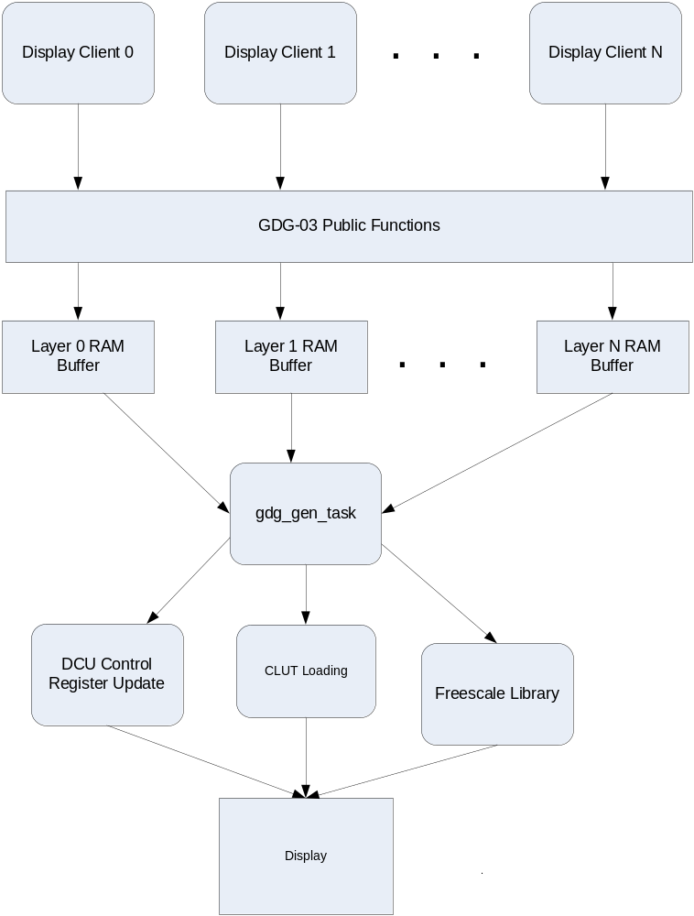

Figure 1 – GDG-03 Architecture

Configurations Items

Special Safety Related Requirements
None.

Regulatory Requirements
None.

Diagnostic Requirements
TBD.

Manufacturing Requirements
None.

Derived Requirements
None.

Other Requirements
None.

Traceability

The requirements for this package are maintained in this document. There is no external document that contains requirements for this package.

Revision History
Revision Level | Affected Sections | Author | Date | Description
1.0 |  | A Shekhar | November 17, 2011 | Initial Release.
1.1 | Section 3.0 | A Shekhar | July 18, 2012 | Updated to add image rotation, mirroring, downscaling, RLE compression, de-compression.

Originator of this Document
Alla Shekhar.

