Unit testing for UiCoreGDT

Introduction:
This document is dedicated to Unit testing of UiCoreGDT. It is requested to update the document with Issue the tester faced and update it with the solution for Future reference.

Before Testing:
Before running the batch file for UI core gdt make the following changes:
In hmi_gfx_mgr02_tv2:
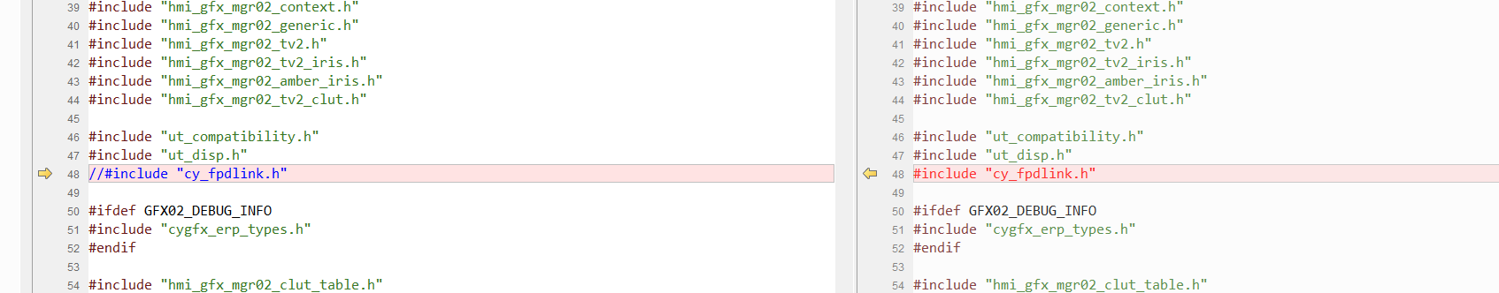
Comment #include "cy_fpdlink.h"
In hmi_gfx_mgr02_shape_engine:
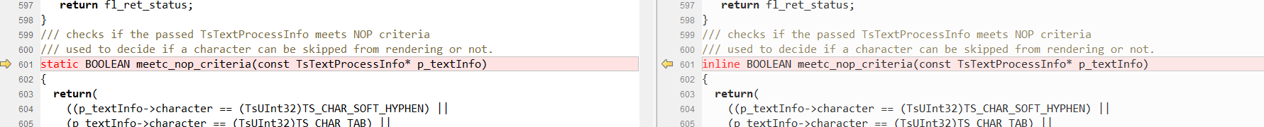
Convert inline to static.

Issues:

1)Segmentation violation:
Usually this issue occurs when a structure or anything similar goes unallocated. So It is

2)Complex script input in user Input:
In hmi_gfx_mgr02_mt_get_text_width the variable print_str_P expects a user input.
For normal text we can directly give the input like L”abcdefgh”
For Arabic,thai or Hebrew we can use we will have to use wchar_t or HMI_CHAR to declare the variable.
wchar_t arabic_string[4];
arabic_string[0]= (wchar_t)0x0645;
arabic_string[1]= (wchar_t)0x0631;
arabic_string[2]= (wchar_t)0x062D;
arabic_string[3]= (wchar_t)0x0627;
size_t num_elements = wcslen(arabic_string) + 1;
HMI_CHAR *ptr = (HMI_CHAR *)malloc(num_elements *sizeof(HMI_CHAR));
wcscpy(ptr,arabic_string);
<<hmi_gfx_mgr02_text.hmi_gfx_mgr02_mt_get_text_width.p_clip_text_info_SP>>[0].print_str_P = (ptr );
Above code is the method to declare the value for the string, That is by for each character we will to give the wchar_t of the Arabic or any complex character and assign to a HMI_CHAR pointer.

3)Malloc structure with user input:
If a structure is in test case with user input and if a custom input is to be provided.
The direct defining of the structure value in user test case may complete the test case but may not read the values properly. Therefore the structure should be declared dynamically using malloc
In hmi_gfx_mgr02_mt_get_text_width the structure dyn_text_def_SP takes user input.
GFX_MGR02_TEXT_DEF_T* Temp_dyn_text =(GFX_MGR02_TEXT_DEF_T*) malloc(sizeof(GFX_MGR02_TEXT_DEF_T));
Temp_dyn_text->string_index = 1076;
Temp_dyn_text->width = 200;
Temp_dyn_text->num_chars = 15;
Temp_dyn_text->font_id = 1;
Temp_dyn_text->num_of_display_lines = 1;
Temp_dyn_text->inter_line_spacing = 0;
Temp_dyn_text->max_num_of_lines = 1;
Temp_dyn_text->ml_string_index = 0;
Temp_dyn_text->alignment = 0;
Temp_dyn_text->orientation = 0;
Temp_dyn_text->draw_mode = 0;
Temp_dyn_text->clip_mode = 2;
Temp_dyn_text->scroll_mode = 1;
Temp_dyn_text->wrap_mode = 0;
Temp_dyn_text->dynamic = 0;
Temp_dyn_text->scroll = 0;
Temp_dyn_text->anim_id = 1145315842;
<<hmi_gfx_mgr02_text.hmi_gfx_mgr02_mt_get_text_width.p_clip_text_info_SP>>[0].dyn_text_def_SP = (const GFX_MGR02_TEXT_DEF_T *)(Temp_dyn_text);

Above code is an example on how to provide input to a structure with user type input.

