3. Exercise2 (OpenVG target)

In this exercise we will integrate popup.core.02 and message.core.01 to achieve some complex control behaviors. The details will be covered below.

Designing Popup and Warnings in the GDT project
Create the folders
exercise1\graphics\images\popup – to store the GDT popup image resources
exercise1\graphics\images\warning – to store the GDT warning image resources

Designing Info Popup in GDT Tool
There are four types of popup.
- POPUP_INFO
- POPUP_PROGRESS
- POPUP_ACK
- POPUP_KEYPAD
- Run the GDT executable gfx_viewer_win32.exe.
- Right click on the SCREENS to add a screen for the info popup with name scr_info_popup.
- In the screen property enter the handler names for Event, Focus and Presentation. These handlers will be implemented in the files generated from popup configurator tool. Since the info popup is designed to have more priority than base screen, the priority is set as 3.
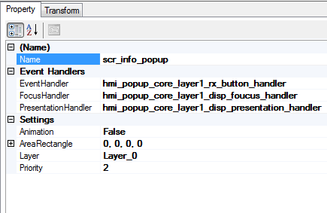
- Right click on the screen and add a widget wdg_info_popup.
- Right click on the widget and add an image from it.
- Name the image as img_info_popup. Select the image file from exercise1\graphics\ images\popup\audio_on.png
- Right click on the widget and add an image from it.
- Name the image as img_info_popup_border. Select the image file from exercise1\graphics\ images\popup\popup_border.bmp
- Right click on the widget and add a text from it. Name the text element as txt_info_header. Enter the text as “Info Popup” with static text mode “True”
- Right click on the widget and add a text from it. Name the text element as txt_info_popup. Select the element to view its properties. Configure the “Static Text Mode” as False so that dynamically text can be displayed.

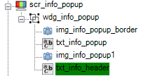
Now info popup is designed in GDT.

Designing Ack Popup in GDT Tool
- Right click on the SCREENS to add a screen for the ack popup with name scr_ack_popup .
- In the screen property enter the handler names for Event, Focus and Presentation. These handlers will be implemented in the files generated from popup configurator tool. Since we are designing the ack popup in same layer where info popup was designed the same handlers are provided for ack popup. Since the ack popup is designed to have more priority than info popup, the priority is set as 3.
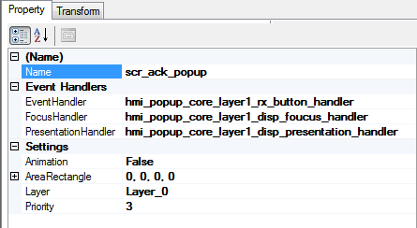
- Right click on the screen and add a widget wdg_ack_popup.
- Right click on the widget and add an image from it.
- Name the image as img_ack_popup_border. Select the image file from exercise1\graphics\ images\popup\popup_warn_border_blue.bmp.
- Right click on the widget and add an image from it.
- Name the image as img_ack_popup. Select the image file from exercise1\graphics\ images\popup\wipe_off.bmp.
- Right click on the widget and add a text from it. Name the text element as txt_ack_header. Enter the text as “Ack Popup” with static text mode as True.
- Right click on the widget and add a text from it. Name the text element as txt_ack_popup. Select the element to view its properties. Configure the “Static Text Mode” as False so that dynamically text can be displayed.

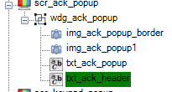
Now ack popup is designed in GDT.

Designing Keypad Popup in GDT Tool
- Right click on the SCREENS to add a screen for the keypad popup with name scr_keypad_popup .
- In the screen property enter the handler names for Event, Focus and Presentation. These handlers will be implemented in the files generated from popup configurator tool. Since we are designing the keypad popup in same layer where above popups were designed the same handlers are provided for keypad popup. Since the keypad popup is designed to have more priority than ack popup, the priority is set as 3.

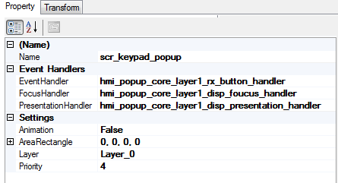

- Right click on the screen and add a widget wdg_keypad_popup.
- Copy the image img_info_popup_border and paste it inside the wdg_keypad_popup.
- Right click on the widget and add a text from it. Name the text element as txt_keypad_popup. Select the element to view its properties. Configure the “Static Text Mode” as False so that dynamically text can be displayed.
- Right click on the widget and add a text from it. Name the text element as txt_keypad_text. Select the element to view its properties. Configure the “Static Text Mode” as True and set the text as “Enter Number”.
- Right click on the widget and add a fill screen from it. Name the fill element as fill_keypad. Select the element to view its properties. Design a small box with fill colour as White.
- Right click on the widget and add a text from it. Name the text element as txt_keypad_entry. Select the element to view its properties. Configure the “Static Text Mode” as False and set the text box position inside the fill element designed above so that text entered in the text box via the keypad popup will be visible remarkably.

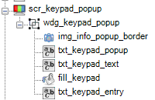

Now keypad popup is designed in GDT.

Designing Progress Popup in GDT Tool
- Right click on the SCREENS to add a screen for the progress popup with name scr_progress_popup .
- In the screen property enter the handler names for Event, Focus and Presentation. These handlers will be implemented in the files generated from popup configurator tool. Since we are designing the progress popup in same layer where above popups were designed the same handlers are provided for progress popup. Since the progress popup is designed to have more priority than keypad popup, the priority is set as 5.

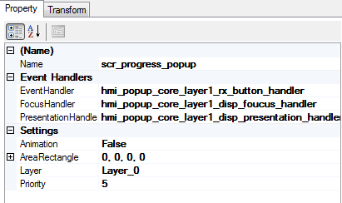

- Copy the image img_info_popup_border and paste it inside the wdg_keypad_popup.
- Right click on the screen and add a text from it. Name the text element as txt_progress. Enter the text as “Propgress Popup” with static text mode True.
- Right click on the screen and add a text from it. Name the text element as txt_progress_popup. Select the element to view its properties. Configure the “Static Text Mode” as False so that dynamically text can be displayed.
- Right click on the screen and add a widget wdg_progress_popup.
- Right click on the widget and add an image from it. Name the image element as dimg_progress.
- Select the property of the image and make it dynamic.

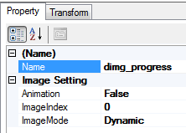

- Add 22 images (img_0.bmp to img_21.bmp) from exercise1\graphics\images\popup.

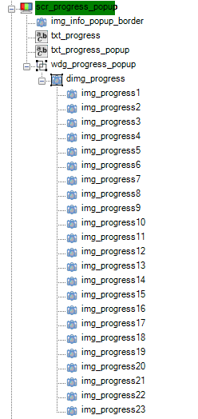
Now progress popup is designed in GDT.

Designing Warning Popup in GDT Tool
- Right click on the SCREENS to add a screen for the warning popup with name scr_warning_popup .
- In the screen property enter the handler names for Event, Focus and Presentation. These handlers will be implemented in the files generated from popup configurator tool. Since we are designing the warnings popup in same layer where above popups were designed in GDT the same handlers are provided for warnings popup. Since the warning popup is designed to have more priority than all the above popups, the priority is set as 6.

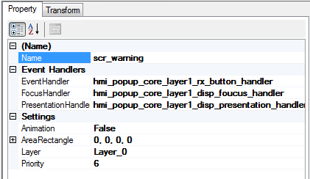

- Right click on the screen and add a widget from it. Name the widget element as dwdg_wrng. Select the element to view its properties. Configure the widget type as “dynamic”.
- Right click on the widget dwdg_wrng and add a widget wdg_hard1.
- Right click on the widget dwdg_wrng and add a widget wdg_soft1.
- Right click on the widget dwdg_wrng and add a widget wdg_info1.
- Right click on the widget wdg_hard1.and add an image from it. Name the image element as img_hardwrng_border. Select the image file from images\warning\warning_bg_red.bmp
- Right click on the widget wdg_hard1.and add an image from it. Name the image element as img_hardwrng1. Select the image file from images\warning\wrn_brake_icon.png
- Right click on the widget wdg_hard1.and add an image from it. Name the image element as img_hardwrng_1. Select the image file from images\warning\wrn_icon_Brake_textamber.png.
- Right click on the widget wdg_hard1.and add a text from it. Name the text element as txt_hardwrng. Select the element to view its properties. Configure the “Static Text Mode” as False so that dynamically text can be displayed.

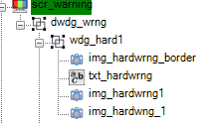

- Right click on the widget wdg_soft1.and add an image from it. Name the image element as img_softwrng_border. Select the image file from images\warning\warning_bg_yellow.bmp
- Right click on the widget wdg_soft1.and add an image from it. Name the image element as img_softwrng1. Select the image file from images\warning\wrn_fuel_icon.png
- Right click on the widget wdg_soft1.and add a text from it. Name the text element as txt_softwrng. Select the element to view its properties. Configure the “Static Text Mode” as False so that dynamically text can be displayed.
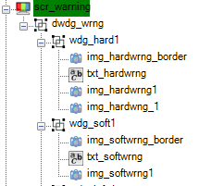

- Right click on the widget wdg_info1.and add an image from it. Name the image element as img_infowrng_border. Select the image file from images\warning\warning_bg_violet.bmp
- Right click on the widget wdg_info1.and add an image from it. Name the image element as img_infowrng1. Select the image file from images\warning\warn_head_light.png
- Right click on the widget wdg_info1.and add a text from it. Name the text element as txt_infowrng. Select the element to view its properties. Configure the “Static Text Mode” as False so that dynamically text can be displayed.

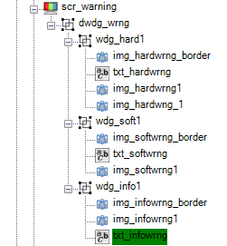
Now warnings are designed in GDT.

Configuring the designed Popups in Popup Configurator Tool
Now run the \ui.core.iceapple.doc\ popup.core.02\ Popup _configurator\ Popup_configurator.exe . Click “New” on File option.
Open the “General Config” menu.
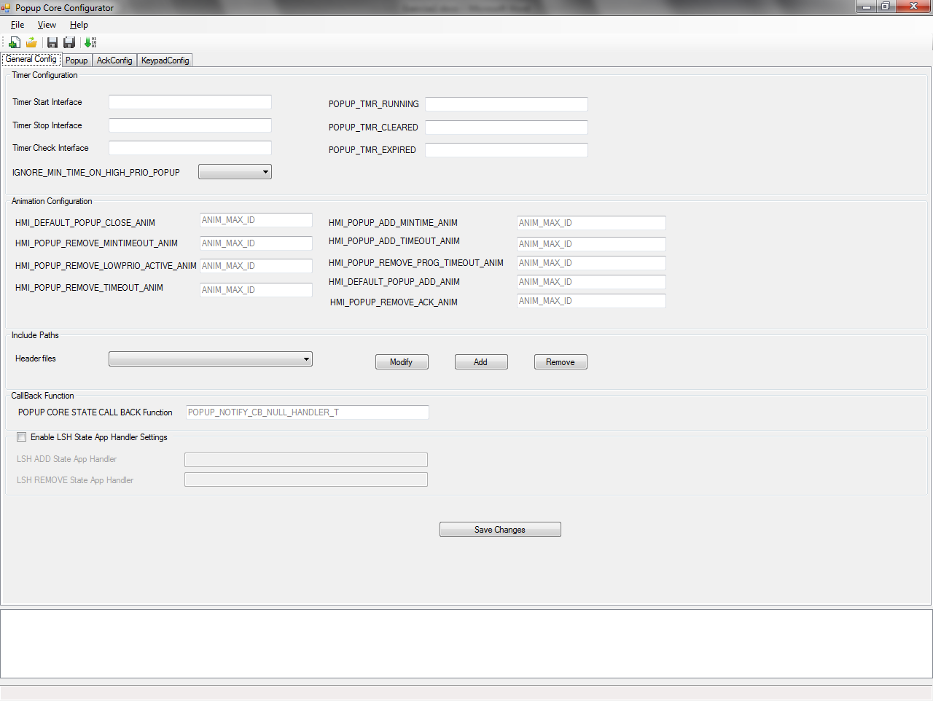
- Mention “Timer Start Interface” as hmi_popup_core_support_timer_start.
- Mention “Timer Stop Interface” as hmi_popup_core_support_timer_stop.
- Mention “Timer Check Interface” as hmi_popup_core_support_timer_check.
- Mention “POPUP_TMR_RUNNING” as HMI_TIMER_RUNNING.
- Mention “POPUP_TMR_CLEARED” as HMI_TIMER_CLEAR.
- Mention “POPUP_TMR_EXPIRED” as HMI_TIMER_EXPIRED.
- By default all the animation configurations will be ANIM_MAX_ID.
- In “Include Paths” click Add and add the necessary header files “hmi_timer_support.h” and “hmi_popup_screen.h” .
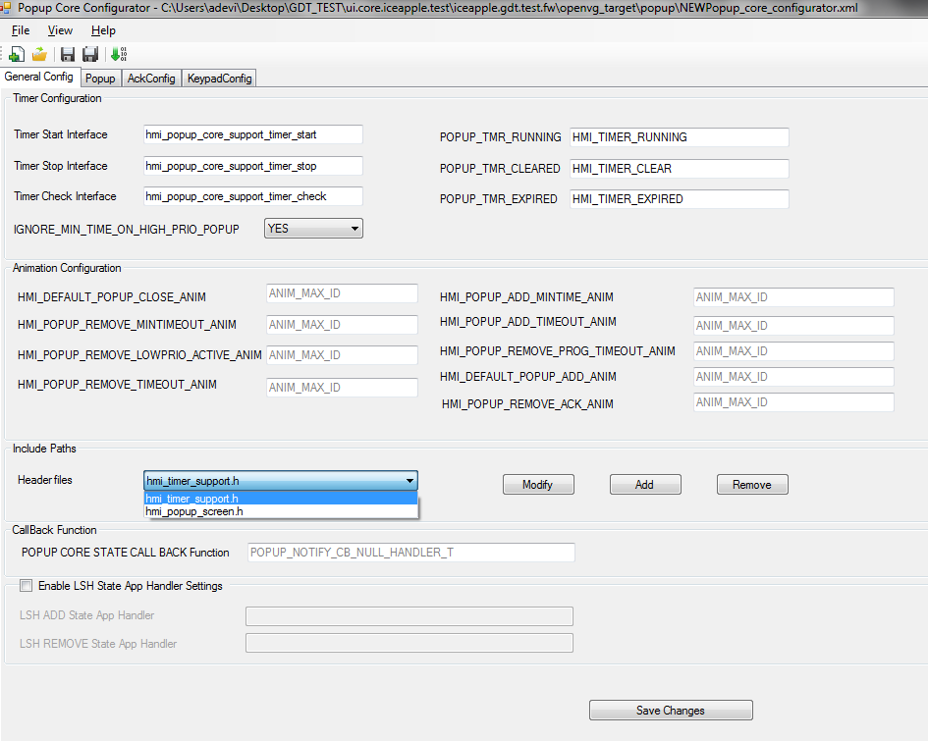

- Click on “Save Changes” button to save changes in “General Config” menu.

Configuring the Warning Popup in Popup Configurator Tool
Open the “Popup Config” menu.
- Right Click on PopupConfig and Insert New Layer as mentioned below.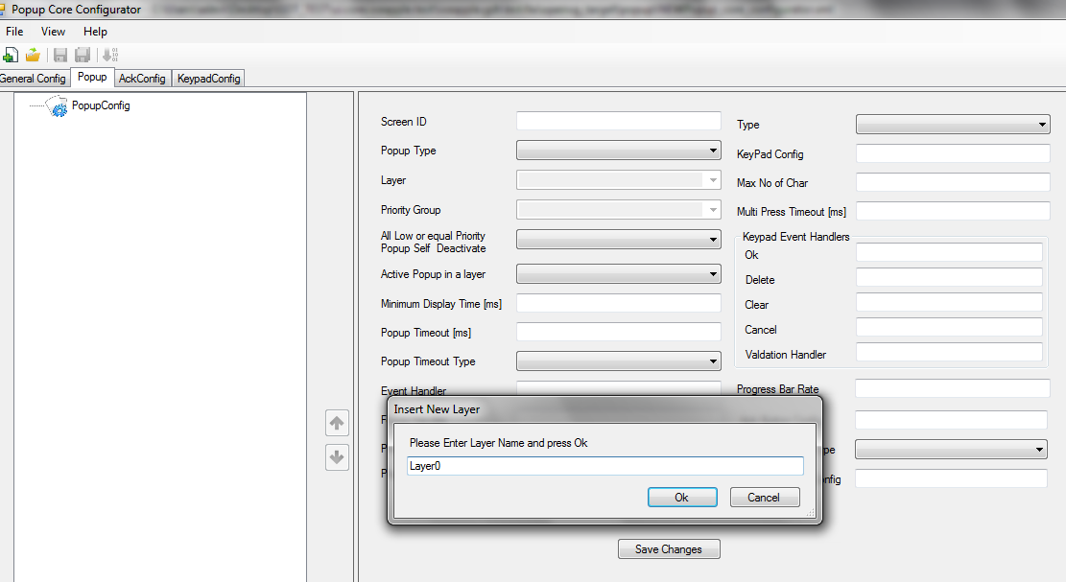
- Right Click on Layer0 and Add New Popup as mentioned below.

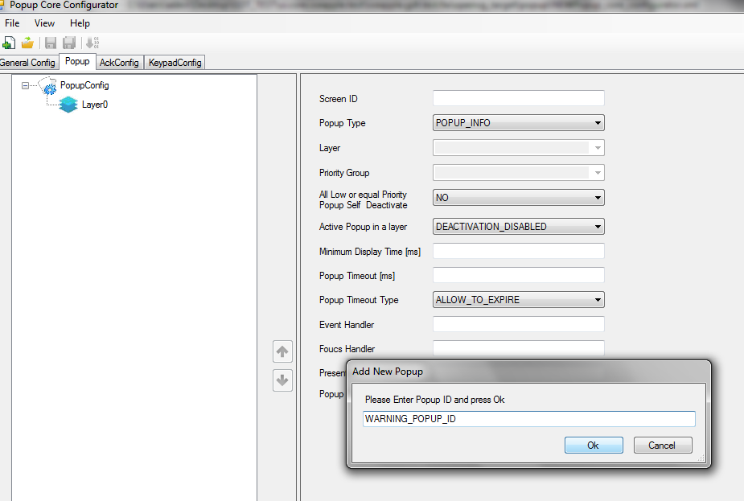

- Select the “WARNING_POPUP_ID” and configure Screen ID as GFX_SCR_WARNING.
- Select the “Popup Type” as POPUP_INFO.
- Configure the “Event Handler” as “scr_warning_popup_event_handler”.
- Configure the “Focus Handler” as “scr_warning_popup_focus_handler”.
- Configure the “Presentation Handler” as “scr_warning_popup_ presentation_handler”.
All these handlers need to be implemented later.
- All other fields are accepted as default values.
- Click on “Save Changes” button to save changes in “Popup Config” menu.
- Configuration of popup to display the warnings is done.
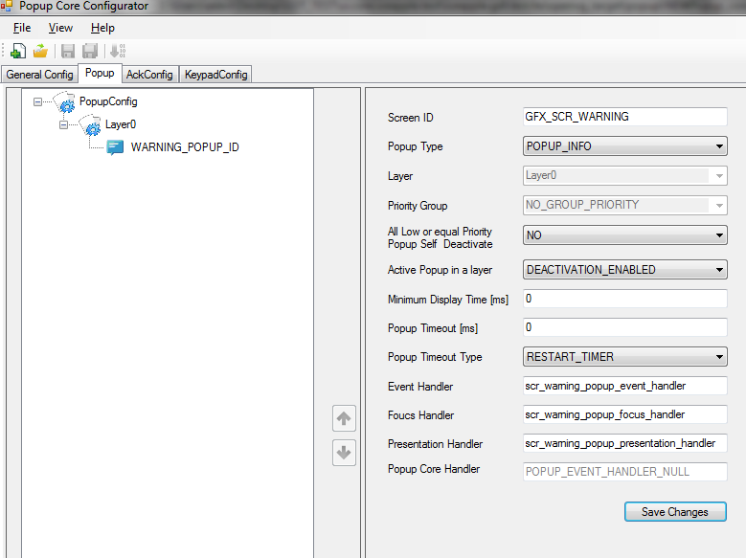

Configuring the Info Popup in Popup Configurator Tool
There are four types of popup.
- POPUP_INFO
- POPUP_PROGRESS
- POPUP_ACK
- POPUP_KEYPAD
Configuration of POPUP_INFO
- Right Click on PopupConfig and Insert New Layer as Layer1.
- Right Click on Layer1 and Add New Popup as INFO_POPUP_ID.
- Select the “INFO_POPUP_ID” and configure Screen ID as GFX_SCR_INFO_POPUP which we have designed earlier.
- Select the “Popup Type” as POPUP_INFO.
- Configure the “Popup Timeout” as 5seconds.
- Configure the “Event Handler” as “scr_info_popup_event_handler”.
- Configure the “Focus Handler” as “scr_info_popup_focus_handler”.
- Configure the “Presentation Handler” as “scr_info_popup_presentation_handler”. These handlers need to be implemented separately.
- All other fields are accepted as default values.
- Click on “Save Changes” button to save changes in “Popup Config” menu.
- Configuration of popup to display the info popup is done.
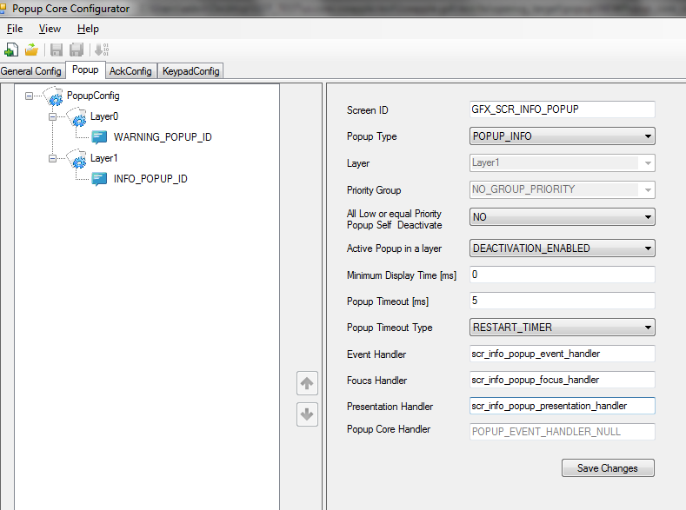

Configuring the Ack Popup in Popup Configurator Tool
- Right Click on Layer1 and Add New Popup as ACK_POPUP_ID.
- Select the “ACK_POPUP_ID” and configure Screen ID as GFX_SCR_ACK_POPUP.
- Select the “Popup Type” as POPUP_ACK.
- Configure the “Event Handler” as “scr_ack_popup_event_handler”.
- Configure the “Focus Handler” as “scr_ack_popup_focus_handler”.
- Configure the “Presentation Handler” as “scr_ack_popup_presentation_handler”.
- Configure the “Ack Button Config” as “gui_common_ack_button_config1”.
- Configure the Not Ack Button Type as PASSED.
- Configure the “Not Ack Button Config” as “gui_common_nack_button_config1”
- All other fields are accepted as default values.
- Click on “Save Changes” button to save changes in “Popup Config” menu.
- Configuration of popup to display the ack popup is done.
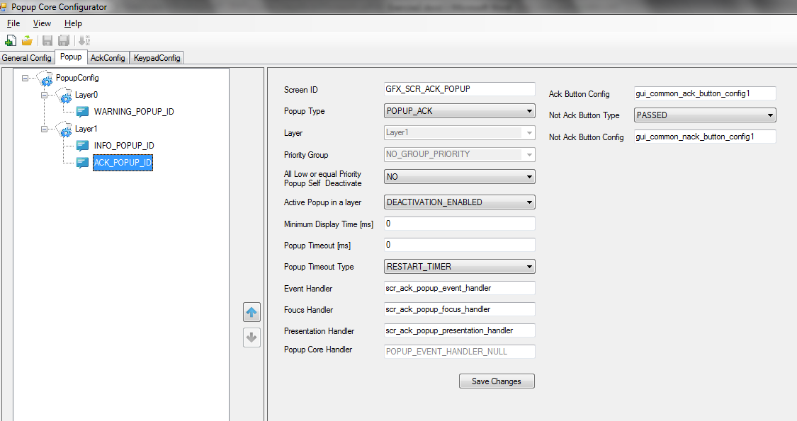

Configuring the Keypad Popup in Popup Configurator Tool
- Right Click on Layer1 and Add New Popup as KEYPAD_POPUP_ID.
- Select the “KEYPAD_POPUP_ID” and configure Screen ID as GFX_SCR_KEYPAD_POPUP.
- Select the “Popup Type” as POPUP_ KEYPAD.
- Configure the “Event Handler” as “scr_keypad_popup_event_handler”.
- Configure the “Focus Handler” as “scr_keypad_popup_focus_handler”.
- Configure the “Presentation Handler” as “scr_keypad_popup_presentation_handler”.
- Configure the “Type” as NUMERIC.
- Configure the Key Pad Config as “Numeric”.
- Configure the Max No of Char as 10.
- Configure the Keypad Event Handlers as follows:
  - OK – BTN_ID_ENTER
  - Delete –BTN_ID_MAX
  - Clear –BTN_ID_MAX
  - Cancel – BTN_ID_MAX
- All other fields are accepted as default values.
- Click on “Save Changes” button to save changes in “Popup Config” menu.
- Configuration of popup to display the keypad popup is done.
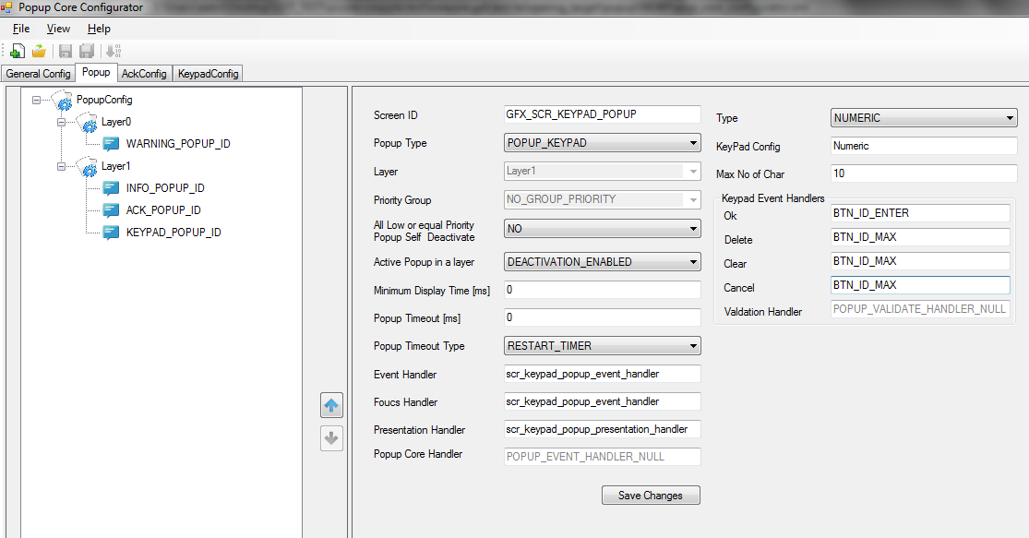

Configuring the Progress Popup in Popup Configurator Tool
- Right Click on Layer1 and Add New Popup as PROGRESS_POPUP_ID.
- Select the “PROGRESS _POPUP_ID” and configure Screen ID as GFX_SCR_ PROGRESS _POPUP.
- Select the “Popup Type” as POPUP_ PROGRESS.
- Configure the “Event Handler” as “scr_progress_popup_event_handler”.
- Configure the “Focus Handler” as “scr_progress_popup_focus_handler”.
- Configure the “Presentation Handler” as “scr_progress_popup_presentation_handler”.
- Configure the “Popup Timeout” as 22.
- Configure the “Popup Core Handler” as “hmi_progress_popup_status_handler”
- Configure the “Progress Bar Rate” as 1.
- All other fields are accepted as default values.
- Click on “Save Changes” button to save changes in “Popup Config” menu.
- Configuration of popup to display the progress popup is done.
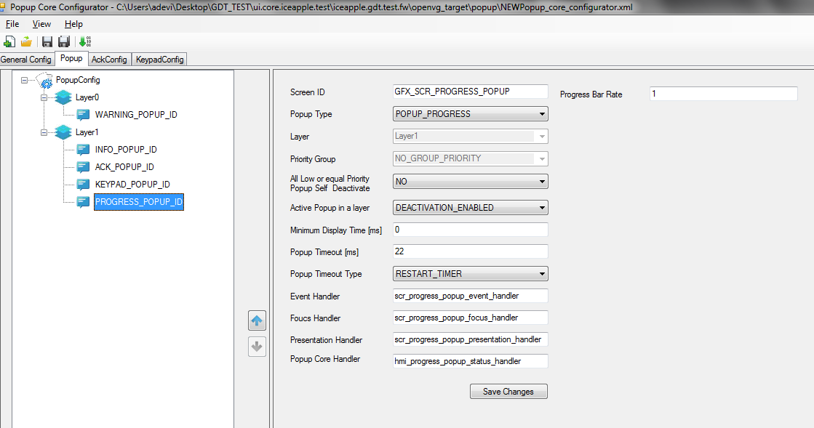
Only for Keypad popup and Ack type of popup the remaining two menus “AckConfig” and “KeypadConfig” need to be done.

Configuring the Ack config menu in Popup Configurator Tool
- Click “Add” beneath “Ack Config Name” and enter the same name which was provided in “Ack Button Config” of “ACK_POPUP_ID” configuration.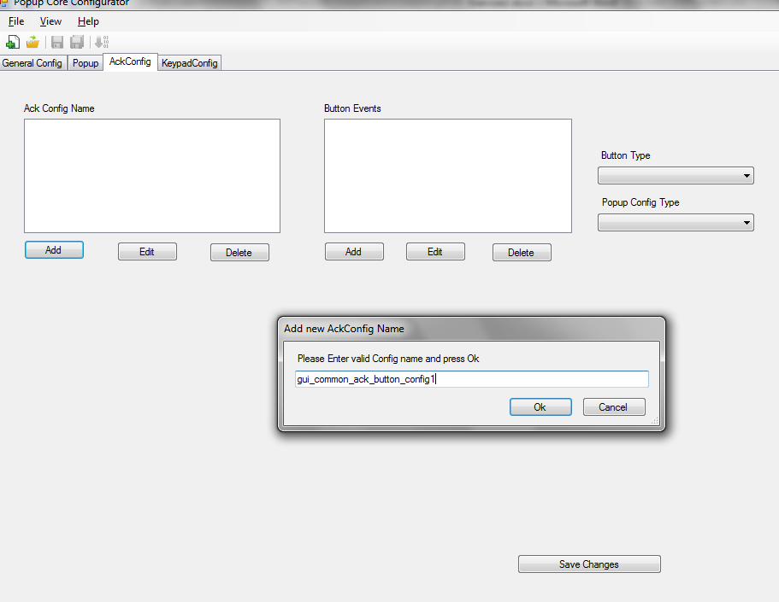

- Click “Add” beneath “Button Events” and configure as “BTN_ID_ENTER”.
- Select the “Button Type” as “PASSED” and “Popup Config Type” as “Ack”.The above configuration indicates that the ACK_POPUP_ID will be acknowledged when “BTN_ID_ENTER” button is pressed.
- Click “Add” beneath “Ack Config Name” and enter the same name which was provided in “Not Ack Button Config” of “ACK_POPUP_ID” configuration.
- Click “Add” beneath “Button Events” and configure as “BTN_ID_POWER”.
- Select the “Button Type” as “ABSORBED” and “Popup Config Type” as “Nack”.The above configuration indicates that the ACK_POPUP_ID will be negatively acknowledged when “BTN_ID_POWER” button is pressed.
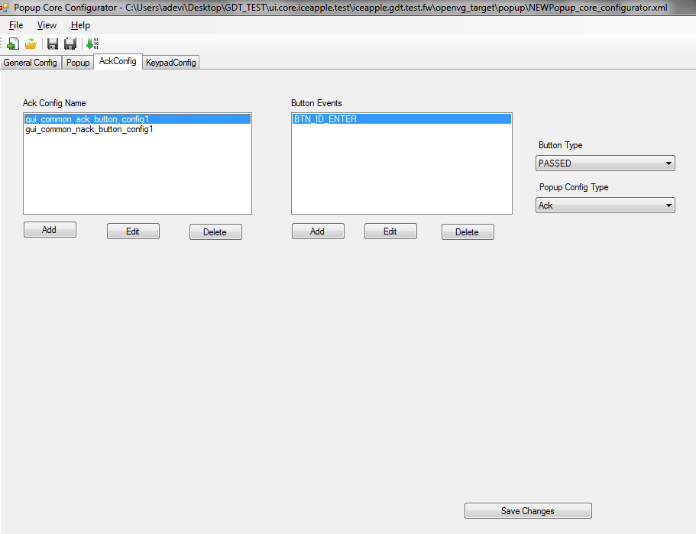

Configuring the Keypad config menu in Popup Configurator Tool
- Click “Add” beneath “Keypad Config Name” and enter the same name which was provided in “Key Pad Config” of “KEYPAD_POPUP_ID” configuration.
- Click “Add” beneath “Button Events” and configure as “KEYPAD_1_IN”.
- Click “Add” beneath “Press Count” so that Press_1 will appear in the drop down.
- Mention the “Press Value” as “1”. The above configuration indicates that the keypad value of number 1 is configured now.
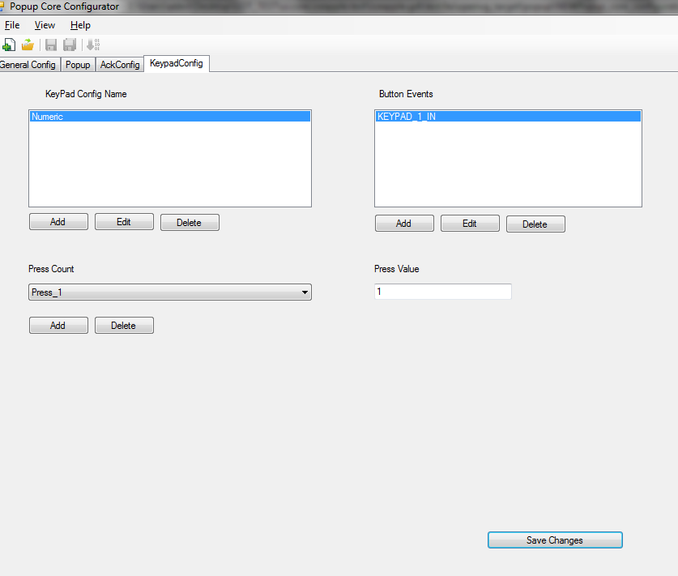
- Similarly add KEYPAD_2_IN for value 2, KEYPAD_3_IN for value 3, KEYPAD_4_IN for value 4, KEYPAD_5_IN for value 5, KEYPAD_6_IN for value 6, KEYPAD_7_IN for value 7, KEYPAD_8_IN for value 8, KEYPAD_9_IN for value 9, KEYPAD_0_IN for value 0.
- Save the changes in the page.
- Configuration of all types of popup is done.
- Save the xml as ia_popup_core_cfg.xml in openvg_target\popup and generate the code from File menu.

Files generated in openvg_target\popup:
- hmi_popup_core.dat
- hmi_popup_core_if.c
- hmi_popup_core_if.h
- hmi_popupcore_readme.txt

Configuring Language:
Open the SID_Language_Table.xls .sheet and add below SID (string identifiers) for our exercise inside the “general” sheet.
Display | Screen | Layout ID  (TextBox) | Text ID | UK_English | French | US_English
Version | NotEmpty | NotEmpty | Version==> | All | All | All
BASE |    |  | HELLO | HELLO Warning | HELLO | HELLO
BASE |  |  | WORLD | WORLD | WORLD | WORLD
BASE |  |  | HARD_WRNG | Brake Failure | Brake Failure | Brake Failure
BASE |  |  | SOFT_WRNG | Low Fuel | Low Fuel | Low Fuel
BASE |  |  | INFO_WRNG | Headlight ON | Headlight ON | Headlight ON
BASE |  |  | INFO_POPUP | Audio ON | Audio ON | Audio ON
BASE |  |  | ACK_POPUP | Wiper OFF | Wiper OFF | Wiper OFF
BASE |  |  | KEYPAD_POPUP | Enter Number | Enter Number | Enter Number
BASE |  |  | PROGRESS_POPUP | Scan In Progress | Scan In Progress | Scan In Progress

Now run the \ui.core.iceapple.doc\language.core.01\language_encoder_tool\ LanguageEncoder.exe and click “Load Configuration”
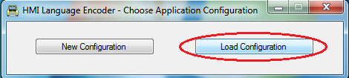
Open the configuration(.cfg) in exercise1\language.
After that click on Start Encoding button to generate the language database files. Three files will be generated inside the language folder
hmi_language_identifiers.h – contains the SID definitions for application usage
hmi_language_1.c – Contains the language database tables
hmi_language_gen.txt – contains information about the code generation

Configuring Button Events:

In simulation the buttons a,s,d,f are used for four types of popup and q,w,e are used for three types of warnings.
In hmi_button.h configure the below enums.

enum{
BTN_ID_POWER,
BTN_ID_UP,
BTN_ID_DN,
BTN_ID_LT,
BTN_ID_RT,
BTN_ID_ENTER,
BTN_ID_INFO_POPUP,
BTN_ID_ACK_POPUP,
BTN_ID_PROGRESS_POPUP,
BTN_ID_KEYPAD_POPUP,
BTN_ID_HARD_WRNG,
BTN_ID_SOFT_WRNG,
BTN_ID_INFO_WRNG,
BTN_ID_DEACTIVATE_WRNG,
BTN_ID_0,
BTN_ID_1,
BTN_ID_2,
BTN_ID_3,
BTN_ID_4,
BTN_ID_5,
BTN_ID_6,
BTN_ID_7,
BTN_ID_8,
BTN_ID_9,
BTN_ID_MAX
};
The dm_switch_array[] in hmi_button.c need to be configured for the above button events.
Note :- Refer \ui.core.iceapple.test\iceapple.gdt.test.fw\openvg_target\common\hmi_button.c for sample implementation

Configuring Warnings in Warnings Configuration Sheet:

Open Warning_configuration.xls from openvg_target\warning
Open the sheet Config_sheet

Configuring hard Warning in Warnings Configuration Sheet:
- Configure the first warning with S No as 1. Variant as Common. Column “Message ID” as HARD_WARNING_ID.
- Column “U08SIF_GET_DATACheckActiveCondition” as “hmi_msg_warn_get_status”.
- Column “ConditionQualifier” as “HARD_WARNING_ID_INDEX”.
- Column “U08SIF_GET_DATAMsgEventCallbackFunction” as “hmi_msg_app_wrn_notify_status_cb”
- Column “CallbackEventQualifier” as “MSG_EVENT_SHOW | MSG_EVENT_ACKNOWLEDGED | MSG_EVENT_HIDDEN | MSG_EVENT_INACTIVE “
- Column “Display TimeOut” as “NO_TIMEOUT”.
- Column “Hold TimeOut” as “NO_TIMEOUT”.
- Column “ eMessageCategory” as “mcHardWarning”.
- Column “Priority” as 1.
- Column “Options” as “HARD_WARNING_OPTIONS”.
- Column “ActiveStates” as “MSG_IGNRUN”.
- Column “Chimes” as “UI_WARNING_CHIME_NONE”.
- Column “Header” and “Header_SID” as 0. If required headers can be designed in GDT tool and can be mentioned here.
- Column “Line1_Text_ID” as “GFX_TXT_HARDWRNG” generated from GDT tool in file “hmi_gfx_mgr02_cfg.h”.
- Column “Line_1_SID” as “SID_HARD_WRNG” generated from language tool in file hmi_language_identifiers.h.
- Column “Line2_Text_ID” and “Line_2_SID” as 0. Column “Line3_Text_ID” and “Line_3_SID” as 0
- Column “Popup ID” as “L0_WARNING_POPUP_ID” the value of popup ID generated in “hmi_popup_core_if.h”.

Configuring soft Warning in Warnings Configuration Sheet:
- Configure the second warning with S No as 2. Variant as Common. Column “Message ID” as SOFT_WARNING_ID.
- Column “U08SIF_GET_DATACheckActiveCondition” as “hmi_msg_warn_get_status”.
- Column “ConditionQualifier” as “SOFT _WARNING_ID_INDEX”.
- Column “U08SIF_GET_DATAMsgEventCallbackFunction” as “hmi_msg_app_wrn_notify_status_cb”
- Column “CallbackEventQualifier” as “MSG_EVENT_SHOW | MSG_EVENT_ACKNOWLEDGED | MSG_EVENT_HIDDEN | MSG_EVENT_INACTIVE “
- Column “Display TimeOut” as “SOFT_WARNING_TIMEOUT”.
- Column “Hold TimeOut” as “NO_TIMEOUT”.
- Column “ eMessageCategory” as “mcSoftWarning”.
- Column “Priority” as 2.
- Column “Options” as “SOFT_WARNING_OPTIONS”.
- Column “ActiveStates” as “MSG_IGNRUN”.
- Column “Chimes” as “UI_WARNING_CHIME_NONE”.
- Column “Header” and “Header_SID” as 0. If required headers can be designed in GDT tool and can be mentioned here.
- Column “Line1_Text_ID” as “GFX_TXT_SOFTWRNG” generated from GDT tool in file “hmi_gfx_mgr02_cfg.h”.
- Column “Line_1_SID” as “SID_SOFT_WRNG” generated from language tool in file hmi_language_identifiers.h.
- Column “Line2_Text_ID” and “Line_2_SID” as 0. Column “Line3_Text_ID” and “Line_3_SID” as 0
- Column “Popup ID” as “L0_WARNING_POPUP_ID” the value of popup ID generated in “hmi_popup_core_if.h”.

Configuring info Warning in Warnings Configuration Sheet:
- Configure the second warning with S No as 3. Variant as Common. Column “Message ID” as INFO_WARNING_ID.
- Column “U08SIF_GET_DATACheckActiveCondition” as “hmi_msg_warn_get_status”.
- Column “ConditionQualifier” as “INFO_WARNING_ID_INDEX”.
- Column “U08SIF_GET_DATAMsgEventCallbackFunction” as “hmi_msg_app_wrn_notify_status_cb”
- Column “CallbackEventQualifier” as “MSG_EVENT_SHOW | MSG_EVENT_ACKNOWLEDGED | MSG_EVENT_HIDDEN | MSG_EVENT_INACTIVE “
- Column “Display TimeOut” as “INFO_WARNING_TIMEOUT”.
- Column “Hold TimeOut” as “NO_TIMEOUT”.
- Column “ eMessageCategory” as “mcSoftWarning”.
- Column “Priority” as 2.
- Column “Options” as “INFO_WARNING_OPTIONS”.
- Column “ActiveStates” as “MSG_IGNRUN”.
- Column “Chimes” as “UI_WARNING_CHIME_NONE”.
- Column “Header” and “Header_SID” as 0. If required headers can be designed in GDT tool and can be mentioned here.
- Column “Line1_Text_ID” as “GFX_TXT_INFOWRNG” generated from GDT tool in file “hmi_gfx_mgr02_cfg.h”.
- Column “Line_1_SID” as “SID_INFO_WRNG” generated from language tool in file hmi_language_identifiers.h.
- Column “Line2_Text_ID” and “Line_2_SID” as 0. Column “Line3_Text_ID” and “Line_3_SID” as 0
- Column “Popup ID” as “L0_WARNING_POPUP_ID” the value of popup ID generated in “hmi_popup_core_if.h”.
Configuration of warnings in the tool is done. Now move to “Introduction” sheet and click on the command button “Click here to generate CFG in output sheet”.

Configuring cfg files in message.core.01:
Cfg files will be available in openvg_target\cfg

Configuring hmi_msgDefinition.cfg:

/*==========================================================================*/
/* I N C L U D E F I L E S */
/*==========================================================================*/
#include “"hmi_msgDefinition.inc" generated from warnings configuration tool
#include "hmi_timer_support.h" -> Need to be written for timer implementation.
#include "hmi_warning_screen.h" -> Need to be written for the warnings handlers

/* Use the category names mentioned in the warning_configuration.xls. */
#define MSG_MESSAGE_CATEGORIES \
mcHardWarning, \
mcSoftWarning, \
mcInfoWarning
/* Mention the timeout values for the macros configured in xls */
#define SOFT_WARNING_TIMEOUT ( (5) )
#define INFORMATION_TIMEOUT ( (5) )
#define NO_TIMEOUT (0)
/* Mention the options for the macros configured in xls */
#define HARD_WARNING_OPTIONS (MSG_OPTION_SEQUENCE |MSG_OPTION_CLEARABLE |MSG_OPTION_STORE )
#define SOFT_WARNING_OPTIONS (MSG_OPTION_SEQUENCE |MSG_OPTION_CLEARABLE |MSG_OPTION_STORE )
#define INFO_WARNING_OPTIONS (MSG_OPTION_SEQUENCE |MSG_OPTION_CLEARABLE |MSG_OPTION_STORE )
Configuring hmi_msgSequencer.cfg:

/*----------------------------------------------------------------------*/
/* MACRO: Request display client to show message. */
/* msgInfo: pointer to MSG_VIEWINFO_T (always reference this */
/* parameter to prevent a QAC warning) */
/* NOTE: If you only want the message ID then use (msgInfo)->Id */
/*----------------------------------------------------------------------*/
#define MSG_DISPLAY_SHOW(msgInfo) hmi_warning_show_notification(msgInfo)
/*----------------------------------------------------------------------*/
/* MACRO: Request display client to hide message. */
/*----------------------------------------------------------------------*/
#define MSG_DISPLAY_HIDE(msg) hmi_warning_hide_notification(msg)
The two functions hmi_warning_show_notification(msgInfo) and hmi_warning_hide_notification(msg) need to be implemented.

#define MSG_START_SW_TIMER(timeout, timer) hmi_msg_core_support_timer_start(timeout, timer)
#define MSG_CLEAR_SW_TIMER(timer) hmi_msg_core_support_timer_stop(timer)
#define MSG_CHECK_SW_TIMER(timer) hmi_msg_core_support_timer_check(timer)
#define MSG_ACKNOWLEDGE_BUTTON_EVENT (BTN_ID_ENTER)
The interfaces configured need to be implemented.

For the other cfg files like hmi_msgTask.cfg, hmi_msgStore.cfg, hmi_msgArbitrator.cfg the default configuration will be fine.

Writing Handlers:
The handlers configured in popup and warnings configuration so far:
- scr_warning_popup_event_handler
- scr_warning_popup_focus_handler
- scr_warning_popup_presentation_handler
- scr_info_popup_event_handler
- scr_info_popup_focus_handler
- scr_info_popup_presentation_handler
- scr_ack_popup_event_handler
- scr_ack_popup_focus_handler
- scr_ack_popup_presentation_handler
- scr_keypad_popup_event_handler
- scr_keypad_popup_focus_handler
- scr_keypad_popup_presentation_handler
- scr_progress_popup_event_handler
- scr_progress_popup_focus_handler
- scr_progress_popup_presentation_handler
- hmi_progress_popup_status_handler
- hmi_popup_core_support_timer_start
- hmi_popup_core_support_timer_stop
- hmi_popup_core_support_timer_check
- hmi_msg_core_support_timer_start
- hmi_msg_core_support_timer_stop
- hmi_msg_core_support_timer_check
- hmi_warning_show_notification(msgInfo)
- hmi_warning_hide_notification(msg)

The prototype of the first 15 handlers will be available in the file hmi_popup_core_if.h.
extern UINT8 scr_warning_popup_event_handler(LSH_EVENT_HANDLER_STATUS_T *p_event_hndl_status_SP);
extern void scr_warning_popup_focus_handler(LSH_FOCUS_HANDLER_STATUS_T *p_focus_hndl_status_SP);
extern void scr_warning_popup_presentation_handler(LSH_PRESN_HANDLER_STATUS_T *p_presn_hndl_status_SP);
extern UINT8 scr_info_popup_event_handler(LSH_EVENT_HANDLER_STATUS_T *p_event_hndl_status_SP);
extern void scr_info_popup_focus_handler(LSH_FOCUS_HANDLER_STATUS_T *p_focus_hndl_status_SP);
extern void scr_info_popup_presentation_handler(LSH_PRESN_HANDLER_STATUS_T *p_presn_hndl_status_SP);
extern UINT8 scr_ack_popup_event_handler(LSH_EVENT_HANDLER_STATUS_T *p_event_hndl_status_SP);
extern void scr_ack_popup_focus_handler(LSH_FOCUS_HANDLER_STATUS_T *p_focus_hndl_status_SP);
extern void scr_ack_popup_presentation_handler(LSH_PRESN_HANDLER_STATUS_T *p_presn_hndl_status_SP);
extern UINT8 scr_keypad_popup_event_handler(LSH_EVENT_HANDLER_STATUS_T *p_event_hndl_status_SP);
extern void scr_keypad_popup_focus_handler(LSH_FOCUS_HANDLER_STATUS_T *p_focus_hndl_status_SP);
extern void scr_keypad_popup_presentation_handler(LSH_PRESN_HANDLER_STATUS_T *p_presn_hndl_status_SP);
extern UINT8 scr_progress_popup_event_handler(LSH_EVENT_HANDLER_STATUS_T *p_event_hndl_status_SP);
extern void scr_progress_popup_focus_handler(LSH_FOCUS_HANDLER_STATUS_T *p_focus_hndl_status_SP);
extern void scr_progress_popup_presentation_handler(LSH_PRESN_HANDLER_STATUS_T *p_presn_hndl_status_SP);
extern void hmi_progress_popup_status_handler(POPUP_EVENTS p_event_e);

In a new file hmi_popup_screen.c the function prototypes need to be copied and implemented.
UINT8 scr_warning_popup_event_handler(LSH_EVENT_HANDLER_STATUS_T *p_event_hndl_status_SP)
{
if(p_event_hndl_status_SP->button_command == LSH_GET_COMMAND(BTN_ID_ENTER, BTN_EV_PRESS))
{
(void)msg_SequencerAction(BTN_ID_ENTER);
}
return(LSH_STATUS_NONE);
}
void scr_warning_popup_focus_handler(LSH_FOCUS_HANDLER_STATUS_T *p_focus_hndl_status_SP)
{

}

void scr_warning_popup_presentation_handler(LSH_PRESN_HANDLER_STATUS_T *p_presen_hndl_status_SP)
{
if(p_presen_hndl_status_SP->presentation_status != LSH_DEACTIVATED_STATUS)
{
hmi_gfx_mgr02_if_set_screen(p_presen_hndl_status_SP->logic_state_id, 1);
}
else{
hmi_gfx_mgr02_if_set_screen(p_presen_hndl_status_SP->logic_state_id, 0);
}
}

The progress popup and keypad popup handlers are quite different.
In a keypad popup the content entered by the user will be available in the keypad entry array. In presentation handler the array need to be fetched and sent to display.

void scr_keypad_popup_presentation_handler(LSH_PRESN_HANDLER_STATUS_T *p_presen_hndl_status_SP)
{
UINT8 keypadcounter;
HMI_CHAR keypad_data[10+1];

POPUP_KEYPAD_CONTENT_TYPE fl_keypad_content;
fl_keypad_content.popup_id = L1_KEYPAD_POPUP_ID;
fl_keypad_content.entry = keypad_data;
/* The lenght of the keypad entry is 10 */
fl_keypad_content.len_U8 = 10;

keypadcounter = hmi_popup_core_get_keypad_content(&fl_keypad_content);

if(p_presen_hndl_status_SP->presentation_status != LSH_DEACTIVATED_STATUS)
{
hmi_gfx_mgr02_if_set_sid(GFX_TXT_KEYPAD_TEXT,SID_KEYPAD_POPUP);
hmi_gfx_mgr02_if_set_text(GFX_TXT_KEYPAD_ENTRY,fl_keypad_content.entry);
hmi_gfx_mgr02_if_set_screen(p_presen_hndl_status_SP->logic_state_id, 1);
}
else{
hmi_gfx_mgr02_if_set_screen(p_presen_hndl_status_SP->logic_state_id, 0);
}
}
In progress popup the progress bar counter value need to be fetched by the user and the image corresponding to the progress bar counter need to be selected.
void scr_progress_popup_presentation_handler(LSH_PRESN_HANDLER_STATUS_T *p_presen_hndl_status_SP)
{
UINT8 fl_prog_bar_cnt_U8 = 0xFF;
POPUP_PROGRESS_COUNT_TYPE fl_progressbar_count_S;

if(p_presen_hndl_status_SP->presentation_status != LSH_DEACTIVATED_STATUS)
{
fl_progressbar_count_S.popup_id = L1_PROGRESS_POPUP_ID;
fl_progressbar_count_S.cnt_ptr_U8 = &fl_prog_bar_cnt_U8;
(void)hmi_popup_core_get_progress_bar_counter(&fl_progressbar_count_S);
hmi_gfx_mgr02_if_set_sid(GFX_TXT_PROGRESS,SID_PROGRESS_POPUP);
hmi_gfx_mgr02_if_select_dimage(GFX_DIMG_PROGRESS,fl_prog_bar_cnt_U8);
hmi_gfx_mgr02_if_set_screen(p_presen_hndl_status_SP->logic_state_id, 1);
}
else{
hmi_gfx_mgr02_if_set_screen(p_presen_hndl_status_SP->logic_state_id, 0);
}
}
The hmi_progress_popup_status_handler configured in popup core will be invoked by popup core everytime at the completion of the progress bar rate configured in popup configurator tool for the progress popup.
In the example taken progress bar rate is 1. So after completion of 1second the hmi_progress_popup_status_handler will be invoked by popup core. This will happen till the progress popup timeout value is reached.(In example 22 seconds).
void hmi_progress_popup_status_handler(POPUP_EVENTS p_event_e)
{
UINT8 fl_prog_bar_cnt_U8 = 0xFF;
POPUP_PROGRESS_COUNT_TYPE fl_progressbar_count_S;

fl_progressbar_count_S.popup_id = L1_PROGRESS_POPUP_ID;
fl_progressbar_count_S.cnt_ptr_U8 = &fl_prog_bar_cnt_U8;

switch(p_event_e)
{
case POPUP_PROGRESS_BAR_INC_EVT:
(void)hmi_popup_core_get_progress_bar_counter(&fl_progressbar_count_S);
if(fl_prog_bar_cnt_U8 == 22 + 1)
{
hmi_popup_core_deactivate_popup(L1_PROGRESS_POPUP_ID, ANIM_MAX_ID);
(void)hmi_popup_core_stop_timer(L1_PROGRESS_POPUP_ID);
}
break;
default:
break;
}
}
Handlers from 17 to 22 are timer related handlers. In our example windows timer is used and implementation is done in hmi_timer_support.c and hmi_timer_support.h.
Handlers 23 and 24 are message core handlers.
- hmi_warning_show_notification(msgInfo)
- hmi_warning_hide_notification(msg)

Whenever there is a change in the warning to be displayed the hmi_warning_show_notification function will be invoked by message core.
void hmi_warning_show_notification(MSG_VIEWINFO_T * alertInfo)
{
hmi_gfx_mgr02_if_select_dwidget(GFX_DWDG_WRNG,alertInfo->Id);
hmi_gfx_mgr02_if_set_sid(msg_config_table[alertInfo->Id].Line1_Text_ID, msg_config_table[alertInfo->Id].Line_1_SID);
hmi_popup_core_activate_popup(msg_config_table[alertInfo->Id].Pop_ID, ANIM_MAX_ID);
msg_SequencerShow();
}
msg_SequencerShow() should be invoked when the warning popup gets the focus and is displayed. In msg_SequencerShow() all the timers related with the warning displayed will be started by message core.
Whenever the last warning in the queue gets deactivated or timed out void hmi_warning_hide_notification(eMessageIdentity MessageID) will be invoked by message core.
void hmi_warning_hide_notification(eMessageIdentity MessageID)
{
msg_SequencerHide();
hmi_popup_core_deactivate_popup(msg_config_table[MessageID].Pop_ID, ANIM_MAX_ID);
}
In msg_SequencerHide() all the timers related with the warning displayed will be stopped by message core.

Updating and building VC++ environment

Add all the source files in to the VC++ project that we have created initially.
Popup core:
..\..\..\..\..\ui.core.iceapple\popup.core.02\src\hmi_popup_core.c

Warnings core:
..\..\..\..\..\ui.core.iceapple\message.core.01\src\hmi_msgArbitrator.c
..\..\..\..\..\ui.core.iceapple\message.core.01\src\hmi_msgTask.c
..\..\..\..\..\ui.core.iceapple\message.core.01\src\hmi_msgDefinition.c
..\..\..\..\..\ui.core.iceapple\message.core.01\src\hmi_msgSequencer.c
..\..\..\..\..\ui.core.iceapple\message.core.01\src\hmi_msgStore.c

Exercise.Specific :-
..\..\common\hmi_popup_screen.c
..\..\common\hmi_warning_screen.c
..\..\common\hmi_timer_support.c

Autogenerated:
..\..\autogen\hmi_popup_core_if.c

Add the necessary include paths
..\..\..\..\..\ui.core.iceapple\message.core.01\src;
..\..\..\..\..\ui.core.iceapple\popup.core.02\src;

Build and run the application and you will see a console window.

Simulation Execution Sequence:

Keypad Button | Action | Screen Features
Letter 'p' | Welcome screen display | Will be on the background always
Letter 'a' | Activate info popup on screen | Info pop up will get timed out after 5 seconds
Letter 's' | Activate ack popup on screen | Ack popup will appear. It has no timeout. Will stay on screen till its acknowledged through ENTER button
Letter 'd' | Activate keypad popup on screen | Keypad popup will appear. Number keys entry from 0 to 9 will be accepted. Max length is 10. Can be deactivated by pressing ENTER button.
Letter 'f' | Activate progress popup on screen | Progress popup will appear. The progress bar will be incremented for 22 seconds and will be closed.
Letter 'e' | Activate info warning | Info warning will appear. Will get timed out in 5 seconds.
Letter 'e' | Activate soft warning | Soft warning will appear. Will get timed out in 5 seconds. Soft warning can be triggered before the info warning gets timed out. Since priority of soft warning is high it will appear immediately once triggered when info warning is on.
Letter 'e' | Activate hard warning | Hard warning will appear. Hard warning has no timeout. Will stay on screen till it is acknowledged through ENTER button. Hard warning can be triggered before the soft warning gets timed out. Since priority of hard warning is high it will appear immediately once triggered when soft warning is on.
Letter 'r' | Deactivate all warnings | All the warnings will be deactivated. Only after deactivation the warnings sequence can be tested again.

