Integrating GDT + Iceapple

Iceapple and GDT components used for this exercises are shown below
RTC Component | Sub component/ Folder | 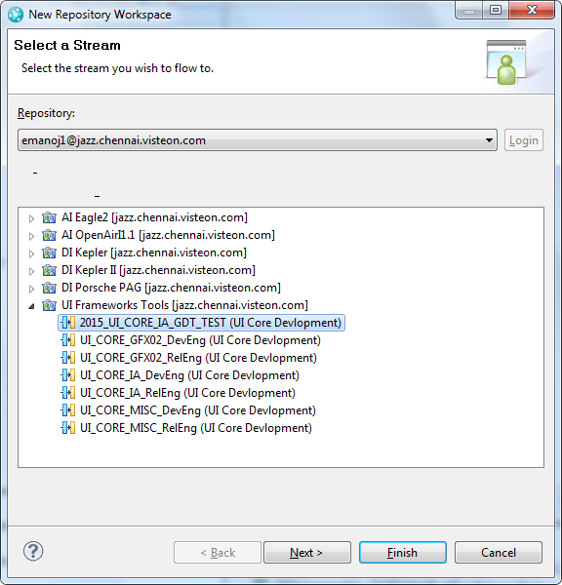
ui-core-services | switch.event.manager
ui-core | hmi.bidi.algo.01
ui-core-gdt | hmi.gfx.manager.02
ui-core-iceapple | animation.core.02
ui-core-iceapple | language.core.01
ui-core-iceapple | menu.core.01
ui-core-iceapple | message.core.01
ui-core-iceapple | popup.core.02
ui-core-iceapple | view.manager.02

A complete simulation project is available in RTC and a snapshot view can be created to refer it any stage. Create a workspace from 2015_UI_CORE_IA_GDT_TEST stream, to get all the necessary components and as well any dependent files to assist in integrating ice.apple and gdt. Following sections explains how to create the default sample project and building it. Skip to section 2 for integrating & building ice.apple application from scratch

Creating workspace
Step1:- Select New repository workspace from RTC eclipse client.
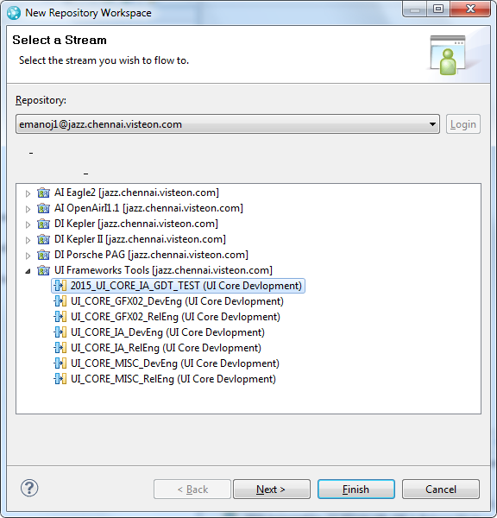

Step2:- Uncheck the Load repository workspace after creation option
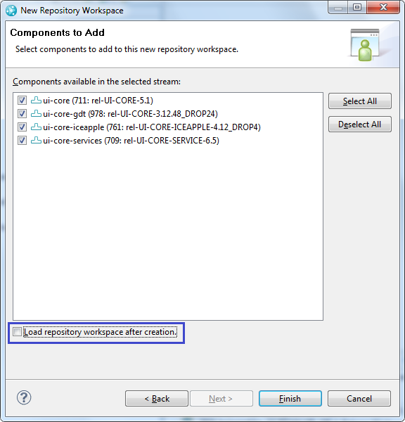

Step 3:- After the workspace is created, rightclick on it and select Load
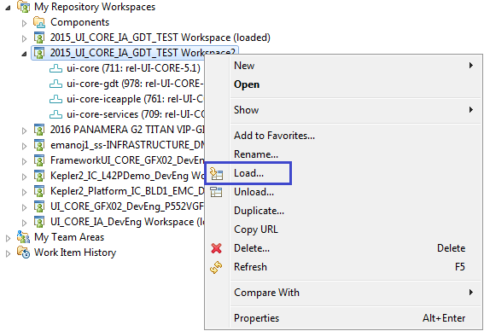

Step4 :- Select Browse components to be loaded option
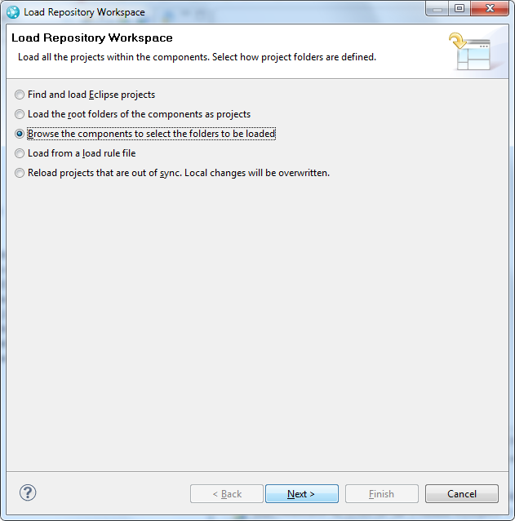

Step5:- Select only switch event manager from ui-core-services component and select the path for the Sandbox
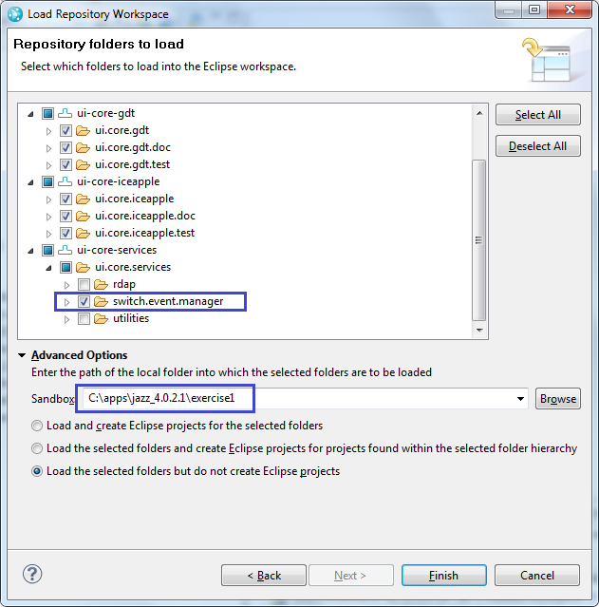

Building the sample project
After creation of the workspace, follow the steps to build & run the sample application
- Unzip the \ui.core.gdt.doc\hmi.gfx.manager.02\release \ gfx_mgr02_gdt.zip
- Run the gfx_viewer_win32.exe
- Open the \ui.core.iceapple.test\iceapple.gdt.test.fw\openvg_target\graphics\ ia_gdt_test1.xml by clicking Project->Open menu
- Click Project->Generate All
- After the code generation complete dialog, open the VC++ solution from \ui.core.iceapple.test\iceapple.gdt.test.fw\openvg_target\make folder
- Two solutions are provided, one for VC 2008 and another for VC 2013 versions
- Build the solution and run the application
- If you see libAmanithVG.dll missing issue, copy the \ui.core.iceapple.test\iceapple.gdt.test.fw\openvg_target\make \libAmanithVG.dll to C:\Windows\system folder
- After the application runs, two windows will be opened
  - A console
  - And a GDT simulation window
- After selecting console window to bring it to focus, press button ‘p’ on keyboard to see the first screen on simulated screen

Exercise1 (OpenVG target)

In the first exercise, following components will be integrated we will integrate to achieve some basic screen control.
- switch.event.manager
- hmi.bidi.algo.01
- hmi.gfx.manager.02
- animation.core.02
- language.core.01
- view.manager.02
After this exercise, menu.core.01, popup.core.02 and message.core.01 will be integrated to achieve some complex control behaviors. Create a folder for the VC++ project. For the documentation & demo purpose, I have created an exercise1 folder under the ui.core.iceapple.test component. Below subfolder structure is as well created to keep the exercise specific files. The details will be covered in the coming sections.
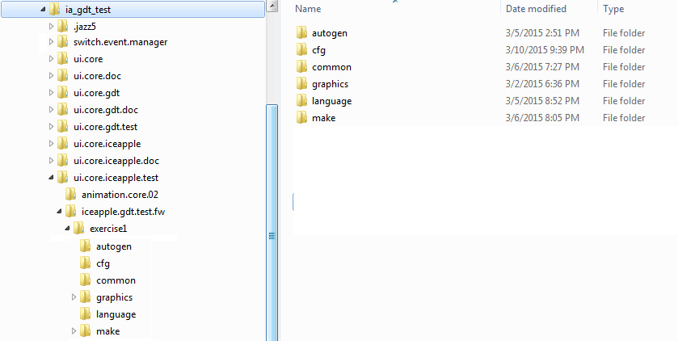

Creating a base VC++ environment
Open visual studio IDE (2008 and above) and create new project, enter the following settings in application settings window and click Finish button.
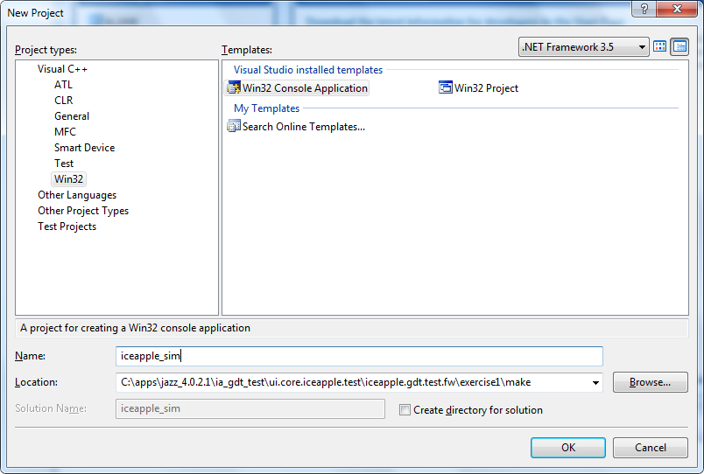 >> 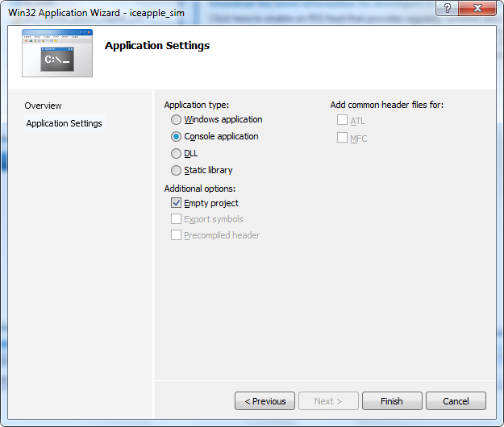
Currently the project is created under the “exercise1\make” folder.
After the project is created, open the project settings dialog and add the CWR_MPC5645S macro to preprocessor definitions and then click Apply followed by OK
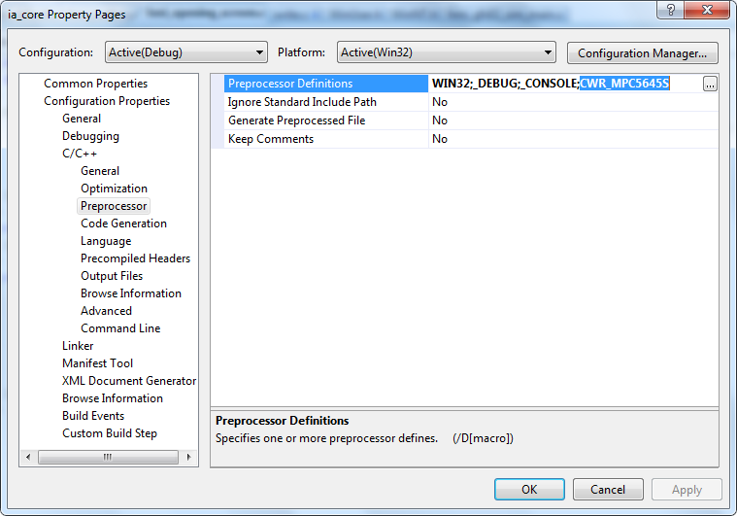
Create common\hmi_gfx02_sim_main.c and implement the “main” function and add it to the project

Create the necessary configuration files

Now create a exercise1\cfg folder and copy the following template $cfg files in to it and rename all the files by removing the $ to create project specific configuration files
\switch.event.manager\src\dm_swch.$cfg
\ui.core.iceapple\language.core.01\src\hmi_language_01.$cfg
\ui.core.iceapple\view.manager.02\src\hmi_logic_state_handler.$cfg
\ui.core.iceapple\animation.core.02\src\hmi_gfx_anim_engine.$cfg
\ui.core.gdt\hmi.gfx.manager.02\cfg\hmi_gfx_mgr02_font.$cfg
\ui.core.gdt\hmi.gfx.manager.02\cfg\hmi_gfx_mgr02_clut_table.$cfg
\ui.core.gdt\hmi.gfx.manager.02\cfg\hmi_gfx_mgr02.$cfg
\ui.core.gdt.test\hmi.gfx.manager.02\test.harness\dcu_win32\hmi_gfx_dcu_sim_w32.$cfg

Configuring the switch event manager
Switch event manager is used to define the available push button switches and define what events are needed to be generated from those buttons. Switch event manager can support the following event generation
- Press
- Held (multiple held events based on duration of press)
  - E.g Short Held & Long Held
- Release (multiple release events based on duration of press)
  - E.g. Short release & Long release
- Repeat (multiple repeat events based on duration of press)
  - E.g Repeat @ 250msec, repeat at 500mSec etc

See the below example timing chart to see how the events are generated
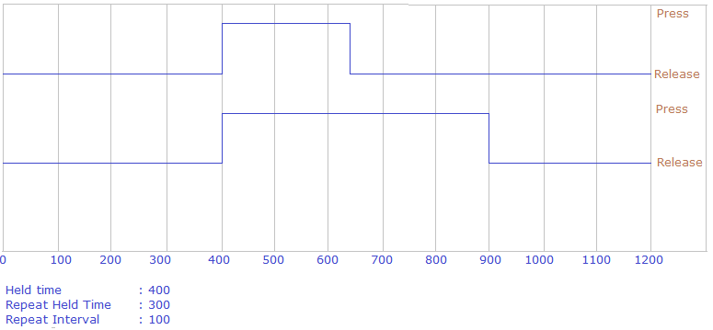
5
2
1
6
4
3
7
1
1, 3 : Press Event
2, 7 : Release event
4 : Repeat event 1
5 : Held Event
6 : Repeat event 2

In order to use the switch event manager, the available buttons and events needs to be defined (done in hmi_button.h), a button event table needs to be created (done in hmi_button.c). Create a folder exercise1\common and create hmi_button.c and .h files
- dm_swch.cfg :- contains configuration information to handle the buttons and button events. One of the important configurations here is to pass the button events to view manager component. This is done by settings REPORT_SWITCH_EVENT(x) macro to hmi_lsh_post_button_event((x >> 8), x). Now whenever a button event is detected by switch event manager, it will be delivered to view manager
- hmi_button.h :- contains the button and button event definitions. For this exercise, 6 buttons are defined POWER, UP, DOWN, LEFT, RIGHT and ENTER. Following events are also defined which the button can emit.
RELEASE – button is released after a press
PRESS – button is pressed
HELD - button is pressed for 2 Seconds
REPEAT - button is pressed for 200mSec and the event is generated every 200mSec
- hmi_button.c :- contains the button event configuration table dm_switch_array[] and associated supporting functions
Both hmi_button.c/.h are application specific files, file naming, button names, button event names and implementation is left to the application’s choice.
In order to initialize the switch event manager dm_switch_reset() shall be called when you start your application.
To perform the periodic button sensing and event generation dm_switch_check_for_events() shall be scheduled every 16mSec
Note :- Refer \ui.core.iceapple.test\iceapple.gdt.test.fw\openvg_target\common\hmi_button.c for sample implementation

Configuring the language
Create a folder exercise1\language and then copy the template language definition language_transtable_template.xls sheet from \ui.core.iceapple.doc\language.core.01\design. Open the xls sheet and add two SID (string identifiers) for our exercise inside the “general” sheet.
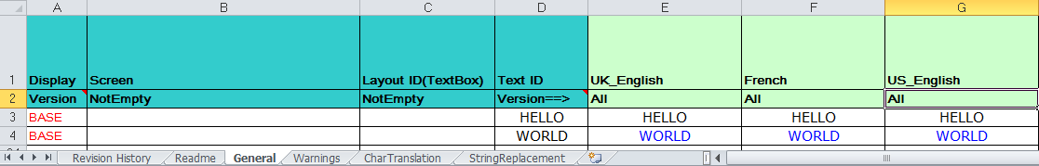
Now run the \ui.core.iceapple.doc\language.core.01\language_encoder_tool\ LanguageEncoder.exe and click “New Configuration” on startup
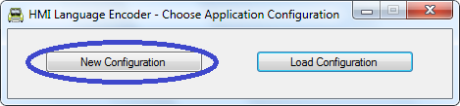

Now make the necessary settings such as project name, prefix for SID, and select Unicode etc. Now click the browse button right to the “Input File” to choose the language SID table xls sheet that we created.
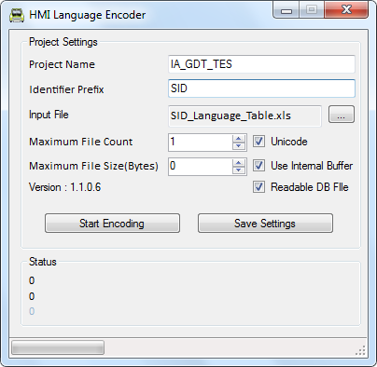
After the settings are made click the save settings button to save the configuration on to the exercise1\language folder. After that click on Start Encoding button to generate the language database files. Three files will be generated inside the language folder
hmi_language_identifiers.h – contains the SID definitions for application usage
hmi_language_1.c – Contains the language database tables
hmi_language_gen.txt – contains information about the code generation
In order to initialize language core invoke hmi_language_initialize() during startup.

Configuring the View manager
View manager needs three configuration files,
- hmi_logic_state_handler.cfg
- hmi_logic_state_handler.dat
- hmi_logic_state_handler.inc

Out of these hmi_logic_state_handler.dat and hmi_logic_state_handler.inc need not be created manually since we have a provision in GDT to generate the same. So we just have to configure the hmi_logic_state_handler.cfg in this exercise.
Now the main configuration is to tell the view manager about the button events. For that we have to include the hmi_button.h we created initially which contains all definitions related to button identifiers and the events
#include "hmi_button.h"
Now map LSH_BUTTON_INACTIVE_STATE to the button event that indicates a released state. In the hmi_button.h file, BTN_EV_RELEASE enumeration indicate a release event for a button, so map that here.
#define LSH_BUTTON_INACTIVE_STATE (BTN_EV_RELEASE)
Now we have to tell view manager on how many button event slots we need to have. Rule is to reserve a slot for every group of button that can be simultaneously generated. Here we are assuming all the 6 button events can be generated simultaneously, so we are reserving 6 slots.
#define LSH_NUMBER_OF_BUTTON_SLOTS (6)
#define LSH_BUTTON_ID_SLOT_CONFIG_LIST \
{BTN_ID_POWER, BTN_ID_POWER }, \
{BTN_ID_UP, BTN_ID_RT }, \
{BTN_ID_UP, BTN_ID_RT }, \
{BTN_ID_UP, BTN_ID_RT }, \
{BTN_ID_UP, BTN_ID_RT }, \
{BTN_ID_ENTER, BTN_ID_ENTER }
If only one button can be operated at a point, then there is no question of multiple button events happening at the same time. In that case we just have reserve a single slot.
#define LSH_NUMBER_OF_BUTTON_SLOTS (1)
#define LSH_BUTTON_ID_SLOT_CONFIG_LIST \
{BTN_ID_POWER, BTN_ID_ENTER }

Now for our exercise, we are going to assume we need 6 slots.

We can just comment out these two macros for the moment as we don’t need them for our exercise.
//#define LSH_FOCUS_STATUS_FOR_ALL_SCREEN
//#define LSH_UNFREEZE_BUTTON_EVENT_HANDLER

Create a file common .\hmi_default.c to implement default handlers for the view manager and graphics manager. #include the below to have access to view manager, graphics manager APIs and button definitions
#include <windows.h>
#include <conio.h>
#include "hmi_logic_state_handler.h"
#include "hmi_gfx_mgr02_if.h"
#include "hmi_gfx_dcu_sim_w32.h"
#include "dm_swch.h"
Implement the default button event handler for the view manager as below.
UINT8 hmi_lsh_default_button_event_handler(LSH_EVENT_HANDLER_STATUS_T * p_btn_command_id){
return(LSH_STATUS_NONE);
}
In order to initialize view manager invoke hmi_lsh_initialize(0) during program startup.
main(){
hmi_lsh_initialize(0);
while(1){
}
}

Configuring the GDT/Graphics Manager

hmi_gfx_mgr02.cfg
Graphics manager will need to schedule the presentations to allow applications to fill in graphic properties. So it need to schedule a GFX_MGR02_IF_APP_PRESENTATION_TASK(). Currently we have mapped this to presentation task of view manager, so #include "hmi_logic_state_handler.h" to allow access to hmi_lsh_task()
#define GFX_MGR02_IF_APP_PRESENTATION_TASK() hmi_lsh_task()

For our exercise, we will be using the OpenVG target, so uncomment GFX_MGR02_ENABLE_FSL_EXTENTIONS to allow usage of some Freescale specific extensions.
#define GFX_MGR02_ENABLE_FSL_EXTENTIONS

Enable dirty area redraw by uncommenting
#define GFX_MGR02_DIRTY_REGION_REDRAW

Comment out below to prevent extra debug information
//#define GFX02_DEBUG_DAR
//#define GFX02_DEBUG_CONTEXT
//#define GFX02_DEBUG_OVG

hmi_gfx_mgr02_clut_table.cfg & hmi_gfx_mgr02_font.cfg
For these two files, no additional configurations needed for our exercise, so it can be left untouched.

In order to integrate the graphics manager, we have to implement to provide support certain callback functionality by the graphics manager and as well do the necessary initialization and task scheduling.

Initializing requirements
Invoke the hmi_gfx_mgr02_if_KSColdInit() to initialize the graphics manager state to cold reset values. Invoke the hmi_gfx_mgr02_if_start() to make graphics manager ready to process user requests. Then setup the display resolution for the simulated display and invoke the simulated display controller. See the following code sequence which needs to be invoked one time during the start of the program.

hmi_gfx_mgr02_if_KSColdInit();
hmi_gfx_mgr02_if_start();
DCU.DISP_SIZE.B.DELTA_X = 800 / 16;
DCU.DISP_SIZE.B.DELTA_Y = 480;
hmi_gfx02_dcu_sim_init(1);
DCU.DCU_MODE.B.DCU_MODE = 1;

Callback needs

hmi_gfx_mgr02_app_anim_done_cb
hmi_gfx_mgr02_app_anim_done_cb – this is the function that will be called by animation engine when an animation is completed.
void hmi_gfx_mgr02_app_anim_done_cb(UINT32 p_anim_id, UINT32 p_client_id){
switch(p_anim_id){
default:break;
}
}

hmi_gfx_mgr02_driver_vsync_isr
hmi_gfx_mgr02_driver_vsync_isr – this is the callback generated by the display controller simulation. For the Kepler target, this function is implemented internally within graphics manager. But for the OpenVG target we have to implement this function to map the framebuffer to the display controller
void hmi_gfx_mgr02_driver_vsync_isr(void)
{
int i;
void * fbp1;
for(i=0; i < GFX_MGR02_NUM_LAYERS; i++){
fbp1 = (void *)hmi_gfx_mgr02_context_swap_layer(i);
switch(lc_layer_def_S[i].pix_format){
case GFX_MGR02_PIX_FORMAT_RGB565 :
DCU.LAYER[i].CTRLDESCL4.B.BPP = GFX_MGR02_16BPP_RGB565;
break;
case GFX_MGR02_PIX_FORMAT_ARGB4444:
DCU.LAYER[i].CTRLDESCL4.B.BPP = GFX_MGR02_16BPP_ARGB4444;
break;
case GFX_MGR02_PIX_FORMAT_ARGB1555:
DCU.LAYER[i].CTRLDESCL4.B.BPP = GFX_MGR02_16BPP_ARGB1555;
break;
case GFX_MGR02_PIX_FORMAT_ARGB8888:
DCU.LAYER[i].CTRLDESCL4.B.BPP = GFX_MGR02_32BPP;
break;
default: fbp1 = 0;break; /* not supported for openvg */
}
if(fbp1 != 0){
/*
** If there is a new buffer available, program it to the display controller
*/
DCU.LAYER[i].CTRLDESCL1.B.WIDTH = lc_layer_def_S[i].area.width;
DCU.LAYER[i].CTRLDESCL1.B.HEIGHT = lc_layer_def_S[i].area.height;
DCU.LAYER[i].CTRLDESCL3.R = (UINT32)(fbp1);
DCU.LAYER[i].CTRLDESCL4.B.TILE_EN = 0;
DCU.LAYER[i].CTRLDESCL4.B.AB = 0;
DCU.LAYER[i].CTRLDESCL4.B.BB = 0;
DCU.LAYER[i].CTRLDESCL4.B.EN = 1;
}
}
}

KernelTriggerGraphicsTask
KernelTriggerGraphicsTask – this function is called by graphics manager when it needs to trigger the graphics rendering task. When this function is called the application needs to schedule the rendering task Graphics_Task() as soon as possible. Once the execution of Graphics_Task() is completed application shall also make a call to graphics manager to notify the completion of the rendering task by invoking Graphics_Task_Done().
Implement KernelTriggerGraphicsTask to start a thread.
void KernelTriggerGraphicsTask(void){
if(gt_hThread == NULL){
gt_hThread = CreateThread(
NULL, // default security attributes
0, // use default stack size
GTThreadFunction, // thread function name
NULL, // argument to thread function
0, // use default creation flags
NULL); // out - thread identifier
}
}
In the thread hander, schedule the Graphics_Task()
DWORD WINAPI GTThreadFunction( LPVOID lpParam ){
Graphics_Task();
return 0;
}
In the main thread monitor completion of the rendering thread and notify graphics manager as soon as the graphics task has finished.
if(gt_hThread != NULL){
if(WaitForSingleObject(gt_hThread, 0) == WAIT_OBJECT_0){
CloseHandle(gt_hThread);
gt_hThread = NULL;
Graphics_Task_Done();
}
}

Scheduling needs
Schedule hmi_gfx_mgr02_if_KSTimedTask() on 4msec periodicity
Schedule hmi_gfx_anim_engine_tick() on 16mSec periodicity

Configuring the GDT simulation environment
hmi_gfx_dcu_sim_w32.cfg is the windows simulation environment configuration file. Following stings has to be made in this file
Set the tick rate to 16mSec to do a 60fps refresh of the simulated display
#define HMI_SIMUL_TICK_MSEC (16)

Set the simulated display width & height
#define HMI_SIM_LCD_WIDTH (800)
#define HMI_SIM_LCD_HEIGHT (480)

Map the simulated vertical sync ISR to hmi_gfx_mgr02_driver_vsync_isr which we created in section 2.6
extern void hmi_gfx_mgr02_driver_vsync_isr(void);
#define HMI_SIM_DCU_ISR hmi_gfx_mgr02_driver_vsync_isr

Creating a GDT project
Create the folders
exercise1\graphics – to store the GDT design
exercise1\graphics\images – to store the GDT image resources
exercise1\autogen – to store the GDT generated files

In order to begin our exercise we will add a startup screen to run a rotating CAR animation in GDT. We will use series of pre-rendered CAR images with rotation angle from 0-360degrees. These images are kept inside \graphics\images\opening_animation. Follow the steps to create the GDT project

- Now unzip \ui.core.gdt.doc\hmi.gfx.manager.02\release\ gfx_mgr02_gdt.zip
- Run the GDT executable gfx_viewer_win32.exe
- After the GDT window shows up, click on Project->New menu
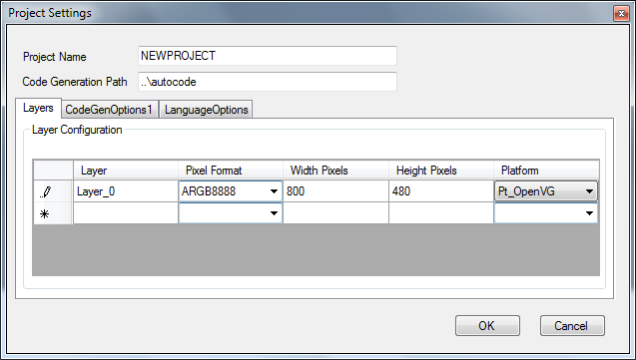
- Enter the code generation path to point to autocode folder that we have created, change the Pixel Format to ARGB8888, Width & Height pixels to 800x480 and platform – Pt_OpenVG
- Update the CodeGenOption1 tab
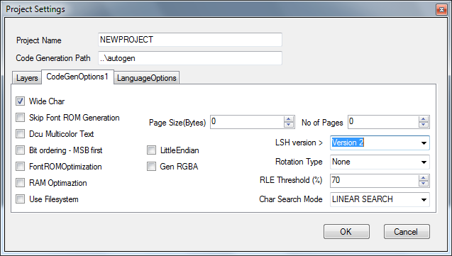
- Enable Wide Char and Change LSH version to Version 2
- Click OK
- Click OK on the Default_Font dialog
- Now click Project->Save and save the project on to exercise1\graphics folder

Adding a startup screen
Now the project is created and we can start adding a startup screen.
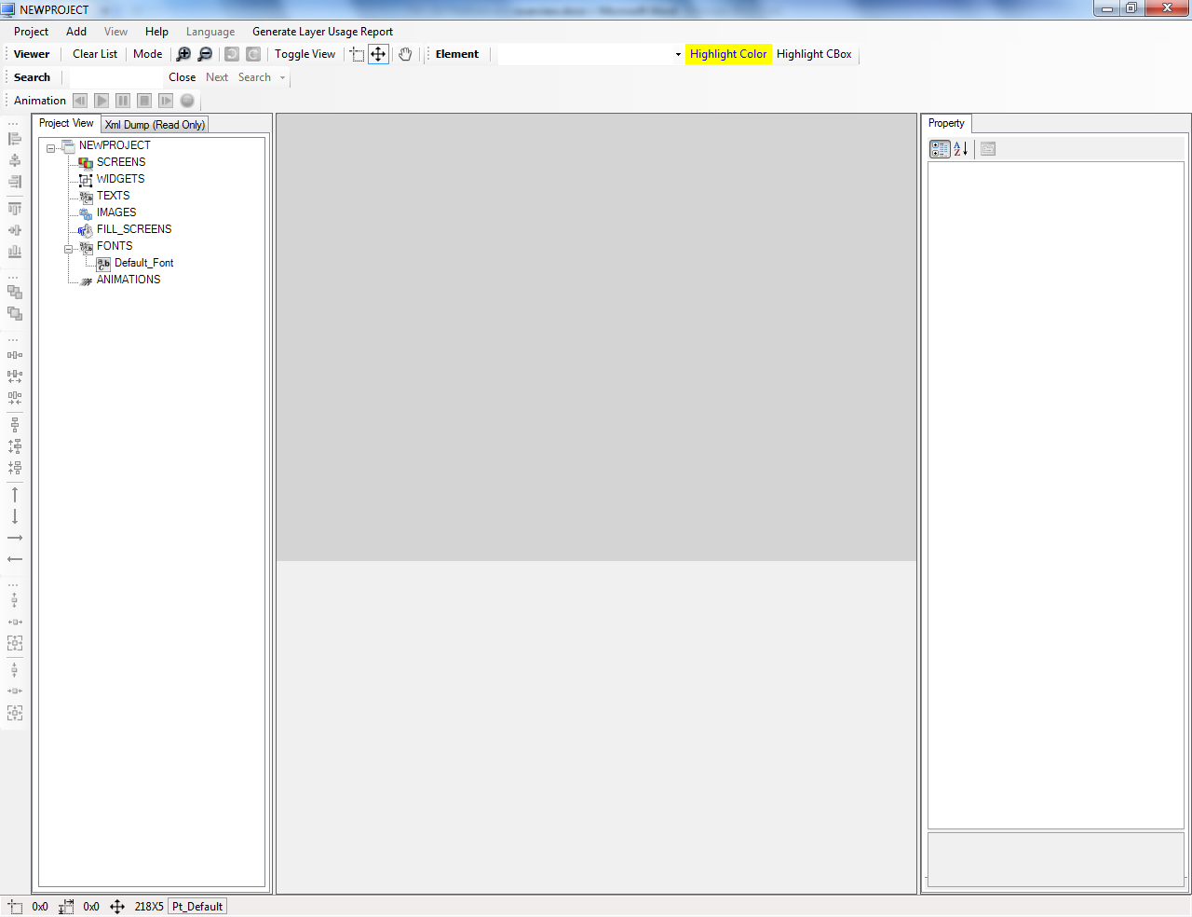
Right click on the SCREENS to add a screen for the startup screen. After adding the screen, Now click on the screen element to show up its property. Rename it as scr_startup. In the screen property enter the hander names for Event, Focus and Presentation
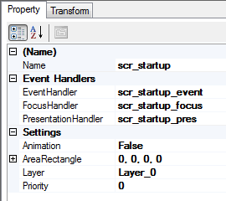
These are the function names which the view manager will be invoking for the event, focus and presentation handling for the screen. The priority for this can be kept as 0 as this is the least possible priority and will be rendered as the bottom most screen. An image element can be added to the screen now so that when we activate the screen we have something shown on display. In order to do this right click on screen and choose New->Image.
After the image element is added, click the element and rename the element as img_startup. Set the imagetype as ARGB888 and as well browse an image file for this element.
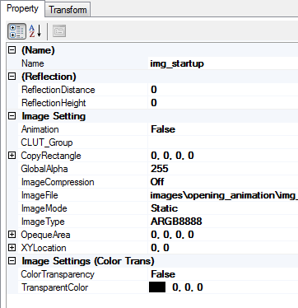
Now do a code generation by clicking Project-> Generate All. Wait for the code generation complete dialog and then you can verify the generated code inside the autogen folder. Open the hmi_gfx_mgr02_code_gen.txt from the generated folder and copy all the #include “xyz.dat” statements underneath the “Generating image ROM and CLUT files” banner
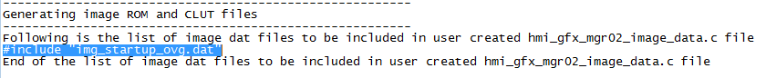

Now create a hmi_gfx02_image_data.c file under the common folder and paste the copied # includes inside it.
Note: - Whenever a new image resource is added inside GDT, hmi_gfx02_image_data.c needs to be updated to include the newly added image resource .dat file to arrest linker errors.
----------------------------- file template --------------------------
/*============================================================================
** I N C L U D E F I L E S
**==========================================================================*/
#include "system.h"
#include "hmi_gfx_mgr02_layout.h"

typedef UINT8 GFX_IMG_DATA_T;
typedef UINT16 GFX_IMG_DATA16_T;
typedef UINT32 GFX_IMG_DATA32_T;
#define GFX_IMG_DATA_PREFIX
#define GFX_IMG_DATA_SUFFIX

/*
** paste all the #include image.dat files below
*/
#include "img_startup_ovg.dat"
----------------------------- file template --------------------------

Now the next step is to implement the event, focus and presentation handler for the startup screen. We will implement this inside hmi_startup_screen.c/.h file. In order to do this open the hmi_logic_state_handler.inc generated during the GDT code generation from the \autogen folder. You can find the required prototype underneath the global function prototype banner as below
/*****************************************************************************
* Global Function Prototypes *
******************************************************************************/
/*
** Prototype definitions for all the View Manager callback functions to
** be implemented by application
*/
extern UINT8 scr_startup_event(LSH_EVENT_HANDLER_STATUS_T *p_event_hndl_status_SP);
extern void scr_startup_focus(LSH_FOCUS_HANDLER_STATUS_T *p_focus_hndl_status_SP);
extern void scr_startup_pres(LSH_PRESN_HANDLER_STATUS_T *p_presen_hndl_status_SP);
Now #include #include "hmi_logic_state_handler.h" and #include "hmi_gfx_mgr02_if.h" inside the hmi_opening_screen.c. hmi_logic_state_handler.h will provide access to all view manager API’s and as well visibility in to the above function prototypes. hmi_gfx_mgr02_if.h will provide access to graphics manager API’s.

Copy and paste the above function prototypes inside hmi_opening_screen.c and implement the function.
UINT8 scr_startup_event(LSH_EVENT_HANDLER_STATUS_T *p_event_hndl_status_SP){
return(LSH_STATUS_ABSORBED);
}
void scr_startup_focus(LSH_FOCUS_HANDLER_STATUS_T *p_focus_hndl_status_SP){
}
void scr_startup_pres(LSH_PRESN_HANDLER_STATUS_T *p_presen_hndl_status_SP){
}

Building VC++ environment
Create hmi_gfx02_sim_main.c file to implement the main entry point and other common handling and add the file to build. All of the graphics manager callback functions (section 2.6.2) can be realized in this file. Also implement a dummy main loop
int main(void){
while(1);
return 0;
}

Additional dependencies to build the project,
sched.h - \ui.core.iceapple.test\iceapple.gdt.test.fw\openvg_target\common
tmwtypes.h - \ui.core.iceapple.test\iceapple.gdt.test.fw\openvg_target\common
libAmanithVG.dll - \ui.core.iceapple.test\iceapple.gdt.test.fw\openvg_target\make
libAmanithVG.lib - \ui.core.iceapple.test\iceapple.gdt.test.fw\openvg_target\make

Copy these dependencies from the sample project \ui.core.iceapple.test\iceapple.gdt.test.fw\openvg_target to appropriate directories of your exercise before proceeding further.
Add all the source files in to the VC++ project that we have created initially.
Add following .c files
Graphics Manager:-
..\..\..\..\..\ui.core.iceapple\animation.core.02\src\hmi_gfx_anim_engine.c
..\..\..\..\..\ui.core.iceapple\animation.core.02\src\hmi_gfx_anim_vm02_if.c
..\..\..\..\..\ui.core.gdt\hmi.gfx.manager.02\src\hmi_gfx_mgr02_amber.c
..\..\..\..\..\ui.core.gdt\hmi.gfx.manager.02\src\hmi_gfx_mgr02_amber_iris.c
..\..\..\..\..\ui.core.gdt\hmi.gfx.manager.02\src\hmi_gfx_mgr02_context.c
..\..\..\..\..\ui.core.gdt\hmi.gfx.manager.02\src\hmi_gfx_mgr02_dcu.c
..\..\..\..\..\ui.core.gdt\hmi.gfx.manager.02\src\hmi_gfx_mgr02_dirty_area.c
..\..\..\..\..\ui.core.gdt\hmi.gfx.manager.02\src\hmi_gfx_mgr02_driver.c
..\..\..\..\..\ui.core.gdt\hmi.gfx.manager.02\src\hmi_gfx_mgr02_generic.c
..\..\..\..\..\ui.core.gdt\hmi.gfx.manager.02\src\hmi_gfx_mgr02_if.c
..\..\..\..\..\ui.core.gdt\hmi.gfx.manager.02\src\hmi_gfx_mgr02_if_chart.c
..\..\..\..\..\ui.core.gdt\hmi.gfx.manager.02\src\hmi_gfx_mgr02_if_model_autocode.c
..\..\..\..\..\ui.core.gdt\hmi.gfx.manager.02\src\hmi_gfx_mgr02_irislib.c
..\..\..\..\..\ui.core.gdt\hmi.gfx.manager.02\src\hmi_gfx_mgr02_layout.c
..\..\..\..\..\ui.core.gdt\hmi.gfx.manager.02\src\hmi_gfx_mgr02_mem.c
..\..\..\..\..\ui.core.gdt\hmi.gfx.manager.02\src\hmi_gfx_mgr02_ogllib.c
..\..\..\..\..\ui.core.gdt\hmi.gfx.manager.02\src\hmi_gfx_mgr02_ovglib.c
..\..\..\..\..\ui.core.gdt\hmi.gfx.manager.02\src\hmi_gfx_mgr02_perflog.c
..\..\..\..\..\ui.core.gdt\hmi.gfx.manager.02\src\hmi_gfx_mgr02_swrlib.c
..\..\..\..\..\ui.core.gdt\hmi.gfx.manager.02\src\hmi_gfx_mgr02_text.c

Ice.Apple :-
..\..\..\..\..\ui.core.iceapple\view.manager.02\src\hmi_logic_state_handler.c
..\..\..\..\..\ui.core.iceapple\view.manager.02\src\hmi_view_manager_02.c
..\..\..\..\..\ui.core.iceapple\view.manager.02\src\hmi_view_manager_02_autocode.c

SimFramework :-
..\..\..\..\..\ui.core.gdt.test\hmi.gfx.manager.02\test.harness\dcu_win32\egl.c
..\..\..\..\..\ui.core.gdt.test\hmi.gfx.manager.02\test.harness\dcu_win32\eglfsl.c
..\..\..\..\..\ui.core.gdt.test\hmi.gfx.manager.02\test.harness\dcu_win32\hmi_gfx_dcu_sim_w32.c

Gdt.Autogen.Files :-
..\..\autogen\Default_Font.c
..\..\common\hmi_gfx02_image_data.c
..\..\autogen\hmi_gfx_mgr02_clut_table.c
..\..\autogen\hmi_gfx_mgr02_font.c
..\..\autogen\hmi_gfx_mgr02_vgfont.c
..\..\language\hmi_language_1.c

Other.Services :-
..\..\..\..\..\switch.event.manager\src\dm_swch.c
..\..\..\..\..\ui.core.iceapple\language.core.01\src\hmi_language_interface.c

Exercise.Specific :-
..\..\common\hmi_button.c
..\..\common\hmi_default.c
..\..\common\hmi_opening_screen.c
We will not add the BiDi related files, as our first example doesn’t have any text to display and therefore BiDi is not needed.
Add the necessary include paths
..\..\autogen;
..\..\menu;
..\..\popup;
..\..\warning;
..\..\common;
..\..\cfg;
..\..\language;
..\..\..\..\..\ui.core.gdt\hmi.gfx.manager.02\src;
..\..\..\..\..\ui.core.gdt.test\hmi.gfx.manager.02\test.harness\dcu_win32;
..\..\..\..\..\ui.core.iceapple\language.core.01\src;
..\..\..\..\..\ui.core.iceapple\view.manager.02\src;
..\..\..\..\..\ui.core.iceapple\animation.core.02\src;
..\..\..\..\..\ui.core.gdt\hmi.gfx.manager.02\src\fsl;
..\..\..\..\..\switch.event.manager\src;
..\..\..\..\..\ui.core\hmi.bidi.algo.01\arabic.cursive.joining\src;
..\..\..\..\..\ui.core\hmi.bidi.algo.01\bidi.algorithm\src

Add the necessary library & include paths
libAmanithVG.lib

Build and run the application and you will see a console window.

Showing the startup screen
Now in order to show the startup screen, we have to write certain logic here
- Update the main() loop to perform initializations
- Schedule the periodic task requirement of components
- Implement the required callbacks
- Add the startup screen to view manager
- Update the presentation handler to send commands to GDT/Graphics manager to show up the screen
Referring section 2.2 – 2.6, implement the necessary initializations, callbacks and scheduling in to hmi_gfx02_sim_main.c and add the file to build as well.
/*============================================================================
**
** CONFIDENTIAL VISTEON CORPORATION
**
** This is an unpublished work of authorship, which contains trade secrets,
** created in 2012. Visteon Corporation owns all rights to this work and
** intends to maintain it in confidence to preserve its trade secret status.
** Visteon Corporation reserves the right, under the copyright laws of the
** United States or those of any other country that may have jurisdiction,
** to protect this work as an unpublished work, in the event of an
** inadvertent or deliberate unauthorized publication. Visteon Corporation
** also reserves its rights under all copyright laws to protect this work as
** a published work, when appropriate. Those having access to this work may
** not copy it, use it, modify it or disclose the information contained in
** it without the written authorization of Visteon Corporation.
**
**============================================================================
**
** Name: hmi_gfx02_sim_main.c
**
** Description: Implements the screen logic and presentation for opening
** screen
**
** Organization: GUI Software Section
**
**============================================================================
**
**==========================================================================*/
#define HMI_GFX02_SIM_MAIN_C

/*============================================================================
** I N C L U D E F I L E S
**==========================================================================*/
#include <windows.h>
#include "hmi_logic_state_handler.h"
#include "hmi_gfx_mgr02_if.h"
#include "hmi_gfx_mgr02_context.h"
#include "hmi_gfx_dcu_sim_w32.h"
#include "dm_swch.h"

#ifdef __cplusplus
extern "C" {
#endif
/*============================================================================
** I N T E R N A L M A C R O A N D T Y P E D E F I N I T I O N S
**==========================================================================*/
#define BASE_TICK_RATE_MS (2)

/*============================================================================
** I N T E R N A L F U N C T I O N P R O T O T Y P E S
**==========================================================================*/
static void hmi_sim_app_2ms_task(void);
static void hmi_sim_app_4ms_task(void);
static void hmi_sim_app_16ms_task(void);
static void hmi_sim_app_32ms_task(void);
extern GFX_MGR02_LAYER_DEF_T const lc_layer_def_S[GFX_MGR02_NUM_LAYERS];

/*============================================================================
** M E M O R Y A L L O C A T I O N
**==========================================================================*/
HANDLE gt_hThread;
int counter=0;

/*============================================================================
** E N T R Y P O I N T S / D A T A A C C E S S S E R V I C E S
**==========================================================================*/

/****************************************************************************
Function Name : main
Description :
Invocation :
Return Value : None
Critical Section : None
Parameters : None
******************************************************************************/
void main(void)
{
HANDLE hTimer = NULL;
LARGE_INTEGER liDueTime;
unsigned int fl_tick = 0;
MSG msg;

dm_switch_reset();
hmi_language_initialize();
hmi_gfx_mgr02_if_KSColdInit();
hmi_lsh_initialize(0);
hmi_gfx_mgr02_if_start();
DCU.DISP_SIZE.B.DELTA_X = 800 / 16;
DCU.DISP_SIZE.B.DELTA_Y = 480;
hmi_gfx02_dcu_sim_init(1);
DCU.DCU_MODE.B.DCU_MODE = 1;

liDueTime.QuadPart = (BASE_TICK_RATE_MS * -10000LL);
hTimer = CreateWaitableTimer(NULL, FALSE, NULL);
SetWaitableTimer(hTimer, &liDueTime, BASE_TICK_RATE_MS, NULL, NULL, 0);

while(1){
if (PeekMessage(&msg, NULL, 0, 0, PM_REMOVE)){
TranslateMessage(&msg);
DispatchMessage(&msg);
}
if(gt_hThread != NULL){
if(WaitForSingleObject(gt_hThread, 0) == WAIT_OBJECT_0){
CloseHandle(gt_hThread);
gt_hThread = NULL;
Graphics_Task_Done();
}
}
if (WaitForSingleObject(hTimer, 0) == WAIT_OBJECT_0){
if((fl_tick % (2/BASE_TICK_RATE_MS)) == 0)hmi_sim_app_2ms_task();
if((fl_tick % (4/BASE_TICK_RATE_MS)) == 0)hmi_sim_app_4ms_task();
if((fl_tick % (16/BASE_TICK_RATE_MS)) == 0)hmi_sim_app_16ms_task();
if((fl_tick % (32/BASE_TICK_RATE_MS)) == 0)hmi_sim_app_32ms_task();
fl_tick++;
#if (BASE_TICK_RATE_MS/2) > 0
Sleep(BASE_TICK_RATE_MS/2);
#endif
}
}
}

/****************************************************************************
Function Name : GTThreadFunction
Description : thread to handle the graphics rendering task
Invocation :
Return Value : None
Critical Section : None
Parameters : None
******************************************************************************/
DWORD WINAPI GTThreadFunction( LPVOID lpParam ){
Graphics_Task();
return 0;
}

/****************************************************************************
Function Name : KernelTriggerGraphicsTask
Description : triggers the graphics rendering task
Invocation : By graphics manager
Return Value : None
Critical Section : None
Parameters : None
******************************************************************************/
void KernelTriggerGraphicsTask(void){
if(gt_hThread == NULL){
gt_hThread = CreateThread(
NULL, // default security attributes
0, // use default stack size
GTThreadFunction, // thread function name
NULL, // argument to thread function
0, // use default creation flags
NULL); // out - thread identifier
}
}

/****************************************************************************
Function Name : KernelTriggerGraphicsTask
Description : Configures the layers with updated frame buffer based
on availability
Invocation : By hmi_gfx_dcu_sim_w32.c display controller
Return Value : None
Critical Section : None
Parameters : None
******************************************************************************/
void hmi_gfx_mgr02_driver_vsync_isr(void)
{
int i;
void * fbp1;
for(i=0; i < GFX_MGR02_NUM_LAYERS; i++){
fbp1 = (void *)hmi_gfx_mgr02_context_swap_layer(i);
switch(lc_layer_def_S[i].pix_format){
case GFX_MGR02_PIX_FORMAT_RGB565 :DCU.LAYER[i].CTRLDESCL4.B.BPP = GFX_MGR02_16BPP_RGB565;break;
case GFX_MGR02_PIX_FORMAT_ARGB4444:DCU.LAYER[i].CTRLDESCL4.B.BPP = GFX_MGR02_16BPP_ARGB4444;break;
case GFX_MGR02_PIX_FORMAT_ARGB1555:DCU.LAYER[i].CTRLDESCL4.B.BPP = GFX_MGR02_16BPP_ARGB1555;break;
case GFX_MGR02_PIX_FORMAT_ARGB8888:DCU.LAYER[i].CTRLDESCL4.B.BPP = GFX_MGR02_32BPP;break;
default: fbp1 = 0;break; /* not supported for openvg */
}
if(fbp1 != 0)
{
/*
** If there is a new buffer available, program it to the display controller
*/
DCU.LAYER[i].CTRLDESCL1.B.WIDTH = lc_layer_def_S[i].area.width;
DCU.LAYER[i].CTRLDESCL1.B.HEIGHT = lc_layer_def_S[i].area.height;
DCU.LAYER[i].CTRLDESCL3.R = (UINT32)(fbp1);
DCU.LAYER[i].CTRLDESCL4.B.TILE_EN = 0;
DCU.LAYER[i].CTRLDESCL4.B.AB = 0;
DCU.LAYER[i].CTRLDESCL4.B.BB = 0;
DCU.LAYER[i].CTRLDESCL4.B.EN = 1;
}
}
}

/****************************************************************************
Function Name : hmi_sim_app_2ms_task
Description : 2mSec task entry point
Invocation : invoked by hmi_gfx02_sim_main.c
Return Value : None
Critical Section : None
Parameters : None
******************************************************************************/
static void hmi_sim_app_2ms_task(void){
}

/****************************************************************************
Function Name : hmi_sim_app_4ms_task
Description : 4mSec task entry point
Invocation : invoked by hmi_gfx02_sim_main.c
Return Value : None
Critical Section : None
Parameters : None
******************************************************************************/
static void hmi_sim_app_4ms_task(void){
hmi_gfx_mgr02_if_KSTimedTask();
}

/****************************************************************************
Function Name : hmi_sim_app_16ms_task
Description : 16mSec task entry point
Invocation : invoked by hmi_gfx02_sim_main.c
Return Value : None
Critical Section : None
Parameters : None
******************************************************************************/
static void hmi_sim_app_16ms_task(void){
dm_switch_check_for_events();
#if GFX_NUM_ANIMATIONS > 0
hmi_gfx_anim_engine_tick();
#endif
}

/****************************************************************************
Function Name : hmi_sim_app_32ms_task
Description : 32mSec task entry point
Invocation : invoked by hmi_gfx02_sim_main.c
Return Value : None
Critical Section : None
Parameters : None
******************************************************************************/
static void hmi_sim_app_32ms_task(void){
}

/*============================================================================
**
**============================================================================
** C M S R E V I S I O N N O T E S
**============================================================================
**
** For each change to this file, be sure to record:
** 1. Who made the change and when the change was made.
** 2. Why the change was made and the intended result.
**
** CMS Rev # Date By
** CMS Rev X.X mm/dd/yy CDSID
**
**============================================================================
**
** CMS Rev 1.0 09-Mar-2015 EMANOJ1
** Creation.
**==========================================================================*/
#ifdef __cplusplus
}
#endif

In order to show up the startup screen, API to be used is LSH_ADD_STATE(state_id, anim_id)

state_id – The ID of the screen generated by GDT as GFX_<screen name in caps> . This can be found inside \autogen\hmi_gfx_mgr02_cfg.h file under the enum type GFX_MGR02_SCR_ELEM_ID.
anim_id - The ID of the animation to be played for the passed state_id. This can be ANIM_MAX_ID since we donot want any animation to be played.

LSH_ADD_STATE(GFX_SCR_STARTUP, ANIM_MAX_ID);
Modify the hmi_lsh_default_button_event_handler() to listen to POWER button press and add the startup screen.
UINT8 hmi_lsh_default_button_event_handler(LSH_EVENT_HANDLER_STATUS_T * p_btn_command_id){
if(p_btn_command_id->button_command == LSH_GET_COMMAND(BTN_ID_POWER, BTN_EV_PRESS)){
LSH_ADD_STATE(GFX_SCR_STARTUP, ANIM_MAX_ID);
}
return(LSH_STATUS_NONE);
}

Modify the startup screen presentation to send command to GDT to show up the screen
void scr_startup_pres(LSH_PRESN_HANDLER_STATUS_T *p_presen_hndl_status_SP){
if(p_presen_hndl_status_SP->presentation_status == LSH_ACTIVATED_STATUS){
hmi_gfx_mgr02_if_set_screen(p_presen_hndl_status_SP->logic_state_id, 1);
}
else if(p_presen_hndl_status_SP->presentation_status == LSH_REFRESH_STATUS){
}
else{ /* LSH_DEACTIVATED_STATUS */
hmi_gfx_mgr02_if_set_screen(p_presen_hndl_status_SP->logic_state_id, 0);
}
}

Now build the project again, and run. Two windows will be opened (GDT sim window & a console window). Now bring console window to focus and press keyboard button ‘p’. You should see the startup screen show up.

Exercise 2 - Opening Screen with animation

Inorder to show a screen with animation, LSH_ADD_STATE(state_id, anim_id) api has to be called with a valid anim_id - The ID of the animation to be played for the passed state_id.

Since GDT is used for this exercise, to create an animation, right click on the SCREENS to add a screen for the opening animation. After adding the screen, Now click on the screen element to show up its property. Rename it as scr_opening_anim. The ID that will be generated for this screen during code generation is GFX_SCR_OPENING_ANIM. Now this ID will be used later in our exercise to interact with the view manager.

In the screen property enter the hander names for Event, Focus and Presentation.
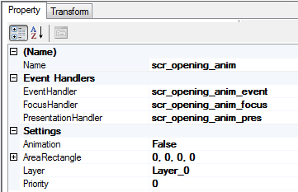
The priority for this can be kept as 0 as this is the least possible priority and will be rendered as the bottom most screen.

Now the next step is to add the rotating car image resources in to GDT. In order to add all the images at once, click on the Add->Images
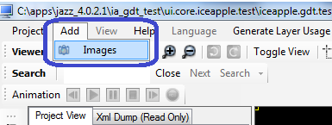

This will open an image browse window. Go the folder where the images are located and select all the images. Then press “Open” button
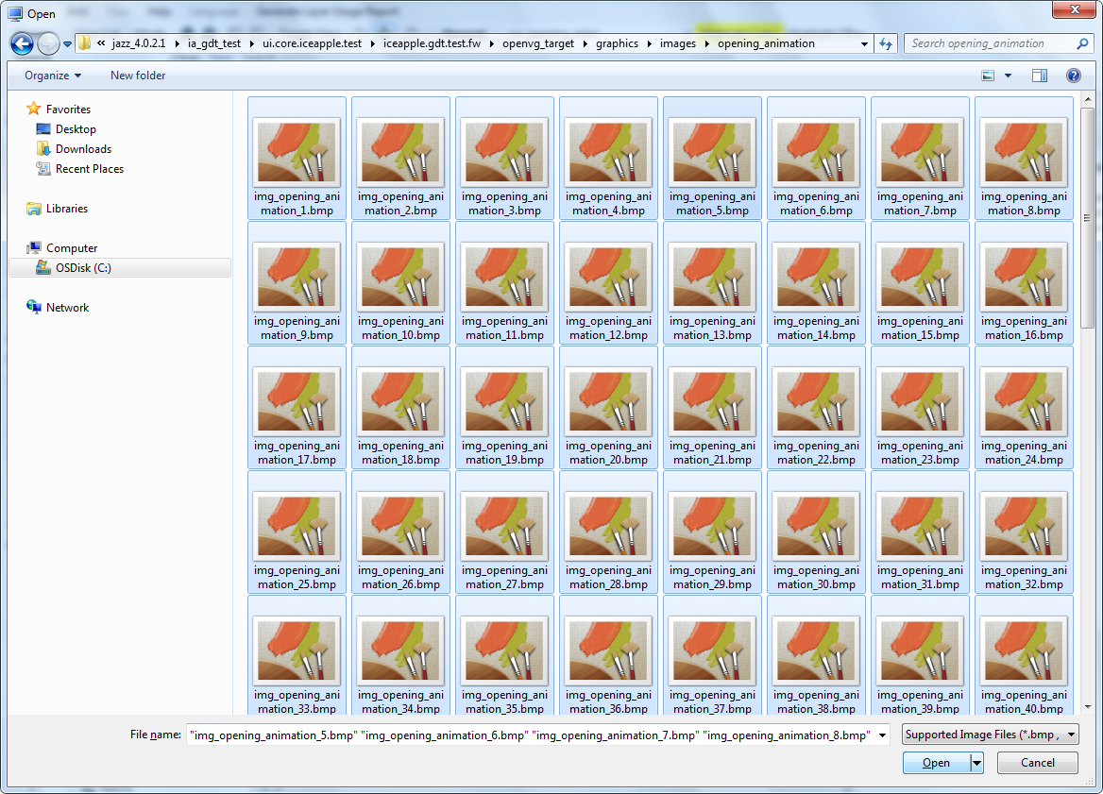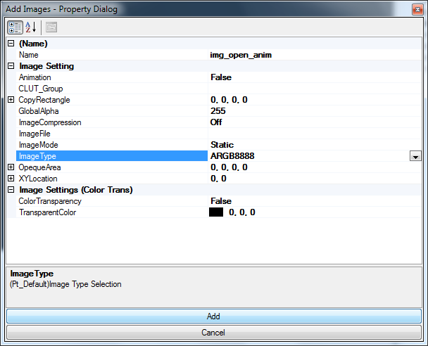

In the property dialog, modify the Name to img_open_anim and ImageType to ARGB8888, then click Add button. Now all the images will be added to GDT and can be seen under the IMAGES group in the project treeview.
Now right click on the scr_opening_anim and Add an image.
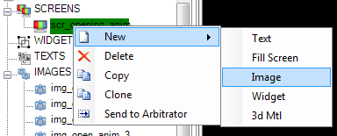

Click on the newly created image and rename it as dimg_opening_anim and change the ImageMode to Dynamic. This will make the image in to a selection group.
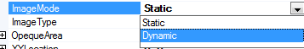

Now from the treeview, IMAGES group – select the first img_opening_anim image. Press and hold the shift button and scroll down the treeview and select the last image img_opening_anim_xx. This will select all the xx images. Now rightclick and choose copy from the context menu. Now move the mouse pointer over the dimg_opening_anim element and right click. From the context menu select paste. This will paste all the xx images on to the image selection group dimg_opening_anim.
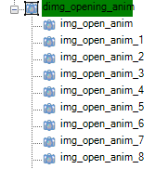

Now the next step is to create an animation to cycle through the image selection group from 0 to xx, i.e. change the selection index of dimg_opening_anim from 0 to xx to simulate the rotating CAR effect. In order to do this, right click on the ANIMATIONS group and add a new animation. Rename the created animation as open_anim.
Right click on the open_anim and then add a new animation frame. Right click on the new frame and then add a data animation.
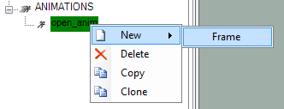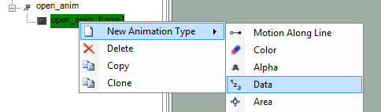
Click the data animation and edit its property for our needs. Enter the start data as 0 and end data as xx since we wanted to change the index from 0 to xx. Now enter the duration of the animation, here we set it as 1Sec (1000mSec). Also set the required fps at which the animation to be played, here we have set 60fps.
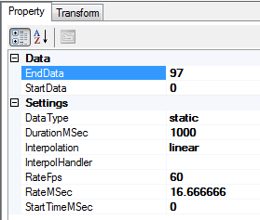
Now drag and drop the dimg_opening_anim inside the data anim object. Now click on the New_data_1 and click the animation play button on the top menu bar to test the animation.
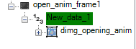

Now we can do a code generation by clicking Project-> Generate All. Wait for the code generation complete dialog and then you can verify the generated code inside the autogen folder. Open the hmi_gfx_mgr02_code_gen.txt from the generated folder and copy all the #include “xyz.dat” statements underneath the “Generating image ROM and CLUT files” banner and update the hmi_gfx02_image_data.c
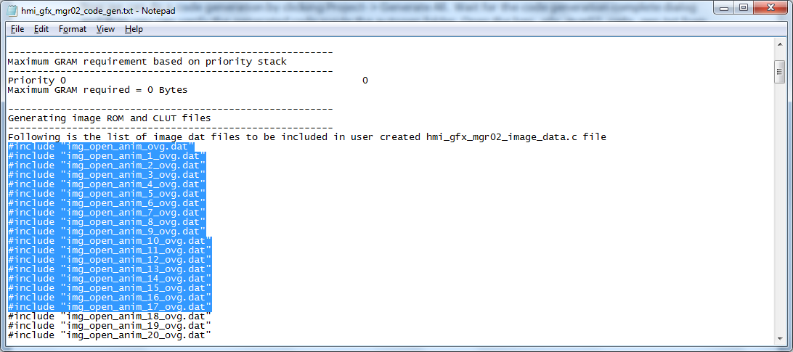

Now the next step is to implement the event, focus and presentation handler for the opening animation screen. We will implement this inside hmi_opening_screen.c/.h file. In order to do this open the hmi_logic_state_handler.inc generated during the GDT code generation from the \autogen folder. You can find the required prototype underneath the global function prototype banner as below
/*****************************************************************************
* Global Function Prototypes *
******************************************************************************/
/*
** Prototype definitions for all the View Manager callback functions to
** be implemented by application
*/
extern UINT8 scr_opening_anim_event(LSH_EVENT_HANDLER_STATUS_T *p_event_hndl_status_SP);
extern void scr_opening_anim_focus(LSH_FOCUS_HANDLER_STATUS_T *p_focus_hndl_status_SP);
extern void scr_opening_anim_pres(LSH_PRESN_HANDLER_STATUS_T *p_presen_hndl_status_SP);
Now #include "hmi_logic_state_handler.h" and #include "hmi_gfx_mgr02_if.h" inside the hmi_opening_screen.c. hmi_logic_state_handler.h will provide access to all view manager API’s and as well visibility in to the above function prototypes. hmi_gfx_mgr02_if.h will provide access to graphics manager API’s.

Copy and paste the above function prototypes inside hmi_opening_screen.c and implement the function.
UINT8 scr_opening_anim_event(LSH_EVENT_HANDLER_STATUS_T *p_event_hndl_status_SP){
return(LSH_STATUS_ABSORBED);
}
void scr_opening_anim_focus(LSH_FOCUS_HANDLER_STATUS_T *p_focus_hndl_status_SP){
}
void scr_opening_anim_pres(LSH_PRESN_HANDLER_STATUS_T *p_presen_hndl_status_SP){
if(p_presen_hndl_status_SP->presentation_status == LSH_ACTIVATED_STATUS){
hmi_gfx_mgr02_if_set_screen(p_presen_hndl_status_SP->logic_state_id, 1);
}
else if(p_presen_hndl_status_SP->presentation_status == LSH_REFRESH_STATUS){
}
else{ /* LSH_DEACTIVATED_STATUS */
hmi_gfx_mgr02_if_set_screen(p_presen_hndl_status_SP->logic_state_id, 0);
}
}

The anim_id is generated by GDT as GFX_<anim name in caps>. This can be found inside \autogen\hmi_gfx_anim_engine_cfg.h. And to activate the screen with animation, invoke

LSH_ADD_STATE(GFX_SCR_OPENING_ANIM, GFX_OPEN_ANIM);

In order to activate this on the Power button press, we can modify the hmi_lsh_default_button_event_handler(). hmi_lsh_default_button_event_handler will be invoked by the view manager when no other screens hanles the buttons. Right now there are no screens active in view manager, so all the button presses should be coming to this function.
UINT8 hmi_lsh_default_button_event_handler(LSH_EVENT_HANDLER_STATUS_T * p_btn_command_id){
if(p_btn_command_id->button_command == LSH_GET_COMMAND(BTN_ID_POWER, BTN_EV_PRESS)){
LSH_ADD_STATE(GFX_SCR_OPENING_ANIM, GFX_OPEN_ANIM);
}
return(LSH_STATUS_NONE);
}

Build and run the application and press p button..

