Exercise3

In this exercise we will integrate menu.core.01 to achieve some complex control behaviors. For this example, we will create a sample menu with four lines for text, icons and show the arrow in case of submenu. Follow the below details to configure the menu.

Create the configuration file
Copy the \ui.core.iceapple\menu.core.01\src\hmi_menu_core_01.$cfg
file in to exercise1\cfg and rename the file by removing the $ to create project specific configuration file
Refer the sample configuration used for this exercise in the following path
ui.core.iceapple.test\iceapple.gdt.test.fw\openvg_target\cfg\hmi_menu_core_01.cfg

Configuring the language sheet
We need to configure the Language sheet to add the menu text dynamically. Open the SID_Language_Table.xls sheet and add below SID (string identifiers) for our exercise inside the “general” sheet.

Display | Screen | Layout ID  (TextBox) | Text ID | UK_English | French | US_English
Version | NotEmpty | NotEmpty | Version==> | All | All | All
BASE |  |  | TxtID_1_13 | Menu | Menu | Menu
BASE |  |  | TxtID_1_14 | Root | Root | Ford Radio
BASE |  |  | TxtID_1_303 | Audio settings | Réglages audio | Audio Settings
BASE |  |  | TxtID_1_309 | Vehicle settings | Réglages véhicule | Vehicle Settings
BASE |  |  | TxtID_1_324 | Ambient light | Lum. ambiante | Ambient Light
BASE |  |  | TxtID_1_920 | Deflation detect | Contr. pr. pneus | Deflation Detect
BASE |  |  | TxtID_1_1024 | ESC | ESC | AdvanceTrac
BASE |  |  | TxtID_1_1038 | Park lock control | Ctrl park lock | Park Lock Ctrl
BASE |  |  | TxtID_1_1052 | SYNC-Media | SYNC-Média | SYNC-Media
BASE |  |  | TxtID_1_1053 | SYNC-Phone | SYNC-Téléphone | SYNC-Phone
BASE |  |  | TxtID_1_1121 | Alarm system | Alarme | Alarm System
BASE |  |  | TxtID_1_1461 | Tyre monitor | Surv. pr. pneus | Tyre monitor
BASE |  |  | TxtID_1_Blank
Now run the \ui.core.iceapple.doc\language.core.01\language_encoder_tool\ LanguageEncoder.exe and click “Load Configuration”
Open the configuration (.cfg) in exercise1\language.
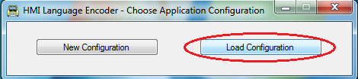
After that click on Start Encoding button to generate the language database files.
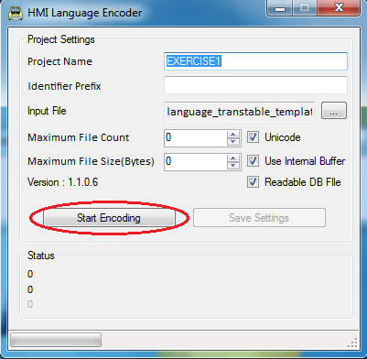
The following files will be generated inside the language folder
hmi_language_identifiers.h – Contains the SID definitions for application usage
hmi_language_1.c – Contains the language database tables
hmi_language_gen.txt – Contains information about the code generation

Configuring GDT
Now we need to add a screen in GDT to display the menu. Follow the below steps to add a screen for menu configuration
Create the following folder ‘exercise1\graphics\images\menu’ to store the GDT menu image resources. We have put some sample images for this menu configuration.
- Run the GDT executable gfx_viewer_win32.exe.
- Right click on the SCREENS to add a screen for the menu screen. After adding the screen, now click on the screen element to show up its property. Rename it as scr_ menu. In the screen property enter the hander names for Event, Focus and Presentation
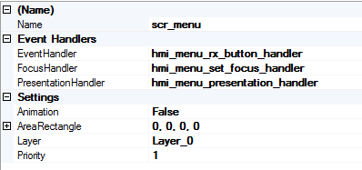
These functions are invoked from the view manager for the event, focus and presentation handling for the screen. Here we are providing the default handlers for menu. These functions are defined in menu core
- Right click on the screen and add a fill screen element and rename it as fill_bg_blue and update the properties as below
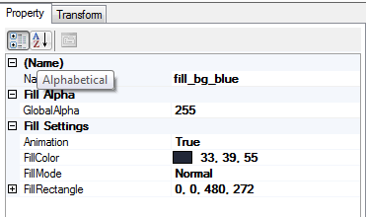
- Add an image by right clicking on the screen and rename it as img_menu_bg. Select the image file from ‘images\menu\g#253.svg’. And set the image format as ‘RGB565’ and set the location as ‘32, 58’.
- Add a widget and rename it as wdg_menu and set the following properties
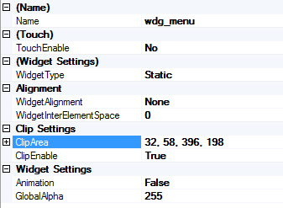
- Add the following elements in ‘wdg_menu’ and set the properties as described in the screenshot. These elements should be placed in the same order
  - Add image and rename it as img_menu_focus_bg
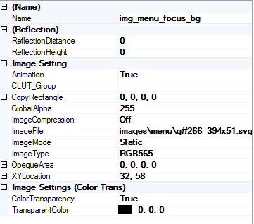
  - Add text elements with the following names and update the location as described below. These elements are used to show the name of menu items in the screen. Text for the menu will be updated dynamically by using SID
Text Element Name | Width Pixels | Num Chars | Animation | Draw Point
txt_menu_vc_c1 | 302 | 30 | True | 78, 70
txt_menu_vc_c2 | 302 | 30 | True | 78, 119
txt_menu_vc_c3 | 302 | 30 | True | 78, 168
txt_menu_vc_c4 | 302 | 30 | True | 78, 217
txt_menu_vc_c5 | 302 | 30 | True | 78, 262
txt_menu_vc_c6 | 302 | 30 | True | 78, 12

  - Next we need to add the icons for the menu items. To achieve this, do the following steps
    - Add a dynamic imge and rename it as ‘img_vc_menu_g1’. To add a dynamic image, change the ‘ImageMode’ property to ‘Dynamic’.
    - Add the following image elements
Image Element Name | Width Pixels | Image Type | XY Location
img_menu_media | images\menu\img_menu_media.png | 8BPP Alpha Mask | 32, 61
img_menu_phone | images\menu\img_menu_phone.png | 8BPP Alpha Mask | 32, 110
img_menu_settings | images\menu\img_menu_settings.png | 8BPP Alpha Mask | 32, 160

    - Do the same procedure to add the following image elements.
      - img_vc_menu_g2
      - img_vc_menu_g3
      - img_vc_menu_g4
      - img_vc_menu_g5
      - img_vc_menu_g6
  - Next step to add the images for displaying arrow for sub menu. For that we need to add the following dynamic images
    - img_arrow_menu_a1
    - img_arrow_menu_a2
    - img_arrow_menu_a3
    - img_arrow_menu_a4
    - img_arrow_menu_a5
    - img_arrow_menu_a6
  - Right click on the dynamic images and add image element and rename it as ‘img_menu_arrow’. Locate the image file to ‘images\menu\img_menu_arrow.png’. Do the same for all the images which we added now
  - Set the location as
    - img_arrow_menu_a1 - 398, 61
    - img_arrow_menu_a2 - 398, 110
    - img_arrow_menu_a3 - 398, 159
    - img_arrow_menu_a4 - 398, 208
    - img_arrow_menu_a5 - 398, 257
    - img_arrow_menu_a6 - 398, 12
- Next we will add the image for focus bar selection. Add new image element and rename it as ’ img_menu_focus’. Set the image properties as follows
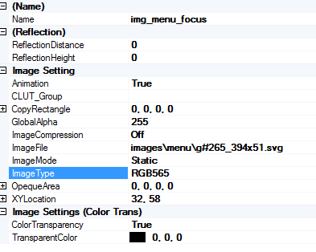
- Next we will add the header for the screen. This is to display the time and current screen information. To do this, add the below elements and set the properties as given below
  - Fill Screen element fill_m08n_2_title_clear
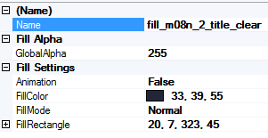
  - Text element to display header label
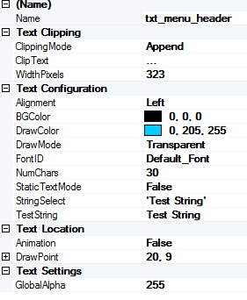
  - Text element to display the time
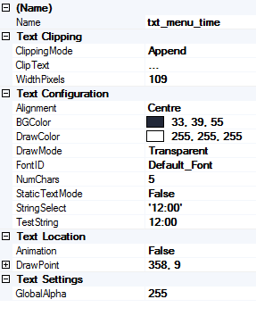
Now we have designed menu screen in GDT.

Configuring Menu Configurator
- Create a folder exercise1\menu.
- Now run MenuConfigurator executable from the following path \ui.core.iceapple.doc\menu.core.01\menu_configurator_tool\MenuConfigurator.exe.
- Click on Project->New to create new configuration.
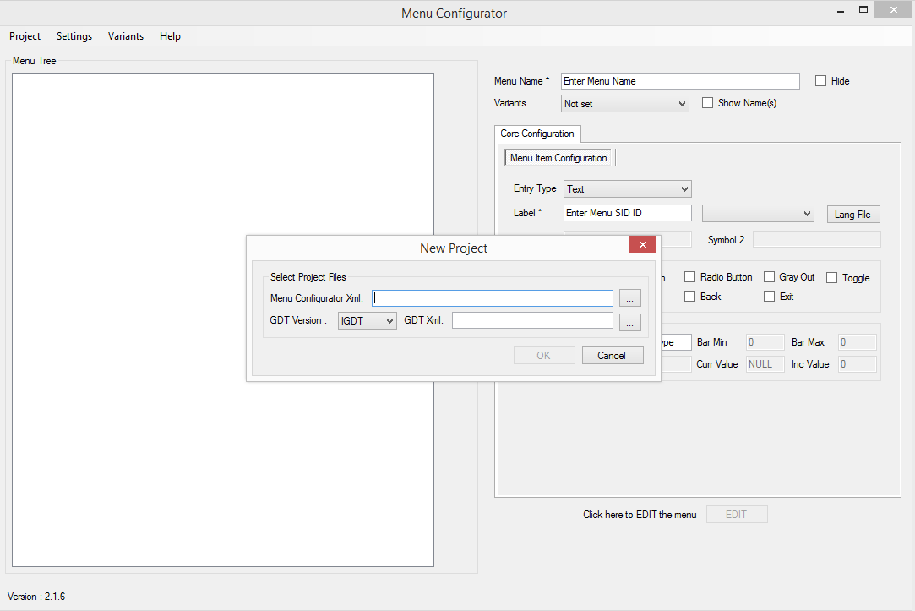
- Click on the browse button, locate the exercise1\menu folder and give the menu configuration xml to save it
- Select the GDT xml from the exercise1\graphics folder and then select OK. GDT xml file is used to validate the screens and its priorities.
- New project will be created with default settings.

Application Configuration

After creating new project, we need to configure the application specific settings. To do that, click on Settings->Properties menu.
Give unique timer id for ‘Menu Open Timer ID’ and ‘Menu Wait Timer ID’ as shown below.
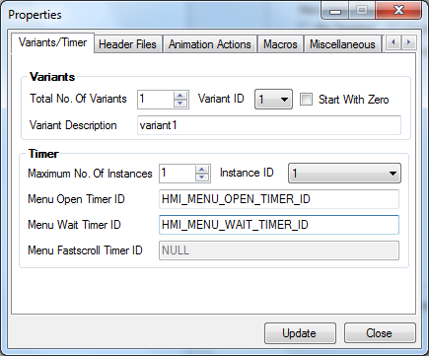
For this sample project, we will disable the fast scroll and enable ‘Item Configuration’ as shown in the below screenshot
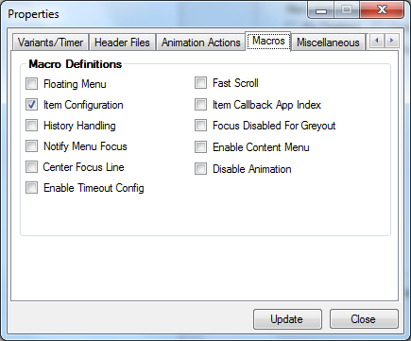
Set the ‘Total Number of Icons’ as ‘1’ for showing icon on the left side of the menu.
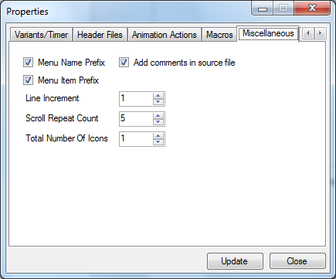
Click on Update and Close to save the application settings.

Adding New Menu

Right click on INSTANCE menu and then select ‘Add’ to add new menu to the project and update the properties on right side of the window. It contains the following configurations
- Menu Item Configuration – Configuration for non-sub menu type
- Menu Configuration – Configuration for sub menu and executable type

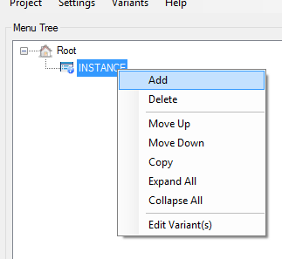

- Set the name as ‘ROOT’. This will be generated as ‘ROOT_MENU_ID’ in the generated code which will be used to communicate with view manager
- Change the entry type as ‘Sub Menu’. This will allow us to configure the next level of the menu
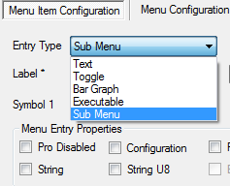
- Next we need to give the label for the menu. Provide the SID as you entered in the SID_Language_Table
TxtID_1_13 | Menu | Menu | Menu

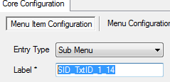

- Next move the ‘Menu Configuration’ tab to provide Sub menu related configurations
- Select the screen id from the list of available screens in the drop down menu. These screens are populated from the given GDT xml file. For this ‘ROOT’ menu, select the ‘GFX_SCR_ROOT_MENU’ as screen id. This screen id is corresponding to ‘scr_root_menu’ screen in GDT
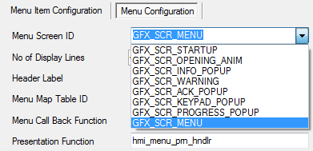
- Set the No. of Display Lines as 4. This is to set the maximum number of displayed lines allowed for this screen.
- Then set timeout value to close the menu after the timeout is expired. To achieve this timeout, we need to call ‘hmi_menu_logic_open_timer_timeout’ function in the timer expired event.
- Update the menu presentation function as shown in below image.
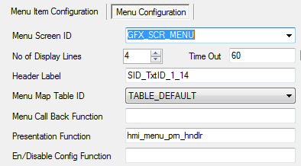
This function should be defined in application files. Refer hmi_menu_presentation.c for sample presentation handler.
Click on ‘Save’ button to save the configuration.
Now ‘ROOT’ menu added in the left side of the tree view.
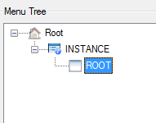
- Add other menu items by referring the below screen shots

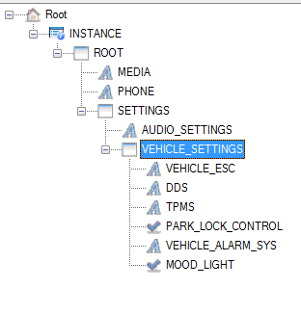
  - Media
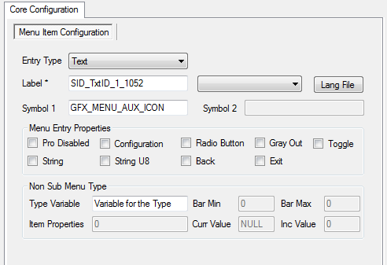
  - Phone
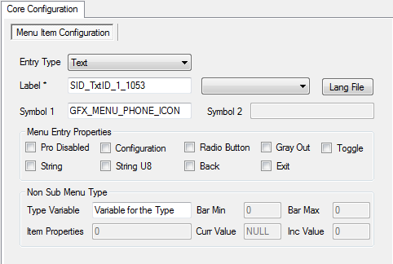
  - Settings
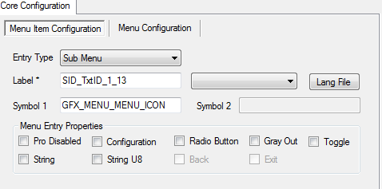
Settings - Menu Item Configuration
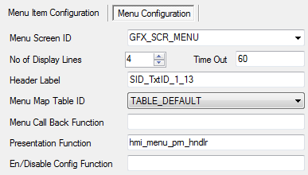
Settings - Menu Configuration
  - Audio Settings
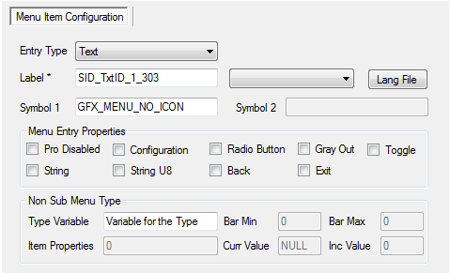
  - Vehicle Settings
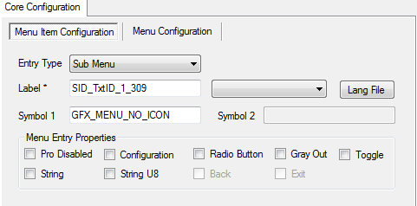
Vehicle Settings - Menu Item Configuration

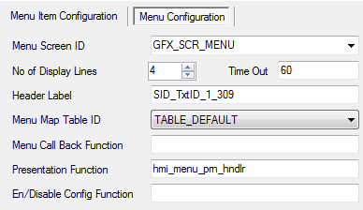
Vehicle Settings - Menu Configuration

  - Vehicle Esc
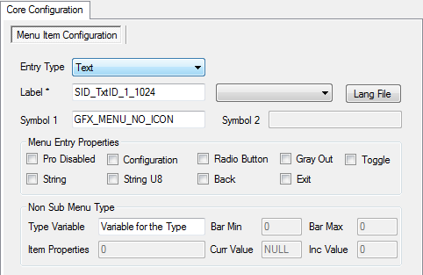

  - DDS
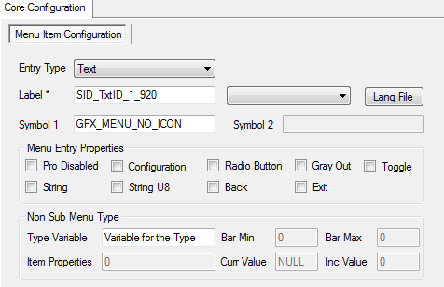
  - TPMS
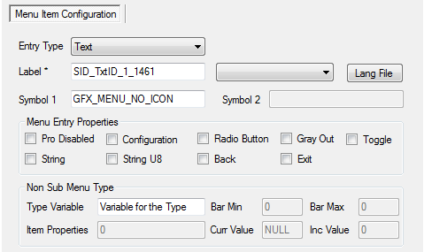
  - PARK_LOCK_CONTROL
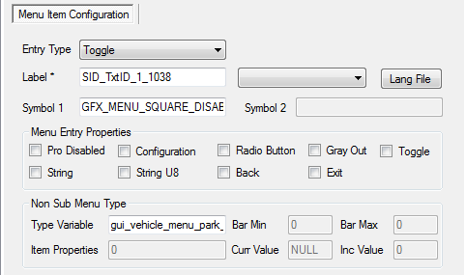
  - VEHICLE_AARM_SYS
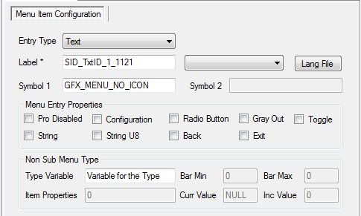
  - MOOD_LIGHT
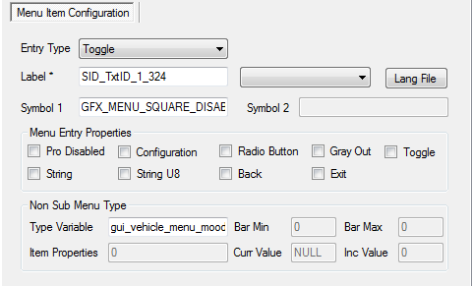
Now we have created the sample menu configuration. After this, we need to set the variants for the menu items. In this sample project, we are having only one variant. Follow the below steps to set the variant for the menu
- Right click on the root menu to display the context menu
- Click on the ‘Edit Variant(s)’ option
- Set the value as ‘1’ and then click on the ‘OK’ button to save
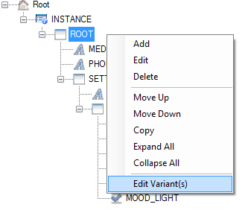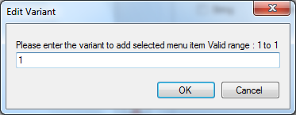

Next step is to generate the code. Click on the ‘Generate Code’ from ‘Project’ menu as shown in below
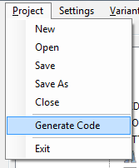

Wait for the code generation complete dialog and then you can verify the generated code inside the menu folder.
Following files will be generated from the tool.
hmi_menu_config_1.inc
hmi_menu_def_1.inc

Configuring Button Events:

In simulation the buttons m and esc are used for opening and closing the menu.
Add BTN_ID_MENU and BTN_ID_ESC in hmi_button.h

enum{
BTN_ID_POWER,
BTN_ID_UP,
BTN_ID_DN,
BTN_ID_LT,
BTN_ID_RT,
BTN_ID_ENTER,
BTN_ID_INFO_POPUP,
BTN_ID_ACK_POPUP,
BTN_ID_PROGRESS_POPUP,
BTN_ID_KEYPAD_POPUP,
BTN_ID_HARD_WRNG,
BTN_ID_SOFT_WRNG,
BTN_ID_INFO_WRNG,
BTN_ID_DEACTIVATE_WRNG,
BTN_ID_0,
BTN_ID_1,
BTN_ID_2,
BTN_ID_3,
BTN_ID_4,
BTN_ID_5,
BTN_ID_6,
BTN_ID_7,
BTN_ID_8,
BTN_ID_9,
BTN_ID_MENU,
BTN_ID_ESC,
BTN_ID_MAX
};
Both hmi_button.c/.h are application specific files, file naming, button names, button event names and implementation is left to the application’s choice.

Note :- Refer \ui.core.iceapple.test\iceapple.gdt.test.fw\openvg_target\common\hmi_button.c for sample implementation

Updating VC++ environment

Add all the source files in to the VC++ project that we have created initially.
Add following .c files
Ice.Apple :-
..\..\..\..\..\ui.core.iceapple\ menu.core.01 \src\ hmi_menu_core_01_chart.c
..\..\..\..\..\ui.core.iceapple\ menu.core.01 \src\ hmi_menu_core_01_logic.c
..\..\..\..\..\ui.core.iceapple\ menu.core.01 \src\hmi_menu_core_01_autocode.c

Add the necessary include paths
..\..\menu;
..\..\cfg;
..\..\..\..\..\ui.core.iceapple\menu.core.01\src;

Simulation Execution Sequence:

Keypad Button | Action | Screen Features
Letter 'p' | Welcome screen display | Will be on the background always
Letter 'm' | Activate root menu | Root menu will get timed out after 5 seconds if we didn’t do any button actions
Down Arrow | Perform ‘Move Down’ action | Focus will be moved to the next menu
Up Arrow | Perform ‘Move Up’ action | Focus will be moved to the previous menu
Left Arrow | Open the parent menu | Show the parent menu items in the screen
Right Arrow/ Enter | Open the sub menu items | Sub menu items will be shown in the screen
Esc | Close the menu | Menu will be closed

