View Manager

Introduction
Composition is a common technique used in graphics rendering to combine graphics from various sources to create the final content that will be shown to the end user.
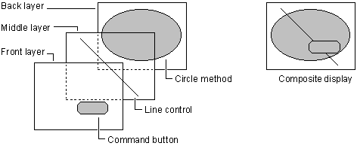
Image1, Source : https://msdn.microsoft.com/en-us/library/aa733621(v=vs.60).aspx

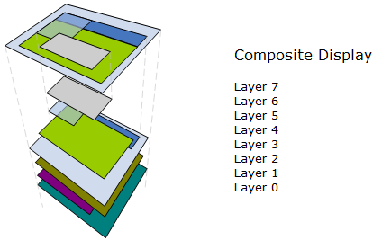
Image2, Source : http://katastrophos.net/symbian-dev/GUID-859CAA08-59C9-5FD3-98DE-6BDD0D6ED50B.html

Each of the graphics object (Layer) is having its priority order, depending on how far it is located from the sight of the end user. The far objects (bottom most, Layer0) is rendered first, then next one top of it and so on. In the image1 above, circle method is the bottommost and command button is top most.
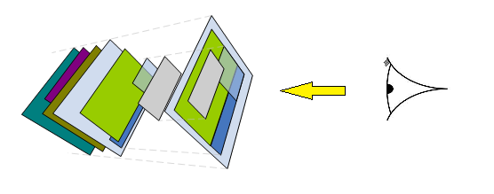
Relating this with Windows OS, we can consider every window as a Layer. There could be multiple windows opened by multiple applications. They all are rendered in order of their layer priority to get the final desktop appearance.
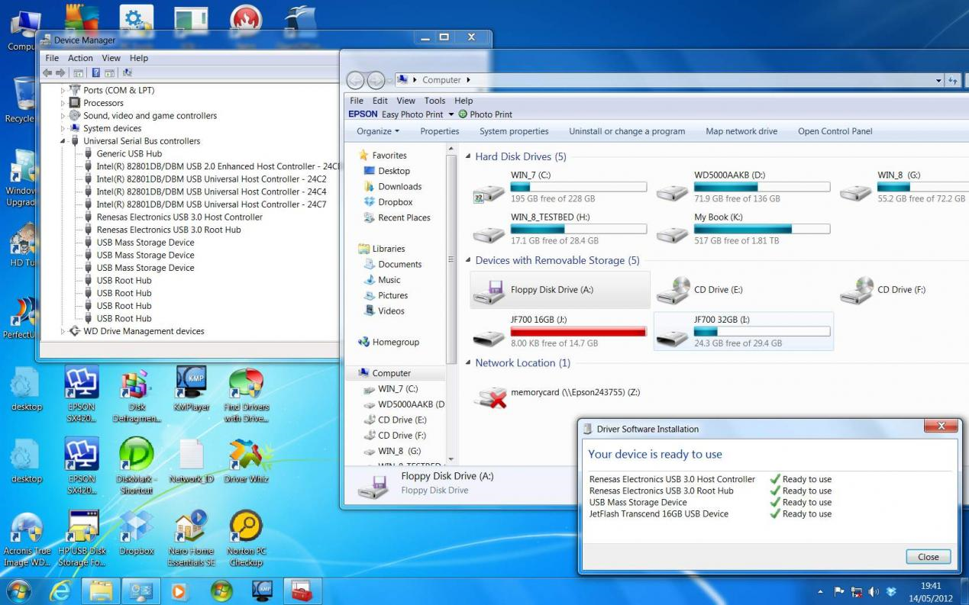
Each of the Windows application are developed independently without considering what other windows may come over it or below it. This is possible because we have a top level intelligence in the form of a window manager to provide services to an application to allow them to create windows, keep track of the window layering order, focus status, event delivery etc.
When GUI intensive applications are developed for low/mid end embedded system, where there is no support for an operating system and a window manager, it becomes a necessity to have some capabilities of the above described window system available. View manager is developed in order to address this weakness that was present in the GUI development.

Overview
Unlike the desktop operating systems, the view manager operates in a statically generated configuration. Each window is statically defined at compile time. Further on, the window will be termed as a View in view manager context.
Each view in the view manager has a priority associated with it, and it determines what the order of rendering is. A priority of 0 corresponds to a view that is bottommost order, 1 corresponds to view above the bottommost. A view with the largest priority value will be topmost on the display and which will also hold the user focus.
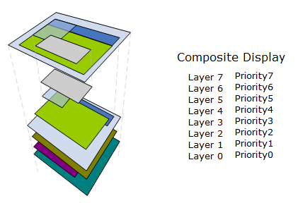
View manager maintains a priority stack which maintains the view information which is active for a priority. If there are 10 priorities supported for an application, the view manager priority stack also will be 10 entries deep. There is only one entry available per priority, so the view manager can hold only one view per priority. An application can have multiple views associated with a single priority. This means, when multiple requests are made to activate views which have the same priority, the view which was requested last will be the one that will remain in the View manager priority stack.
E.g. if Tuner and CD play screen share the same priority, and the tuner application requested adding Tuner play screen at (t+0sec) and CD application requested CD play screen at (t+5sec), then the view manager will have CD play screen on its priority stack.
As and when view manager receives a request to activate a view, it replaces the existing active view on the same priority as the newly requested view priority.

Features
View manager offers the following features for each view client
- Add/Remove View
  - Add/remove with or without performing an animation
  - Client ID
- Focus Notifications
  - Got focus : when a view regains top priority
  - Lost focus : when a view is overridden by another high priority view
  - Animation Started
  - Animation Completed
  - Deactivated : view is removed
  - Deactivation pending : Deactivation request accepted but pending due to removal animation in progress
- Button event routing
- Presentation scheduling for active views

Operation
View manager partitions its state machines in to two parallel states, one synchronous to the UI controller and one synchronous to the UI View (in MVC terms). This is because when a UI controller requests a view, it cannot be synchronously activated. Requested view can be activated only when the rendering system is ready to render the requested view. So every view request is stored in the controller context initially and as soon as the rendering system becomes available, it is moved to the view context. The UI controller application gets the focus notification only when the view is moved to the view context. This kind of setup allows the UI controller to accept view change requests quickly in response to user events or system events without really worrying about the status of the rendering engine.
Processing in Controller context is purely event driven, meaning it depends on requests from the UI controller. The processing in View context is periodic in nature. On every X mSec, the View context checks the status of rendering, and if the rendering is not busy then it process the views by
- Making requests for animations
- Scheduling its presentation functions
- Notification of focus information to UI controller

Adding/Removing a View
A view can be added by invoking the following API,
LSH_ADD_STATE(state, anim)
LSH_ADD_STATE_EXT(state, anim, client)

A view can be removed by invoking the following API,
LSH_REM_STATE(state, anim)
LSH_REM_STATE_EXT(state, anim, client)

- state – the identifier for the view (generally the enumeration ID generated by the graphics toolchain to identify the view) in the range of 0 – 254.

- anim – animation identifier (generally the enumeration ID generated by the animation tool chain to identify the animation) in the range of 0 – 254. Pass ANIM_MAX_ID incase no animations are needed.

- client – an application defined identifier in the range of 0 to 254. A client ID is useful when a single view is getting used to show multiple information. For example a warning view may be used to display many warnings. For the view manager perspective, it’s a single view but from the application perspective it can be one of many warning. So the applications in this case pass a client ID to identify the exact warning they wanted to activate. View manager will pass the client ID as well on further notifications to application, so the application can easily identify for which warning the notification is provided by just looking at the client ID.

Receiving Focus Notifications
Focus notifications are provided via a focus handler. Every view can statically register a focus callback, if notifications are required.

void focus_handler(LSH_FOCUS_HANDLER_STATUS_T * p_focus){
}

typedef struct
{
LSH_STATE_ID_T logic_state_id;
UINT8 focus_status;
LSH_STATE_ID_T focus_id;
UINT8 client_id;
}LSH_FOCUS_HANDLER_STATUS_T;
focus_status - focus status can have following information as bitfield.
Focus Statusbit | Bit Mask | Description
LSH_LOST_FOCUS_STATUS | 0x01 | Indicates the focus is lost to another high priority view
LSH_GOT_FOCUS_STATUS | 0x02 | Indicates got the focus
LSH_ANIM_STARTED_STATUS | 0x20 | Animation has been started
LSH_ANIM_COMPLETE_STATUS | 0x10 | Animation is completed
LSH_DEACT_PENDING_STATUS | 0x04|0x20 | Deactivation is pending due to animation in progress
LSH_DEACTIVATED_STATUS | 0x04 | View Deactivated
Since deactivation pending is combination of multiple bits, in order to check actual deactivation, the condition has to be properly ordered as below
If((focus_status & LSH_DEACT_PENDING_STATUS) == LSH_DEACT_PENDING_STATUS){
//deactivation is pending
}
else if((focus_status & LSH_DEACTIVATED_STATUS) != 0){
// deactivated
}
else{
}
logic_state_id – is the ID for the state or the view (same value as passed during ADD/REMOVE)
client_id – is the client ID associated with the view (same value as passed during ADD/REMOVE)
focus_id – in case if the focus_status is for a LOST focus notification, the focus_id ID of the ID of the view which caused the LOST focus.

Receiving Button Events
Button event notifications are provided via an event handler. Every view can statically register an event callback if notifications are required.

UINT8 event_handler(LSH_EVENT_HANDLER_STATUS_T * p_event){
}
typedef struct
{
LSH_STATE_ID_T logic_state_id;
UINT16 button_command;
UINT8 client_id;
}LSH_EVENT_HANDLER_STATUS_T;
logic_state_id & client_id is same as focus handler.
button_command – is an encoded form of a button ID and button event. The encoding is user defined. Either an 8bit encoding or 16bit encoding can be chosen.
#if (LSH_BTN_ID_MASK_CFG == LSH_ID_8_BIT_MASK)
#define LSH_ID_MASK (0xFF00)
#define LSH_ANIM_MASK (0x0080)
#define LSH_STATUS_MASK (0x007F)
#define LSH_GET_ID(x) ((x & LSH_ID_MASK) >> 8)
#define LSH_IS_ANIM(x) ((x & LSH_ANIM_MASK) == LSH_ANIM_MASK)
#define LSH_GET_STATUS(x) (x & LSH_STATUS_MASK)
#define LSH_GET_COMMAND(id, sts) (((id) << 8)|(sts))
#else
#define LSH_ID_MASK (0x7FF0)
#define LSH_ANIM_MASK (0x8000)
#define LSH_STATUS_MASK (0x000F)
#define LSH_GET_ID(x) ((x & LSH_ID_MASK) >> 4)
#define LSH_IS_ANIM(x) ((x & LSH_ANIM_MASK) == LSH_ANIM_MASK)
#define LSH_GET_STATUS(x) (x & LSH_STATUS_MASK)
#define LSH_GET_COMMAND(id, sts) (((id) << 4)|(sts))
#endif /* #if LSH_BTN_ID_MASK_CFG */

For 8bit encoding,
8bits are used for button ID
7bits are used for button status
1bit is used for animation status
For 12bit encoding,
11bits are used for button ID
4bits are used for button status
1bit is used for animation status

- For applications to extract the button ID use LSH_GET_ID(button_command)
- For applications to extract the button status use LSH_GET_STATUS(button_command)
- For applications to check animation bit use if(LSH_IS_ANIM(button_command))
- For applications to form an encoded button command from a button ID and button status use LSH_GET_COMMAND(id, sts)

Return status can be any of the below
- LSH_STATUS_ABSORBED – Can be returned if the button needs to be registered with the view. View manager doesn’t route this button any further to lower priority views, if this status is returned. A button is registered on the first event of the button. Once a button is registered with the view, next events of the same button will be directly delivered to the registered view until a button inactive (release) event is detected.
- LSH_STATUS_NONE – Can be returned if the button is not intended for this view. By returning this status view manager routes the button to the next active view further down in priority stack.
- LSH_STATUS_ACTION – This alone cannot be a return status, but this can be logically or with other two return status indicate that the view has performed some action in response to the button

If none of the view consumes a button event, it will be delivered to a default button event handler and will also get registered with it. Button event routing is detailed in the below provides flow charts.
Figure : Button routing on first button event of a button (normally a press condition)

Figure : Button routing on further button event of a button (normally a held or repeat condition, but not a release event)

Figure : Button routing for last button event of a button (normally a release event)
Example:-
Assume that we have two buttons
BTN_ID_POWER
BTN_ID_VOLUME_UP
Assume we have two button status
BTN_STATE_PRESSED
BTN_STATE_RELEASED
Now if the requirement is to
- Increment volume on VOLUME_UP button press
- Toggle the power on POWER button release.
- VOLUME_UP shall not be processed when animation in progress
- POWER can be processed regardless of animation status
- POWER button shall not be routed to lower priority view
- VOLUME_UP shall be routed to lower priority

UINT8 event_handler(LSH_EVENT_HANDLER_STATUS_T * p_event){
UINT32 fl_button_command = p_event->button_command;
UINT8 fl_ret_sts = LSH_STATUS_NONE;
if(p_event->button_command == LSH_GET_COMMAND(BTN_ID_VOLUME_UP, BTN_STATE_PRESSED){
Increment_volume();
}
fl_button_command &= ~ LSH_ANIM_MASK;
if(p_event->button_command == LSH_GET_COMMAND(BTN_ID_POWER, BTN_STATE_PRESSED){
fl_ret_sts = LSH_STATUS_ABSORBED;
}else if(p_event->button_command == LSH_GET_COMMAND(BTN_ID_POWER, BTN_STATE_RELEASED){
toggle_power();
fl_ret_sts = LSH_STATUS_ABSORBED;
}
return(fl_ret_sts);
}

Button freeze
View manager provides an API to freeze the button event notifications of buttons registered with a view. It is useful for the cases when a view gets deactivated, it can freeze the buttons registered with it as well. The buttons will gets automatically unfreeze when the release events are notified to the view manager
hmi_lsh_freeze_button_events(LSH_STATE_ID_T p_logic_state_id_U16)
hmi_lsh_freeze_button_events_ext(LSH_STATE_ID_T p_logic_state_id_U16, UINT8 p_client_id_U8) – This api has to be used if the view has been added with a client ID (with LSH_ADD_STATE_EXT() api). The call will be ignored if the client id of the active view maintained by view manager doesn’t match with what is being passed.

Button remapping
View manager provides API to remap a registered button with a low priority view to a higher priority view, so that rest of the events can be processed by the higher priority view. This is normally useful when a low priority view activates a numeric keypad popup, but does not want to miss the numeric which was used to trigger the popup itself.
hmi_lsh_remap_button_events(UINT16 p_button_id_U16, LSH_STATE_ID_T p_target_ls_id)
hmi_lsh_remap_button_events_ext(UINT16 p_button_id_U16, LSH_STATE_ID_T p_target_ls_id, UINT8 p_client_id_U8)
p_button_id_U16 – is the button ID to be remapped. Please note that this is the raw button id and not an encoded button command.
p_target_ls_id – ID of the view to which the button needs to be remapped. If the user passes LSH_NUMBER_OF_LOGIC_STATES instead of the view ID, then instead of remapping, the button is de-registered. So the next event of the button will be redistributed from top priority as if it’s the first event.

Presentation
Presentation handler is the function that is invoked by view manager to allow a view to refresh its content.
void pres_handler(LSH_PRESN_HANDLER_STATUS_T * p_pres) {
}

typedef struct
{
LSH_STATE_ID_T logic_state_id;
UINT8 presentation_status;
UINT8 client_id;
}LSH_PRESN_HANDLER_STATUS_T;

presentation_status – can be any of the three
LSH_DEACTIVATED_STATUS – Passed when a view is deactivated.
LSH_ACTIVATED_STATUS - Passed on first activation of view
LSH_REFRESH_STATUS - Passed on subsequent execution of presentation handler after first activation

void pres_handler(LSH_PRESN_HANDLER_STATUS_T * p_pres) {
if(p_pres->presentation_status == LSH_ACTIVATED_STATUS){
//do first time steps
}
else if(p_pres->presentation_status == LSH_REFRESH_STATUS){
// do refresh activities
}
else{
// do cleanup activities
}
}

It is to be noted that
- if an animation is scheduled by the view manager for a view, then the presentation handler is not scheduled by view manager.
- Application can use hmi_lsh_execute_presentation() api if it wants to forcefully execute the presentation during this period.

Files

RTC Information
Project Area : UI Frameworks Tools
Component : ui-core-iceapple
Path : \ui.core.iceapple\view.manager.02\src

hmi_logic_state_handler.c | VM API implementations.  Include in build
hmi_logic_state_handler.h | Public interface header
hmi_view_manager_02.c | Include in build (Private)
hmi_view_manager_02.h | Internal header file (Private)
hmi_view_manager_02_autocode.c | Include this in build(Private)
hmi_view_manager_02_autocode.h | Internal header file(Private)
hmi_logic_state_handler.$cfg | Template cfg file. Copy to application folder & rename by removing the $ and configure(Private)
hmi_logic_state_handler.$dat | Template static configuration tables. Copy to application folder & rename by removing the $ and configure (Private). If GDT is used, this file is generated from GDT
hmi_logic_state_handler.$inc | Template static configuration tables include file. Copy to application folder & rename by removing the $ and configure (Private). If GDT is used, this file is generated from GDT

Revision
Rev #.# | cdsid | Date | Comments
1.0 | emanoj1 | 16/Mar/2015 | Creation

