Software Design Specification

Message Core Programmers Guide

VOB Name:

sw_hmi_ss\hmi_message_core_01\02_design

Version : 1.0
Issue Date : 25-June-2012
Author : kbalakr1



DI Software Group,
Visteon Corporation

INDEX

1 Introduction 3
1.1 Overview 3
1.2 Purpose 3
1.3 Definitions/Acronyms 3
1.4 Reference 3
2 Message Core 4
3 Configuring Message Core 5
3.1 Arbitrator configuration 5
3.2 Sequencer configuration 6
3.3 Store configuration 7
3.4 Message Task configuration 7
3.5 Message Definitions configuration 7
4 Revision history 10

Introduction

Overview

This Message core component provides the functionality for managing application - defined messages and showing them on the display (LCD). Each message belongs to the defined set of message types which are rated according to their severity. In addition, the user (driver) can browse stored messages via the external interfaces available in the device.

Purpose

The purpose of this document is to provide details on features supported by “Message Core” Component and its configuration stuff.

Definitions/Acronyms

Term | Definition
HMI | Human Machine Interface
HLD | High Level Design
DD | Detailed Design
TBD | To Be Defined

Reference

- hmi_message_core_HLD.doc
- hmi_message_core_DD.doc
\sw_hmi_ss\hmi_message_core_01\02_design

Message Core

Arbitrator
Sequencer
Store
Display Message
Acknowledge
Message request
Retrieve Messages
Message Core Component
User can acknowledge a message
to clear it from the display
Message display request is
passed to the display manager.
Messages can be retrieved from the
store so that they can be cycled
(when ignition is OFF)
New message request
detected by application feature

Component diagram

The general operation supported in this feature is as follows:

1. A new message will be shown immediately provided that the display is available. 2. If the message cannot be shown immediately, it will be queued so that it can be shown when the display is available.
3. If a message becomes inactive, it will be removed from the display or queue immediately and if the minimum timeout exist for the message it will wait until the minimum timeout.
4. When a displayed message is acknowledged, it will be removed from the display
and held in the message store.
5. Messages in the store can be reviewed by the user.
6. Messages in the queue can be shown to the user.
7. Cycling all messages of a category is also supported.

This component is divided into 3 independent modules.

Arbitrator : Module which perform message detection.
Sequencer : Module which perform message displaying.
Store : Module which perform message storing.

Each module is linked via a set of link macros which provides easy expansion and customization if needed. Each module in this process is configured separately for each message. This allows, for example, a message to bypass the sequencer and be passed directly to the message store.
In addition to the above 3 modules message core is associated with isolated application modules “message definition” and “message task”.

Message definition : Module which holds project specific application message definitions.

Message task : Module which handles Kernel (OS) interface functions.

Following are the kernel interfaces
hm_msg_KSColdInit -> Component cold initialization
hm_msg_KSWarmInit -> Component Warm initialization
hm_msg_KSRRobin -> Component task
hm_msg_KSRRobin -> Component sleep actions
hm_msg_KSWakeup -> Component wakeup actions

The standard interface functions (indicated by STD_INTERFACE_FN) use the following function.

SIF_STATUS name(void *Data, UINT32 Qualifier)

Get message category status. This is called by the message task whenever the message state is processed, but it can also be called by the application when a specific status needs to be checked.

Configuring Message Core

Arbitrator configuration

Step 1 → Create file with name “hmi_msgArbitrator.cfg” and define hmi_msgArbitrator_CFG

Then under this hmi_msgArbitrator_C definition
Configure the following Macor’s in Arbitrator module to interact with sequencer module.

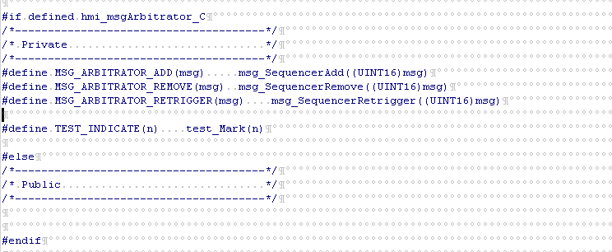

msg_SequencerAdd → Adds a new message into the sequencer queue.
msg_SequencerRemove → Remove a message from the sequencer queue.
msg_SequencerRetrigger → To Restart the display timeout of the warning if requested message ID is same as current message in display (seq_CurrentMessageID)

Macro’s that gives state of messages.

MSG_CONDITION_OFF -> Indicates the message is not exist / deactivated. MSG_CONDITION_ACTIVE -> Indicates the message is active (currently show on display).
MSG_CONDITION_FORCED -> Indicates the message is forced to be ACTIVE and behave as if this is a new message. Ex: Possibility that more than one message is active at an instance but only one is shown on display. Using this message can be forced to become active if in case other active message needs to bring up on display.
MSG_CONDITION_RETRIGGER -> Indicates the message is retriggered. Ex: Consider a case if any event / user action needs to reset the active message timeout then that can be achieved by this condition.

Sequencer configuration

Step 1 → Create file with name “hmi_msgSequencer.cfg” and define hmi_msgSequencer_CFG. Then under this hmi_msgSequencer_C definition

Step 2 → Configure MSG_DISPLAY_SHOW(msgInfo) macro with HMI application function to request display client (presentation module) to show the new message. The display client has to call msg_SequencerShow() to indicate the message core to handle the timeout for the requested message. This shall be called every time when the topmost warning of the queue is changed.

Step 3 → Configure MSG_DISPLAY_HIDE(msg) macro with HMI application function to request client to remove the message. The display client has to call msg_SequencerHide() to indicate the message core to handle timeout for the removed message. This shall be called only when the queue becomes empty, not on every msg removal.

Step 4 → Configure MSG_SEQUENCER_CLIENT_ADD(msg) macro with msg_StoreAdd(msg) to request client to add a message. Action is dependant on the message options. If MSG_OPTION_STORE (see section 3.5) is set, the message is added to the store, otherwise the message is transferred directly to the client (if defined).
Step 5 → Configure MSG_SEQUENCER_CLIENT_REMOVE(msg) macro with (void)msg_StoreRemove(msg) to request client to remove a message.

Step 6 → Define MSG_SEQUENCER_NOTIFY_VIEWER() macro with HMI application function to notify that a message has changed.

Step 7 → Define following timers to kernel timer if private timers were not used.
SEQ_DISPLAY_TIMER_ID hmi_msg_sequence_display_KSWTIMER
SEQ_HOLD_TIMER_ID hmi_msg_sequence_hold_KSWTIMER
SEQ_CYCLE_TIMER_ID hmi_msg_sequence_cycle_KSWTIMER
Step 8 → Define macro HMI_MSG_CYCLE_TIME to TO_MILLISEC(4000) (project specific).
Step 9 → Define macro MSG_SEQUENCER_VIEWER_OPTIONS to OPTION_VIEWER_NONE if no special actions needed.
OPTION_VIEWER_WRAP if message to display in wraparound from top to bottom and bottom to top is needed.

Store configuration

Step 1 → Create file with name “hmi_msgStore.cfg” and define hmi_msgStore_CFG. Then under this hmi_msgStore_C definition

Step 2 → Define macro MSG_STORE_VIEWER_OPTIONS to OPTION_VIEWER_WRAP if Wrap top to bottom and bottom to top is needed.

Step 3 → Define macro MSG_STORE_PURGE(msg) with msg_SequencerAdd(msg) to
add a new message into the sequencer.

Step 4 → Define macro MSG_STORE_NOTIFY_VIEWER() with HMI application function to update the presentation whenever there is addition or removal in the stored message queue.

Message Task configuration

Step 1 → Create file with name “hmi_msgTask.cfg” and define hmi_msgTask_CFG. Then under this hmi_msgTask_C definition

Step 2 → Define following status reporting macros
MSG_DEFAULT_MODULE_SELECTION to (MSG_ALL_CATEGORY)
MSG_DEFAULT_MODULE_THRESHOLD to (0ul)

Message Definitions configuration

Step 1 → Create file with name “hmi_msgDefinitions.cfg” and define hmi_msgDefinitions_CFG. Then under this hmi_ msgDefinitions msgTask_C definition

Step 2 → Define the set of message types and these must be in DESCENDING priority order. Define with macro MSG_MESSAGE_CATEGORIES

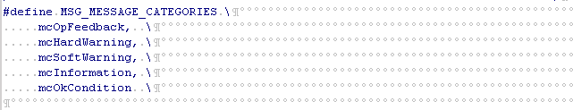

In the above example mcOpFeedback message type has highest priority and mcOkCondition with low priority. Each messages were configured to specific “message type” base on the severity of the message to display.

Step 3 → Define the number of messages used in application. Message priority must be in DESCENDING order. (0 shall be highest priority)
Define with macro MSG_MESSAGE_IDENTITIES.
Messages defined here belongs to one of the message type defined in step 2. All the messages under one type or category can have it’s own priority order 0 → n (0 shall be highest priority).

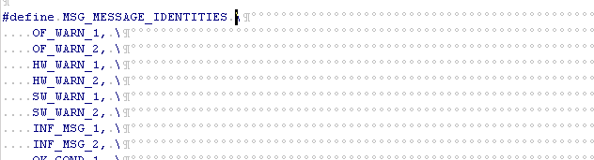

Messages defined in the above example OF_WARN_1 and OF_WARN_2 belongs to the message type “mcOpFeedback” and has priority order OF_WARN_1 with high and OF_WARN_2 with low. (i.e. Op. Feedback has priority 0, 1, Hardwarning also has priority 0, 1).

Step 4 → Define Standard interface definitions.
MSG_STATUS_OK (0)
MSG_STATUS_ERROR (BIT0)
MSG_STATUS_NOT_CONFIGURED (BIT1)
MSG_STATUS_UNKNOWN (BIT2)

Step 5 → Define power modes to configure message active states.
MSG_GET_IGNITION_STATE() (0xFF)
MSG_IGNOFF (1)
MSG_IGNACC (2)
MSG_IGNRUN (4)
MSG_IGNCRANK (8)

Step 6 → Define set of option supported by different types of messages.

HARD_WARNING_OPTIONS (MSG_OPTION_SEQUENCE | MSG_OPTION_CLEARABLE
| MSG_OPTION_STORE )
SOFT_WARNING_OPTIONS (MSG_OPTION_SEQUENCE |MSG_OPTION_CLEARABLE
| MSG_OPTION_STORE )
INFORMATION_OPTIONS (MSG_OPTION_SEQUENCE |MSG_OPTION_CLEARABLE
| MSG_OPTION_STORE )
OK_CONDITION_OPTIONS (0|0|MSG_OPTION_STORE)
OP_FEEDBACK_OPTIONS (MSG_OPTION_SEQUENCE|MSG_OPTION_CLEARABLE|0)

MSG_OPTION_SEQUENCE -> which enables the feature to add the message to the sequencer that brings up the message to display after timeout of any higher priority message exists.

MSG_OPTION_STORE -> which enables the feature to store the message and that provides the option to the user verify / check the message if needed.

MSG_OPTION_CLEARABLE -> which enables the feature to clear the message once it is acknowledged.
MSG_OPTION_CYCLE -> which enables the feature to show the message until the user acknowledges by resetting the timer associated to the message.

Step 7 → Define timeout for different types of messages used in application.
HARD_WARNING_TIMEOUT ( MS(1010) )
SOFT_WARNING_TIMEOUT ( MS(1020) )
INFORMATION_TIMEOUT ( MS(1030) )
OK_CONDITION_TIMEOUT ( MS(1040) )
OP_FEEDBACK_TIMEOUT ( MS(1050) )

Note: Step 8 can achieve in two ways.

Step 8.a → Define the set of messages used in application. Define with macro MSG_MESSAGE_LIST

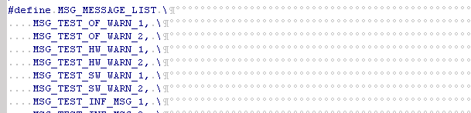

Then define each message with following elements.

typedef struct _msgMessageStruct
{
U08SIF_GET_DATA CheckActiveCondition;
U08SIF_GET_DATA MsgEventCallback;
UINT8 ConditionQualifier;
UINT8 EventQualifier;
UINT16 DisplayTimeout;
UINT16 HoldTimeout;
eMessageCategory Category;
UINT8 Priority;
UINT8 Options;
UINT8 ActiveStates;
} MSG_MESSAGE_STRUCT;

1. Element to Check Active Condition status.
2. Element to provide Message Event Callback.
3. Element to Condition Qualifier.
4. Element to Event Qualifier.
5. Element to specify message Display Timeout.
6. Element to specify message Hold Timeout.
7. Element to specify message Category.
8. Element to specify message Priority.
9. Element to specify message Options.
10. Element to specify message Active States in various power modes.

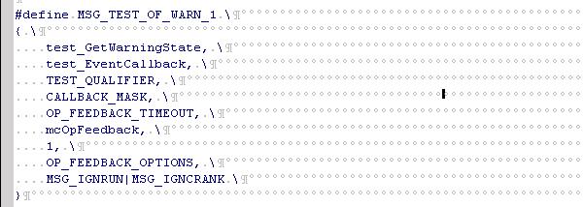

Refer file below


Step 8.b → Define the set of messages used in application using the auto coder.
C520_Warning_configuration.xls in below cc path
sw_hmi_ss\ 07_subsystem\2012_ford_c520_ic\common\ message_app\02_design

Follow instruction in introduction tab and generate file “hmi_msgDefinition.inc”
Note : This auto coder has extra support, specific to C520 variant requirement. So this auto coder needs changes to generate files with only message definitions.

Revision history

Version | Section | Date | Cdsid | Nature of change
1.0 | All | 25-Jun-12 | Kbalakr1 | Initial Version
1.1 | All | 30-July-12 | Kbalakr1 | Review comments updates

