Software Detailed Design

HMI message core

VOB Name : sw_hmi_ss\hmi_message_core_01\02_design
Version : 4.3
Issue Date : 24 Oct 2012



DI Software Group, Visteon Corporation
Table Of Contents
1 Introduction 3
1.1 Overview 3
1.2 Purpose 3
1.3 Scope 3
1.4 References 3
1.5 Acronyms 3
1.6 Definitions 3
2 Detailed Design 4
2.1 Component activity diagram 4
2.2 Arbitration module 4
2.3 Sequencer module 5
2.4 Message Store module 6
2.5 Design Constraints and Decisions 6
2.6 Data Design 7
2.7 Configuration 10
2.8 Functional Design 11
3 Metrics 11
3.1 Assumptions made for the CRS issues: 12
4 Hardware Resources used 13
5 Traceability 14
6 Revision history 14

Introduction

Overview
The functionality of this component is based on the warnings component created for the CD34X cluster. The component provides the following basic features:
- Message detection from application-provided features. These are arranged in a priority order such that the highest priority message request is always presented to the subsequent layers.
- Ordered display of active messages with optional timeout and user acknowledgement for each message depending on the configuration of each message.
- Message storage facility so that messages that have been cleared from the display can be reviewed on demand (normally through the menu system).
This component is divided into 3 independent modules. Message detection is performed by the arbitrator; message display is performed by the sequencer; and message storage is performed by the store. Each module is linked via a set of link macros which provides easy expansion and customization if needed.
The basic principle is that the arbitrator detects an application request to show a message. This message is passed to the sequencer which decides which message should be shown on the display. The user can then acknowledge the displayed message (or it can timeout automatically) and be passed to the message store.
Each stage though this process is configured separately for each message. This allows, for example, a message to bypass the sequencer and be passed directly to the message store.

Purpose

This section provides purpose of the module.

Scope

This section defines the scope of this document.

References

Acronyms
This section shall expand all the acronyms used in this document.
DI Driver Information
HSIS Hardware Software Interface Specification
HLD High Level Design
SRS Software Requirements Specification
TBD To Be Decided

Definitions
This section shall define the definition of terminologies used in this document.

Detailed Design

Component activity diagram
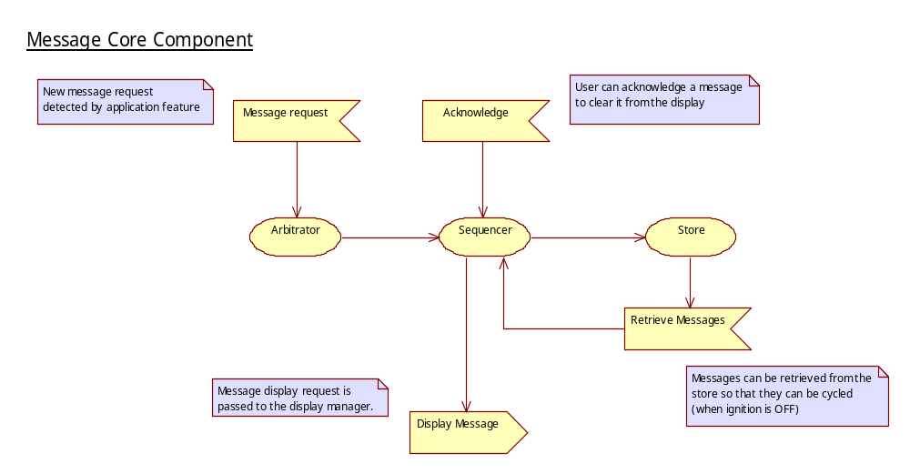

Arbitration module
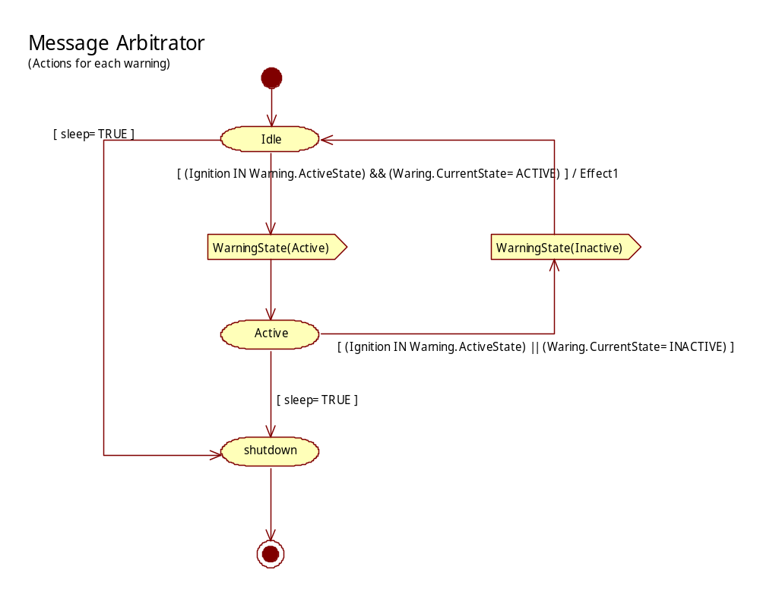

Sequencer module
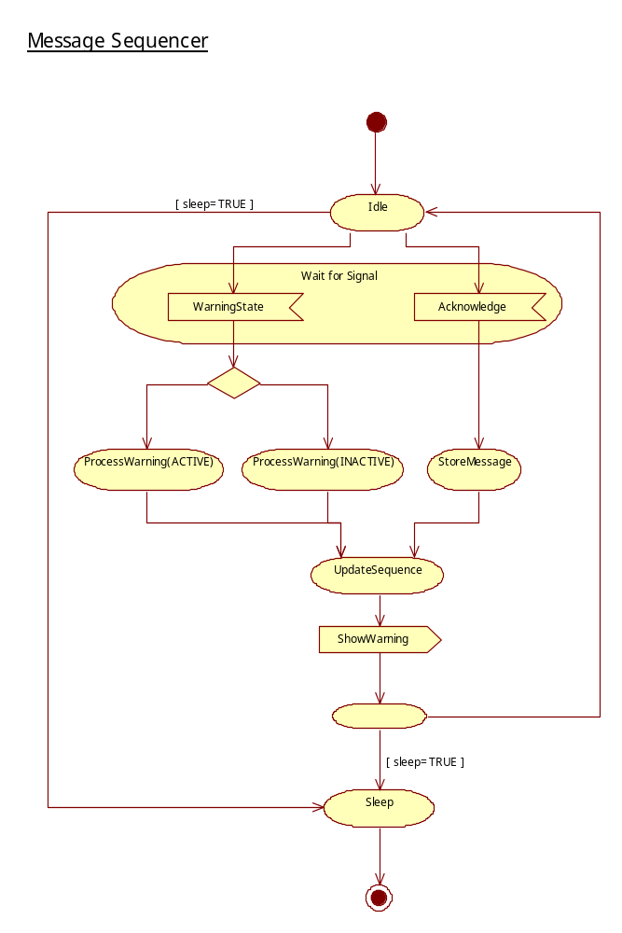

Message Store module
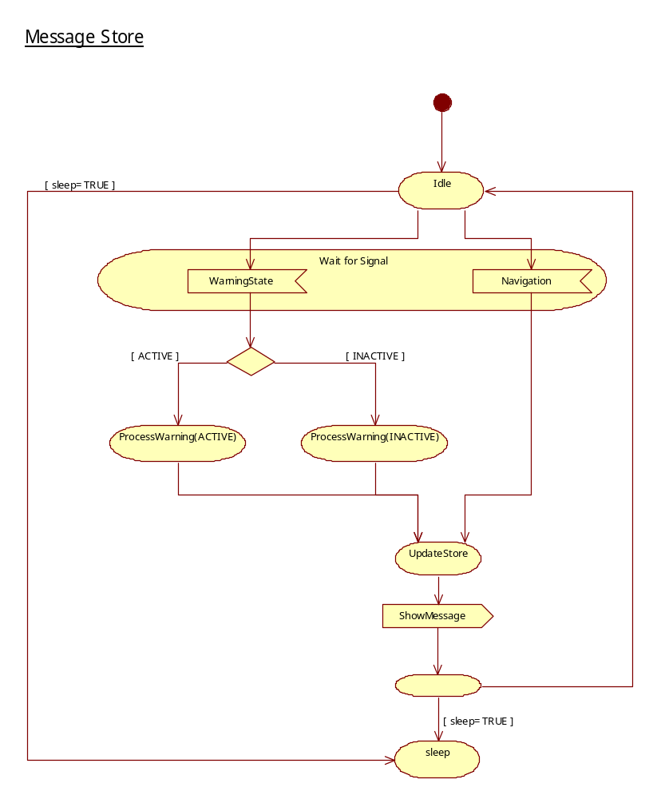

This section is an optional section. Requirement of this section needs to be discussed with the Senior tech lead and lead engineer upon the start of the design. Requirement of this section will be decided based on the complexity of the module and if any data transaction is done based on time of execution. Draw a sequence diagram with all the data transaction involved of the module and transition between them.
Example:

Design Constraints and Decisions

Data Design

Data Types and Macro Definition:
/*--------------------------------------------------------------------------*/
/* Define the set of message types that are present in the application. */
/* These must be in DESCENDING priority order. */
/*--------------------------------------------------------------------------*/
#define MSG_MESSAGE_CATEGORIES \
mcOpFeedback, \
mcHardWarning, \
mcSoftWarning, \
mcInformation, \
mcOkCondition \

/*--------------------------------------------------------------*/
/* Message categories. */
/*--------------------------------------------------------------*/
typedef enum
{
MSG_MESSAGE_CATEGORIES,
mcMaximum
} eMessageCategory;

/*--------------------------------------------------------------*/
/* Message Identities. */
/*--------------------------------------------------------------*/
typedef enum
{
MSG_MESSAGE_IDENTITIES

miMaximum,
miUndefined
} eMessageIdentity;
#define MSG_NUM_MESSAGES (miMaximum)

#ifdef MSG_ENABLE_GROUP_ACKNOWLEDGEMENT
typedef enum
{
MSG_MESSAGE_ACK_GROUPS,

mgUndefined
} eMessageAcknowledgeGroup;
#define MSG_ACK_GROUP_UNDEFINED (mgUndefined)
#endif

Structures Definition
typedef struct _msgMessageStruct
{
#if MSG_NUM_INSTANCES > 1
U16SIF_GET_DATA_MULTI_INST CheckActiveCondition;
U16SIF_GET_DATA_MULTI_INST MsgEventCallback;
#else
U16SIF_GET_DATA CheckActiveCondition;
U16SIF_GET_DATA MsgEventCallback;
#endif
UINT8 InstanceID;
#if defined SIF_SUPPORT_EXTENDED_QUALIFIER
UINT16 *ConditionQualifier;
UINT8 *EventQualifier;
#else
UINT16 ConditionQualifier;
UINT8 EventQualifier; /* See callback indication */
#endif
UINT16 DisplayTimeout;
#if defined MSG_GET_DYN_HOLD_TIME
U16_GET_DATA HoldTimeout;
#else
UINT16 HoldTimeout;
#endif
eMessageCategory Category;
UINT8 Priority;
UINT32 Options;
UINT8 ActiveStates;
#ifdef HMI_MSG_ENABLE_NEW_MESSAGE_SEQ_QUEUE_TIMEOUT
UINT16 SeqQTimeout;
#endif
#ifdef HMI_MSG_UNIQUE_DISP_IND_TIME
UINT16 DispIndTimeout;
#endif
#ifdef MSG_ENABLE_GROUP_ACKNOWLEDGEMENT
eMessageAcknowledgeGroup AckGroup;
#endif
} MSG_MESSAGE_STRUCT;

CheckActiveCondition | Feature supplied function that is called to detect if the message trigger conditions are true.  Parameters:  Data: pointer to the warning status. Valid values are MSG_CONDITION_OFF - no message required  MSG_CONDITION_ACTIVE – message should be displayed (action is only taken on the transition from MSG_CONDITION_OFF to MSG_CONDITION_ACTIVE)  MSG_CONDITION_FORCED – Force the re-display of the message. This will also re-start the message timeout, so should only be used when needed.  Qualifier: Optional data to the feature that can be used to define which message is being polled.
MsgEventCallback | Feature supplied function that is called when a notifiable event has occurred in the message core. See EventQualifier.  Data: pointer to the event data.  Qualifier: Condition qualifier value.
ConditionQualifier | Feature supplied Qualifier data. This is passed to the CheckActiveCondition function to enable the feature to assist with determining if the message trigger condition exists.
EventQualifier | Events that will be notified to the feature:
  MSG_EVENT_ACKNOWLEDGED | Acknowledged by User
  MSG_EVENT_TIMEOUT | Message has timed-out
  MSG_EVENT_HIDDEN | Message has been hidden by another
  MSG_EVENT_SHOW | Message has been shown
  MSG_EVENT_ACTIVE | Message is active
  MSG_EVENT_INACTIVE | Message in inactive
DisplayTimeout | Message timeout duration (in TIMER units). If no message timeout is required, this should be set to the value MSG_NO_TIMEOUT.
HoldTimeout | The time (in TIMER units) that message should be held on the display (t_feedback). If MSG_GET_DYN_HOLD_TIME is configured, the holdtimeout is declared as a function pointer. Application can configure the holdtimeout value during run time.  Prototype of the Application function :  UINT16 function_name(UINT16 messageId);  The function name should be configured in hmi_msg_sequencer.inc instead of the value directly.
Category | Message category name. This will always be set to one of the values defined in MSG_MESSAGE_CATEGORIES (see above).
Priority | Message Priority. A value of zero is the highest priority.
Options | Sets the message handling options. One or more of the following is allowed:
  MSG_OPTION_SEQUENCE | Message can be sequenced for display.
  MSG_OPTION_STORE | Message can be stored when it time-out or is acknowledged.
  MSG_OPTION_CLEARABLE | Message can be acknowledged by a button press.
  MSG_OPTION_CYCLE | Message will be cycled with others in the same category
  MSG_OPTION_ACK_AFT_MIN_TOUT | Message can be acknowledged only when the minimum time out period gets expired.
  MSG_OPTION_DISPLAY_HOLDTIME | When one alert is interrupted by another the alert will be displayed for T2 interval during first time show followed by the next alert.
  MSG_OPTION_ALLOW_LOWCATEGORY | Allows the lower category message to be displayed for T2
  MSG_OPTION_OVERLAY_HIGHCATEGORY | Even if high priority alert interrupts the low priority message overlays the high priority for T2 interval.
  MSG_OPTION_SEQ_QUEUE_LIFO | The newly occurred alert is brought to display immediately.
  MSG_CYCLE_OPTION_WITH_TIMEOUT | Perform cycling operation with a time out value.
  MSG_CYCLE_OPTION_ALL_CATEGORY | Performing cycling operation for all category messages.
  MSG_OPTION_ALLOW_INACTIVE_TO_TIMEOUT | When a message becomes inactive then allow the message to get timed out without removing it from display. Even if the message is not on display currently the message will not be removed from the message queue.
  MSG_OPTION_NEW_MSG_SEQ_Q_TIMEOUT | When a time is specified, the warning shall timeout from the new warning (i.e. removed from Sequencer) queue if the timer is expired and it has been held off from being displayed because of higher priority warnings.
MSG_OPTION_OLD_WRNG_REPEAT - When a warning is made old after first time show and when it is required to repeat the old warning as a new warning then this option need to be enabled.

MSG_OPTION_ACK_WRNG_REPEAT – When a warning is acknowledged and if it is required to display the acknowledged warning as an old warning again then this option need to be enabled.

MSG_OPTION_REM_FRM_SEQ_IN_NA_IGN_MODE – When there is a change in ignition mode the warnings that are not applicable for that ignition mode will be removed from sequencer (warnings queue) and the arbitrator flag will also be cleared. But if this option is enabled, then only the warnings in the sequencer queue will be removed. If the warning is not available in sequencer queue (i.e. timed out or acknowledged) then the arbitrator flag will not be cleared, so that this warning will not appear as a new warning during next ignition transition. Requirement Info: If any warning is acknowledged or timed out then this warning will not be displayed again due to ignition mode change. The warning will be displayed only when the warning trigger conditions get changed in the applicable ignition mode.

MSG_OPTION_INS_AFT_CUR | Insert the new incoming message after the current active message. If there is no active message or new message is from different category, then use the existing flow as it is
MSG_OPTION_STASH_LOW - MSG_NO_REDISPLAY_AFTER_INTERRUPTION should be enabled to enable this option. When a low priority warning is interrupted by a high priority warning, application is provided an option to maintain the warning in the queue or to stash it. General core behaviour is that, the low priority will resume for its display timeout like a new message once the high priority
warning completes its presence along with other messages in priority queue. If the warning is configured with MSG_OPTION_NO_REDISPLAY, then it will be removed from
the queue once it is overriden by the high priority warning.

ActiveStates | Active ignition states for this message.  Set this to 0xFF if the feature is going to handle which states the message is active in.
SeqQTimeout | This option is applicable only if HMI_MSG_ENABLE_NEW_MESSAGE_SEQ_QUEUE_TIMEOUT is defined.  Message Sequencer Q timeout duration (in TIMER units). If no message timeout is required, this should be set to the value HMI_MSG_SEQ_TIMEOUT_INVALID_U16 (i.e. 0xffff).
DispIndTimeout | This option is applicable only if HMI_MSG_UNIQUE_DISP_IND_TIME is defined. Unique new warning display time for every message can be configured.
AckGroup | This option is only applicable if MSG_ENABLE_GROUP_ACKNOWLEDGEMENT is defined. Each Warning can be assigned a Group for acknowledging. If a warning does not belong to any group, configure it with mgUndefined.

typedef struct msg_viewinfo
{
UINT16 Id;
UINT16 Position;
UINT16 Count;
UINT8 Status;
} MSG_VIEWINFO_T;

Id | Message ID
Position | Position in current list
Count | Number of messages in list.
Status | BIT0 - Indicates status of message ID(Recycle/Normal)

Application interfaces
MSG_GET_IGNITION_STATE() | This macro is called to obtain the current ignition (or operating) state. Assign to an application function that will return each state as a separate bit.

External Interface (called by message core)

MSG_DISPLAY_SHOW(msg)  Parameters:  msg: Message information | Called when there is a new message to be shown in “Alert” mode.  msg is a pointer to a MSG_VIEWINFO_T  Structure.
MSG_DISPLAY_HIDE(msg)  Parameters:  msg: Message ID | Called when no more messages are required in “Alert” mode.  msg is the ID of the message being hidden.
MSG_STATUS_CHANGE(pData, Qualifier)  Parameters:  pData: New Status  Qualifier: Qualification info. | Called when the message status changes. See also hm_msg_GetStatus() which can modify the qualification settings used for status reporting.

External Interface (called by application)

STD_INTERFACE_FN hm_msg_GetStatus() | Get message core status information.  Data: New status value.  Qualifier: Specifies which modules should be checked, the threshold value, and “latch” mode.
STD_INTERFACE_FN msg_SequencerGetAlertInfo() | Get information about the current message in “Alert” mode.
STD_INTERFACE_FN msg_SequencerSelectFirst() | Find first (highest priority) message in “View” mode.
STD_INTERFACE_FN msg_SequencerSelectNext() | Find next message in “View” mode.
STD_INTERFACE_FN msg_SequencerSelectPrevious() | Find previous message in “View” mode.
STD_INTERFACE_FN msg_SequencerGetCurrent() | Get information about the current message in “View” mode.
STD_INTERFACE_FN msg_SequencerGetmessage() | Checks if a specified message is active in the sequencer. Message ID should be passed via the Qualifier parameter. Status (TRUE/FALSE) is returned by the Data parameter.
void msg_SequencerShow(void)  Parameters:  None.  Returns:  None. | Indicate that the “Alert” message has focus.
void msg_SequencerHide(void)  Parameters:  None.  Returns:  None. | Indicate that the “Alert” message has lost focus.
UINT8 msg_SequencerAction(UINT16 Button)  Parameters:  Button: Button identification  Returns:  Button usage status. | Perform button event action
STD_INTERFACE_FN msg_StoreSelectFirst() | Find first (highest priority) message in “Review” mode.
STD_INTERFACE_FN msg_StoreSelectNext() | Find next message in “Review” mode.
STD_INTERFACE_FN msg_StoreSelectPrevious() | Find previous message in “Review” mode.
STD_INTERFACE_FN msg_StoreGetCurrent() | Get information about the current message in “Review” mode.
BOOLEAN msg_StoreIsMsgPresentInStoreQueue(eMessageIdentity MessageID) | Interface to check whether a message is present in store queue or not
void msg_StorAckWrngRepTimerControl(eAckWrngRepTimerStatus p_AckWrngRepTimerAction) | To control the Ack warning repeat timer this interface can be used by application.

The standard interface functions (indicated by STD_INTERFACE_FN) use the following function prototype:
SIF_STATUS name(void *Data, UINT32 Qualifier)

Except where stated above, the parameters are:

Parameters:
*Data: | This must point to a MSG_VIEWINFO_T structure, where  Id = Message ID  Count = Number of messages in the list  Position = Position of this message in the list  Status = Status of message ID
Qualifier: | The mask for the categories that you want to view. Only used in the …SelectFirst() functions.
Return:
Sif_OK | No error detected
Other | Error detected. Values in Data are not valid.

Kernel interface
void hm_msg_KSColdInit(void)  Parameters:  None.  Returns:  None. | Component cold initialization
void hm_msg_KSWarmInit(void)  Parameters:  None.  Returns:  None. | Component Warm initialization.  Macro MSG_WARM_INIT used for configuration of initialization routines to be invoked during warm initialisation condition.
void hm_msg_KSRRobin(void)  Parameters:  None.  Returns:  None. | Component task
void hm_msg_KSSleep(void)  Parameters:  None.  Returns:  None. | Component sleep actions. Macro MSG_SLEEP_INIT used for configuration of initialization routines to be invoked during sleep initialisation condition.
void hm_msg_KSWakeup(void)  Parameters:  None.  Returns:  None. | Component wakeup actions. Macro MSG_WAKEUP_INIT used for configuration of initialization routines to be invoked during wake up initialisation condition.
BOOLEAN hm_msg_KSNvRamCheck(void)  Parameters:  None.  Returns:  None. | Component memory fault detection.

Configuration

    - Compiler Switches:

- Freeze Mode:
MSG_FREEZE_IGN_MODE is the macro defined for the below purpose.
Whenever it is required to process certain warnings and retain some old warnings during a particular ignition state, the above macro will be defined. For Eg: Consider the freeze mode is ignition crank. The warnings that are configured to be processed during crank mode alone will be processed and updated to the client(sequencer). The other warnings will be freezed and retain their previous states during ignition crank.

- Sequencer Queue Order:
SEQ_QUEUE_FIFO is the macro defined for the below purpose.
Whenever its required to process the messages in first in first out manner the above macro will be defined. When two or more messages with equal priority enter the sequencer queue then the messages will be displayed in first in first out manner. The newly occurred messages will not be placed at the top of the queue.

- Displaying Timeout and No timeout messages:
DISP_TOUT_NO_TOUT_MSG_BY_PRIORITY is the macro defined for the below purpose.
- When a category has both time out and no timeout messages and when it is required to cycle all the messages in the category such that allowing the timeout messages to timeout completely and cycle option enabled messages to cycle for the cycle time.
- Every new message in a category will be displayed for the minimum display time. Even if a new message gets triggered the current new message will be displayed for minimum display time followed by the new message. The last new message in the queue will be continued for its full time out period.

- Allow Current Message During Display Indication Time:
ALLOW_CURRENT_DURING_DISP_INDICATION_TIME is the macro defined for the below purpose.
When option MSG_OPTION_DISP_INDICATIONTIME is enabled for a message and if it is interrupted by a high priority message then the current message is continue to display. Any high or low priority message cannot override the high priority message during the display indication time interval.

- New Message queue Timeout:
HMI_MSG_ENABLE_NEW_MESSAGE_SEQ_QUEUE_TIMEOUT macro shall be defined for below purpose:
- When this macro defined, there is a timeout value (SeqQTimeout) shall be configured in “MSG_MESSAGE_STRUCT”.
- When a time is specified in SeqQTimeout, the warning shall timeout from the new warning (i.e. removed from Sequencer) queue if the timer is expired and it has been held off from being displayed because of higher priority warnings.
- The new warning queue timeout shall be applicable whenever the warning is triggered newly or retriggered.
Example configuration values: (As per HONDA TG7A warning summary table)
• If the time is 0, then if the warning is not the highest priority warning, it will not be displayed at all.
• When this value is None or N/A, this timeout logic does not apply. (None or N/A shall be configured as 0xffff in software).

- Old Warning Repetition:
MSG_OLD_WRNG_REPETITION macro shall be defined for the following purpose:
- When a warning is made old after first time show and if it is required to make the old warning new after a specific duration then this macro should be enabled.
- HMI_MSG_OLD_WRNG_REP_DUR is the macro to be configured. It indicates the time duration after which the old warning should be made new again.
- MSG_OPTION_OLD_WRNG_REPEAT option should be enabled for this feature.

- Acknowledged Warning Repetition:
MSG_ACK_WRNG_REPETITION macro shall be defined for the following purpose:
- When a warning is acknowledged it is stored in store queue and if it is required bring the warning to display again by making it old after specific duration, this macro should be enabled.
- HMI_MSG_ACK_WRNG_REP_DUR is the macro to be configured. It indicates the time duration after which the acknowledged warning should be made old again.
- MSG_OPTION_ACK_WRNG_REPEAT option should be enabled for this feature.

- Unique Display Indication Time:
HMI_MSG_UNIQUE_DISP_IND_TIME macro shall be defined for the following purpose:
- When this macro defined, there is a timeout value (DispIndTimeout) shall be configured in “MSG_MESSAGE_STRUCT”.
- When unique display indication time is required for each and every message then the
time duration need to be configured through DispIndTimeout.
- The display indication timer will run for the duration specified in DispIndTimeout for the warning.

- Ack Warning Repeat Timer Control:
MSG_ACK_WRNG_TIMER_CONTROL macro shall be defined for the following purpose:
- Interface void msg_StorAckWrngRepTimerControl(eAckWrngRepTimerStatus p_AckWrngRepTimerAction) can be used by application to control the stor_AckWrng_Rep_Timer
- Application can pause or restart or resume the timer based on their requirements.

- Bring Undisplayed Low Priority To Display:
ALLOW_LOW_PRIORITY_UNDISPLAYED_MSG_IMMEDIATELY macro shall be defined for the following purpose:
- When this configuration is enabled, then first time display will be tracked for all the warnings. A new flag seq_DisplayedOnceFlags is introduced to hold the data.
- When a high priority is on the display and if any low priority undisplayed warning gets activated then it will be shown for the minimum amount of time configured in display indication timer.
- Scanning will be done from high priority category to the low priority category.
- During every instant of scanning, only one high priority low category warning should interrupt. All the other high priority warnings in all the low categories should be forcefully set as "DisplayedOnce", so that interruption will not happen in the consequent round robin cycles of message core.
- Stash a low priority warning during interruption.
MSG_NO_REDISPLAY_AFTER_INTERRUPTION shall be defined for the following purpose.
When a low priority warning is interrupted by a high priority warning, application is provided an option to maintain the warning in the queue or to stash it. General core behavior is that, the low priority will warning completes its presence along with other messages in priority queue. If the warning is configured with MSG_OPTION_STASH, then it will be removed from the queue as soon as it is overriden by the high priority warning. With this suggestion, there is no need to worry about what message has to be processed next.
The following points are to be kept in mind.
- No redisplay case is applicable only for a warning that is active in queue and interrupted by another message irrespective of priority.
- Message Core does not remember about the display status of a message rather its only an option for configuration.
- Message with no redisplay will be considered as a fresh message and redisplayed if the input condition got changed ( CAN deactivation or acknowledged )
- During ignition transition, messages that are not applicable for that ignition mode will be flushed and will be treated as fresh warnings once the transition is back to applicable modes. In this case as well, a message with no redisplay will be redisplayed after the other applicable warnings complete. The re-display status will not be remembered during the transition.

Option MSG_OPTION_STASH doesn’t mean that the warning will not be displayed at all again. It is only when the warning is active in the queue and during interruption only. When the input is triggered again, it will be re-displayed.

- Acknowledging Group of warnings in single button press

MSG_ENABLE_GROUP_ACKNOWLEDGEMENT shall be defined for the following purposes.

This functionality enables users to acknowledge group of warnings simultaneously with a single button press. For instance, if the application has defined certain warnings under Group A, acknowledging any one of these Group A warnings will also acknowledge all other active warnings within Group A in the sequencer queue.

To assign group for each warning, a new parameter called "AckGroup" has been incorporated into the "MSG_MESSAGE_STRUCT" structure.

Refer "Warning_configuration_group_ack.xlsm" sheet from the path "ui.core.iceapple.doc\message.core.01\design\" for the generation of AckGroup parameter.

    - Features:

- Insert new message after current active message
This feature allows the user to insert new incoming message after the current active message without checking priority of the message in the sequencer queue. For this feature, MSG_OPTION_INS_AFT_CUR option shall be enabled in MSG_MESSAGE_STRUCT->Options and new incoming message should be the same category of the current message.

Refer the below diagram for more details
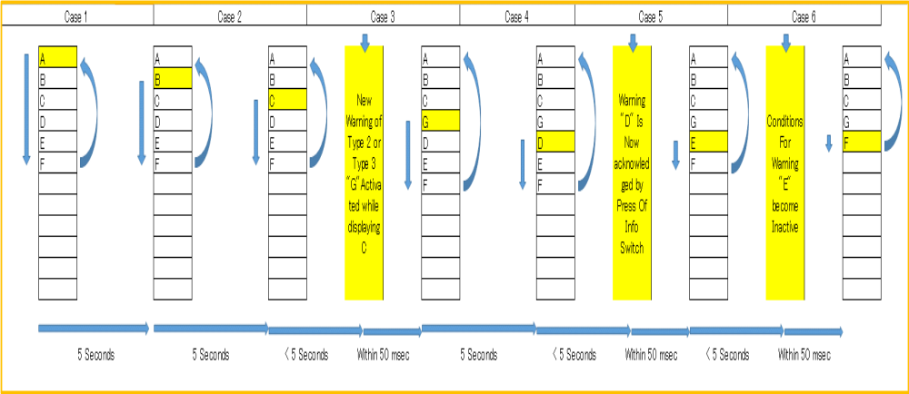

Case1: Six warnings are in queue, where Warning A is first in the queue and being displayed
Case 2:
a) Warning A has been displayed for 5 sec and display transition to Warning B. No new incoming Warning.
b) Warning B has been displayed for 5 sec and display transition to Warning C. No new incoming Warning.
Case 3: New incoming Warning G is received, display transition to Warning G(with in 50 msec) after Warning C has been displayed for 5 sec.
Case 4: Warning G has been displayed for 5 sec and display transition to Warning D. No new incoming Warning.
Case 5: Warning D gets acknowledged and removed from queue. Display transit to next warning (warning E) in queue.
Case 6: Warning E becomes Deactivate, it shall be removed from the queue and next warning (warning F) shall be displayed.

- Acknowledge all the warnings simultaneously in a single button event.

This feature allows the user to acknowledge all the active warnings in the Sequencer Queue simultaneously in a single button event. For this, msg_SequencerAction() should be called with “MSG_ACKNOWLEDGE_ALL_BUTTON_EVENT” button event.

MSG_ACKNOWLEDGE_ALL_BUTTON_EVENT macro should be defined in hmi_msgSequencer.cfg with suitable button value.

- Acknowledge group of warnings simultaneously in a single button event.

Same as explained in section 2.7.1.12

Declare all the variables in the module in corresponding "C" and "H" file. Each variable declaration (Both Local and global) will accompany a comment with the following details.
Purpose
Critical section (Y/N)
Unit
Resolution
Valid Range
Validity Check
When the variable is in RAM “Validity check” will be YES if NVRAM check is required else NO,
When the variable is in NVM “Validity check” will be YES if Boundary check is required else NO
Declare the global and local macros and manifest constants in corresponding "H" and "C" file. Each declaration shall accompany by a comment with following details.
Brief description of the macro/manifest constant.

Declare all the Constants (ROM) in the module in corresponding "C" and "H" file. Each variable declaration (Both Local and global) will accompany a comment with the following details.
Purpose
Unit
Resolution

In case of reusable package is being used all the configuration files of the package needs to be filled with the following comments . This configuration file needs to be treated as a separate design document and to be submitted for peer review. It shall also have a revision history
Name
Description
Name – should mention program name

Note: Partially completed(With all the above described info.) "XXXXXXXXDD.C" file, "XXXXXXXXDD.H" file and "XXXXXXXXDD.cfg"(optional)file needs to be submitted for the design review
XXXXXXXX- Refers to the shortened module name.

Functional Design
The main action performed by message core component is to detect when a new message request occurs. Normally when the ignition is RUN or CRANK the HMI logic will show the message (“Alert” mode). When the ignition is OFF of ACC, the HMI will usually ignore new message requests and just show the messages that are active in a cyclic manner (“Review” mode). It is up to the HMI logic layer to decide which mode is to be used.

RDescription: Description of the function
Invocation: Shall explain from where this function would be invoked
Parameters (Description, Range, Resolution and Unit)
Return Value (Description, Range, Resolution and Unit)
Critical Section: Shall mention the critical section data used in this function
All the local and global function declaration also to be done in the "C" and Header file accordingly.

Functional description of all the function with the above details needs to be completed upon completion of the detailed design. "C" files and Header files with this information need to be submitted to design review.

Metrics

Estimated Execution time information alone needs to be filled in here. This table needs to be replicated in Unit test plan document and the actual needs to be filled when the unit test is conducted on the functions.
No. | Function Name | Estimated Execution Time | Actual Execution Time

This Section is to capture some details about the execution time of the function. Actual time needs to be filled in during the unit testing.

Assumptions made for the CRS issues:
SL No | CQID/Issue No | Assumption Made

Hardware Resources used

None.

Traceability

Trace back to the corresponding high-level design document for this module

Revision history
Revision Level | Section/ Page | Date | Description | Author  (CDSID)
V 1.0 | All | 09-Feb-2010 | Initial Release | emanoj1
V 1.1 | 2.6 Data Design modified. 2.7 Configuration included. | 18-12-2012 | Change in Requirements for P42 project Addressed. | adevi
V1.2 | 2.6 Data Design modified. 2.7 Configuration included. | 26-03-2013 | Change in requirements for P552 project addressed. | adevi
V1.3 | 2.6 Data Design modified. 2.7 Configuration included. | 26-Oct-2013 | Message structure Configuration added to support Honda TG7A requirement | Vsarava2
V1.4 | 2.6 Data Design modified. 2.7 Configuration included. | 09-Jan-2014 | Change in requirements for HONDA TG7A addressed. (Old warning and acknowledged warning repetition) | adevi
V1.5 | 2.6 Data Design modified. 2.7 Configuration included. | 27-Jun-2014 | Unique display indication time out configuration added. | adevi
V1.6 | 2.7 Configuration included. | 27-Aug-2015 | Ack warning repeat timer control added. | adevi
V1.7 | 2.7 Configuration included. | 27-Dec-2015 | Change in requirements for Hyundai AE addressed. Undisplayed low priority message to display. | adevi
V1.8 | 2.6 Data Design modified.  2.7 New subsection “2.7.2” Features added | 24-Jul-2017 | Change in requirements for MAZDA addressed. Inserting new message after the current active one. | arajase2
V1.9 | Section 2.6 updated  Section 2.7.1 and 2.7.2 updated | 20-Nov-2023 | T38XD29284-59633 - [DEFECT][GUI] Special process for short press BACK-SW - core support - Group Acknowledge feature T38XD29284-59633 - [DEFECT][GUI] Special process for short press BACK-SW - core support - Group Acknowledge feature  T38XD29284-21361: Warnings are not getting acknowledged on Back Button Long press-Core support – Acknowledge all feature | mchoudha
V1.10 | Section 2.6 modified | 07-Mar-2024 | TATA27883-32484 - [X451_MCE] Store queue API for returning the store add/removal status to HMI - Notification List Implementation | mchoudha

