Software Design Specification

HMI message core High Level Design

VOB Name : sw_hmi_ss\hmi_message_core_01\02_design
Version : 2.0
Issue Date : 7 September 2010



DI Software Group, Visteon Corporation

INDEX

1 INTRODUCTION 3
2 PURPOSE 3
3 DEFINITIONS/ACRONYMS 3
4 OVERVIEW 3
5 DESIGN FLOW 4
6 INPUTS & OUTPUTS 4
7 MESSAGE CORE – Modules 5
8 SEQUENCE DIAGRAMS 7
9 FILES 8
10 INTERFACES 8
11 REVISION HISTORY 9

INTRODUCTION
This document provides an overview of the Message Core feature.

PURPOSE
To capture the structure of the module and describe the principles of operation and the external interfaces available.

DEFINITIONS/ACRONYMS

Term | Definition
HMI | Human Machine Interface
HLD | High Level Design
TBD | To Be Defined
MC | Motion Control
LCD | Liquid crystal Display

OVERVIEW
This feature provides the overall functionality for managing a number of application-defined messages and (typically) showing them on the instrument display (LCD). Each message belongs to the defined set of message types which are rated according to their severity. In addition, the user (driver) can browse stored messages via the external interfaces available in the instrument.

Historically, this feature has been described as a “warnings manager” however this will now handle many different types of announcements, or messages that need to be conveyed to the user.

The general operation of this feature is as follows:
- A new message will be shown immediately provided that the display is available.
- If the message cannot be shown immediately, it will be queued so that it can be shown when the display is available.
- If a message becomes inactive, it will be removed from the display or queue immediately.
- When a displayed message is acknowledged, it will be removed from the display and held in the message store.
- Messages in the store can be reviewed by the user.
- Messages in the queue can be shown to the user.

Message configuration items:
- MessageType – defines the major priority level and general behaviour within the queue and store.
- MessagePriority – the priority of the message within its message type. This is used to determine the position of the message within the queue and store.
- DisplayTimeout – defines the timeout period of the message when displayed
- DisplayIdentity – the ID of the display message to be shown

DESIGN FLOW
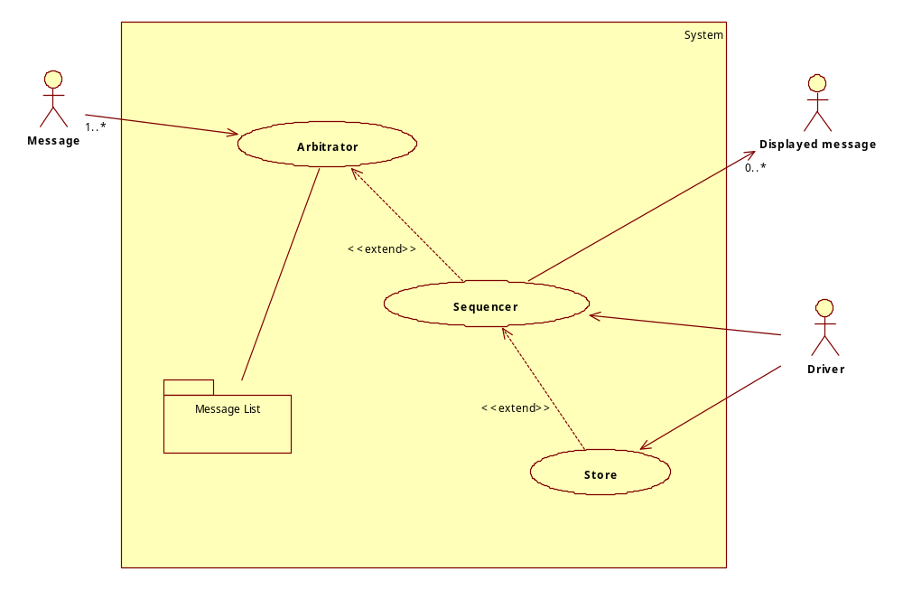

There are three main functional sub-modules within the message core. The Arbitrator chooses which message should be activated. The Sequencer selects the correct message to show on the LCD and interacts with the user. The Store holds saved messages so that they can be reviewed by the user.

In addition to the functional modules, there is a message configuration list which defines all messages recognized by the application and their operating characteristics.

INPUTS & OUTPUTS

- INPUTS
- A set of triggers from the application to show Messages to the driver.
- User management requests (normally from the driver) to manipulate the messages being shown.

- OUTPUTS
- Display messages to inform the user (driver) of specific conditions within the vehicle system. Depending on the mode of operation of this package (which is defined externally), messages are shown asynchronously or in a static sequence.

MESSAGE CORE – Modules

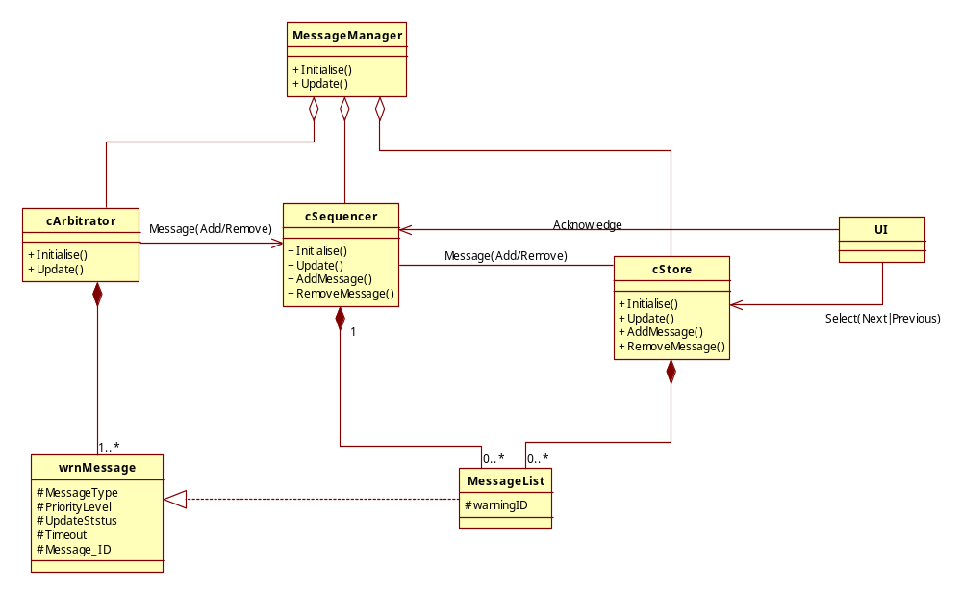

The individual blocks are explained in detail below.

- MESSAGE MANAGER
  - This is the top-level module for the message core feature. In effect this ensures that the internal sub-modules are sequenced correctly

- MESSAGE ARBITRATOR
  - This module polls all available message sources to find which are active or inactive.
  - On the transition from inactive to active, the arbitrator will activate the highest priority message so that this can be acted on by the message sequencer.
  - On the transition from active to inactive, the arbitrator will notify the sequencer so that the message can be removed from the system. Note: just because a message has gone inactive does not mean that it has (or is) being displayed.

- MESSAGE SEQUENCER
  - This module handles the display of the correct message as provided by the arbitrator (and optionally the message store – see below).
  - Messages may be manually or automatically acknowledged (by the user) as determined by the configuration for each message.

- MESSAGE STORE
  - This module holds messages that are stored in the instrument so that they may be reviewed by the user (normally at Ignition RUN), or shown in a cyclic manner (normally at Ignition OFF).

- UI (User Interface)
This is not really part of the message core, but is shown for clarity.
  - This module will communicate the driver commands to the message core to control the way that messages are held within the message core
  - Driver interaction is typically performed by a set of physical buttons.
  - Message output (the actual message required to be shown to the user) is normally shown on an LCD. These can occupy all or part of the actual display, as determined by the presentation layer.

- wrnMESSAGE
  - This is the basic structure for the definition of a message. This defines all of the attributes necessary for showing each message in the correct format and with the correct user interactions.
  - The complete message list for the application is defined in an array of this structure.

- MessageList
  - This object contains a reference to an individual message. The sequencer and store modules use this object type to hold the list of messages that are active. NOTE: This is the same object type, not the same object instance.

SEQUENCE DIAGRAMS
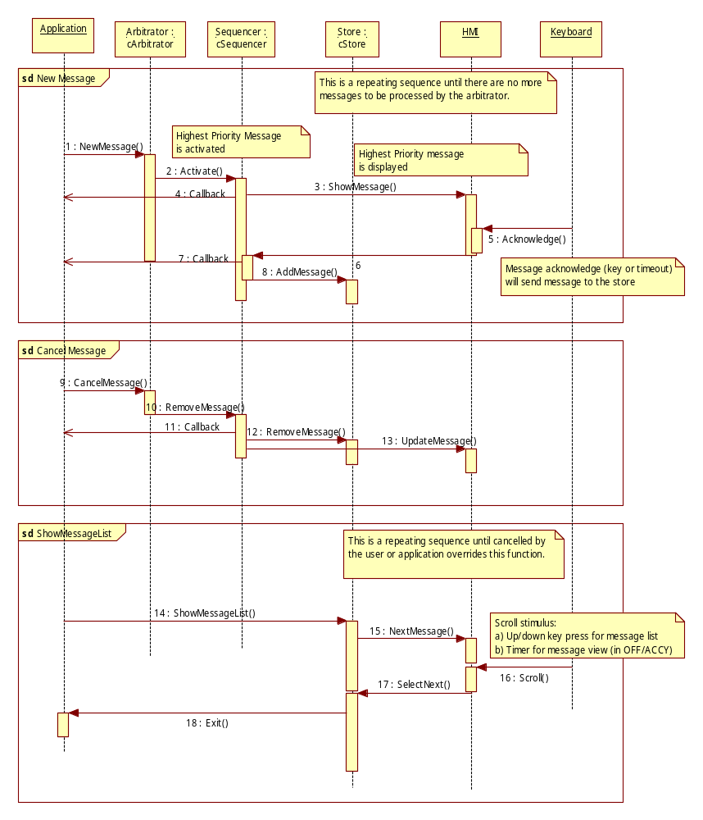
This diagram shows typical sequences for the processing of message requests from the application.

FILES

Sl.No | Name of the File | LAYER

INTERFACES
Listed below are the interfaces provided by the MENU Core to the external environment.

Note: (Not updated completely)

hmi_message_???.h
No | Name of the Interface | Description

REVISION HISTORY

Version | Section | Date | Cdsid | Nature of change
1.0 | All | 30-Mar-10 | AFERRIS2 | Initial Version

