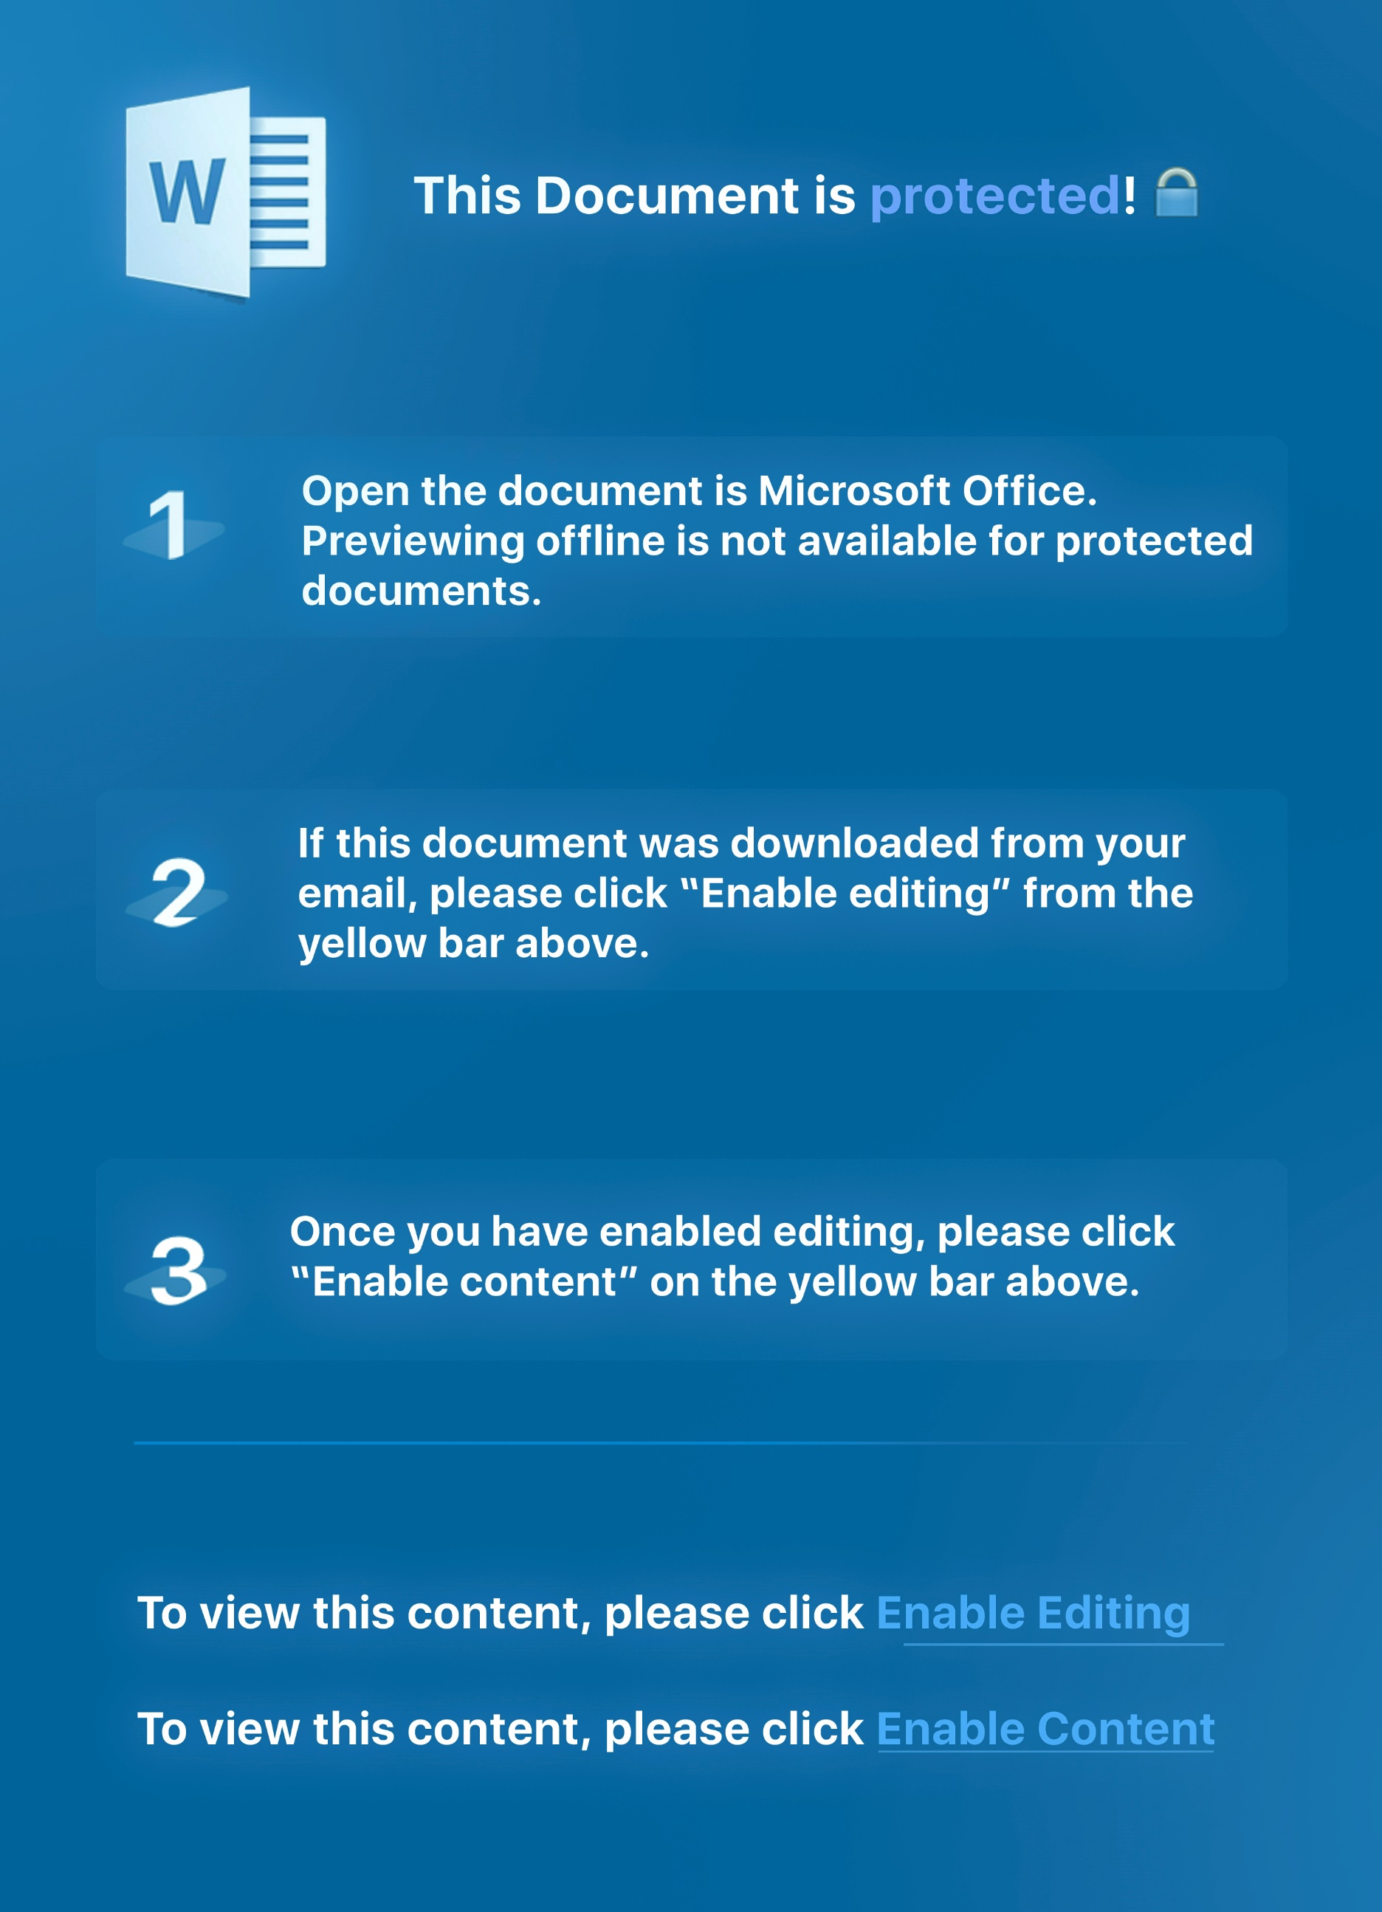

**YouTube Network Partnership Agreement**

This agreement (the**"Agreement, Contract"**) sets forth the mutually

agreed upon terms and conditions by and between

Rocksteady Studios Ltd registered in the United Kingdom at Unit 601, 53-47 Highgate Rd,

London NW5 1TL and Applicant ;on the basis of the First and

Last name entered into the application form

**(“Content Creator, you, your”**) concerning Content Creator's grant of certain rights to Rocksteady Studios Ltd with

respect to Content Creator's YouTube Channel on the basis of the channel entered into the “Your YouTube Channel” field on the application form.

Including any other URLs which may be separate

YouTube channels or refer back to the YouTube channel enetered as above and any future substantially similar YouTube channels launched by Content Creator during the Term of this Agreement (i.e., feature the same or similar subject matter or content, Content Creator's name, Channel name or trademark or logo, etc.), all of which above channels and URLs shall be subject to the terms of this Agreement and collectively referred to herein as the "Content Creator YouTube Properties." Additional channels that Content Creator may launch or desire to include as part of this Agreement as Content Creator YouTube Properties, that are not otherwise automatically included hereunder by the terms of this Agreement, may be added by mutual consent of the parties in writing (for this purpose, email shall suffice, provided the email is from an authorized Rocksteady Studios Ltd representative, clearly sets forth the name of the channel(s) to be added, and Content Creator responds confirming Content Creator's consent to add such channel(s))

**In consideration of the mutual promises contained herein, and other consideration the sufficiency of which is hereby acknowledged, the parties hereby agree as follows:**

**1. Overview.**

Content Creator is the owner of the Content Creator's YouTube Properties and also the producer/creator/authorized licensee of content that appears therein. Content Creator desires, in exchange for the payment to Content Creator of the fees payable hereunder, for the Content Creator YouTube Properties to become part of the muti-channel network owned or controlled by Rocksteady Studios Ltd ("MCN") and included directly in Network's relationship with YouTube for the purposes of total video views, unique impressions, inventory sales, optimization and ongoing management, and reporting, among other things. This will enable official advertising and messaging to be served and embedded in and displayed against content in the Content Creator YouTube Properties, the sale and management of which shall be handled on Content Creator's behalf by Network as set forth herein. Network shall have the exclusive right (other than YouTube's independent, direct sales efforts, if any) to sell advertising on the Content Creator YouTube Properties and to collect any and all revenue generated from the Content Creator YouTube Properties (i.e., ad sales, Google Ad Sense, video ad sense, premium sponsorships, etc.), all as set forth in greater detail below.

**2. Channel Views/Rollup.**

As of the Effective Date and throughout the Term of this Agreement, all channel views (including viewership for so-called "live streaming" content or delivery of content through any other means via the Content Creator YouTube Properties) for the Content Creator YouTube Properties shall be included or "rolled up" exclusively into Rocksteady Studios Ltd 's total numbers on YouTube and Rocksteady Studios Ltd shall be entitled to receive any and all payments in connection therewith directly from YouTube. This shall include, but is not limited to, any content made available on the Content Creator YouTube Properties, through any means (streaming VOD, "live-streaming," or other models of delivery as may be made available by YouTube) and through any devices enabled by YouTube, as Rocksteady Studios Ltd may determine.

**3. Payments.**

**3.1 VOD Content.** Subject to Content Creator's compliance with the terms and conditions of this Agreement and the terms and conditions of any other agreements Content Creator may have with Rocksteady Studios Ltd (and provided that Content Creator is not a consultant, affiliate or employee of Rocksteady Studios Ltd), for each piece of video content that is displayed in streaming VOD format on Content Creator's YouTube Properties hereunder, Content Creator shall be entitled to receive from Rocksteady Studios Ltd:

◦ **100** percent of the prepayment of _.

**3.2 Payment Terms.** Rocksteady Studios Ltd shall pay Content Creator any fees owed hereunder within thirty (30) days following Rocksteady Studios Ltd receipt of payment from YouTube in connection with the Content Creator's YouTube Properties.

Payments can be made by bank transfer, Paypal or Western Union

;to an account that Content Creator specifies and may, at Rocksteady Studios Ltd election, be combined with any other payments that may be owed to Content Creator. All references herein to dollars shall be to United States dollars. Notwithstanding the foregoing, Rocksteady Studios Ltd will have no obligation to pay any amounts, and is permitted to deduct or withhold any amounts owed, determined or reasonably suspected by Rocksteady Studios Ltd in its sole discretion to have resulted from: (i) Action Fraud (as defined in the section titled "Action Fraud" below), including without limitation through any clicks originating from Content Creator's IP addresses or computers under Content Creator's control, solicited by payment of money, false representation or request for end users to click on Ads, or (ii) fraudulent, misleading or false activities or activities that Rocksteady Studios Ltd and/or YouTube believe to be fraudulent or misleading or violative of either of their respective terms of service, guidelines, rules, or privacy policies. Rocksteady Studios Ltd reserves the right to withhold or deduct payment, if applicable, pending Rocksteady Studios Ltd reasonable investigation of any of the foregoing or any breach of this Agreement by Content Creator.

**4. Ownership/Control.**

As between the Parties, Content Creator shall retain full control and ownership of, and absolute liability

for, the Content Creator YouTube Properties and all content contained therein. This shall include creation, procurement, and uploading of any and all content therein, and the ongoing management and look and feel of the Content Creator YouTube Properties. Rocksteady Studios Ltd will not have the ability to upload content, alter the design or layout, etc. of the Content Creator YouTube Properties; provided, however, that Rocksteady Studios Ltd shall have the absolute right to require Content Creator to remove content immediately upon any notice of copyright violation, or violation of any party's rights, or concern thereof. Any video content or other content (live streaming, text, annotations, or otherwise) that is in violation of the terms of this agreement or violates any laws, rules or regulations, including YouTube's and/or Rocksteady Studios Ltd terms, rules, policies or other business interests, shall also be removed immediately upon request. Content Creator shall not use annotations or other similar YouTube tools and features in a manner that would conflict or interfere with Rocksteady Studios Ltd promotional or sales efforts and ongoing advertising campaigns.

**5. Right to Sell Content Creator YouTube Properties.**

**5.1** Rocksteady Studios Ltd will have the right, throughout the Term of this Agreement, to represent, sell, and manage any and ad inventory on the Content Creator YouTube Properties, including any ad sales against content contained therein, inclusion of advertising by ad Rocksteady Studios Ltd, advertising that may be included as part of live-streaming content, new units that YouTube may make available or that Rocksteady Studios Ltd or Content Creator may devise, usage of annotations and related features insofar as such usage may be part of an advertising campaign, and the serving and monitoring of all campaigns. Rocksteady Studios Ltd will collect all revenues generated from its work with the Content Creator YouTube Properties directly (including, for example, through Ad Sense, Video Ad Sense, YouTube direct sales, Rocksteady Studios Ltd direct sales, or sales by any other party on the Content Creator YouTube Properties), and then make payments to Content Creator in accordance with this Agreement (as set forth below). Rocksteady Studios Ltd shall have the right to turn YouTube's ad sales "off', i.e. not allow YouTube to sell the Content Creator YouTube Properties directly or through Ad Sense. Each party acknowledges and agrees that Content Creator may have external advertising relationships (“External Advertising Relationships”) that shall be managed by Content Creator. In every case, Rocksteady Studios Ltd shall coordinate with Content Creator to work harmoniously with such External Advertising Relationships.

**5.2** Either party sell 'branded integrations' or 'product placements' (“Integration”) with respect to content on Content Creator's YouTube Properties, provided any such Integration and terms associated therewith are approved by Content Creator. The parties will divide any such Integration revenue as agreed by the parties based on factors such as each party’s contribution to originating and negotiating each opportunity. The parties shall endeavor to work together on mutually agreed terms for any Integration. However, Content Creator may, at Content Creator’s discretion, execute any External Advertising Relationship related to an Integration without involvement with Network.

**6.1. Action Fraud.**

Content Creator will not, and will not enable,allow or authorize any party to, directly or indirectly, generate automated, fraudulent or otherwise invalid advertising actions. If, in Rocksteady Studios Ltd reasonable business judgment, activity related to content on Content Creator's YouTube Properties is suspected or determined to be so-called "action fraud," "click fraud" or "impression fraud," or fraud of any other kind, whether in any automated or human way, by the use of a person, an automated script or a computer

program (for example, online robots or "bots") to click on an any form of response mechanism, annotation or advertising unit, or any other fraudulent means, to increase impressions, skew results or imitate a legitimate user of a web browser, for example, by clicking on an ad unit for the purpose of generating an improper click value and generating revenue (collectively, "Action Fraud"), Rocksteady Studios Ltd may withhold any payments owed and have the right to terminate this Agreement retroactively and permanently, or until such time as the matter is resolved to Rocksteady Studios Ltd satisfaction.

**6.2. Copyright Infringment.**

Content Creator will not, and will not enable,allow or authorize any party to, directly or indirectly, upload content to their YouTube Properties that infringes on any copyrighted properties of another company or individual or,also that breaches YouTube's current or previous copyright terms of service. In the event of Rocksteady Studios Ltd. If content on Content Creator's YouTube Properties is suspected or determined to be in breach of the said terms or infringing on said material, Rocksteady Studios Ltd may withhold any payments owed and have the right to terminate this Agreement retroactively and permanently, or until such time as the matter is resolved to Rocksteady Studios Ltd satisfaction.

**7. Access to Content Creator's YouTube Accounts/Reporting to Content Creator To fully Integrate the Account onto our CMS**

Content Creator shall provide Rocksteady Studios Ltd with all necessary access and controls to its applicable YouTube account(s) in connection with the various Content Creator YouTube Properties to enable Content Creator YouTube Properties to become part of the Rocksteady Studios Ltd MCN with YouTube, including for example in Rocksteady Studios Ltd YouTube "CMS" or content management system or any other content management system that Rocksteady Studios Ltd may use. This access shall be limited only to Rocksteady Studios Ltd employees or contractors on a need-to-know or need-to-use basis, and shall only be used for purposes necessary to further the subject matter of this Agreement (i.e., to monitor traffic, views, prepare reports, check Ad Sense numbers, etc.). Rocksteady Studios Ltd agrees to provide Content Creator with a true and correct version of the most then-current YouTube report Rocksteady Studios Ltd receives with respect to Content Creator YouTube Properties, on no less than a monthly basis or as available to Rocksteady Studios Ltd from YouTube. In addition, Content Creator reserves the right to confirm the accuracy of the Rocksteady Studios Ltd report directly with YouTube provided such informational requests are conducted through and in coordination with Rocksteady Studios Ltd and limited to no more than one time per year.

**8. Term/Termination/Survival.**

8.1 This agreement is valid for a 10 days period from the point of Rocksteady Studios Ltd approval. The agreement will further extend by 24 months at the end of the contract period if not canceled by the Content Creator during this initial term.

8.2 **At any time either party may terminate this Agreement with 30 days written notice for any reason or no reason.** Upon any such termination, neither party will have any further obligation, rights or duties to the other party, except: that any undisputed payments owed by Rocksteady Studios Ltd to Talent prior to the date of termination will still be deemed payable in the manner provided in Section 3 above.

**9. Rights & Grants.**

Content Creator hereby grants to Rocksteady Studios Ltd any and all necessary rights and licenses it may need to perform in accordance with the terms of this Agreement, including for example the right to use

her/his/its name, likeness, and logo, registered marks if any, names of properties, etc., and to represent Rocksteady Studios Ltd as representative of any ad inventory/ad units/sales opportunities for the Content Creator YouTube Properties as set forth herein. Notwithstanding anything to the contrary herein, Content Creator reserves all rights not granted herein, including the right to monetize Content Creator’s intellectual property outside the scope of this Agreement.

**10. Independent Responsibilities.**

Each party agrees that it will be fully responsible and liable for its own content and any and all third party claims that may arise from its properties, sites, and content. This Agreement confers no ownership or control and does not constitute a 'partnership' or 'joint venture' within the legal/corporate meanings of those terms. The parties remain independent of each other and maintain their liabilities as their own.

**11. Limited Confidentiality.**

Each party and it’s affiliates understand and acknowledge that the existence of and terms of this Agreement is not confidential. However, from time to time during the performance of this Agreement each party may receive certain information from the other party marked confidential. Each party and it’s affiliates shall not, without the express written consent of the other, disclose that information disclosed by one party to the other and designated confidential to any third party, nor to any employees, contractors, vendors, consultants or affiliates other than those employees who have an actual need to know such information in order to perform their duties. The parties acknowledge and agree that this Agreement may be made publicly available or available to third-parties.

**12. Representations and Warranties; Covenants.**

Content Creator represents, warrants and agrees that: (a) it has the full right and power to make and perform this Agreement without the consent of any third party; (b) it has any and all necessary rights or clearances it may need in connection with the Content Creator YouTube Properties (to the extent it would be necessary for the specific use, i.e., display on YouTube); (c) that Rocksteady Studios Ltd use of, and sale of advertising on, the Content Creator YouTube Properties as set forth herein will not infringe on the rights of any person or entity, defame any person or entity, or violate any right of publicity or privacy of any person or entity; and (d) that Content Creator will not include in any Content Creator YouTube Properties any content or materials that would violate any laws, rules or regulations, including YouTube's and/or Rocksteady Studios Ltd general rules, terms and/or policies.

**13. Indemnity; Limitation on Liability.**

**13.1** Indemnity. Content Creator hereby agrees to indemnify and hold harmless Rocksteady Studios Ltd, its shareholders, its affiliates, officers, directors, employees, agents, successors, licensees and assigns, from and against any and all causes of action, claims, damages, obligations, losses, liabilities, costs or debt, and expenses (including but not limited to attorney's fees) (collectively, "Claims") arising out of any breach by Content Creator of any of the obligations, agreements, representations and/or warranties made hereunder or Content Creator’s negligence or willful misconduct.

**13.2** Except with respect to breaches of Section 12 (Confidentiality), indemnification payments owed to third parties, fraud, gross negligence or willful misconduct, no party shall be liable to the other for

amounts in excess of that paid by Rocksteady Studios Ltd to Content Creator under this Agreement or for special, consequential or incidental damages or for lost profits.

**14. Assignment.**

Neither party may assign this Agreement without the prior written permission of the other party, however, Content Creator understands and agrees that Rocksteady Studios Ltd may freely assign this Agreement in the event of a sale of all or substantially all of its stock or assets.

**15. Miscellaneous.**

**15.1** Content Creator as Independent Contractor and Responsibility for Personnel. This Agreement shall not render the Content Creator an employee, partner, agent of, or joint venturer with the Company for any purpose. The Content Creator is and will remain an independent contractor in relationship to the Company. Rocksteady Studios Ltd shall not be responsible for withholding taxes with respect to the Content Creator’s compensation hereunder. The Content Creator shall have no claim against the Rocksteady Studios Ltd hereunder or otherwise for vacation pay, sick leave, retirement benefits, social security, worker’s compensation, health or disability benefits, unemployment insurance benefits, or employee benefits of any kind. Content Creator’s representatives and all personnel supplied directly by Content Creator shall be deemed employees or subcontractors of Content Creator and will not be considered employees, agents or subcontractors of Rocksteady Studios Ltd for any purpose whatsoever.

**15.2** CHOICE OF LAW AND Arbitration. This Agreement shall be construed under, and governed by, the laws of the REPUBLIC OF IRELAND, as between IRISH residents, and as if all transactions were conducted in the COUNTRY OF THE REPUBLIC OF IRELAND. The parties agree that jurisdiction and venue for any legal proceedings arising from or in any way connected to this Agreement will lie in thE REPUBLIC OF IRELAND. Any disputes between the parties to this agreement shall be settled IN THE REBPUBLIC OF IRELAND SETTLED BY IRISH LAW

**15.3** Counterparts. For the convenience of the parties, the parties may execute any number of counterparts of this Agreement hereto. Each such counterpart shall be deemed to be an original instrument but all such counterparts taken together shall constitute one and the same Agreement. Notice shall be in writing via e-mail or fax, and federal express overnight delivery, or other such overnight courier and shall be deemed given as of the date of such delivery.

**15.4** Entire Agreement. If the foregoing correctly sets forth the understanding and agreement between Content Creator and Rocksteady Studios Ltd, please sign and return a copy of this Agreement to Rocksteady Studios Ltd, whereupon this document shall constitute a binding agreement between the parties as of the Effective Date and supersedes any and all prior written or oral agreements between the parties in connection with the subject matter hereof. This Agreement may not be modified or amended except in writing signed by the parties hereto (save for the addition of channels as contemplated in Section 1, above, which may be effected by email)

**15.5** Severability. If any provision or clause of this Agreement or compliance by any of the parties with any provision of this Agreement constitutes a violation of any law, or is or becomes unenforceable or void, then such provision shall be deemed modified to the extent necessary so that it is no longer

unenforceable.

**BY SUBMITTING THE FORM, YOU AGREE TO THESE TERMS AND CONFIRM THAT YOU ARE EITHER AN ADULT OR HAVE PARENTAL OR GUARDIAN PERMISSION.**

Full name:______

Phone number: ______

Email: ______

Address: ______

Payment system: ______

Payment details: ______