**Detail Design**

**Table of Contents**

Modification History ……. 2

Classes..……. 3

User Interface Design …….

**Modification History**

Revised Pseudocode 11/27/2016

Update Class Diagram 11/27/2016

**Classes**

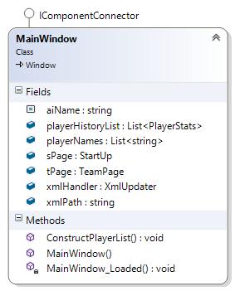

* Main Window()
  + Initialize Components()
* ConstructPlayerList()
  + First it clears the current players names
  + Try{ add players names}
  + catch{Error Message}
* Main Window_Loaded()
  + It calls ConstructPlayerList()
  + Adds new Startup page.

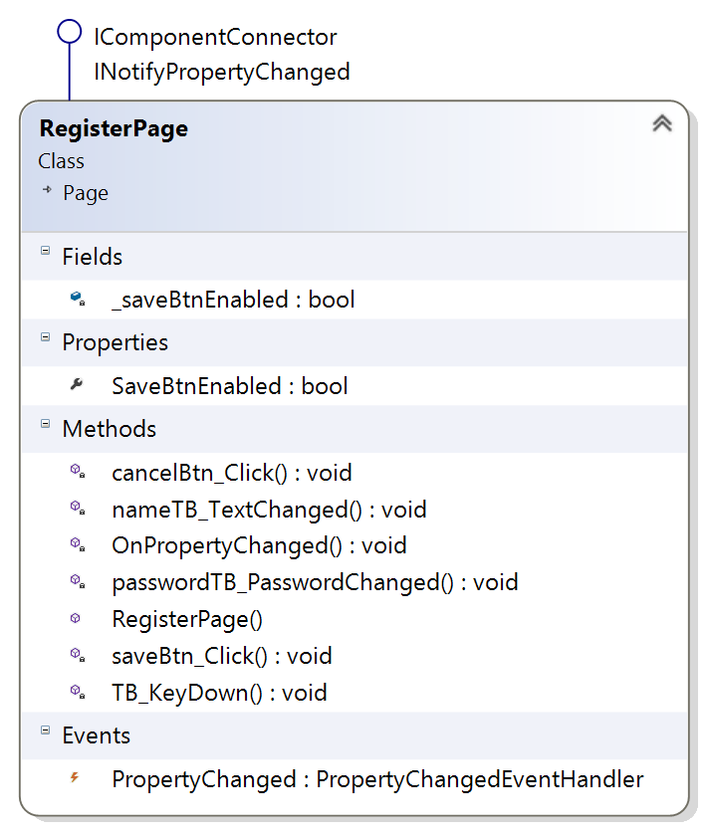

* cancelBtn_Click()
  + loads main window sPage
* nameTB_TextChanged()
  + if name is invalid, then save button is enable
  + else save button is disable
* OnPropertyChanged()
  + if handler is not null then it calls handler function
* passwordTB_PasswordChanged()
  + if password is less then 4 char then invalid label is visible
  + else invalid label is invisible
  + if password is above 4 char then save button is enabled
  + else save button is disabled
* RegisterPage()
  + InitializeComponent()
* saveBtn_Click()
  + If click, then name and password is added to xmlupdater
* TB_KeyDown()
  + if name and password is not empty then the save button is active

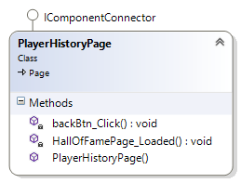

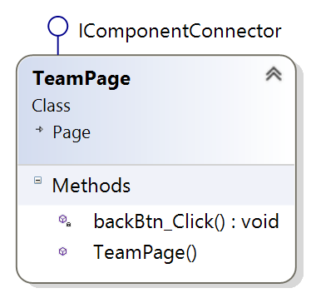

* TeamPage()
  + InitalizeComponent()
* backBtn_Click()
  + If click then it goes back to main window

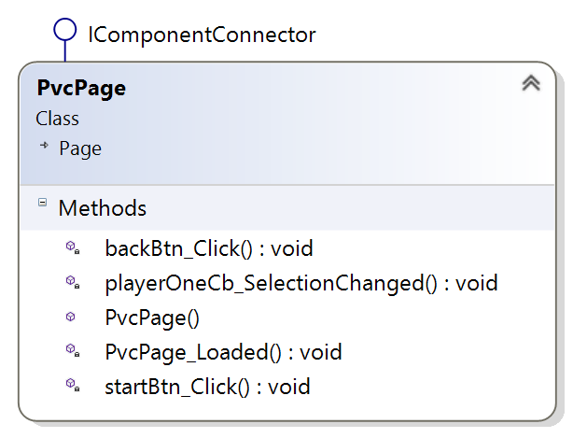

* backBtn_Click()
  + If click then it goes back to main window
* PvcPage()
  + InitializeComponent()
* PvcPage_Loaded()
  + loaded player one name
  + player one button is checked
* startBtn_Click()
  + if player one button is checked then player one goes first
  + if AI easy is checked then AI 1 is assigned
  + if AI medium is checked then AI 2 is assigned
  + if AI hard is checked then AI 3 is assigned
* playerOneCb_SelectionChanged()
  + if player one selected item is not null then start button is enabled
  + else start button is disabled

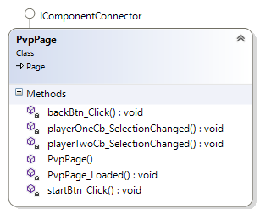

* backBtn_Click
  + It goes to main window page.
* playerOneCb_SelectionChanged
  + If player one and player two selected item is not null and not the same item, the start button is enabled
  + else the start button is disabled
* playerTwoCb_SelectionChanged
  + f player one and player two selected item is not null and not the same item, the start button is enabled
  + else the start button is disabled
* startBtn_Click
  + If player one button is checked then player one goes first
  + else player two goes first

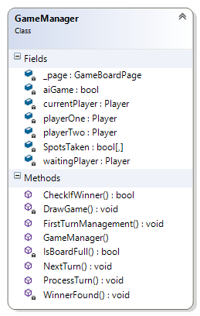

* CheckIfWinner()
  + Checks game board spots taken for winner
* DrawGame()
  + Checks game board spots taken for Draw
* FirstTurnManagement()
  + If player one radio button is checked then player one goes first
  + Else player two or AI goes first
* GameManager()
  + InitializeComponent()
* IsBoardFull()
  + Returns true if all spots are taken
  + Else returns False
* NextTurn()
  + Switches current player and returns new current player’s name
* ProcessTurn()
  + Stores Player move in array
  + If CheckIfWinner is true, then return winner
  + Else if IsBoardFull() is true, then game is draw
  + Else Next players turn
* WinnertFound()
  + Try{Update player stats}
  + Catch{error}

**User Interface Design**

1. Main Window

* The first UI window that appears when the game application starts.

1. EVENT Register New Player button click
2. EVENT Single Player Game button click
3. EVENT Multiplayer Game button click
4. EVENT Player History button click
5. EVENT The Team button click
6. EVENT Exit button click
7. Shutdown the game application
8. Register Window

* This window is displayed to register a new player into the game database.

1. EVENT Save button click
2. EVENT Cancel Button click
3. Team Window

* This window is displayed to view the game development team.

1. EVENT Back button click
2. Player History

* This window displays the player history of registered users of the game.

1. EVENT Back button click
2. Returns to main window.
3. Single Player Game

* This window opens when Player vs. Computer button is clicked.

1. EVENT Start button click

IF (Name selected from Player 1 drop down list) {

Enable Start button }

ELSE (No name selected from Player 1 drop down list) {

Disable Start button }

1. EVENT Back button click
2. Return to main window
3. Multiplayer Game

* This window opens when the Player vs. Player button is clicked.

1. EVENT Start button click

IF (Name selected from Player 1 drop down list = name selected Player 2 drop down list)

{ Disable Start button }

ELSE IF (Name is selected from Player 1 & Player 2 drop down list) {

Enable Start button }

ELSE (No name selected from Player 1 & Player 2 drop down list) {

Disable Start button }

1. EVENT Back button click
2. Return to main window

F. Game Window

* This windows is displayed when the Game window is loaded.

1. EVENT Grid button
   1. Display message for player’s turn
   2. Player select stone
   3. Assign stone to playerone
   4. Disable button for selected stone
   5. Display message for next player’s turn
   6. Player select stone
   7. Assign stone string filename to playertwo