FULL STACK ASSIGNMENT-01
A24126552146
1.Design HTML Web Page (Static)

Aim
To design a static HTML web page for a personal profile, showing details such as about-me, skills, education, hobbies, and contact information, using basic HTML tags.

Program
<!DOCTYPE html>
<html>
<head>
<title>My Static Web Page</title>
</head>
<body>

<h1 align="center">Welcome to My Web Page</h1>
<hr>

<h2>About Me</h2>
<p>
Hello! My name is K.Rakesh.
I am a B.Tech student interested in Artificial Intelligence
and Machine Learning.
</p>

<h2>My Skills</h2>
<ul>
<li>HTML</li>
<li>CSS</li>
<li>Java</li>
<li>Python</li>
</ul>

<h2>My Education</h2>
<table border="1" cellpadding="10">
<tr>
<th>Qualification</th>
<th>Year</th>
<th>Percentage</th>
</tr>
<tr>
<td>B.Tech</td>
<td>2026</td>
<td>85%</td>
</tr>
<tr>
<td>Intermediate</td>
<td>2022</td>
<td>90%</td>
</tr>
<tr>
<td>SSC</td>
<td>2020</td>
<td>95%</td>
</tr>
</table>

<h2>My Hobbies</h2>
<ol>
<li>Learning new technologies</li>
<li>Listening to music</li>
<li>Reading</li>
</ol>

<h2>Contact</h2>
<p>Email: example@gmail.com</p>
<p>Phone: 9876543210</p>
<hr>
<p align="center">
© 2026 My Static Web Page
</p>

</body>
</html>

Output
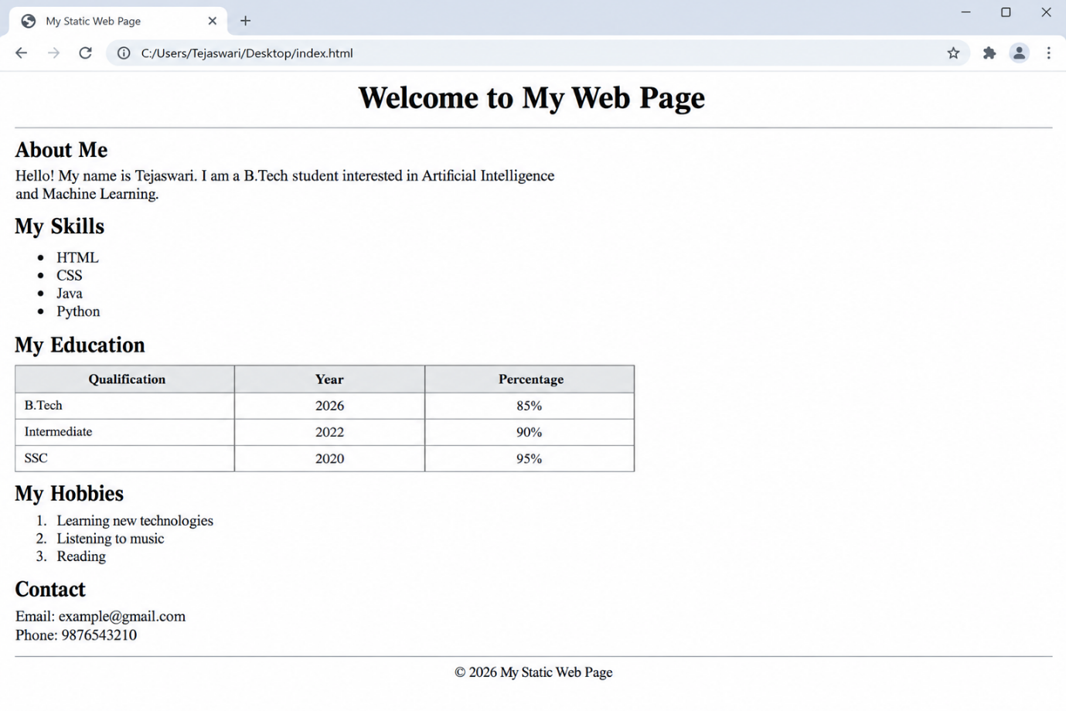

2.Types of CSS

Aim
To write an HTML program that demonstrates the three types of CSS — Inline, Internal, and External — used to style a web page.

Program

index.html
<!DOCTYPE html>
<html>
<head>
<title>Types of CSS</title>

<!-- Internal CSS -->
<style>
body {
font-family: "Times New Roman", serif;
}
.internal-box {
border: 2px dashed black;
padding: 10px;
width: 300px;
}
</style>

<!-- External CSS -->
<link rel="stylesheet" href="style.css">

</head>
<body>

<h1 align="center">Types of CSS</h1>
<hr>

<h2>1. Inline CSS</h2>
<p style="font-weight:bold; text-decoration:underline;">
This line is styled using Inline CSS (style attribute on the tag itself).
</p>

<h2>2. Internal CSS</h2>
<div class="internal-box">
This box is styled using Internal CSS (style written inside the <style> tag in the head).
</div>

<h2>3. External CSS</h2>
<div class="external-box">
This box is styled using External CSS (style written in a separate style.css file).
</div>

</body>
</html>

style.css (external CSS file)
/* External CSS file: style.css */
h2 {
font-family: Arial, sans-serif;
}
.external-box {
border: 2px solid black;
padding: 10px;
width: 300px;
}

Output
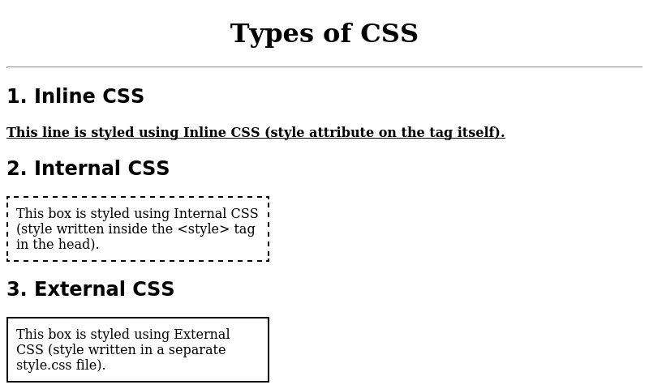
A24126552146
K.Rakesh

