CENG 3420 Lab1 Report

Name: Tam Rocky Lok Ki SID:1155158247

Lab1.1

Step by step algorithm:

I need to define two variable var1 and var2, which is stored with 15 and 19 respectively. After that, the program will print the address of them which is using la a0, var1 and var2 to print the address with address 268500992, and 268500996. Then, I use addi to increase var1 by 1 and use li t0, 4 and mul a0, a0, t0 to load the imm 4 and multiply with the var2. After that we will get 16 and 76. Finally, we need to swap the two number which var1 is 16 and var2 is 76. I use lw to load the word to the address and la for remembering the address. After that sw to store back the word to the remembered address.

Main Code:

Print Address: Add and Multiply: Swap:

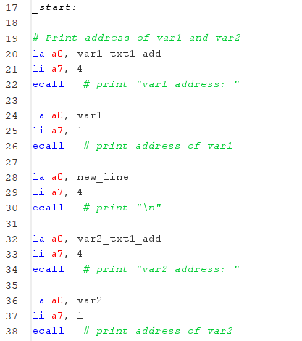 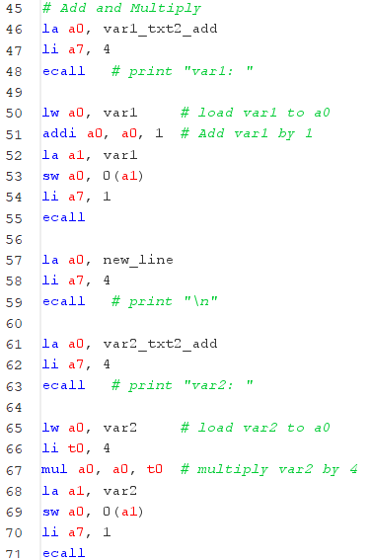 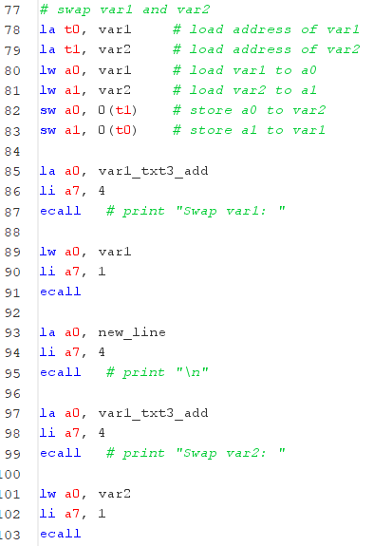

Console results:

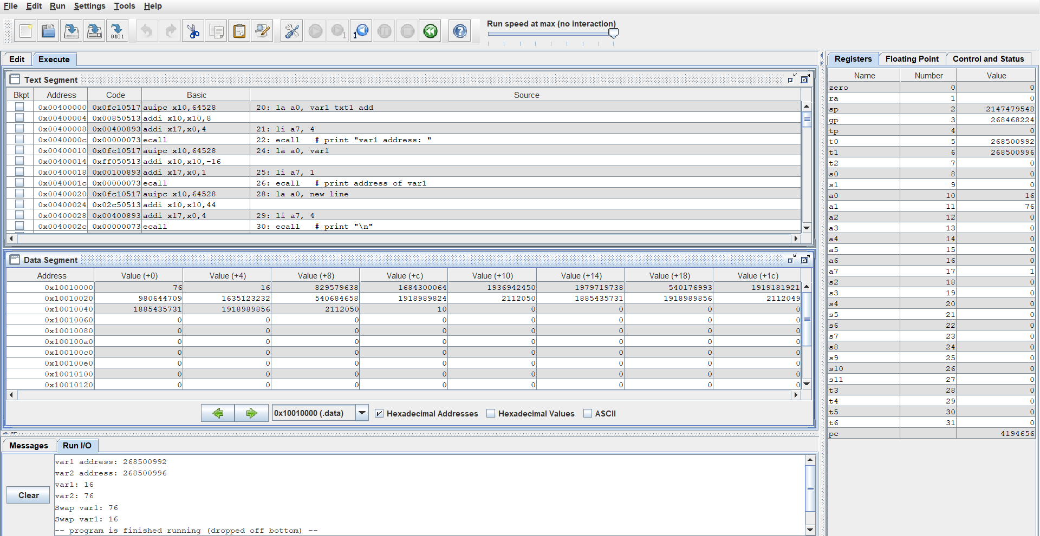

Lab1.2

Step by step algorithm:

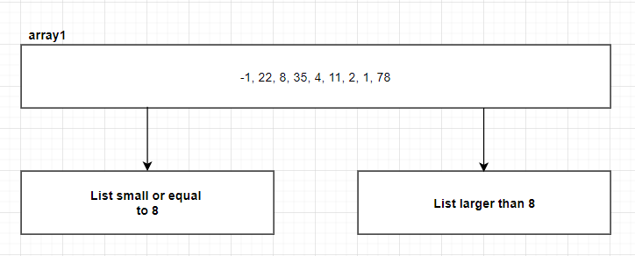In this lab, 8 is the middle value. The left-hand side will have -1, 1, 2, 4, 5 and the right-hand side will have 11, 22, 35, 78. The method will be shown in the graph below:

1)

I am going to separate array1 which two list which is the list that small and equal to third element 8 and the list larger than 8.

2) 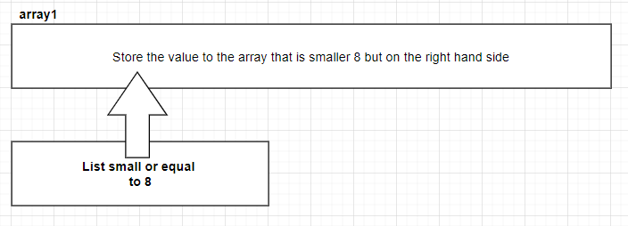

First, I store the value that smaller than the third element 8.

3) 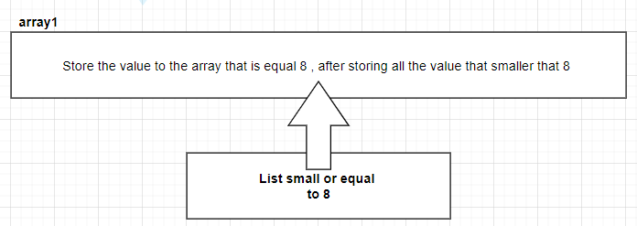

After storing all the smaller value, than we can store the third element of 8 to the array1.

4) 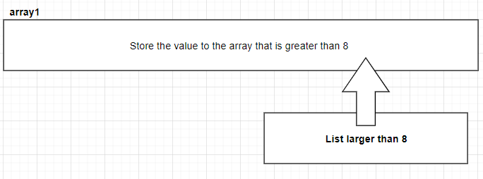

Finally, we store the remain element that is smaller than the third element of 8 to the array1.

At last the array1 will be replaced by the new arrangement to fit the requirement.

C Code:

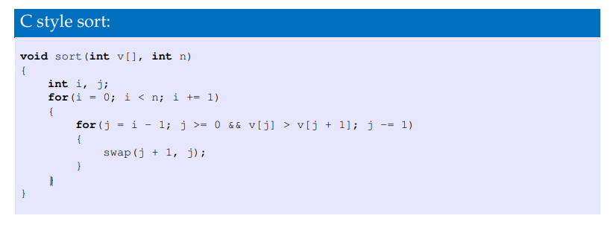

Console results:

Input:

Output:



Lab1.3

Step by step algorithm:

Assembly implementation function:

(quick sort function) (print function) (_start)

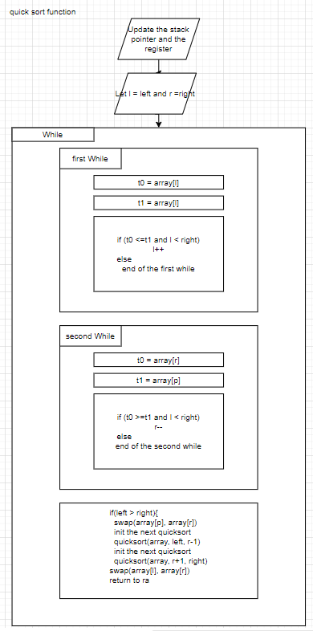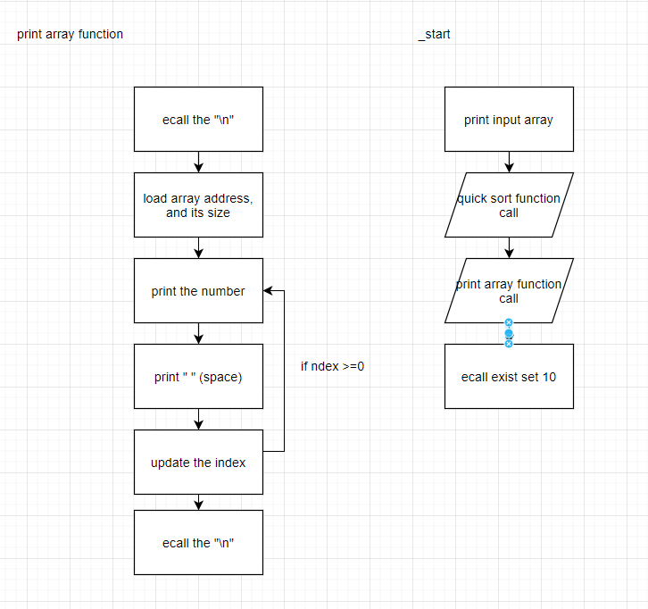

Assembly key code:

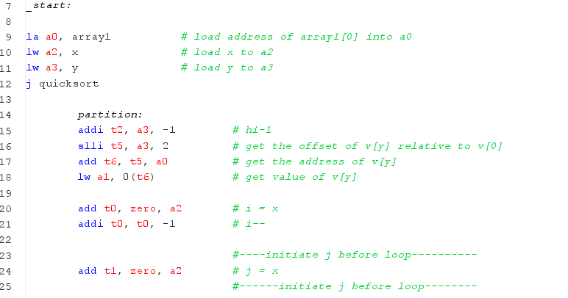

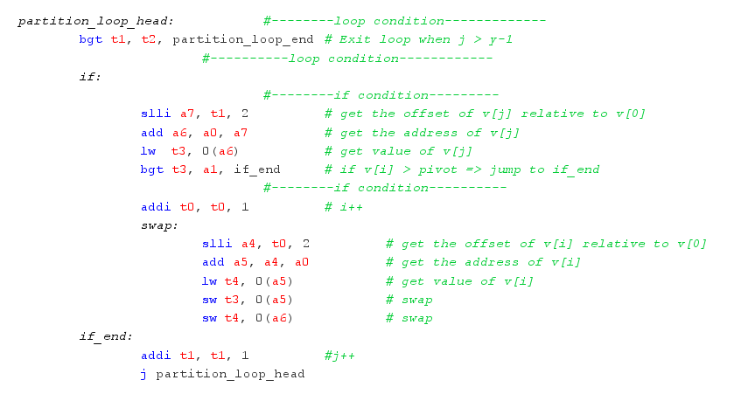

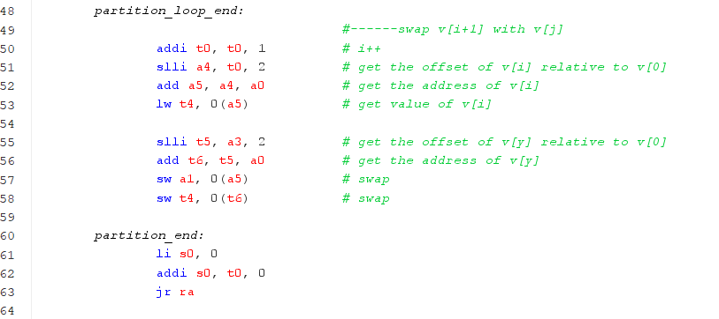

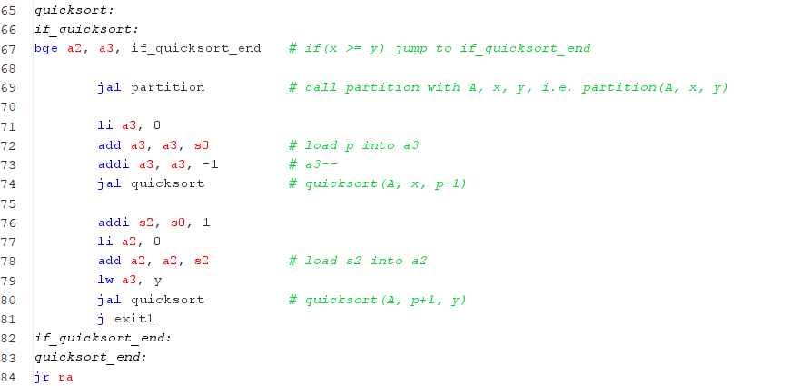

Console results:

