The adjacency cinstraint - ограничение грида на генерацию

NP-complete problem - время решения растёт експоненциальнос проблемой

Solution – разбить на части

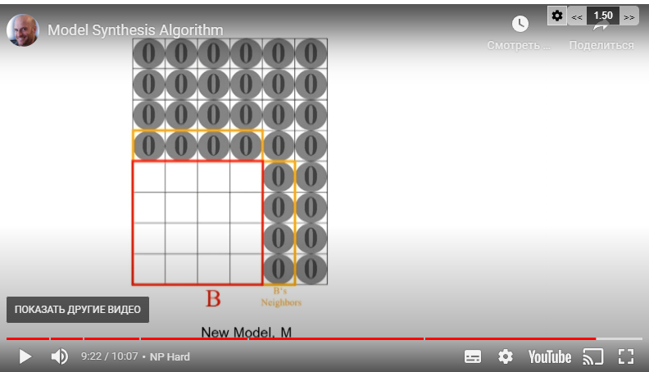

Model synthesis more on 3d

WFC more on 2d

Backtracking

Entropy

* How frequently element meets in example model => calculate entropy from this

Overlapping WFC

In different locations uses different probability for different elements to calculate entropy. (For example in dangeon tree has lower probability(or weights) than in forest or like that)

Overlapping 2x2 and Overlapping 3x3 => pattern from example meets much frequently

AC-4 faster than AC-3 algorithm ()

Fixed tiles

* Fix the entrance and exit points of a level
* Pre-author some content, and let WFC draw around it.
* Generate parts of the level with a different algorithm, then fill in the details
* Draw the boundary / floorplan for the level, and let WFC fill in the interior

Burst compiler | job system (when generating chunks)

Random path generation

