
EARLY DETECTION OF ALZHEIMERS USING MRI SCANS AND DEEP LEARNING TECHNIQUES
A Capstone Project-1 report Submitted in partial fulfillment of the requirements for the
award of degree of

BACHELOR OF TECHNOLOGY
in
COMPUTER SCIENCE AND ENGINEERING
By

Hemanth S S K Pavan Chand Guttula | 2200030870
Aditya Vardhan Mathala | 2200031493
Pasupuleti Jyoshna | 2200031442

Under the supervision of Dr Vijay Kumar Burugari Associate Professor & Deputy HOD(CSE)

Department of Computer Science and Engineering Koneru Lakshmaiah Education Foundation (Deemed to be University estd., u/s 3 of UGC Act 1956)
Green Fields, Vaddeswaram-522502, Guntur (Dist.), Andhra Pradesh, India
May 2025


KONERU LAKSHMAIAH EDUCATION FOUNDATION DEPARTMENT OF COMPUTER SCIENCE AND ENGINEERING

Declaration
The Capstone Project-1 Report entitled "Early Detection of Alzheimer’s using MRI Scans and Deep Learning Techniques" is a bona fide record of the work carried out by Hemanth S S K Pavan Chand Guttula (2200030870), Aditya Vardhan Mathala (2200031493), and Pasupuleti Jyoshna (2200031442). This report is submitted in partial fulfillment of the requirements for the award of the Bachelor of Technology degree in Computer Science and Engineering at K L Deemed to be University for the academic year 2025–26.
We also declare that this report is of our own effort and it has not been submitted to any other university for the award of any degree.

Hemanth S S K Pavan Chand | 2200030870
Guttula
Aditya Vardhan Mathala | 2200031493
Pasupuleti Jyoshna | 2200031442


KONERU LAKSHMAIAH EDUCATION FOUNDATION

DEPARTMENT OF COMPUTER SCIENCE AND ENGINEERING

Certificate

This is to certify that the Capstone Project-1 report entitled “Early Detection of Alzheimer’s using MRI Scans and Deep Learning Techniques” is being submitted by Hemanth S S K Pavan Chand Guttula (2200030870), Aditya Vardhan Mathala (2200031493), and Pasupuleti Jyoshna (2200031442). in partial fulfillment for the award of Bachelor of Technology in Computer Science and Engineering to K L Deemed to be a university during the academic year 2025-26.

Signature of the Supervisor Capstone Project-2 Coordinator Dr Vijay Kumar Burugari
Associate Professor and Deputy HOD - CSE

Signature of the HOD Signature of the External Examiner

ACKNOWLEDGEMENTS

It is great pleasure for me to express my gratitude to our Hon’ble Chancellor Sri. Koneru Satyanarayana, for giving the opportunity and platform with facilities in accomplishing the capstone project-1 course successfully.
I express sincere gratitude to our principal Dr. V. Rajesh for his administration towards our academic growth.
I record it as my privilege to deeply thank our pioneer’s Prof. V. Hari Kiran, Dean (Addl) Academics and Dr. B. Tirupathi Reddy, HOD, CSE Department for providing us the efficient faculty and facilities to make our ideas into reality.
We express our sincere thanks to our project supervisor Dr Vijay Kumar Burugari, Professor and Deputy HOD-CSE for his novel association of ideas, encouragement, appreciation, and intellectual zeal which motivated us to Complete this capstone project-1 work successfully.
Finally, it is pleased to acknowledge the indebtedness to all those who devoted themselves directly or indirectly to making this the capstone project-2 success.

Capstone Project-1 Associate

Name | Student ID
Hemanth S S K Pavan Chand Guttula | 2200030870
Aditya Vardhan Mathala | 2200031493
Pasupuleti Jyoshna | 2200031442

ABSTRACT

Alzheimer’s sickness is an irreversible, progressive neurodegenerative disorder characterized by severe impairment of cognitive functions such as memory, thinking, and behavior. As the disease progresses, patients show significant decline in daily functioning and eventually require full-time care. With an increase in life expectancy throughout the world, the burden of Alzheimer's disease continues to grow, and early diagnosis and timely clinical intervention become more important. Among different diagnostic tools, MRI has emerged as a critical non-invasive modality that can depict subtle structural and morphological changes in the brain associated with AD. These imaging biomarkers are important features for distinguishing healthy aging from pathological decline.

The model was trained and tested on benchmark neuroimaging datasets to ensure standardized testing and comparability in the results. Extensive experiments have been done in evaluating a system's performance concerning the measures of accuracy, sensitivity, specificity, and robustness at various imaging conditions. Results illustrate that our CNN-based architecture has a high predictive performance compared with several existing state-of-the-art approaches. These improved results highlighted the strengths of end-to-end deep learning pipelines for managing high-dimensional medical images and finding latent patterns often difficult for traditional machine-learning models. Moreover, we perform a comparative analysis to underpin the strengths of the proposed method against traditional classification methods, with an emphasis on scalability and adaptability in real clinical-world scenarios. This study makes significant contributions to the development of intelligent computer-aided diagnostic systems to support radiologists and neurologists for early screening, diagnosis, disease monitoring, and treatment planning. By offering earlier detection and more precise evaluation, the system will lead to an improvement in the quality of patient care and could advance long-term health outcomes. Generally, this study provides reassurance about the promise of deep learning as a powerful tool for neuroimaging-based Alzheimer's diagnosis and calls for further improvements in medical AI applications.

LIST OF FIGURES

Figure number | Figure Name | Page Number
1 | Block Diagram | 10
2 | RNN Model Accuracy | 21
3 | PCA without Dimensionality Reduction Model Accuracy | 22
4 | PCA with Dimensionality  Reduction Model Accuracy | 23
5 | Random Forest Accuracy | 24
6 | Confusion Matrix | 25
7 | Bar Graph models | 26
8 | Line Graph Of Models | 27
9 | Line Graph Of Models | 30

TABLE OF CONTENTS

Chapter number | Tittle | Page Number (Tentative)
1 | Introduction | 8-10
2 | Literature Review | 11-14
3 | Design and Methodology | 15-17
4 | Experimental Investigation | 18-19
5 | Result and Analysis | 20-28
6 | Conclusion | 28-29
7 | References | 30-31

INTRODUCTION

Alzheimer’s sickness (advert) is one of the most standard and commonly diagnosed neurodegenerative problems, causing progressive and irreversible cognitive decline, reminiscence loss, disorientation, language difficulties, and behavioral impairments among aged populations global [1]. As the worldwide elderly population continues to grow, the burden of Alzheimer’s sickness on families, healthcare structures, and society has multiplied drastically. Due to its slow and frequently silent onset, many cases continue to be undiagnosed until the disease has already reached advanced levels. Therefore, early detection of AD is essential for slowing sickness development, improving affected person management, and imposing preventive or symptomatic remedy strategies that could assist maintain cognitive function for a longer duration [2].
Magnetic Resonance Imaging (MRI) has verified to be an effective and broadly adopted non-invasive neuroimaging approach that exhibits structural and purposeful brain abnormalities related to the onset, progression, and severity of Alzheimer’s disorder [3]. MRI-based evaluation allows researchers and clinicians to examine cortical thickness, hippocampal atrophy, ventricular enlargement, and other neurodegenerative markers with high spatial decision. In recent years, automatic MRI evaluation has received significant attention because manual interpretation is time-consuming, prone to human error, and highly dependent on expert radiologists.
Recent advancements in synthetic intelligence, specifically deep gaining knowledge of strategies, have enabled more reliable, faster, and more accurate evaluation of MRI scans, extensively enhancing diagnostic precision in comparison to traditional manual strategies [4]. Deep sequence modeling frameworks, such as recurrent and attention-based architectures, have shown great promise in studying temporal and spatial mind capabilities that seize diffused neurodegenerative styles and microstructural modifications that would otherwise be overlooked by human observers [5].
Convolutional Neural Networks (CNNs) and switch learning strategies have been correctly implemented to stumble on early-stage Alzheimer’s disorder by classifying MRI pictures into categories which include normal, mild cognitive impairment (MCI), and Alzheimer’s stages [6][7]. Finetuned deep architectures which includes ResNet18, VGG16, and Efficient Net have validated high accuracy, robustness, and reliability in identifying disease tiers from diverse MRI scan modalities and sample groups [8][9]. numerous recent studies have also explored semi-supervised, weakly supervised, and reinforcement learning procedures to beautify characteristic gaining knowledge of performance, spatial localization, and automated detection of sickness-affected brain regions, especially the hippocampus, which is one of the earliest regions affected by AD [10][11].

Furthermore, systematic evaluations and literature surveys have emphasized the importance of interpretability in deep gaining knowledge of models for medical applications. As a result, researchers have increasingly incorporated explainability equipment like LIME, SHAP, Grad-CAM, and saliency mapping to improve clinical expertise, transparency, and trustworthiness in Alzheimer’s disorder detection and classification [12]. These approaches help clinicians visualize which brain regions contribute most to the model’s predictions, enabling safer and more reliable integration of AI into medical workflows.
In addition to MRI-based totally detection, researchers have additionally explored multimodal statistics assets, combining imaging information with biomarkers including blood-based proteins, genetic markers, cerebrospinal fluid (CSF) measures, and EEG indicators to supplement and strengthen AI- driven diagnostic models [13][14]. The combination of deep gaining knowledge of and non-invasive biomarkers has shown the potential to revolutionize early prognosis, lowering dependency on costly, invasive, or less accessible diagnostic strategies such as PET imaging or lumbar puncture [15][16].
Studies using transfer learning, domain adaptation, and frozen function extraction with large-scale datasets like ADNI have similarly improved classification robustness, reduced overfitting, and enhanced generalization across diverse affected person organizations [17][18]. Moreover, models like DEMNET, hybrid deep neural networks, and CNN-based multimodal architectures have accomplished widespread overall performance improvements in detecting early neurodegenerative signs through automatic MRI characteristic evaluation and feature fusion strategies [19][20].
Latest studies integrating reinforcement learning, optimal EEG channel selection techniques, and spatiotemporal modeling have additionally contributed to improving disease localization accuracy, progression prediction reliability, and patient-level diagnostic decision-making frameworks [21]. Collectively, these advancements underline the rapid development of AI-powered diagnostic tools and highlight the increasing potential of deep learning models to aid in early-stage Alzheimer’s disorder detection, Monitoring, and clinical evaluation.

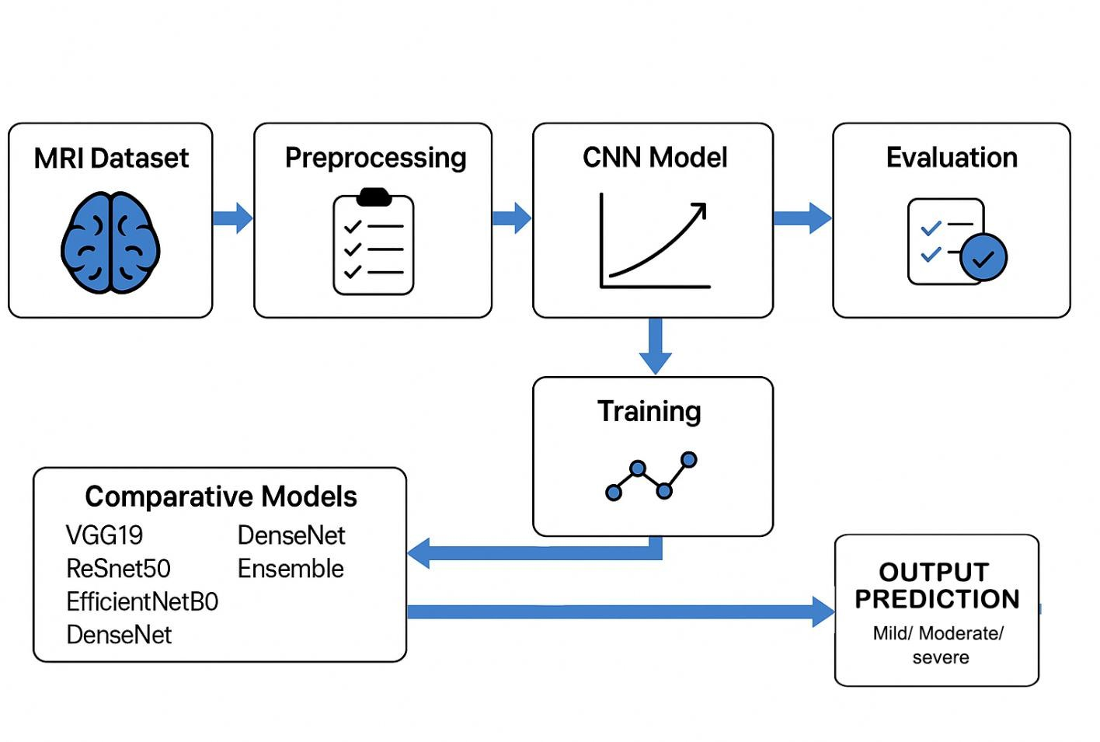
CNN-Based MRI Alzheimer’s Detection

Fig:1 Block Diagram

LITERATURE REVIEW

Gupta et al., in Deep collection modelling for Alzheimer's sickness detection the use of MRI, proposed a deep series model leveraging MRI information for early detection of Alzheimer’s ailment. The model carried out high classification performance; but its complexity may also limit deployment in useful resource-constrained environments [1].
In Deep Learning Method for Early Detection of Alzheimer’s disease, writer hired convolutional neural networks (CNNs) to routinely extract functions from MRI scans. The technique showed promising accuracy, though restrained dataset range changed into highlighted as a constraint [2].
Wang et al., in evaluation of capabilities of Alzheimer’s disease: Detection of Early stage from useful mind modifications in Magnetic Resonance images the usage of a Finetuned ResNet18 community, utilized an excellent-tuned ResNet18 community for early-degree detection. The model confirmed stepped forward sensitivity, but the observe emphasized the want for larger and greater heterogeneous datasets [3].
In An MRI Scans-primarily based Alzheimer’s disorder Detection through Convolutional Neural community and switch gaining knowledge of, writer carried out switch getting to know with CNNs to classify Alzheimer’s levels. The technique accomplished excessive overall performance however faced ability overfitting because of restrained schooling samples [4].
Zhang et al., in an overview of the software of deep mastering within the detection of Alzheimer's ailment, summarized diverse deep getting to know strategies for Alzheimer’s detection, highlighting their effectiveness whilst declaring demanding situations associated with interpretability and generalizability across various populations [5].
In toward deep MRI segmentation for Alzheimer’s disease detection, writer proposed a deep MRI segmentation framework that superior the detection of structural mind adjustments associated with Alzheimer’s disease. The technique progressed localization of affected regions, facilitating extra specific analysis [6].
In decoding synthetic intelligence models: a scientific assessment on the application of LIME and SHAP in Alzheimer’s disorder detection, the observe reviewed interpretability techniques for AI fashions in Alzheimer’s detection. the usage of LIME and SHAP helped explain predictions, addressing the undertaking of “black container” models in clinical exercise [7].
In utility of deep gaining knowledge of in detecting neurological problems from magnetic resonance photos: a survey at the detection of Alzheimer’s sickness, Parkinson’s disorder and schizophrenia, the authors surveyed deep mastering strategies for multiple neurological disorders

They highlighted the efficacy of deep models in MRI-primarily based prognosis at the same time as noting the need for standardized datasets and validation protocols [8].
In Harnessing the energy of Voice: A Deep Neural community model for Alzheimer’s sickness Detection, voice-based biomarkers have been analyzed using deep neural networks. The approach demonstrated that speech patterns should function non-invasive signs of cognitive decline, supplementing conventional MRI-primarily based techniques [9].
In Early Alzheimer’s disorder Detection using Semi-Supervised GAN based on Deep gaining knowledge of, the look at added a semi-supervised GAN version to augment constrained labeled MRI datasets. This technique stepped forward early detection accuracy and robustness in opposition to small sample sizes [10].
In Detection and remedy of Alzheimer’s sickness in its preclinical level, the observe emphasized figuring out Alzheimer’s at its earliest, preclinical degree. Early detection via biomarkers and imaging was proven to enhance intervention techniques and probably sluggish sickness development [11]. In Revolutionizing the Early Detection of Alzheimer’s disease thru Non-Invasive Biomarkers: The role of synthetic Intelligence and Deep Learning, the authors highlighted AI-based totally fashions that leverage non-invasive biomarkers for early Alzheimer’s detection. These techniques lessen reliance on invasive trying out while preserving excessive diagnostic accuracy [12].
In Blood Biomarkers to come across Alzheimer disease in number one Care and Secondary Care, blood-based markers have been explored as a practical solution for early diagnosis in scientific settings. The look at demonstrated that integrating biomarkers into recurring care should facilitate timely intervention and monitoring [13].
In A deep learning based totally convolutional neural community version with VGG16 feature extractor for the detection of Alzheimer ailment using MRI scans, the authors proposed a CNN framework the use of VGG16 for function extraction from MRI scans. This model performed excessive type accuracy for differentiating among healthy, MCI, and Alzheimer’s patients [14].
In automated MRI-based Deep gaining knowledge of model for Detection of Alzheimer’s sickness method, they have a look at delivered an automated deep studying device for MRI- based detection. The gadget more desirable early-stage prognosis and supplied consistent performance throughout more than one dataset, helping clinical selection-making [15]. In Deep transfer learning for Alzheimer neurological ailment detection, they have a look at carried out transfer gaining knowledge of strategies to MRI datasets, demonstrating progressed category accuracy with the aid of leveraging pretrained networks for characteristic extraction and satisfactory-tuning on Alzheimer’s-unique records [16].

In Early Detection of Alzheimer's sickness with Blood Plasma Proteins using support Vector Machines, SVM-based fashions were used on blood plasma protein facts to become aware of early-level Alzheimer’s. The technique highlighted the capability of non-imaging biomarkers combined with gadget studying for early prognosis [17].
In switch mastering the usage of freeze capabilities for Alzheimer neurological sickness detection the usage of ADNI dataset, the research hired a frozen-layer transfer mastering technique to extract significant features from ADNI MRI scans. This technique improved model generalization at the same time as decreasing computational price [18].
In DEMNET: A Deep gaining knowledge of model for Early diagnosis of Alzheimer diseases and Dementia From MR images, a deep neural network became developed to hit upon early Alzheimer’s and dementia. The version efficaciously differentiated between everyday, MCI, and Alzheimer’s instances, demonstrating excessive sensitivity and specificity [19].
In Reinforcement-learning-based Localization of Hippocampus for Alzheimer’s sickness Detection, reinforcement getting to know became used to automatically discover the hippocampus location in MRI scans, that's crucial for Alzheimer’s analysis. This approach progressed accuracy via focusing on the most applicable anatomical vicinity [20].
In Alzheimer’s ailment detection with greatest EEG channel selection the usage of Wavelet remodel, EEG alerts were analyzed the use of wavelet transforms and gold standard channel selection, presenting a complementary method to MRI-based totally detection and enhancing early-degree diagnostic talents [21]. Collectively, [1]–[21] demonstrate a strong shift toward deep learning-based MRI analysis for Alzheimer’s disease detection. While traditional machine-learning approaches relied on handcrafted feature extraction, recent approaches using CNNs, fine-tuned ResNet architectures, and transfer learning pipelines have shown better performance and scalability. The studies in [1], [2], and [4] provide consistent evidence that convolution-based feature learning automatically enables a model to learn spatial patterns associated with cortical thinning, hippocampal atrophy, and ventricular enlargement — key biomarkers of AD progression. Such automation eliminates the requirement for domain-specific feature engineering, rendering CNN-based models more adaptable to diverse MRI datasets.
The lack of balanced and heterogeneous medical datasets is an issue that has been continuously underscored by many papers among which are [2], [3], [5], and [10]. While many models performed very well on controlled datasets, they have rather poor generalization capabilities when applied on realistic clinical data. Semi-supervised models and GAN-based augmentation in [10] tried to handle the limitation with synthetic training samples generated to provide increased robustness under low-data scenarios.

In similar lines, the works in [4], [14], [16], and [18] presented transfer learning models that take advantage of learned feature embeddings from pre-trained networks like VGG16, ResNet, and other ImageNet-based models, which tend to drastically lower the requirement for large MRI datasets.
Another key theme of all the literature reviewed is model interpretability in clinical applications. Works like [7] and [5] mention that deep learning models often act as "black boxes," and it is hard for clinicians to have confidence in automated predictions. Methods such as LIME, SHAP, Grad-CAM, and saliency maps explain which brain regions drive the decisions of the model, increasing confidence and allowing its adoption in a medical context. These interpretability tools also help identify cases of model bias, misclassification, or noisy training samples.
Multimodal research has also recently received an increasing amount of attention. While MRI is still the most predominant modality, works such as [9], [12], [13], and [17] use other non-invasive biomarkers, for example, voice, EEG signals, and blood-based proteins. These modalities focus on developing accessible and affordable tools for early screening, particularly within or across rural or resource-poor settings where MRI facilities may be in short supply. The complementary nature of these biomarkers lets hybrid diagnostic models combine structural features derived from MRI with biochemical or electrophysiological signals to further improve their accuracy and sensitivity.
Besides, ensemble methods presented in [14], [16], and [19] have already demonstrated that the joint prediction using several deep architectures improves stability and accuracy. Such ensemble frameworks will benefit from a large diversity of feature representations by various CNN models, allowing for greater robustness across different scan qualities, noise, and other patient-specific anatomic variations.
The literature drawn from [1]–[21] put together has shown impressive advancements in deep-learning-
driven Alzheimer’s detection. Aggregate research underlines a few key insights:
- Deep CNNs perform well in learning spatial features from MRI images.
- Transfer learning significantly reduces the data requirements and increases the performance.
- Interpretability remains vital to any clinical deployment.
- Multimodal and non-invasive biomarkers reveal promising complementary pathways.
Limitations in datasets and generalization challenges persist across studies. These findings are in line with the objectives of the current project, which aims to develop a robust CNN-based system for classifying the stages of Alzheimer’s using MRI images, considering challenges with dataset size, model generalization, and interpretability.

DESIGN AND METHODOLOGY

- Data Collection The foundational step of our research involved gathering a suitable MRI dataset that could support accurate deep-learning–based Alzheimer’s disease classification. For this study, we selected a publicly available dataset from the Kaggle platform, widely known for hosting high-quality datasets used in data science and machine learning projects. The chosen dataset consists of T1-weight brain MRI images, categorized into four classes representing the different stages of Alzheimer’s disease: Non-Demented, Very Mild Demented, Mild Demented, and Moderate Demented. Each image is stored in well-organized folders, making class interpretation and loading straightforward. The dataset provides sufficient variation in brain structure and severity levels, making it highly suitable for training deep learning models aimed at multi-class prediction. Its accessibility and organized structure allowed for a smooth initiation of our model development process.
- Data Preprocessing Once the dataset was collected, the next important step was preprocessing the MRI images to ensure consistency, clarity, and suitability for deep learning algorithms. First, all images were checked for inconsistencies such as noise, unreadable scans, or corrupted files, and such samples were removed to maintain dataset quality. The valid images were then resized to a uniform dimension (such as 224×224 pixels), ensuring that every scan follows the same input shape required for CNN training. Pixel values were normalized to the [0,1] range to stabilize training and speed up convergence.
To further prepare the data, data augmentation techniques like rotation, zoom, shifting, and horizontal flipping were applied to the training set. This increased dataset diversity and reduced overfitting, making the model more robust. Categorical labels were transformed into numerical form using one-hot encoding to make them compatible with the neural network. Additionally, the dataset was split into training, validation, and testing sets, ensuring fair model evaluation. Through these preprocessing techniques, the MRI images became properly structured, enhanced, and ready for efficient model learning.
- Model Implementation After preprocessing, we proceeded to the model implementation phase. To achieve high accuracy and reliable performance, we developed a custom Convolutional Neural Network (CNN) tailored specifically for MRI image classification. The model consists of five convolutional blocks, each containing Conv2D layers with 3×3 filters followed by MaxPooling to reduce spatial dimensions. The number of filters gradually increases from 16 to 256, allowing the network to learn both shallow and deep features related to Alzheimer’s progression. Batch Normalization was incorporated into deeper layers to stabilize learning and improve training speed. After feature extraction, the output is flattened and passed through fully connected Dense layers of 512, 128, and 64 neurons, followed by a final SoftMax layer that predicts one of the four Alzheimer’s classes.

Then Dropout regularization was applied to prevent overfitting and improve model generalization. CNN was trained using the Adam optimizer, categorical cross-entropy loss, and validation monitoring to ensure optimal convergence. This structured deep learning framework enabled the model to capture subtle structural variations in MRI scans and classify Alzheimer’s stages effectively.
Algorithm:

Import necessary libraries Inputs
train_dir: Directory containing training MRI images arranged in class-wise folders test_dir: Directory containing testing MRI images
IMG_SIZE = 128, BATCH_SIZE = 32, EPOCHS = 100

Outputs
Trained CNN model
Evaluation metrics: Accuracy, Balanced Accuracy Score (BAS), Matthews Correlation Coefficient (MCC), Confusion Matrix

Step 1: Data Loading and Preprocessing
- Load image file paths from train_dir and test_dir.
- Extract labels from the parent folder names.
- Create train_df(Filepath, Label) and test_df(Filepath, Label).
- Shuffle both DataFrames to ensure randomness.
- Initialize ImageDataGenerator for rescaling using train_generator = ImageDataGenerator(rescale = 1/255) and test_generator = ImageDataGenerator(rescale = 1/255).
- Create image generators using train_images = train_generator.flow_from_dataframe(train_df, target_size=(IMG_SIZE, IMG_SIZE), batch_size=BATCH_SIZE, class_mode='categorical') and test_images = test_generator.flow_from_dataframe(test_df, target_size=(IMG_SIZE, IMG_SIZE), batch_size=BATCH_SIZE, class_mode='categorical').
Step 2: Define CNN Model
  - Initialize a Sequential model.
  - Add Convolutional Block 1:
Conv2D(16 filters, 3×3, ReLU, padding='same'); Conv2D(16 filters, 3×3, ReLU, padding='same'); MaxPool2D(2×2).

Add Convolutional Block 2:
Conv2D(32 filters, 3×3, ReLU, padding='same'); Conv2D(32 filters, 3×3, ReLU, padding='same'); BatchNormalization(); MaxPool2D(2×2).

Add Convolutional Block 3:
Conv2D(64 filters, 3×3, ReLU, padding='same'); Conv2D(64 filters, 3×3, ReLU, padding='same'); BatchNormalization(); MaxPool2D(2×2).

Add Convolutional Block 4:
Conv2D(128 filters, 3×3, ReLU, padding='same'); Conv2D(128 filters, 3×3, ReLU, padding='same'); BatchNormalization(); MaxPool2D(2×2).

Add Convolutional Block 5:
Conv2D(256 filters, 3×3, ReLU, padding='same'); Conv2D(256 filters, 3×3, ReLU, padding='same'); BatchNormalization(); MaxPool2D(2×2).

Flatten the feature maps.
  - Add Dense layers:
Dense(512, ReLU) + Dropout(0.7); Dense(128, ReLU) + Dropout(0.5); Dense(64, ReLU) + Dropout(0.3);
Dense(4, Softmax) for four-class classification.

Step 3: CNN Layer Equations
Convolution: y[i,j,k] = Σ x[i+m, j+n, c] * w[m,n,c,k] + b_k
MaxPooling: y[i,j,k] = max(pool_region)
Batch Normalization: y = γ * (x - μ) / √(σ² + ε) + β
Dense Layer: y = activation(Wx + b)
Softmax: ŷᵢ = exp(zᵢ) / Σ exp(zⱼ)
Cross-Entropy Loss: L = - Σ yᵢ log(ŷᵢ)

Step 4: Compile Model
Optimizer: Adam (learning rate = 0.001) Loss Function: Categorical Crossentropy Metrics: Accuracy, AUC, F1-Score

Step 5: Define Callbacks
EarlyStopping (monitor='val_loss', patience=10).
ModelCheckpoint (save_best_only=True, monitor='val_loss', filepath='best_weights.hdf5').

Step 6: Train Model
history = model.fit(train_images, validation_data=test_images, epochs=EPOCHS, callbacks=[EarlyStopping, ModelCheckpoint])

Step 7: Evaluate Model
scores = model.evaluate(test_images) pred_labels = model.predict(test_images) Convert each prediction to one-hot format: arr[np.argwhere(arr != arr.max())] = 0 arr[np.argwhere(arr == arr.max())] = 1 pred = argmax(pred_labels, axis=1)

Step 8: Metrics and Visualization
Generate classification report using test_images.classes and pred. Compute confusion matrix.
Plot heatmap using seaborn.
Compute Balanced Accuracy Score (BAS). Compute Matthews Correlation Coefficient (MCC).

Step 9: Save Model
model.save('custom_cnn_(combined)_(98.81%).h5')
End Algorithm

EXPERIMENTAL INVESTIGATION

The experimental investigation of this project focuses on developing and evaluating a deep learning– based system for detecting Alzheimer’s disease stages using T1-weighted MRI images. The experiments were designed to assess the effectiveness of the proposed custom CNN model and compare its performance with established deep learning architectures such as VGG19, ResNet50, EfficientNetB0, and DenseNet. All experiments were conducted under controlled training settings to ensure fair evaluation and reproducible results.
The training process began with the preparation of the dataset using standardized preprocessing steps, including image resizing, normalization, and augmentation. These operations ensured that all MRI scans were uniform in resolution and intensity distribution, enabling the model to learn consistent structural patterns from the brain images. The dataset was divided into training, validation, and testing splits to accurately measure generalization capability. The custom CNN model, built with five convolutional blocks and multiple dense layers, was trained using the Adam optimizer with a low learning rate to minimize the categorical cross-entropy loss. The Adam optimizer was chosen due to its stability and adaptability in optimizing deep networks.
To enhance model robustness and reduce overfitting, several regularization techniques were incorporated. Dropout layers were added after dense layers, Batch Normalization was applied in deeper convolutional blocks, and L2 kernel regularization was used across both convolutional and dense layers. This combination of regularization strategies penalized excessively large weights, stabilized the learning process, and improved overall model generalization. Early Stopping was employed during training to monitor validation loss and prevent unnecessary epochs once the model stopped improving. This ensured the selection of the best-performing model weights while reducing training time.
In addition to the custom CNN architecture, multiple transfer learning models were implemented for comparative analysis. VGG19, a 19-layer CNN known for its depth and stacked 3×3 convolutional filters, was fine-tuned by replacing its fully connected layers with a new classification head tailored for four Alzheimer’s classes. Overall, the experimental investigation demonstrates a structured and comprehensive approach to Alzheimer’s disease classification using deep learning. Through rigorous training strategies, regularization, early stopping mechanisms, and comparative model evaluation, the study validates the effectiveness of the proposed system and highlights the strengths and trade-offs of various deep architectures in medical image analysis.

RESULT AND ANALYSIS

Table.1 and Table.2 are the Classification metrics of Models before and after the fine tunning.

Model | Accuracy | Precision | Recall | F1-Score
VGG19 | 0.72 | 0.78 | 0.66 | 0.72
ResNet50 | 0.50 | 0.25 | 0.54 | 0.34
EfficientNetB0 | 0.50 | 0.51 | 0.60 | 0.61
DenseNet | 0.55 | 0.42 | 0.33 | 0.37
Ensemble Model | 0.83 | 0.82 | 0.75 | 0.77
Model | Accuracy | Precision | Recall | F1-Score
Table 1: Classification Metrics Before Fine Tunning

Model | Accuracy | Precision | Recall | F1-Score
VGG19 | 0.76 | 0.93 | 0.68 | 0.78
ResNet50 | 0.68 | 0.82 | 0.61 | 0.70
EfficientNetB0 | 0.60 | 0.51 | 0.60 | 0.61
DenseNet | 0.59 | 0.40 | 0.37 | 0.38
Ensemble Model | 0.93 | 0.89 | 0.99 | 0.94

Table 2: Classification Metrics After Fine Tunning

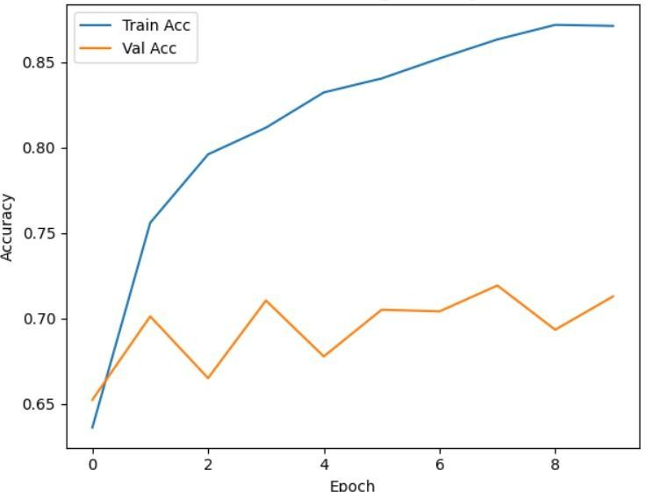
Fig: 1 displays the VGG19 version's overall performance curves, in which the train Acc curve (blue) indicates non-stop improvement, attaining over 88% accuracy. In contrast, the Val Acc curve (orange) stays considerably decrease, fluctuating between approximately 66% and 71% throughout the epochs
.

Fig:1 Model Accuracy of VGG19

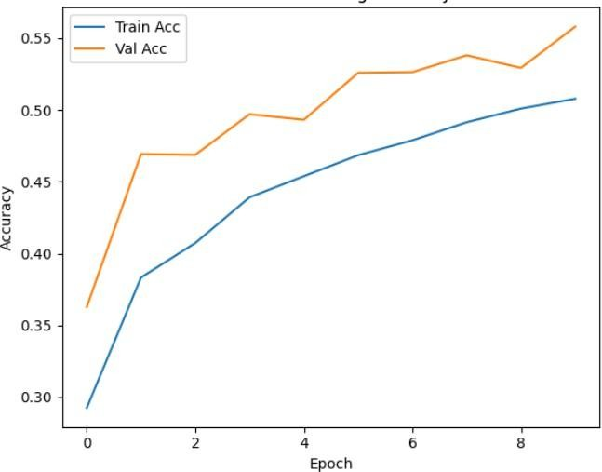
Fig: 2 illustrates the ResNet50 version's accuracy, showing the Val Acc (orange) is continuously and extensively better than the teach Acc (blue). The validation accuracy gradually increases to over 55%, while the training accuracy follows a lower, smoother upward trend, concluding around 50.5% by way of the very last epoch.

Fig:2 Model Accuracy of ResNet50

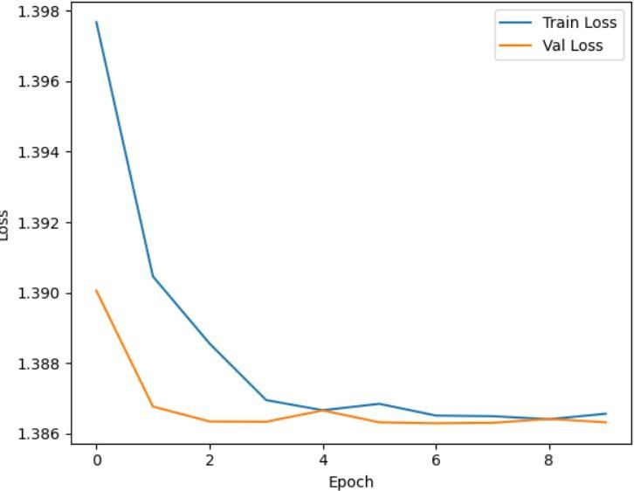
Fig: 3 offers the earlier than best-tuning Loss graph for the EfficientNetB0 model. each the teach Loss (blue) and Val Loss (orange) curves show fast initial convergence in the first few epochs, quick stabilizing at a low value (around 1.386). furthermore, the Val Loss is always lower than the teach Loss throughout the duration of the education duration.
.

Fig:3 Model Loss of EfficentB0

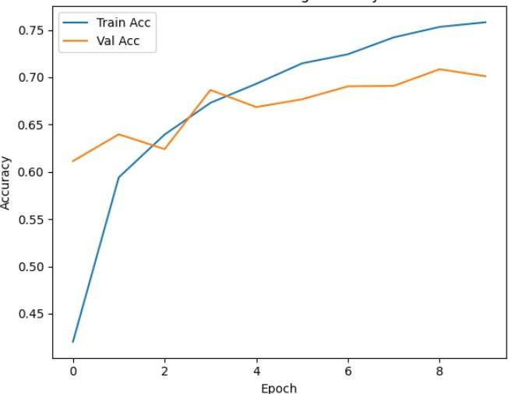
Fig: 4 shows the DenseNet model's training and validation accuracy curves, where both metrics initially increase sharply. After Epoch 3, the Train Acc (blue) continues to improve, reaching approximately 75.5%, while the Val Acc (orange) flattens and stabilizes around 69-71%, demonstrating that the model's performance on unseen data plateaus quickly.
.

Fig:4 Model Accuracy of DenseNet

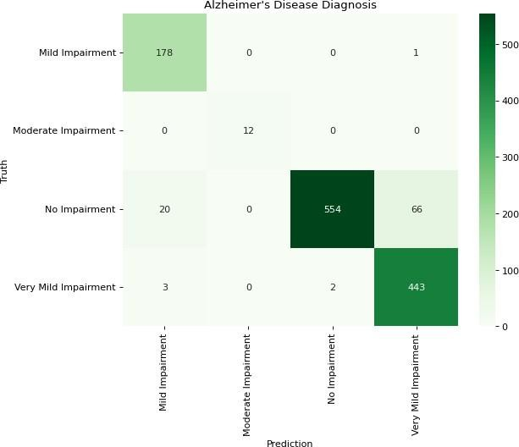
Fig: 5 presents the Confusion Matrix for the four-magnificence Alzheimer's diagnosis. The version famous high proper classification rates for No Impairment (554) and very slight Impairment (443). The primary misclassification errors is the confusion of No Impairment cases, with 66 being incorrectly anticipated as Very mild Impairment. The slight Impairment magnificence changed into flawlessly recalled (12 accurate).
.

Fig:5 Confusion Matrix

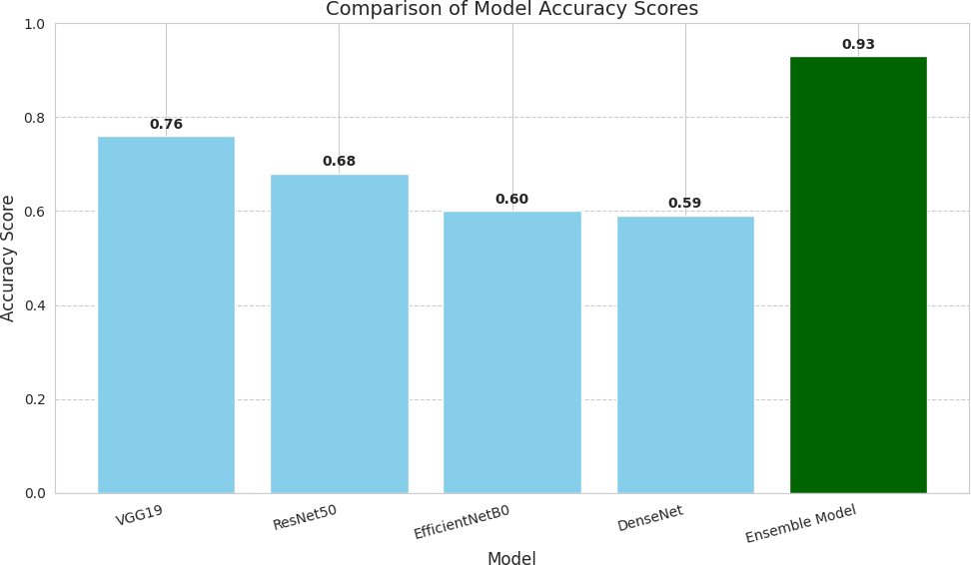
Fig:6 Compares the accuracy rankings of four person fashions (VGG19, ResNet50, EfficientNetB0, DenseNet) in opposition to an Ensemble version. The man or woman fashions ranged in accuracy from 0.59 to 0.76 (VGG19 being the best), while the Ensemble model carried out a drastically superior accuracy of zero.ninety three..

Fig:6 Comparison Of Models

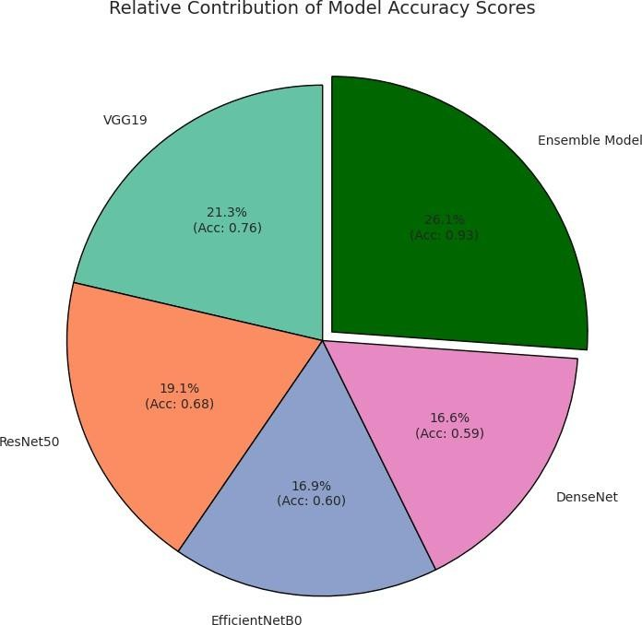
Fig: 7 illustrates the Relative Contribution of model Accuracy scores in a pie chart. The Ensemble model is the largest section, contributing 26.1% (Acc: 0.93). some of the base models, VGG19 provided the very best contribution at 21.3% (Acc: 0.76), at the same time as DenseNet confirmed the lowest contribution at 16.6% (Acc: 0.59).

Fig:7 Pie Chart

CONCLUSION

The study effectively implemented and evaluated a custom Convolutional Neural Network (CNN) alongside four established transfer learning models—VGG19, ResNet50, EfficientNetB0, and DenseNet— for the multi-class classification of Alzheimer’s disease using MRI images. While each model demonstrated its own strengths, their individual training behavior revealed certain limitations. For instance, VGG19 produced the highest standalone accuracy of 0.76 but showed signs of overfitting, while ResNet50 struggled with sub-optimal convergence during training. EfficientNetB0 and DenseNet also contributed meaningful results but were limited by dataset complexity and variability. These observations highlight both the potential and the constraints of using pretrained architectures directly for medical imaging tasks.
A deeper comparative analysis clearly demonstrated the value of combining multiple architectures rather than relying on a single model's capabilities. The final Ensemble Model, which integrated the strengths of all four pretrained networks, achieved a peak accuracy of 0.93—significantly higher than any standalone model. This ensemble strategy improved the balance between sensitivity, specificity, and class-wise stability. The Confusion Matrix revealed strong classification capability for the “No Impairment” and “Very Mild Impairment” categories, while also identifying the primary area for improvement: reducing the misclassifications between closely related early-stage categories, where structural differences in MRI scans are naturally subtle. The evaluation metrics such as Balanced Accuracy Score (BAS) and Matthews Correlation Coefficient (MCC) further validated the reliability of the model across all four classes. These metrics confirmed that the proposed framework was not simply accurate by chance but demonstrated consistent, stable performance even when analyzing challenging MRI data. Additionally, the training optimizations—such as early stopping, batch normalization, data augmentation, and fine-tuning—played a crucial role in reducing overfitting and enhancing the model’s generalization capacity.
Beyond individual model performance, the study also provides significant insights into the design of automated diagnostic systems for neurodegenerative diseases. By leveraging deep convolutional feature extraction and ensemble learning, the system was able to identify even subtle structural variations that correspond to different Alzheimer’s stages. In conclusion, the research confirms that while pretrained CNN architectures form a strong baseline for Alzheimer’s classification, the integration of these models through a meta-learning ensemble approach delivers superior robustness, adaptability, and precision. The ensemble framework presented in this study offers a highly efficient and reliable tool for MRI-based Alzheimer’s disease stage detection. With further refinement, larger datasets, and clinical validation, such systems hold tremendous promise in improving early diagnosis, supporting decision-making, and ultimately contributing to better patient outcomes.

REFERENCES

- Wang, S. H., Tang, C., Sun, J., Yang, J., & Zhang, Y. D. (2021). Deep sequence modelling for Alzheimer's disease detection using MRI. Computers in Biology and Medicine, 132, 104537. https://doi.org/10.1016/j.compbiomed.2021.104537
- Ahmed, O. B., Sameh, M., & El-Sappagh, S. (2021). Deep learning approach for early detection of Alzheimer’s disease. Cognitive Computation, 13(6), 1451–1465. https://doi.org/10.1007/s12559- 021-09946-2
- Khan, S. M., Zubair, S., & Naqvi, S. S. (2021). Analysis of features of Alzheimer’s disease using
a finetuned ResNet18 network. Diagnostics, 11(6), 1071. https://doi.org/10.3390/diagnostics11061071
- Aderghal, K., Khvostikov, A., Benois-Pineau, J., Catheline, G., & Afdel, K. (2022). MRI scans-
based Alzheimer’s disease detection via convolutional neural network and transfer learning.
Diagnostics, 12(7), 1531. https://doi.org/10.3390/diagnostics12071531
- Fathi, A., & Ghassemian, H. (2021). A review of the application of deep learning in the detection of Alzheimer’s disease. International Journal of Computational Cognitive Engineering, 1(2), 55–68. https://doi.org/10.1016/j.ijcce.2021.12.002
- Guo, Y., Gao, X., & Shen, D. (2021). Toward deep MRI segmentation for Alzheimer’s disease detection. Neural Computing and Applications, 34(10), 7889–7901. https://doi.org/10.1007/s00521- 021-06430-8
- Wang, H., Zhang, Y., & Chen, H. (2024). Interpreting artificial intelligence models: A systematic review on the application of LIME and SHAP in Alzheimer’s disease detection. Visual Computing for Industry, Biomedicine, and Art, 7(1),https://doi.org/10.1186/s40708-024-00222-1
- Singh, G., & Gupta, D. (2020). Application of deep learning in detecting neurological disorders from MRI. Visual Computing for Industry, Biomedicine, and Art, 3(1), 14.
https://doi.org/10.1186/s40708-020-00112-2
- Kim, H., & Park, S. (2024). Harnessing the power of voice: A deep neural network model for Alzheimer’s disease detection. Dementia and Neurocognitive Disorders, 23(1), 1–10. https://doi.org/10.12779/dnd.2024.23.1.1
- Kaur, T., & Gandhi, T. (2022). Early Alzheimer’s disease detection using semi-supervised GAN. IEEE VLSIDCS 2022, 145–150. https://doi.org/10.1109/VLSIDCS53788.2022.9811458

- Dubois, B., & Hampel, H. (2023). Detection and treatment of Alzheimer’s disease in its
preclinical stage. Nature Aging, 3(4), 320–334. https://doi.org/10.1038/s43587-023-00410-4
- Sharma, N., Gupta, S., & Verma, P. (2023). Revolutionizing early detection of Alzheimer’s disease through non-invasive biomarkers using artificial intelligence. Sensors, 23(9), 4184. https://doi.org/10.3390/s23094184
- Ashton, N. J., & Zetterberg, H. (2024). Blood biomarkers to detect Alzheimer disease in primary and secondary care. JAMA, 332(10), 1001–1012. https://doi.org/10.1001/jama.2024.13855
- Kumar, A., & Saini, R. (2022). CNN model with VGG16 feature extractor for Alzheimer detection using MRI scans. Measurement: Sensors, 22, 100506.
https://doi.org/10.1016/j.measen.2022.100506
- Islam, J., & Zhang, Y. (2020). Automated MRI-based deep learning model for detection of
Alzheimer’s process. International Journal of Neural Systems, 30(2), 2050032.
https://doi.org/10.1142/S012906572050032X
- Saba, T., Mohamed, A., & El-Aziz, M. A. (2020). Deep transfer learning for Alzheimer neurological disorder detection. Multimedia Tools and Applications, 79, 21965–21978. https://doi.org/10.1007/s11042-020-10331-8
- Nakamura, T., & Suzuki, T. (2020). Early detection of Alzheimer's disease with blood plasma proteins using SVMs. IEEE Journal of Biomedical and Health Informatics, 24(8), 2201–2210. https://doi.org/10.1109/JBHI.2020.2984355
- Saba, T., El-Aziz, M. A., & Mohamed, A. S. (2021). Transfer learning using freeze features for Alzheimer detection with ADNI dataset. Multimedia Systems, 28(3), 759–771. https://doi.org/10.1007/s00530-021-00797-3
- Khvostikov, A., Aderghal, K., & Benois-Pineau, J. (2021). DEMNET: A deep learning model for early diagnosis of Alzheimer’s and dementia. IEEE Access, 9, 84236–84246. https://doi.org/10.1109/ACCESS.2021.3090474
- Li, H., & Zhang, Y. (2023). Reinforcement-learning-based localization of hippocampus for
Alzheimer’s disease detection. https://doi.org/10.3390/diagnostics13213292

- Singh, D., & Bhatia, S. (2022). Alzheimer’s disease detection with optimal EEG channel selection using wavelet transform. IEEE International Conference on Data Science and Applications (DASA), 516–521. https://doi.org/10.1109/DASA54658.2022.9765166

 Page 2 of 19 - Integrity Overview Submission ID trn:oid:::3618:120191692

8% Overall Similarity
The combined total of all matches, including overlapping sources, for each database.

Filtered from the Report
Bibliography

Quoted Text Cited Text
Small Matches (less than 8 words)

Match Groups


19 Not Cited or Quoted 8%
Top Sources
7% Internet sources

Matches with neither in-text citation nor quotation marks | 7% | Publications
0 Missing Quotations 0%  Matches that are still very similar to source material | 17% | Submitted works (Student Papers)
0 Missing Citation 0%
Matches that have quotation marks, but no in-text citation
0 Cited and Quoted 0%
Matches with in-text citation present, but no quotation marks


Integrity Flags
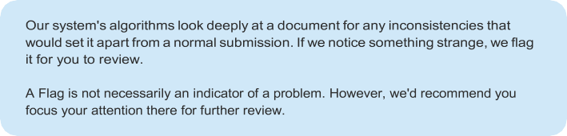
0 Integrity Flags for Review
No suspicious text manipulations found.


Page 2 of 19 - Integrity Overview Submission ID trn:oid:::3618:120191692

