行云 APP接口文档

返回参数格式为JSONObject的字符串形式.

|  |  |  |  |
| --- | --- | --- | --- |
| 值标识 | 值名称 | 值类型 | 值说明 |
| result | 返回结果 | String | “0”：成功  “1”：失败 |
| desc | 描述信息 | String |  |
| data | 查询数据信息 | json | Json字符串 |

一 取全部商品分类 （子分类同样使用此方法）

URL: 120.25.249.28/Api/Goods/get_category_child_list?parent_id=0

请求方式：get

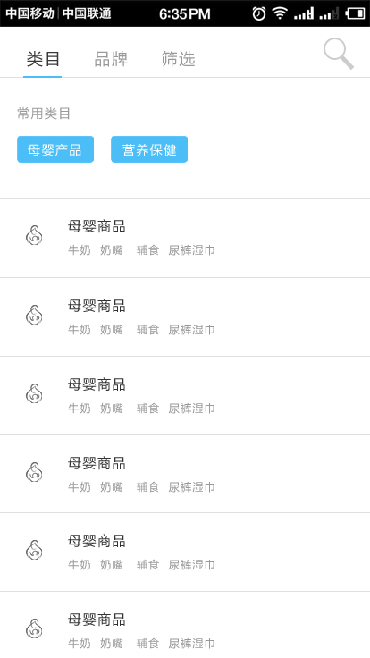请求参数：

Action ：get_category_child_list （固定）

（固定）

parent_id：0 //父级ID

childCount 子分类显示数量

返回data

格式: title: 要显示的文 ，id:类别ID , chidList:子分类， imgurl ：图标URL

数据：

{

"result": "0",

"error_code": 0,

"desc": "查询成功!",

"data": [

{

"gc_id": "1",

"gc_name": "母婴用品",

"childList": [

{

"gc_id": "3",

"gc_name": "宝宝用品"

},

{

"gc_id": "9",

"gc_name": "宝宝食品"

},

{

"gc_id": "10",

"gc_name": "孕产妇用品"

},

{

"gc_id": "13",

"gc_name": "宝宝服饰"

},

{

"gc_id": "18",

"gc_name": "宝宝洗护"

},

{

"gc_id": "19",

"gc_name": "宝宝玩具"

}

]

},

{

"gc_id": "4",

"gc_name": "食品保健",

"childList": [

{

"gc_id": "5",

"gc_name": "进口食品"

},

{

"gc_id": "148",

"gc_name": "进口饮品"

},

{

"gc_id": "149",

"gc_name": "功效分类"

}

]

},

{

"gc_id": "6",

"gc_name": "生活数码",

"childList": [

{

"gc_id": "256",

"gc_name": "家用电器"

},

{

"gc_id": "257",

"gc_name": "厨房餐具/烹饪用具"

},

{

"gc_id": "258",

"gc_name": "数码音响"

},

{

"gc_id": "259",

"gc_name": "家居生活"

},

{

"gc_id": "260",

"gc_name": "收藏"

}

]

},

{

"gc_id": "7",

"gc_name": "美妆个护",

"childList": [

{

"gc_id": "99",

"gc_name": "美妆护肤"

},

{

"gc_id": "100",

"gc_name": "彩妆/香水"

},

{

"gc_id": "101",

"gc_name": "个人护理/美容工具"

}

]

},

{

"gc_id": "8",

"gc_name": "服饰鞋包",

"childList": [

{

"gc_id": "187",

"gc_name": "运动户外"

},

{

"gc_id": "188",

"gc_name": "箱包/鞋靴"

},

{

"gc_id": "189",

"gc_name": "饰品/手表"

},

{

"gc_id": "190",

"gc_name": "女装/女士内衣"

},

{

"gc_id": "191",

"gc_name": "男装/男士内衣"

}

]

}

]

}

二 、取指分类下的商品列表

url接口地址：

120.25.249.28/Api/Goods/get_goods_list?category_id=0&pagesize=50&pageindex=1&origin_of_goods=NLD&order=_price

请求方式：get

请求参数：

Action ：get_goods_list （固定）

token可选 (会员价登录可见)

category_id= 类别ID

keyword=关键词

pagesize= 每页返回商品数量(必传)

pageindex= 取第几页(必传)

origin_of_goods:原产地(code码如NLD代表荷兰)

brand：品牌id(int，如1)

//order=排序类型 （asc,desc）

//order_filed =要排序的字段 (sort_price 按价格排序, vol 按销量排序)

为简化请求暂定为：order=price(价格+升序) 或 order=_price(价格+降序) 或 order=gnum(销量+升序) 或 order=_gnum(销量+降序)

返回data

数据：

{

"result": "0",

"error_code": "0",

"desc": "取产品列表成功",

"data": {

"totalcount": 3,

"filter": [

{

"name": "origin_of_goods",

"title": "原产地",

"item_option": [

{

"k": "荷兰",

"v": "NLD"

}

]

},

{

"name": "brand",

"title": "品牌",

"item_option": [

{

"k": "迈可适 Maxi-Cosi",

"v": "190"

},

{

"k": "Snurk",

"v": "101"

},

{

"k": "佳贝艾特 Kabrita",

"v": "166"

}

]

}

],

"goodslist": [

{

"g_id": "1588",

"g_trade": "1",

"number_least": "1",

"g_on_sale": "2",

"gb_name": "迈可适 Maxi-Cosi",

"g_update_time": "2016-05-31 00:18:46",

"g_name": "荷兰迈可适Maxi-Cosi儿童安全座椅Pria 70 (Mineral Grey) 矿石灰",

"g_cname": "",

"extension_spec": "",

"g_price": "2388.00",

"g_market_price": "2388.00",

"g_picture": "http://www.xingyun.com:8080/Public/Uploads/v78/goods/20160513/14631088551628.jpg",

"g_weight": "0.00",

"g_unit": "台",

"g_salenum": "0",

"pmlp_price": "1784.000",

"n_name": "荷兰",

"n_pic": "http://www.xingyun.com:8080/Public/Uploads/v78/editor/20160518/146356448248.jpg",

"pdt_sn": "MBY0107-B",

"pdt_stock": "100",

"gc_id": "57",

"gc_name": "安全座椅"

},

{

"g_id": "1587",

"g_trade": "1",

"number_least": "1",

"g_on_sale": "2",

"gb_name": "迈可适 Maxi-Cosi",

"g_update_time": "2016-05-31 00:18:37",

"g_name": "荷兰迈可适Maxi-Cosi儿童安全座椅Pria 70 (Bohemian Blue) 波西米亚蓝",

"g_cname": "",

"extension_spec": "",

"g_price": "2388.00",

"g_market_price": "2388.00",

"g_picture": "http://www.xingyun.com:8080/Public/Uploads/v78/goods/20160513/14631086655140.jpg",

"g_weight": "0.00",

"g_unit": "台",

"g_salenum": "0",

"pmlp_price": "1803.000",

"n_name": "荷兰",

"n_pic": "http://www.xingyun.com:8080/Public/Uploads/v78/editor/20160518/146356448248.jpg",

"pdt_sn": "MBY0103-B",

"pdt_stock": "100",

"gc_id": "57",

"gc_name": "安全座椅"

},

{

"g_id": "1593",

"g_trade": "1",

"number_least": "1",

"g_on_sale": "1",

"gb_name": "迈可适 Maxi-Cosi",

"g_update_time": "2016-06-02 02:06:17",

"g_name": "荷兰迈可适Maxi-Cosi儿童安全座椅Pria 85 Car seat(Havana Pink)粉色",

"g_cname": "",

"extension_spec": "粉色",

"g_price": "2388.00",

"g_market_price": "2388.00",

"g_picture": "http://www.xingyun.com:8080/Public/Uploads/v78/goods/20160513/14631098999237.jpg",

"g_weight": "0.00",

"g_unit": "台",

"g_salenum": "0",

"pmlp_price": "1874.000",

"n_name": "荷兰",

"n_pic": "http://www.xingyun.com:8080/Public/Uploads/v78/editor/20160518/146356448248.jpg",

"pdt_sn": "MBY04449-B",

"pdt_stock": "100",

"gc_id": "57",

"gc_name": "安全座椅"

}

]

}

}

返回参数说明

|  |  |  |
| --- | --- | --- |
| **名称** | **类型** | **说明** |
| error_code | int | 返回码 |
| reason | string | 返回说明 |
| data | string | 返回结果集 |
| g_id | int | 商品id |
| g_trade | int | 贸易类型 1保税 2直邮 0普通 |
| number_least | int | 最小起发数 |
| g_update_time | date | 商品修改时间 |
| g_name | string | 商品名称 |
| g_cname | string | 副标题 |
| g_price | String | 销售价 |
| g_market_price | String | 市场价 |
| g_picture | String | 商品图片 |
| pdt_sn | int | 货号 |
| pdt_stock | String | 库存 |
| extension_spec | String | 商品扩展属性 |
| n_name | String | 国籍 |
| gb_name | String | 品牌 |
| g_unit | String | 单位 |
| g_weight | String | 重量 |
| g_on_sale | int | 销售状态：1在架，2下架，3预上架 |
| gc_id | string | 分类id |
| gc_name | string | 分类名 |
| pmlp_price | string | 会员价 |