1. **JavaScript Reversing an array:**

<!DOCTYPE html>

<html>

<body>

<h2>JavaScript Array Sort Reverse</h2>

<p>The reverse() method reverses the elements in an array.</p>

<p>

By combining sort() and reverse() you can sort an array in descending

order:

</p>

<p id="demo1"></p>

<p>Reversed</p>

<p id="demo2"></p>

<script>

const fruits = ["Banana", "Orange", "Apple", "Mango"];

document.getElementById("demo1").innerHTML = fruits;

fruits.sort();

fruits.reverse();

document.getElementById("demo2").innerHTML = fruits;

</script>

</body>

</html>

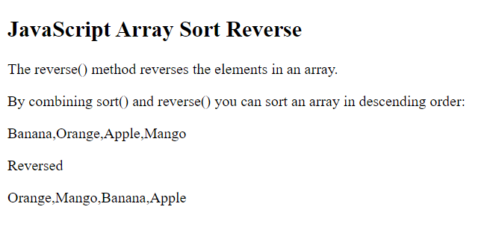

1. **Calculate Area of Circle Using JavaScript:**

<!DOCTYPE html>

<html>

<head>

<title>Area of Circle</title>

<script type="text/javascript">

{

var r = prompt("Enter The Value OF R = ");

document.write("<h3>","CALCULATED AREA OF CIRCLE = ",3.14 * r * r,"</h3>");

}

</script>

</head>

</html>

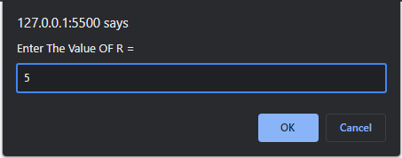

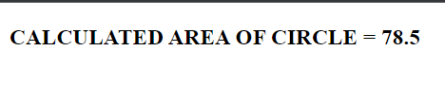

1. **JavaScript Code To Find Factorial Of Number:**

<!DOCTYPE html>

<html>

<head>

<script>

function show() {

var i, no, fact;

fact = 1;

no = document.getElementById("num").value;

for (i = 1; i <= no; ++i) {

fact = fact * i;

}

document.getElementById("answer").value = fact;

}

</script>

</head>

<body>

<p>Enter Number: <input type="text" id="num" /></p>

<input type="button" value="Factorial" onclick="show()" />

<input type="text" id="answer" />

</body>

</html>

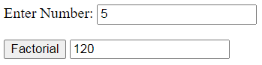

1. **If-else With Date() Function in JavaScript:**

<!DOCTYPE html>

<html>

<body>

<h2>JavaScript if .. else</h2> <p>A time-based greeting:</p>

<p id="demo"></p>

<script>

const time = new Date().getHours();

let greeting;

if (time < 10) {

greeting = "Good morning";

} else if (time < 20) {

greeting = "Good day";

} else {

greeting = "Good evening";

}

document.getElementById("demo").innerHTML = greeting ;

</script>

</body>

</html>

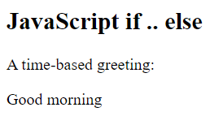

1. **JavaScript Switch Case Statement:**

<!-- JavaScript Switch Statement -->

<!DOCTYPE html>

<html>

<body>

<h2>JavaScript switch</h2>

<p id="demo"></p>

<script>

let day;

switch (new Date().getDay()) {

case 0:

day = "Sunday";

break;

case 1:

day = "Monday";

break;

case 2:

day = "Tuesday";

break;

case 3:

day = "Wednesday";

break;

case 4:

day = "Thursday";

break;

case 5:

day = "Friday";

break;

case 6:

day = "Saturday";

}

document.getElementById("demo").innerHTML = "Today is " + day;

</script>

</body>

</html>

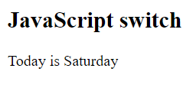

1. **JavaScript Array Methods push():**

<!DOCTYPE html>

<html>

<body>

<h2>JavaScript Array Methods</h2>

<h2>push()</h2>

<p>The push() method appends a new element to an array:</p>

<p id="demo1"></p>

<p id="demo2"></p>

<script>

const fruits = ["Banana", "Orange", "Apple", "Mango"];

document.getElementById("demo1").innerHTML = fruits;

fruits.push("Kiwi");

document.getElementById("demo2").innerHTML = fruits;

</script>

</body>

</html>

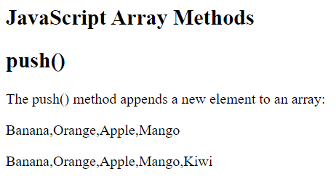

1. **JavaScript Array Methods Pop():**

<!-- Javascript pop() and push() -->

<!DOCTYPE html>

<html>

<body>

<h2>JavaScript Array Methods</h2>

<h2>pop()</h2>

<p>The pop() method removes the last element from an array.</p>

<p id="demo1"></p>

<p id="demo2"></p>

<script>

const fruits = ["Banana", "Orange", "Apple", "Mango"];

document.getElementById("demo1").innerHTML = fruits;

fruits.pop();

document.getElementById("demo2").innerHTML = fruits;

</script>

</body>

</html>

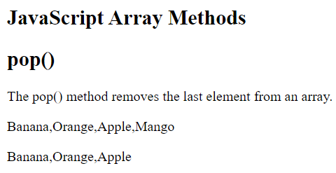

1. **Multiplication Table:**

<!DOCTYPE html>

<html>

<head>

<title> </title>

</head>

<body>

<script type="text/javascript">

{

var n, c;

var n = prompt("Enter The Table OF Number=");

document.write("<h3>", "Multiplication Table Of ", n, " is :- ","</h3>");

for (c = 1; c <= 10; ++c)

document.write(n, "*", c, "=", n * c, "<br>");

}

</script>

</body>

</html>

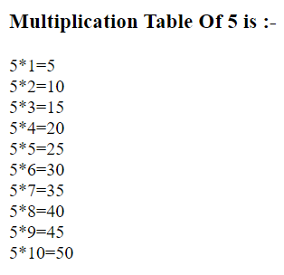

1. **Javascript program to find the largest and smallest among 10 numbers in an array.**

<!DOCTYPE html>

<html>

<head>

<title>Largest and Smallest Numbers</title>

</head>

<body>

<h1>Largest and Smallest Numbers</h1>

<button onclick="findLargestAndSmallest()">Find Largest and Smallest</button>

<div id="result"></div>

<script>

function findLargestAndSmallest() {

let array = [];

for (let i = 1; i <= 10; i++) {

let num = parseInt(prompt("Enter number #" + i));

array.push(num);

}

let max = array[0];

let min = array[0];

for (let i = 1; i < array.length; i++) {

if (array[i] > max) {

max = array[i];

}

if (array[i] < min) {

min = array[i];

}

}

document.getElementById("result").innerHTML = "Largest element is: " + max + "<br>Smallest element is: " + min;

}

</script>

</body>

</html>

