LEVEL 2: Navigation Core Synchronization Sequence
Aim:
The navigation subsystem responsible for escape route computation has been severely damaged during the crash. To reinitialize the navigation core and recover critical trajectory data, the auxiliary control processor requires the synchronization sequence 5, 3, 2, 1 to be transmitted digit by digit. Design and implement a 4-bit FSM-based sequence generator that cycles through the decimal digits 5 → 3 → 2 → 1 repeatedly, outputting one digit per state. Each digit is then encoded into its 2421 BCD representation using a combinational encoder, and the resulting 4-bit code is shifted out serially, MSB first, one bit per clock cycle. On the receiving end, the incoming serial bits are accumulated back into 4-bit parallel form using a shift register and then decoded back into their original binary form.

Basic Approach:
The project is divided into four major blocks:
FSM Sequence Generator 2421 Encoder Serial Transmitter Receiver Decoder
State | Output Digit | Binary Output
S5 | 5 | 0101
S3 | 3 | 0011
S2 | 2 | 0010
S1 | 1 | 0001
The FSM generates one digit at a time. The generated digit is represented in normal 4-bit binary form. This binary digit is then passed to a 2421 BCD encoder.
The encoder output is loaded into a shift register or selected bit-by-bit using serial transmission logic. The encoded data is transmitted MSB first. At the receiver end, the incoming serial bits are shifted into a register and grouped into 4-bit codes. These codes are then decoded back into the original binary digit.

FSM Sequence Generator:
The FSM is designed to repeatedly generate the sequence:
5 – 3 – 2 – 1 – Repeat
The FSM states are:
The state transition is:
S5 S3 S2 S1 S5
We need to make it so that the FSM advances to the next digit only after the current 4-bit encoded value has been transmitted serially.
First, we use a counter to loop through 00 – 01 – 10 – 11 well assign each state to one of the numbers in binary
S1 | S0 | Output Needed | D3 | D2 | D1 | D0
0 | 0 | 0101 | 0 | 1 | 0 | 1
0 | 1 | 0011 | 0 | 0 | 1 | 1
1 | 0 | 0010 | 0 | 0 | 1 | 0
1 | 1 | 0001 | 0 | 0 | 0 | 1

D3: D2:
Here we can see D2 is 1 only when S0 and S0 are 0 this is NAND logic So,
D2 = (S1NOT) NAND (S0NOT)
S1 | S0 | D3
0 | 0 | 0
0 | 1 | 0
1 | 0 | 0
1 | 1 | 0
S1 | S0 | D2
0 | 0 | 1
0 | 1 | 0
1 | 0 | 0
1 | 1 | 0
Here we can see D3 is always 0, so
D3 = 0

D1: D0:
Here we can see D1 is 1 only when S1 or S0 is 1 this is XOR logic So,
D1 = S1 XOR S0
Here we can see D0 is 1 when any one of S1NOT or S0 is 1 this is OR logic So,
D1 = (S1NOT) OR S0
S1 | S0 | D1
0 | 0 | 0
0 | 1 | 1
1 | 0 | 1
1 | 1 | 0
S1 | S0 | D0
0 | 0 | 1
0 | 1 | 1
1 | 0 | 0
1 | 1 | 1

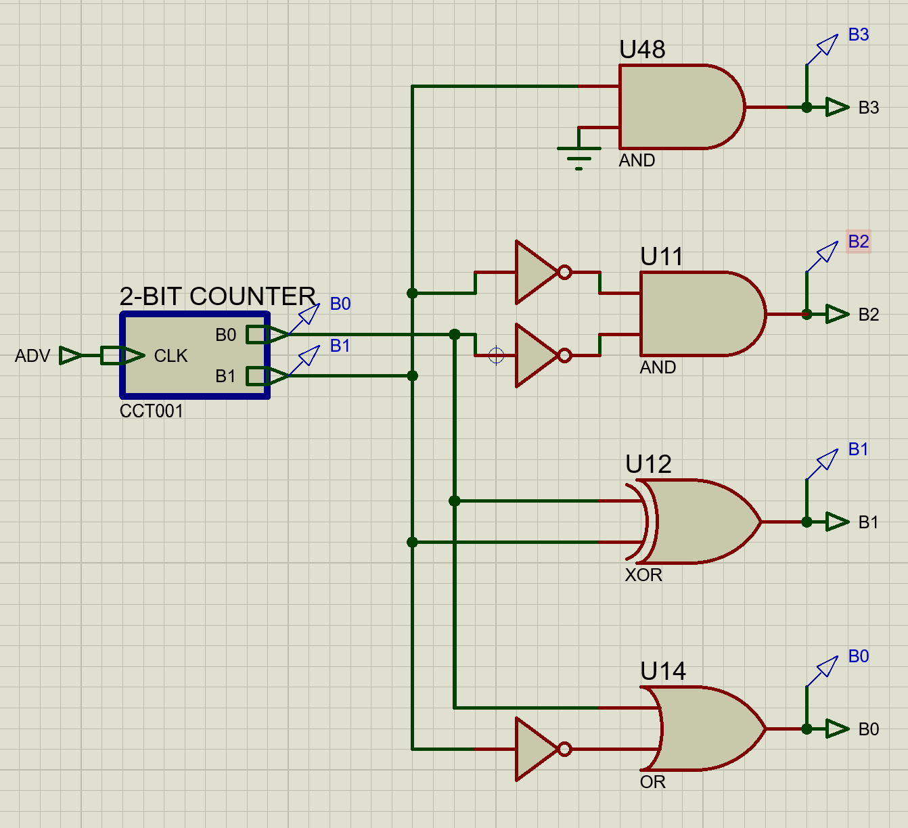

2421 BCD Encoding:
The generated digit is encoded into 2421 BCD form. The 2421 code is a weighted BCD code with weights:
2 4 2 1
Truth Table
Decimal | Input (A, B, C, D) | Output (W, X, Y, Z)
0 | 0 0 0 0 | 0 0 0 0
1 | 0 0 0 1 | 0 0 0 1
2 | 0 0 1 0 | 0 0 1 0
3 | 0 0 1 1 | 0 0 1 1
4 | 0 1 0 0 | 0 1 0 0
5 | 0 1 0 1 | 1 0 1 1
6 | 0 1 1 0 | 1 1 0 0
7 | 0 1 1 1 | 1 1 0 1
8 | 1 0 0 0 | 1 1 1 0
9 | 1 0 0 1 | 1 1 1 1
10-15 | 1010 to 1111 | X X X X (Don't Care)

K – Maps Simplification:
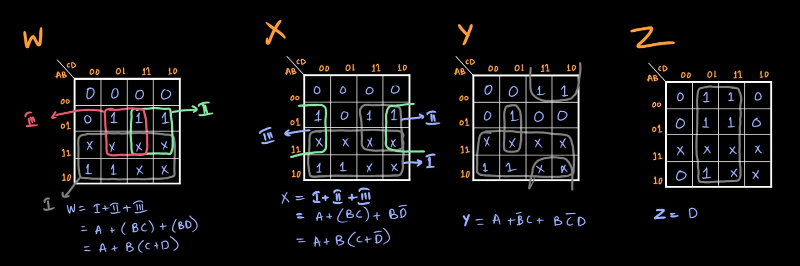
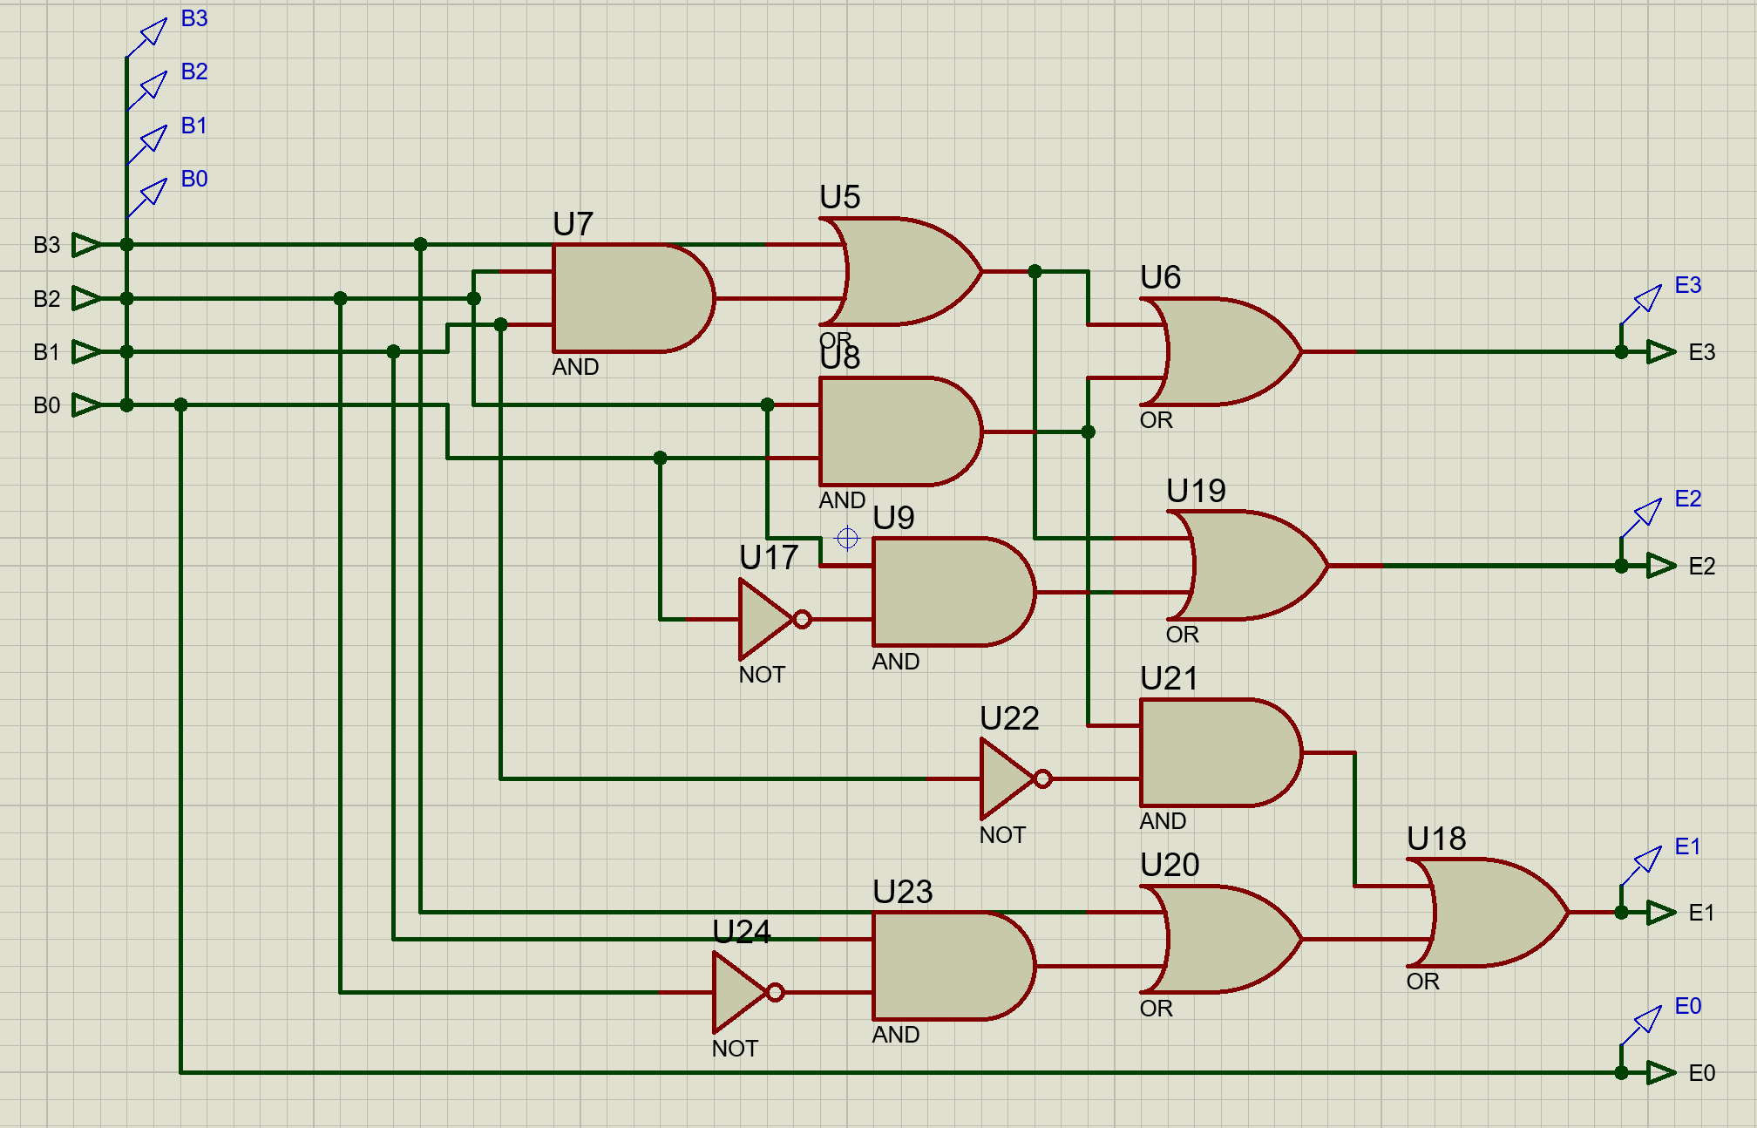

Serial Transmission:
The 2421 BCD code is transmitted serially, MSB first.
So, one complete transmission cycle is:
1011 0011 0010 0001
As a continuous bit stream:
1011001100100001
After this, the same stream repeats.

Test Cases:
My serial input and Parallel output aren’t working properly soo, I don’t really have any test cases.
My circuit works till the encoder perfectly then it fumbles for some reason.

Issues Encountered and Method of Solving:
I’m counter was counting down in a weird way 00 – 11 – 10 – 10 – 00
It was an issue with my wiring.
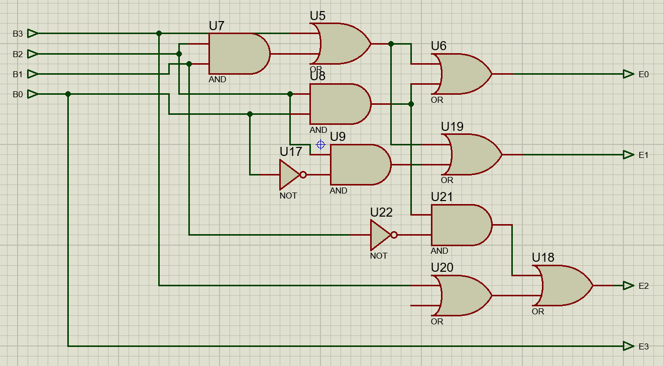

Scope of Development:
- Support More Digits
- Programmable Sequence Generator
- Error Detection:
Parity bits can be added to detect transmission errors.
- Display Output:
A 7-segment display can be added to show the decoded digit directly.

