Subcircuit-1: Signal Generation

Subcircuit-2: Signal Modulation and Transmission
Aim:
- For high-speed transmission, they should be modulated onto a 50 kHz carrier.
- The 1kHz X signal should be mixed with a 50kHz cosine wave, and the 1kHz Y signal should be mixed with a 50kHz sine wave.
- These signals should travel together through the single long wire to the bot as one single high-frequency package.
These 1 kHz signals are too low-frequency for direct long-wire transmission, so convert them into a 50 kHz high-frequency signal package.

Approach:
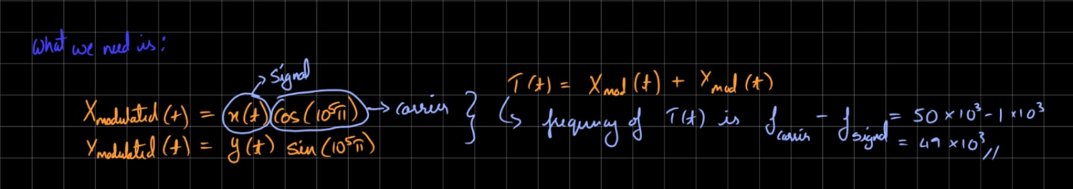So, we need:
Then both modulated signals are added, so that they can be transmitted in the same wire:
So we use a multiplier and then an adder to get our modulated signal on 1 wire.
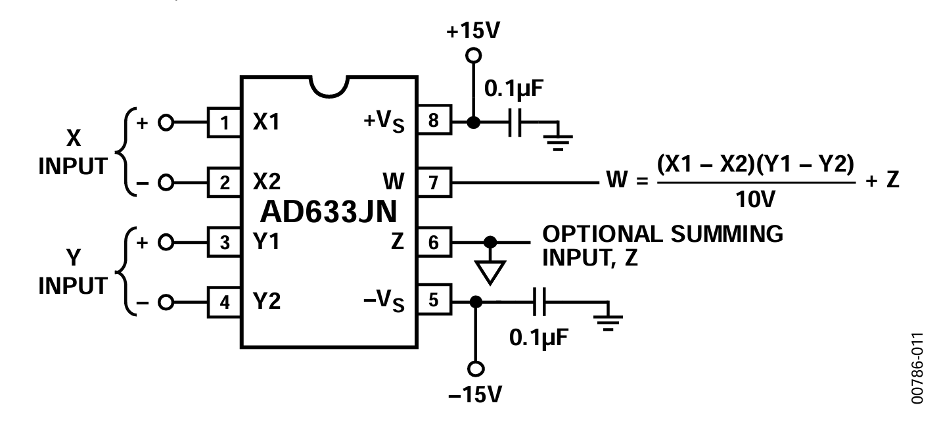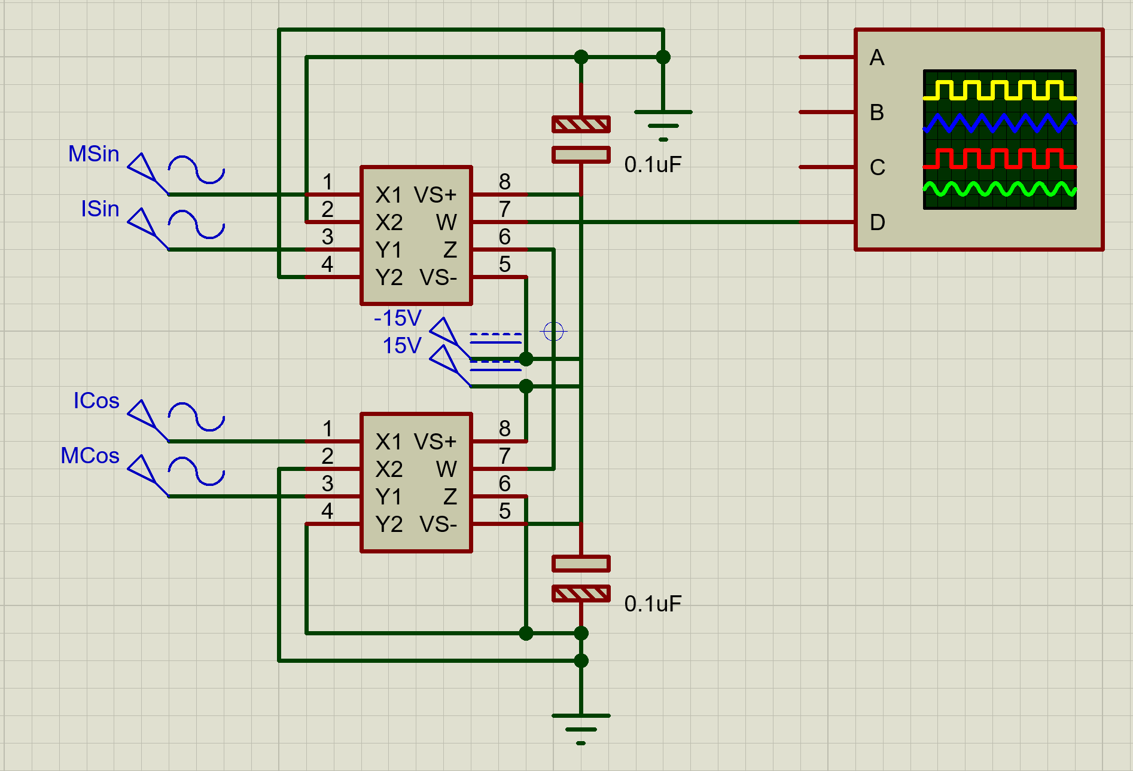

Source: https://www.analog.com/media/en/technical-documentation/data-sheets/AD633.pdf
- I used the offset in AD633 as the adder, as it was free.

Subcircuit-3: Signal Capture and Intermediate frequency Signal Reconstruction
AIM:
It is observed that the ocean floor somehow has a lot of high-frequency noises. To keep the signal clean, the robot should translate the received high-frequency signal down to an intermediate frequency of 10 kHz through heterodyning methods.
This stops any external noises from affecting the signal.
Heterodyning is the process of mixing two signals of different frequencies to generate new frequency components equal to the sum and difference of the original frequencies.

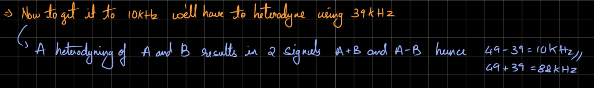
So, after the multiplier, you will get:
10 kHz wanted signal + 88 kHz unwanted signal
Then we must use a low-pass filter, as we must remove the 88 kHz component and keep the 10 kHz component, which is the lower-frequency component.

Low pass filter:
Source: https://www.youtube.com/watch?v=lagfhNjMuQM
Now we have to calculate the resistance and capacitance for our low-pass filter.
So, our calculation of fc should be close to, but greater than, 10 kHz. Not exactly 10 kHz.
Because in a low-pass filter, the cutoff frequency $f_{c}$ is the point where the signal already starts reducing. At fc the output is only about 70.7% of the input, or -3 dB.
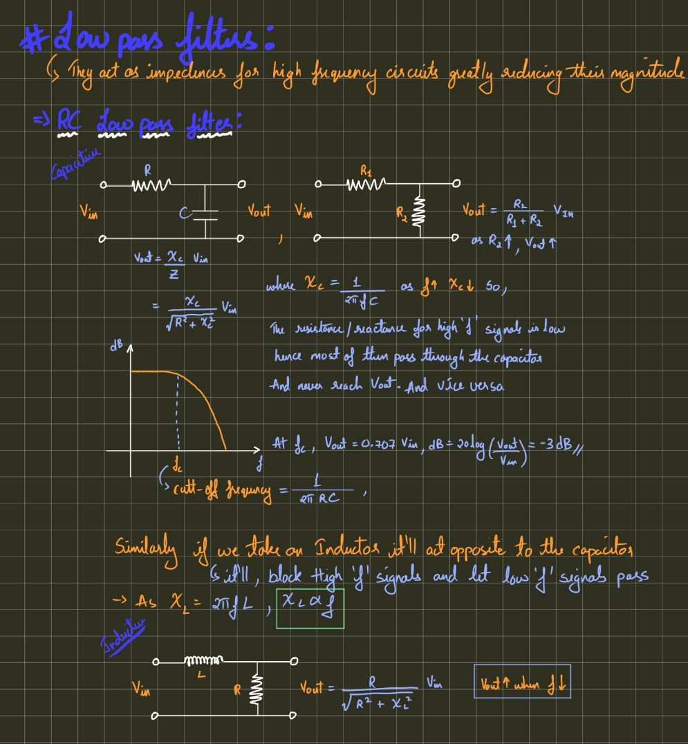

For our circuit:
Wanted signal = 10 kHz
Unwanted signal = 88 kHz
So, we choose:
$f_{c}= 15 – 20$
Pass 10 kHz reasonably well and Reduce 88 kHz

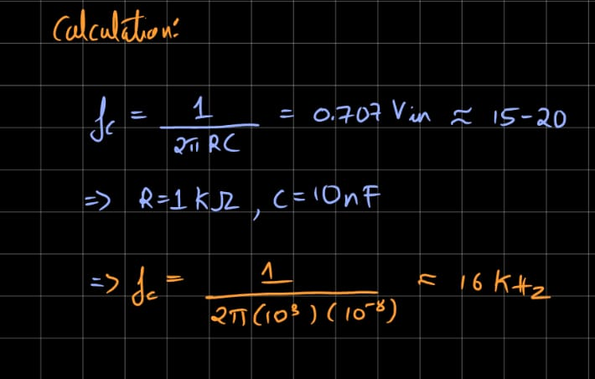
We’ll use 2 x capacitive low-pass filters just to be sure our signal is as close to 10 kHz as possible.
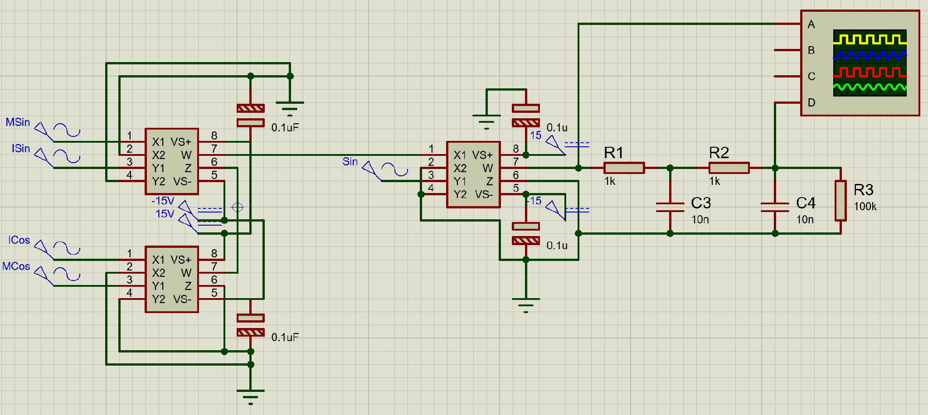
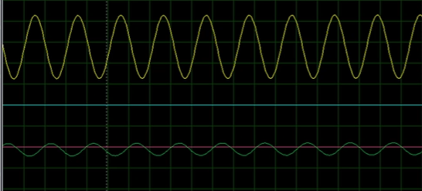

Subcircuit-4: Signal Demodulation and Recovery
AIM:
Once the signal has been converted to an intermediate frequency of 10 kHz, the 10 kHz cosine and sine sources in the bot should demodulate and separate the X and Y commands.
This process unmixes the carrier and restores the original 1 kHz waves so they can be used to drive the propellers.
The fetched signals will have attenuated amplitudes compared to the input signals, so appropriate signal conditioning must be performed to restore them to the desired amplitudes. The outputs signals of this stage are expected to be clean AC signals without any significant noises or DC offsets
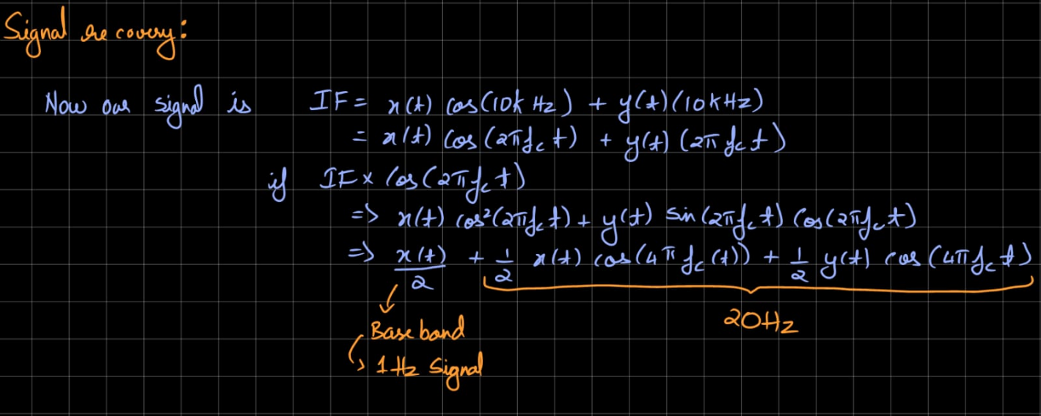
Low-pass filter cutoff for this stage
This is important.
Here you are recovering the 1 kHz original command, so your filter cutoff should be
greater than 1 kHz
but much less than 20 kHz
a good choice:
fc = 3 kHz to 5 kHz
A simple RC value which works is
R = 4 kΩ
C = 10 nF
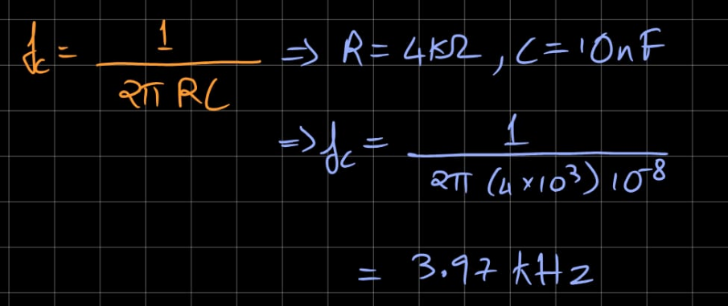
Use this after each multiplier.
We’ll use 2 x capacitive low-pass filters just to be sure our signal is as close to 1 kHz as possible.

