Subcircuit-2: Signal Modulation and Transmission

After modulation, before adding:
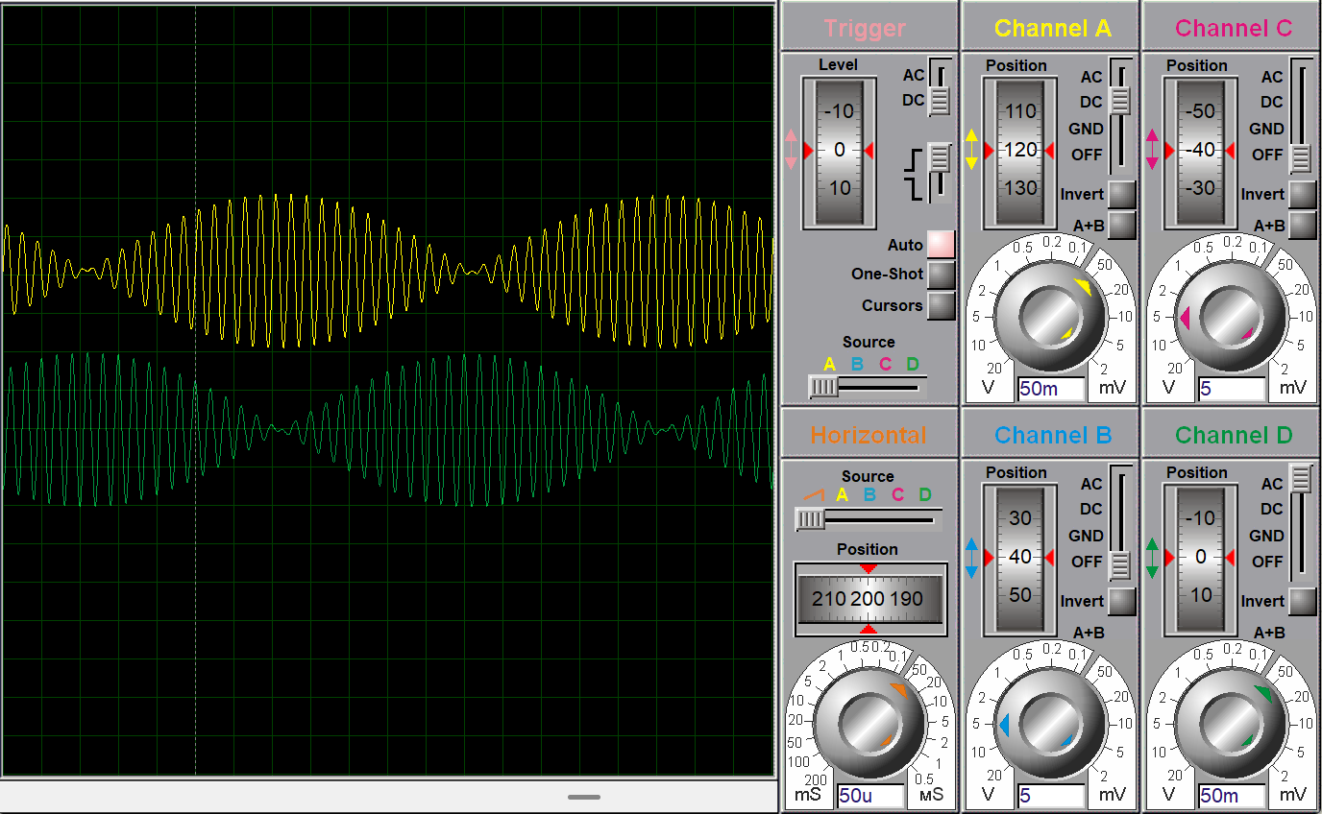

After adding,Transmission signal:
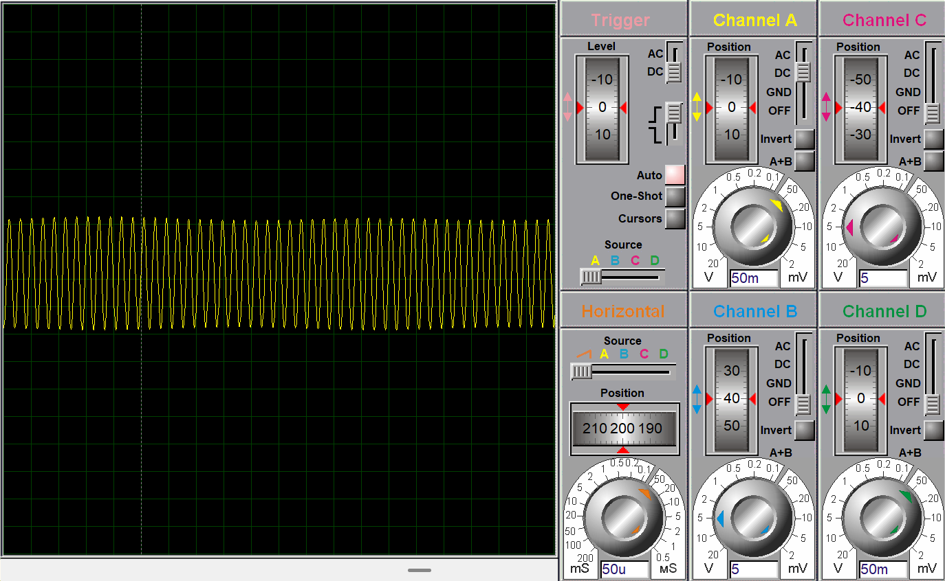
Subcircuit-3: Signal Capture and Intermediate frequency Signal Reconstruction
