LEVEL 1: Seismic Feedback and Safety Interlocks
AIM:
- Assume a MPU6050 is mounted directly to the drill head. You must read the gyroscope data to detect "rock hardness" through vibrations and sudden jerks. Calculate the magnitude of the jerk using the formula:
$$Jerk= \sqrt{{(GyroX}^{2}+{GyroY}^{2})}$$
- If this calculated Jerk exceeds a predefined threshold, the system registers a hard rock strike. As vibrations increase, the drill heats up; map the RGB LED to the Jerk magnitude, ranging from Blue (cool/smooth drilling) to Red (hot/hard rock).
- If the RGB LED turns pure red (maximum vibration threshold), the system must instantly freeze the Stepper Motor, trigger the Buzzer, display "HARD ROCK HIT!" on the OLED, and return to the main menu.
- If the user re-enters "Control Drill" while the drill is still jammed, downward inputs must be blocked and "WARNING: DRILL STUCK" displayed — only upward (retract) inputs are allowed. Once the user retracts the drill fully clear of the rock, the jam state resets and the drill can descend again normally.

Interfacing:

MPU6050:
Sources:
- Register Map: https://cdn.sparkfun.com/datasheets/Sensors/Accelerometers/RM-MPU-6000A.pdf
- Datasheet: https://www.cdiweb.com/datasheets/invensense/mpu-6050_datasheet_v3%204.pdf
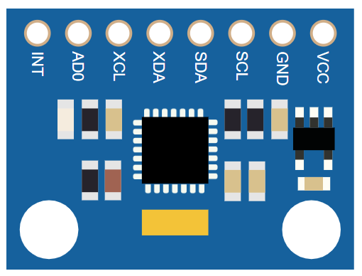
- Follows I2C Protocol
- We know: $Jerk= \sqrt{{(GyroX}^{2}+{GyroY}^{2})}$
  - We only need GyroX and GyroY:
they are at address 0x43 as seen in the Register map
  - 0x43 - Gyro X (High Byte)
  - 0x44 - Gyro X (Low Byte)
  - 0x45 - Gyro Y (High Byte)
  - 0x46 - Gyro Y (Low Byte)
  - 0x47 - Gyro Z (High Byte)
  - 0x48 - Gyro Z (Low Byte)
- To convert the raw values into actual GyroX and GyroY:
  - We need to use the formula:
$$Gyro=rawGyro / 131.0$$

Name | Description
R | Red LED
G | Green LED
B | Blue LED
COM | Common pin

RGB-LED:
Source: https://docs.wokwi.com/parts/wokwi-rgb-led
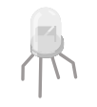
- By default, the common pin is the anode (positive). You can change it by setting the "common" attribute to "cathode".
You can just change the R G B values separately from 0-255 to get your desired color.

Buzzer:

