LEVEL 2: Trench Mapping and Memory Logging
AIM:
As you venture deeper, the system must visually map the excavation process and permanently log the coordinates of any impenetrable hazards encountered in the dark.
- Display a downward-pointing triangle on the Dot Matrix representing the drill, animated to simulate spinning while the Stepper Motor descends. When the drill hits a hard rock hazard, log the exact depth (Stepper position) and Jerk value into a memory array, and permanently mark that depth as a lit dot on the Dot Matrix to build a visual hazard map during descent.
- Expand the OLED main menu with a second option:
"2. View Readings".
- In this sub-menu, scroll through logged hazards using the joystick, displaying each entry's depth and Jerk magnitude on the OLED. Simultaneously, the Dot Matrix switches to a bar graph mode, mapping up to 8 hazards across 8 columns with row height proportional to each hazard's Jerk magnitude.
Bonus: Use the Servo Motor's real-time tilt value to dynamically angle the drill triangle on the Dot Matrix, visually matching the physical arm's orientation.
Constraints: Hardware Interrupts: The "Select" and "Go Back" push buttons must use interrupts. Hardware Limits: Introduce a software limit so that the drill should not go beyond the dot matrix Memory Management: The hazard memory array must handle data overflow gracefully. If the array is built with a capacity of 10 hazards, encountering an 11th must not crash the microcontroller or overwrite critical memory segments.

Interfacing:

Dot Matrix:
Source:
- https://docs.wokwi.com/parts/wokwi-max7219-matrix
- https://www.hackster.io/mdraber/controlling-8x8-dot-matrix-with-max7219-and-arduino-7314a7
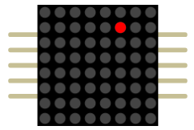
- This uses SPI Protocol instead of the I2C we have been using.
- Im doing this without libraries
- The first time I tried to animate it I used delay which made everything else get stuck but then I saw I was just switching between two things to animate it so I can use an condition statement like (x ? ans1(if x is true) : ans2(if x is false)) so now I just need to toggle x between true and false at intervals using millis

Drill animation:

First try:
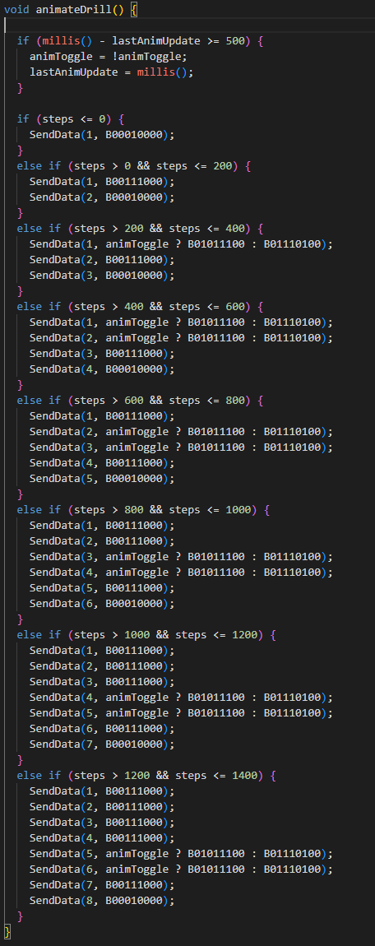
Yes, I HARD CODDED it, but there was a problem retracting as I don’t rewrite the lowest level of my drill it stays lit up on the dot matrix so.

Second try:
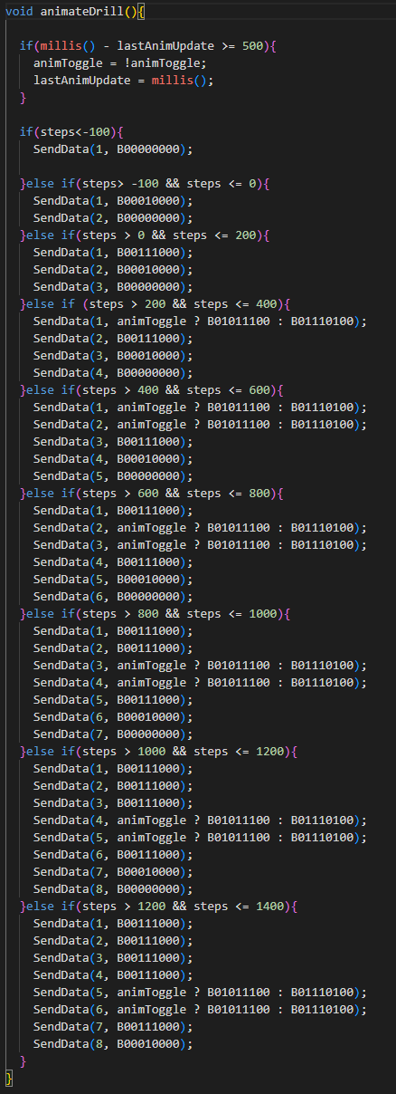
Fixed the trailing Dots,
but still is HARD CODDED.
And I also need a way to show the levels at which I hit a hard rock on the dot matrix.

Third try:
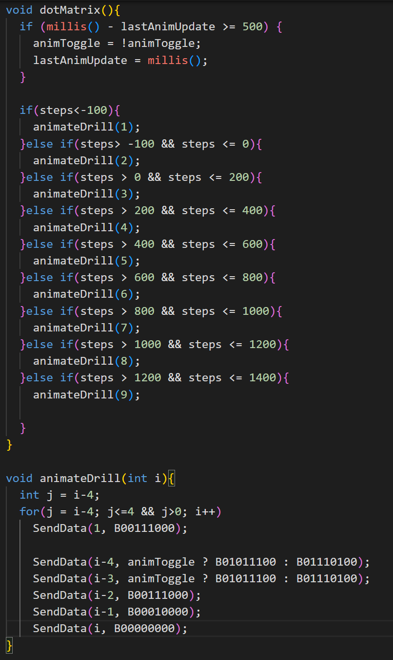
I made a new function animateDrill,
But everything was breaking as animateDrill uses senddata and as the send data function breaks with -ve numbers this wasn’t working

Fourth try:
The thing is sendData() was creating the problem, whats the upside of not using libraries I made send data. So I fixed it.to not accept values below 0 or above 8.
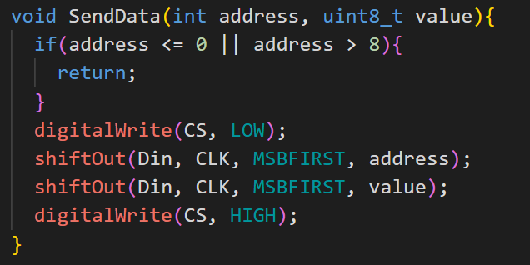
After debugging for some time:

Final Code:
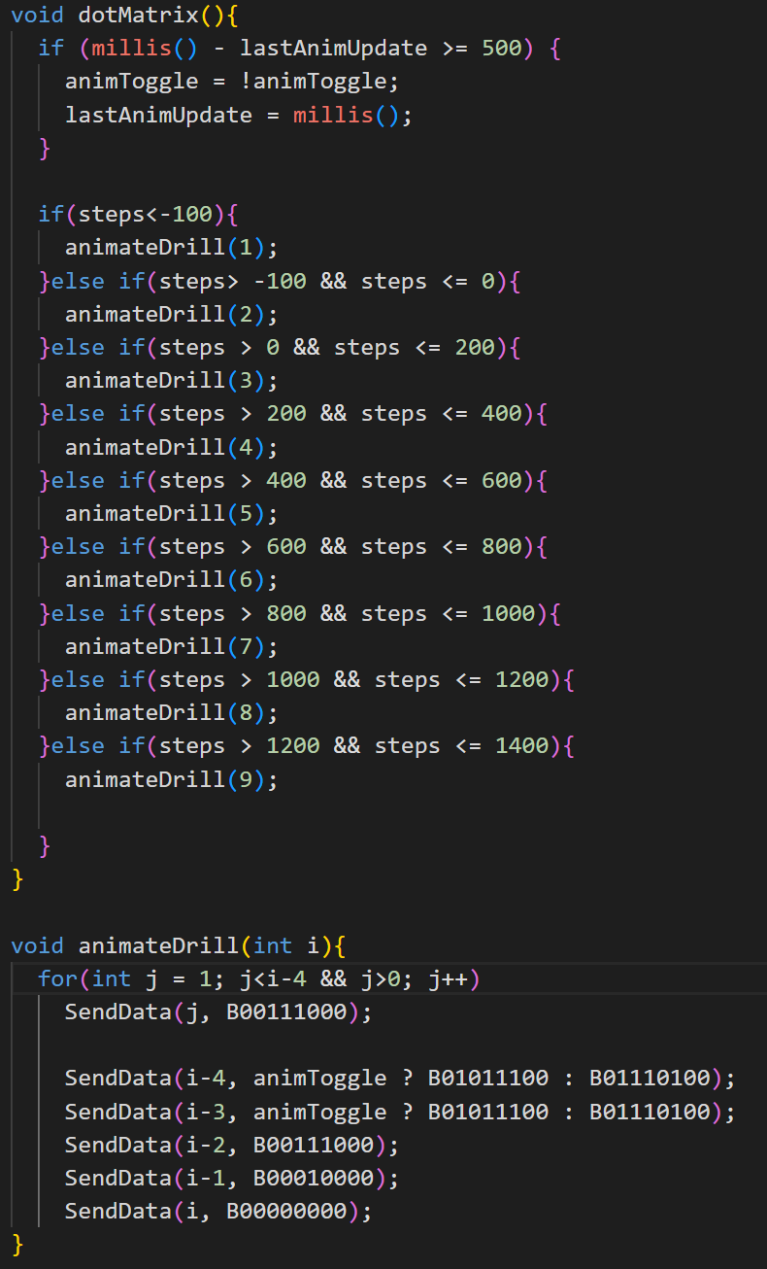
Then I Thought of this:
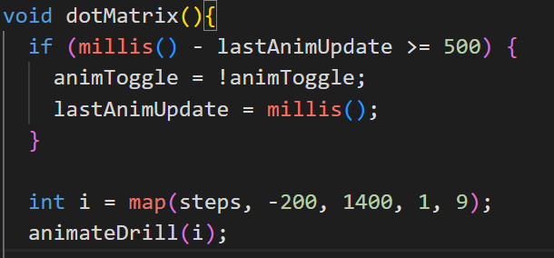
Brilliant IDEA I can replace the whole thing with gust 6 lines, instead of the huge if else chain.

2.View Readings:
