LEVEL 0: The Interface and Physical Base
AIM:
- Program the OLED display to act as a menu-driven interface, using the Joystick's Y-axis as a cursor to scroll through options, Push Button 1 to Select, and Push Button 2 to Go Back.
- Create your first menu option: 1. Control Drill. When this mode is selected, you will take manual control of the arm.
- The Stepper Motor acts as the depth winch; read the Joystick's Yaxis to step the motor up (retract) or down (descend).
- The Servo Motor acts as the drill's tilt mechanism, controlled dynamically by sweeping the Joystick's X-axis.
- Throughout this operation, the OLED must function as a telemetry dashboard, dynamically displaying the real-time Depth (Stepper position), Tilt Angle (Servo position), and the current directional status ("Upwards”, "Downwards", ”stationary”).
Constraints:
- The delay () function is strictly prohibited.
- The "Select" and "Go Back" push buttons must use interrupts.

Circuit:
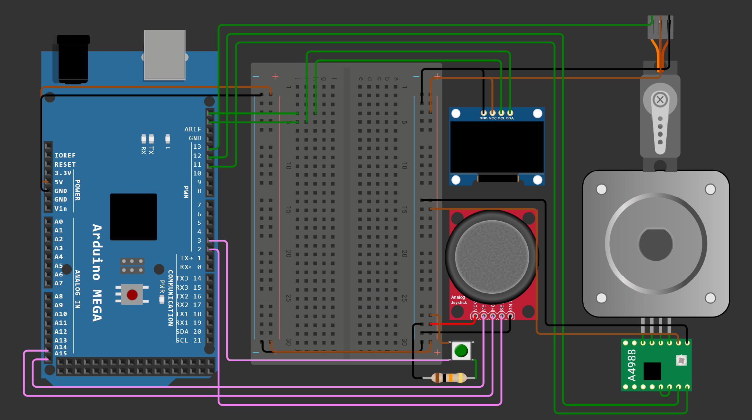

Interfacing:

Joystick:
Source: https://docs.wokwi.com/parts/wokwi-analog-joystick
Position | HORZ | VERT
Top-Left | 1023 | 1023
Top | 512 | 1023
Top-Right | 0 | 1023
Left | 1023 | 512
Centre | 512 | 512
Right | 0 | 512
Bottom-Left | 1023 | 0
Bottom | 512 | 0
Bottom-Right | 0 | 0

Name | Description
VCC | Positive power supply
VERT | Vertical axis output (analog)
HORZ | Horizontal axis output (analog)
SEL | Push button
GND | Ground
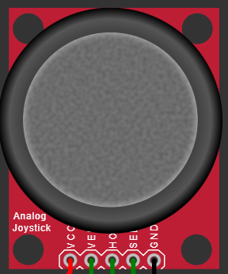

- Instead of taking input values at the boundary like 1023 and 0 I took a range so itll be smoother >1000
and <100.
- I’m using the button on the Joystick as my Select botton and another button for back.

OLED - Display:
Source:https://github.com/mcdominik/source/blob/main/arduino/oled_tutorial/oled_text_example.ino
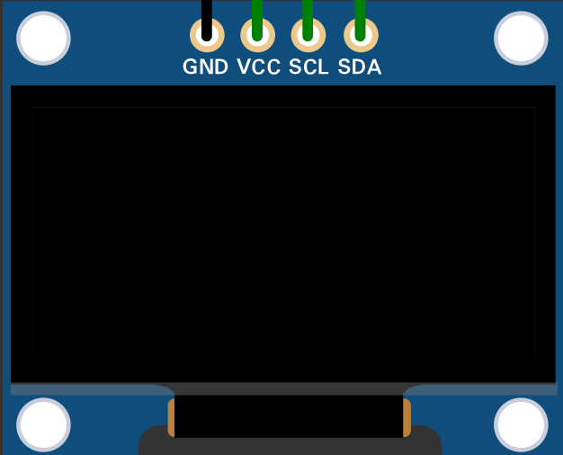
- It uses I2C Protocol
- I have worked with an LCD screen before this is similar to it

Stepper Motor:
Source: https://docs.wokwi.com/parts/wokwi-a4988
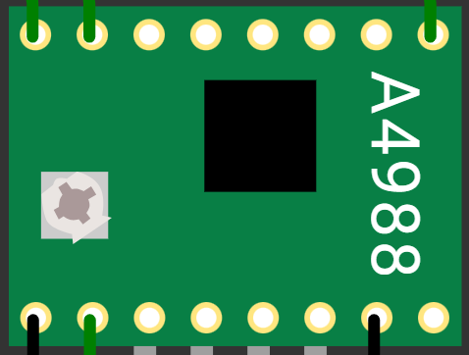
I’m using the stepper motor with a stepper motor driver(A4988), as there is no battery in Wokwi and it simulates properly even if the voltage or current isn’t correct, I don’t need a battery to run the Stepper Motor. But normally the battery is connected to the motor driver.
Name | Description | Default *
ENABLE | Enable pin, active low (pulled down) | Low (0)
MS1 | Microstep select pin 1 | Low (0)
MS2 | Microstep select pin 2 | Low (0)
MS3 | Microstep select pin 3 | Low (0)
RESET | Reset pin, active low (floating)
SLEEP | Sleep pin, active low (pulled up) | High (1)
STEP | Step input, connect to microcontroller
DIR | Direction input: 0=counterclockwise, 1=clockwise
GND | Ground
VDD | Logic power supply
1B | Connect to motor's B-
1A | Connect to motor's B+
2A | Connect to motor's A+
2B | Connect to motor's A-
VMOT | Motor power supply, not used in the simulation

MS1 | MS2 | MS3 | Operation mode | Degrees | Microsteps/revolution
0 | 0 | 0 | Full step (default) | 1.8 | 200
1 | 0 | 0 | Half step | 0.9 | 400
0 | 1 | 0 | 1/4 step* | 0.45 | 800
1 | 1 | 0 | 1/8 step* | 0.225 | 1600
1 | 1 | 1 | 1/16 step* | 0.1125 | 3200

- I’m taking MS1 = 0, MS2 = 0, MS3 = 0, for my simulation.

Servo Motor:
Source: https://blog.wokwi.com/learn-servo-motor-using-wokwi-logic-analyzer/
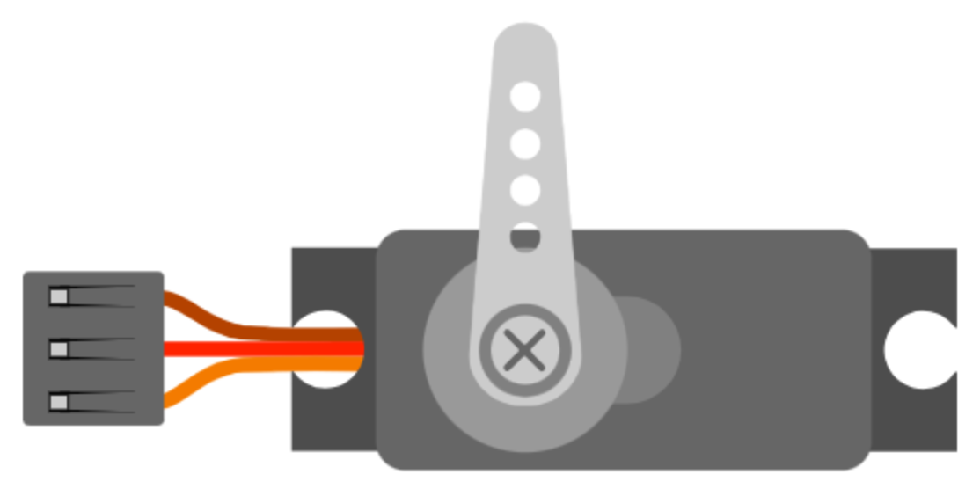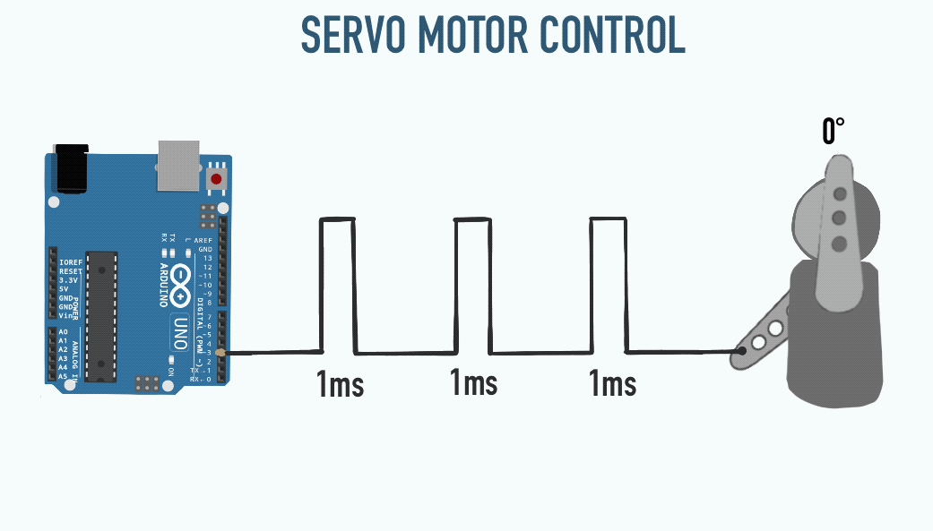

I tried to do this without libraries with this logic but in wokwi
- 1ms – 0deg
- 1.5ms – 90deg
- 2.4ms – 180deg
So, the mapping wasn’t proper, so I left it.

