LEVEL 2: Trench Mapping and Memory Logging
AIM:
As you venture deeper, the system must visually map the excavation process and permanently log the coordinates of any impenetrable hazards encountered in the dark.
- Display a downward-pointing triangle on the Dot Matrix representing the drill, animated to simulate spinning while the Stepper Motor descends. When the drill hits a hard rock hazard, log the exact depth (Stepper position) and Jerk value into a memory array, and permanently mark that depth as a lit dot on the Dot Matrix to build a visual hazard map during descent.
- Expand the OLED main menu with a second option:
"2. View Readings".
- In this sub-menu, scroll through logged hazards using the joystick, displaying each entry's depth and Jerk magnitude on the OLED. Simultaneously, the Dot Matrix switches to a bar graph mode, mapping up to 8 hazards across 8 columns with row height proportional to each hazard's Jerk magnitude.
Bonus: Use the Servo Motor's real-time tilt value to dynamically angle the drill triangle on the Dot Matrix, visually matching the physical arm's orientation.
Constraints: Hardware Interrupts: The "Select" and "Go Back" push buttons must use interrupts. Hardware Limits: Introduce a software limit so that the drill should not go beyond the dot matrix Memory Management: The hazard memory array must handle data overflow gracefully. If the array is built with a capacity of 10 hazards, encountering an 11th must not crash the microcontroller or overwrite critical memory segments.

Interfacing:

Dot Matrix:
Source:
- https://docs.wokwi.com/parts/wokwi-max7219-matrix
- https://www.hackster.io/mdraber/controlling-8x8-dot-matrix-with-max7219-and-arduino-7314a7
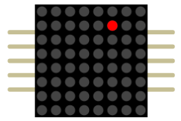
- This uses SPI Protocol instead of the I2C we have been using.
- Im doing this without libraries
- The first time I tried to animate it I used delay which made everything else get stuck but then I saw I was just switching between two things to animate it so I can use an condition statement like (x ? ans1(if x is true) : ans2(if x is false)) so now I just need to toggle x between true and false at intervals using millis

Drill animation:

First try:
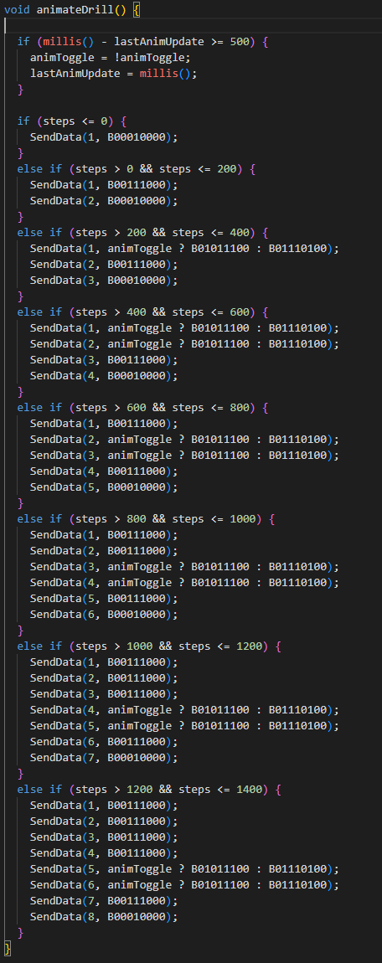
Yes, I HARD CODDED it, but there was a problem retracting as I don’t rewrite the lowest level of my drill it stays lit up on the dot matrix so.

Second try:
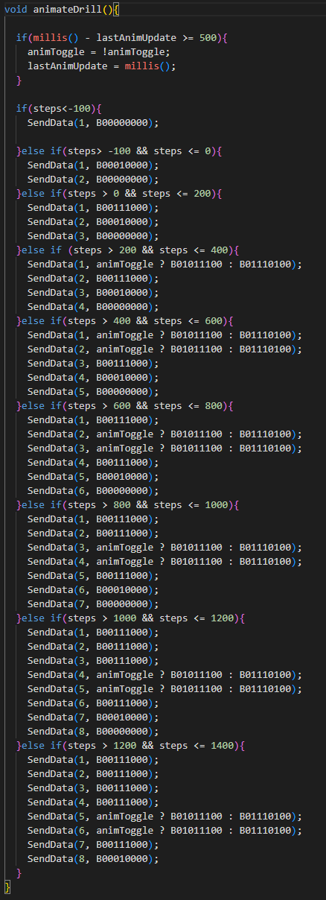
Fixed the trailing Dots,
but still is HARD CODDED.
And I also need a way to show the levels at which I hit a hard rock on the dot matrix.

Third try:
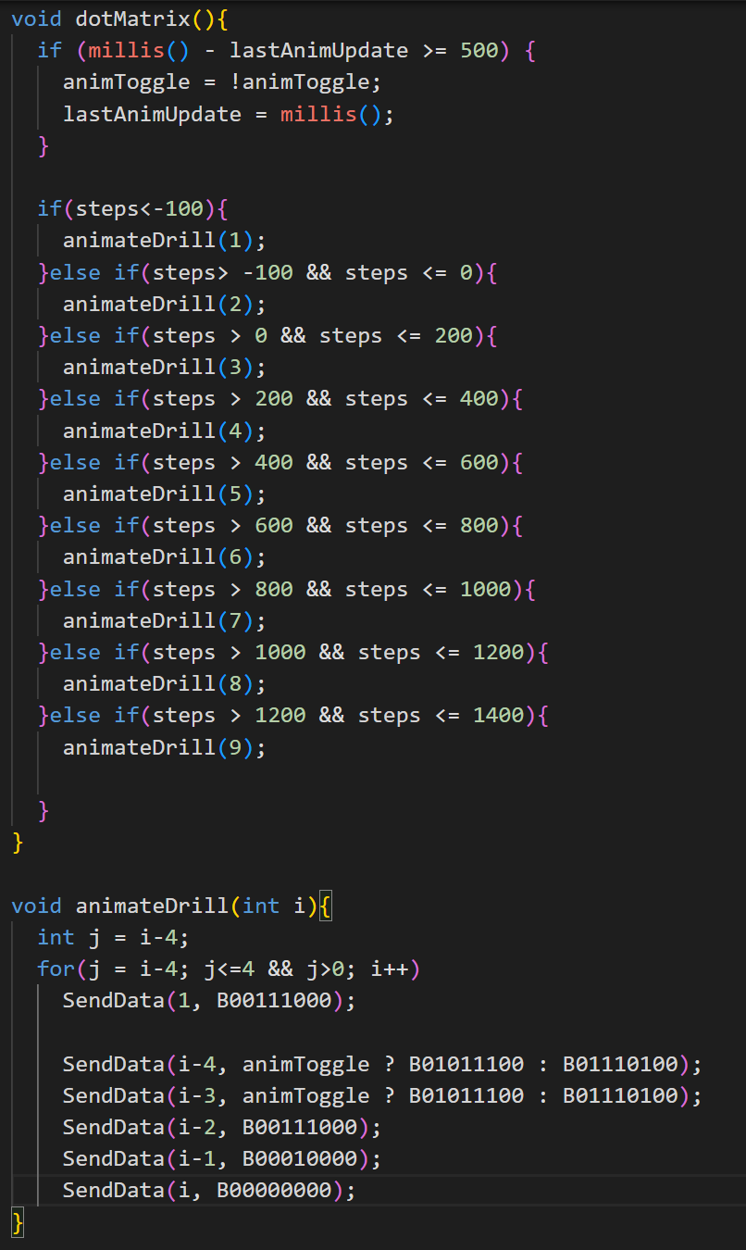
I made a new function animateDrill,
But everything was breaking as animateDrill uses senddata and as the send data function breaks with -ve numbers this wasn’t working

Fourth try:
The thing is sendData() was creating the problem, whats the upside of not using libraries I made send data. So I fixed it.to not accept values below 0 or above 8.
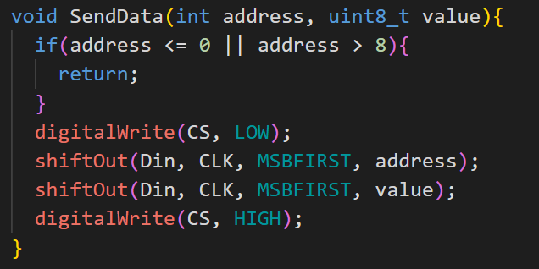
After debugging for some time:

Final Code:
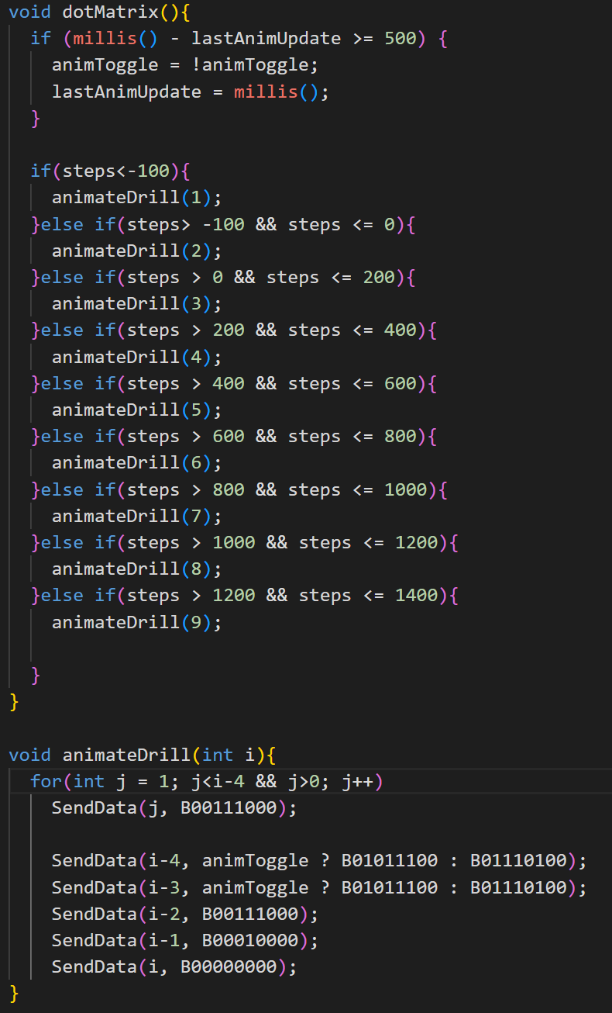
SIKE Then I thought of this:
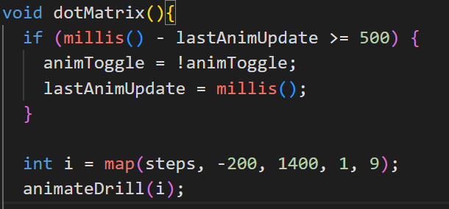
Brilliant IDEA I can replace the whole thing with gust 6 lines, instead of the huge if else chain.
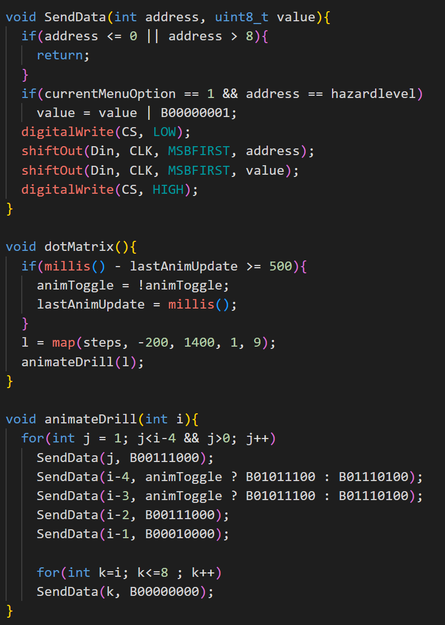
This is the actual Final Dot Matrix code.

2.View Readings:
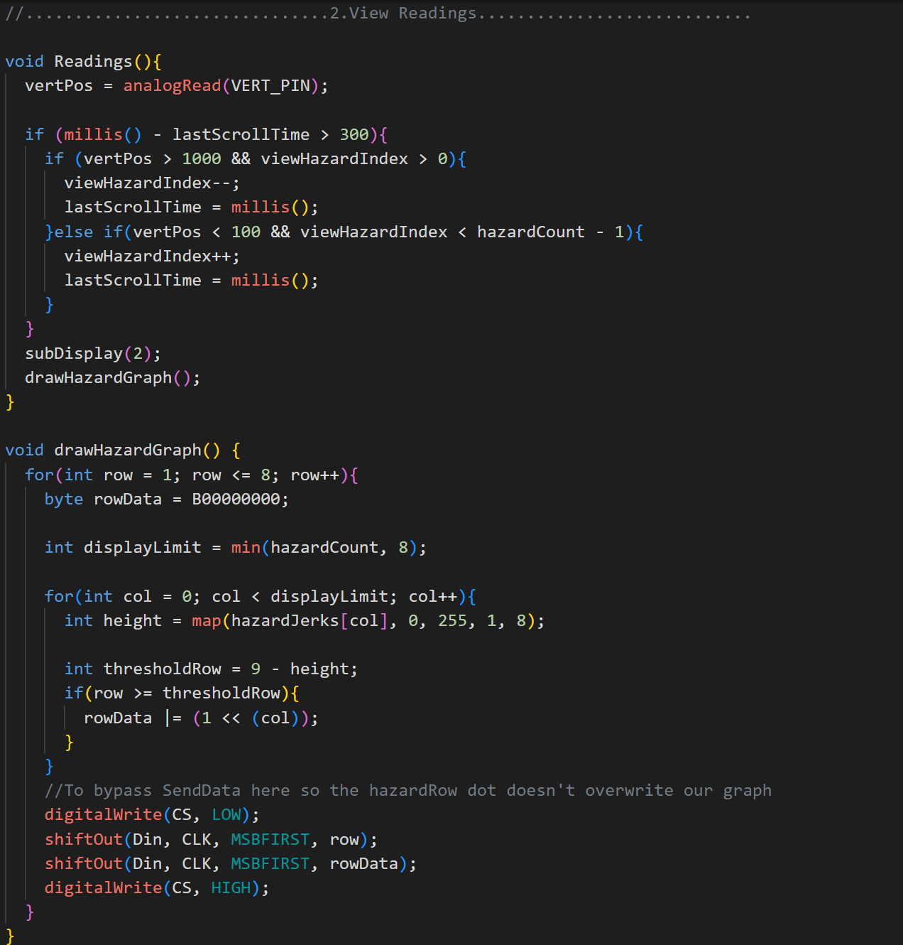
it is similar to how we dealt with the main screen scrolling code.

2.Hazard graph plotter:
here the dot matrix needs the Row and the column data in that row which is that B00000000 first we start with a clean slate.
we cap the data at 8 as we have only 8 columns.
the first for loop goes through the columns mapping their height to 1-8, after which we have to invert the number as the rows are counted from top, and if the row we are currently on is greater than the threshold number then that column is lit.

