EMBEDDED
Source: https://ww1.microchip.com/downloads/en/DeviceDoc/AVR-Instruction-Set-Manual-DS40002198A.pdf

LEVEL 0:
  - System Boot Sequence:
The Alterra Repulsion Cannon has just been deployed from the
Cyclops and is performing its startup diagnostics.
Before entering operational mode, the system must initialize all
onboard hardware and verify that the weapon platform is ready for use.
  - Components:
- ATmega32
- 16×2 LCD
  - Output expected:
Upon power-up the LCD shall display:
ALTERRA OS BOOTING...
for exactly 3 seconds.

Source:https://docs.google.com/file/d/0B5_mAdKvdKTlQlBPS2pwbE9ONFE/edit?resourcekey=0--86qfwS_AFjtkmQOlgw7uA

Stack Pointer:
Pg:135
LDI R21, HIGH(RAMEND)
OUT SPH, R21
LDI R21, LOW(RAMEND)
OUT SPL, R21
- Syntax: LDI loads an immediate value into a register. OUT sends that value to an I/O register.
- Why: this initializes the Stack Pointer. Without this, the CALL instructions used later for delays and subroutines would crash the system.

Configure I/O Ports
LDI R21, 0b11111111
OUT LCD_DDDR, R21
OUT LCD_CDDR, R21
- Why: Writing 1s to the Data Direction Registers makes all those pins act as outputs, allowing them to send voltage to the screen.

LCD interfacing:
Source:https://docs.google.com/file/d/0B5_mAdKvdKTlQlBPS2pwbE9ONFE/edit?resourcekey=0--86qfwS_AFjtkmQOlgw7uA
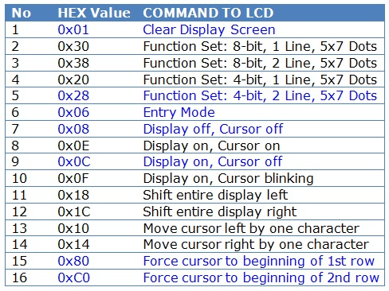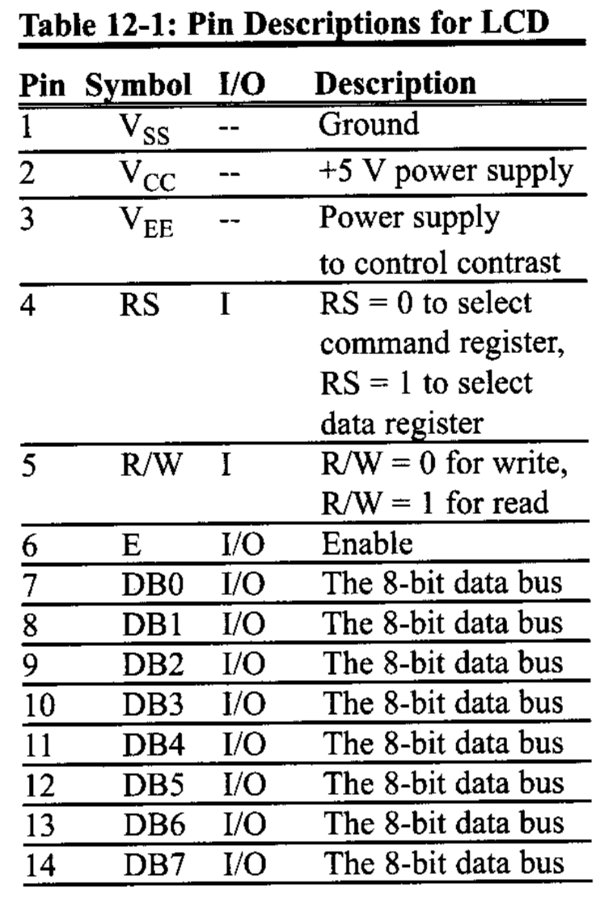
Only the registers from R16 to R31 load a constant immediately with the LDI instruction, R0 to R15 don't do that. This restriction is not very fine but could not be avoided during construction of the instruction set for the AVRs. There is one exception from that rule: setting a register to Zero. This instruction CLR MyPreferredRegister is valid for all registers.
I used the LCD in 8 Bit mode at first but later i have a shortage of I/O pins so changing LCD to 4-bit mode
1. What is 16×2 LCD 4-bit mode?
A normal 16×2 LCD has 8 data pins: D0 D1 D2 D3 D4 D5 D6 D7
In 8-bit mode, we connect all 8 data pins.
In 4-bit mode, we connect only: D4 D5 D6 D7
So, one 8-bit command/data byte is sent in two parts:
Example: command 0x28
Binary: 0x28 = 0010 1000
high low
The LCD receives:
First: 0010
Second: 1000

Before:
DATAWRT:
OUT LCD_DPRT, R16
SBI PORTD, LCD_RS
SBI PORTD, LCD_EN
CALL SDELAY
CBI PORTD, LCD_EN
CALL DELAY_100us
RET

We just have to do this 2 times instead, for higher nibble and lower nibble
DATAWRT:
; Send high nibble
MOV R27, R16
ANDI R27, 0xF0
OUT LCD_DPRT, R27
SBI LCD_CPRT, LCD_RS
SBI LCD_CPRT, LCD_EN
CALL SDELAY
CBI LCD_CPRT, LCD_EN
CALL DELAY_100us

; Send low nibble
MOV R27, R16
SWAP R27
ANDI R27, 0xF0
OUT LCD_DPRT, R27
SBI LCD_CPRT, LCD_EN
CALL SDELAY
CBI LCD_CPRT, LCD_EN
CALL DELAY_100us
RET
Similar thing is done with the CMNDWRT: as well

Features:
I used a character counter to count 16 characters after which the LCD goes to the next line to print.

LEVEL 1:
Basic Cannon Operation
The Repulsion Cannon is now active and ready for defensive operation.
Components:
- Trigger Push Button
- Fire Indicator LED
- stepper motor
- stepper motor driver (Any suitable stepper driver may be used (ULN2003, L293D, L298, etc.)
- LCD pushbutton for mode changes
The player begins with:
Energy = 10 Which will be displayed on LCD
Firing Action:
Each successful shot shall:
- The Fire Indicator LED shall turn ON during a firing action and turn OFF automatically after the shot is completed.
- Rotate Stepper Motor by 1 step
- Decrease Energy by 1
- Update LCD The
weapon shall not fire when: Energy = 0
Weapon Modes
A dedicated push button shall be used to toggle the weapon mode.
Each press shall switch between SINGLE and AUTO modes.
The active mode shall be displayed on the LCD.
SINGLE Mode
One trigger press fires one shot.
Trigger must be released before firing again.
AUTO Mode
Weapon continuously fires while trigger is held.
Each shot consumes 1 Energy and rotates the stepper motor by 1 step.
Firing stops when the trigger is released or Energy reaches 0.
The LCD shall continuously display:
E: 10 MODE: S or E: 10 MODE: A
The weapon shall remain responsive to always trigger and mode change inputs

Updating LCD:
- The use of ORI
MOV R16, ENERGY
ORI R16, '0'
CALL DATAWRT
- The value in the variable Energy is in binary but the LCD doesn’t understand Binary and by binary number OR ASCII ‘0’ give the ASCII of that Binary number.
- The space:
LDI R16, ' ' ; Adding a space as there were 2 digits before(10)
- DO_PRINT_MODE:
CALL PRINT_STRING
RET
I’m using this in the code to print a string, it seems redundant, but it seems CALL AND RET take up space in the flash memory so combining them into one like this will take up only 1 memory location instead of two.

Interrupts:
Source:https://docs.google.com/file/d/0B5_mAdKvdKTlQlBPS2pwbE9ONFE/edit?resourcekey=0--86qfwS_AFjtkmQOlgw7uA
Pg.375
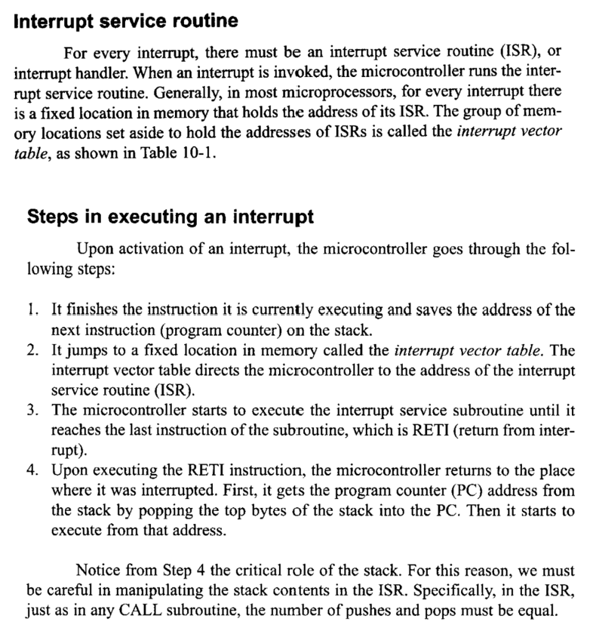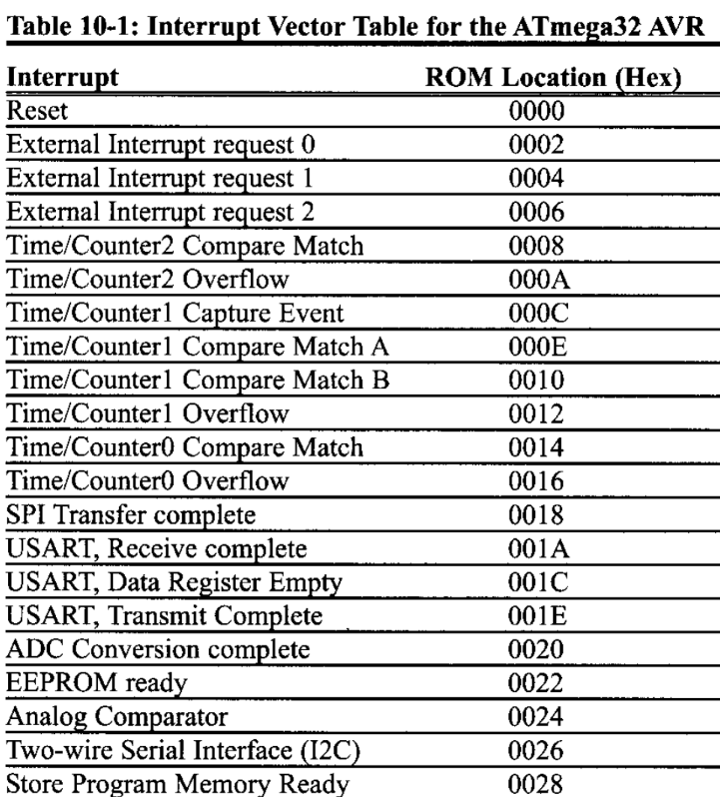
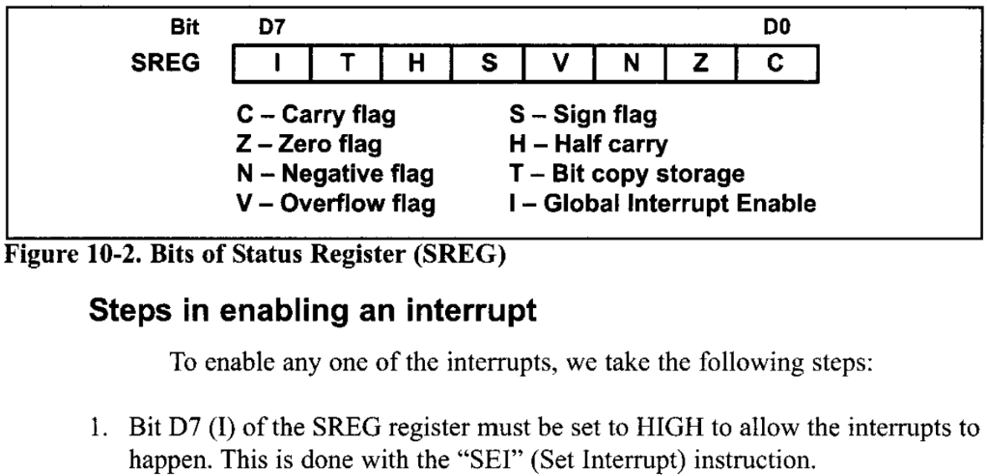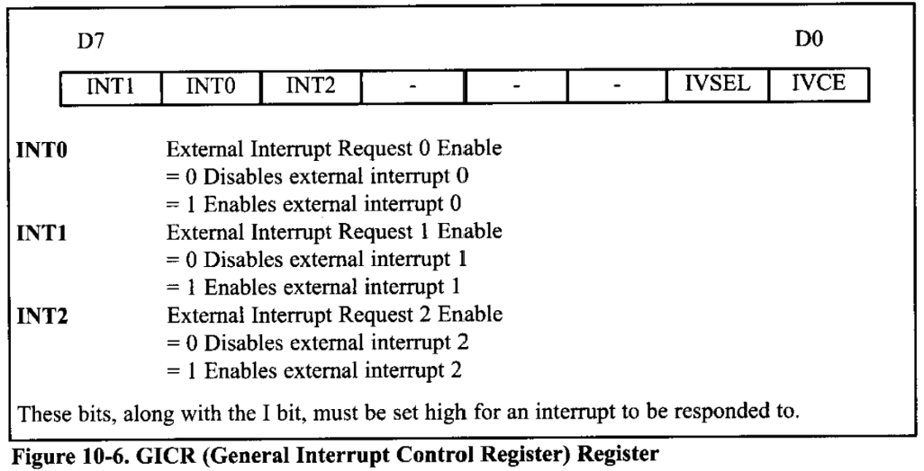
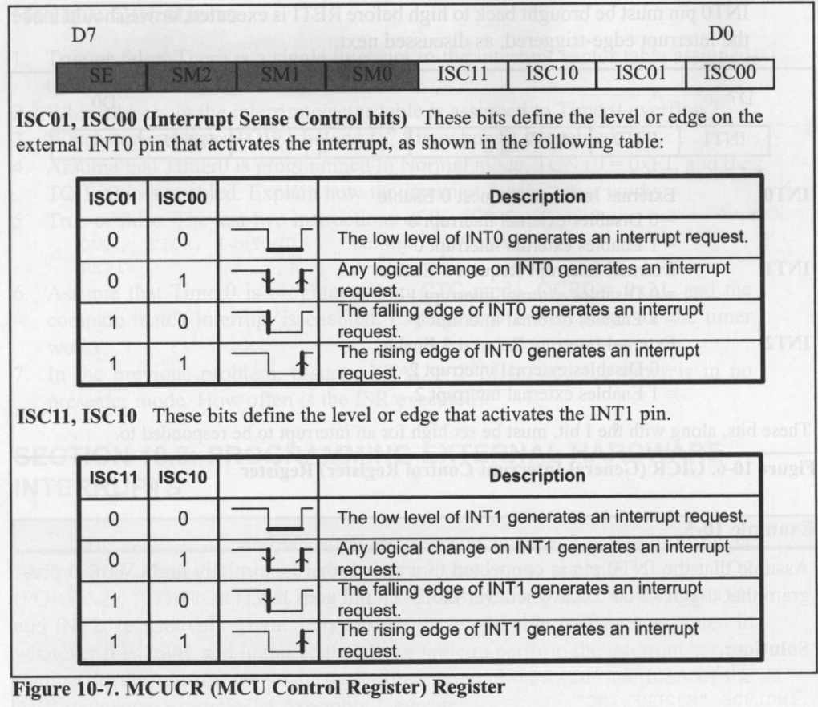
LDI R21, (1<<ISC11) | (0<<ISC10) | (1<<ISC01) | (0<<ISC00); configuring Interupts to
trigger on the rising edge
OUT MCUCR, R21
LDI R21, (1<<INT1) | (1<<INT0); Enabling INT1 and INT0
OUT GICR, R21
We turn the global interrupts on after the boot sequence as we don’t want it to fire while its booting.
Doing heavy work (like moving a motor) inside an ISR is bad practice because it blocks the CPU from doing anything else for a long time. Instead, we just set a "flag"
The operational loop which is running infinitely will be checking on these flags

Stepper motor Interfacing:
Source:
https://docs.google.com/file/d/0B5_mAdKvdKTlQlBPS2pwbE9ONFE/edit?resourcekey=0--86qfwS_AFjtkmQOlgw7uA
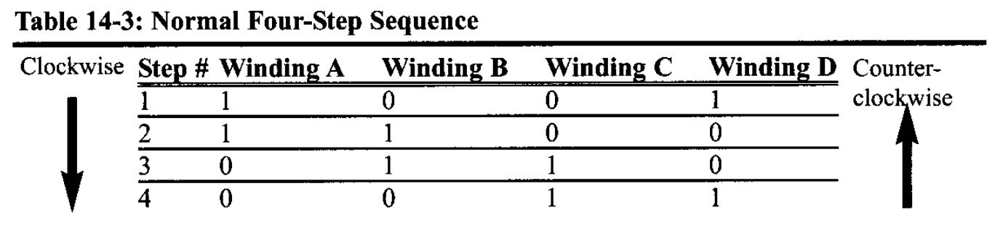
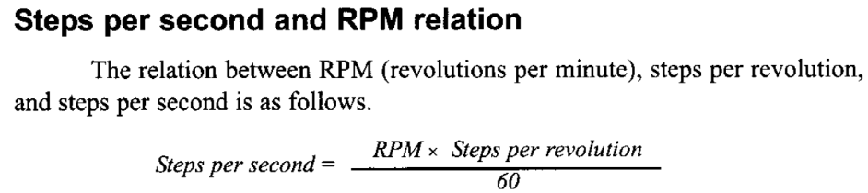
- Problem faced:
The motor was getting to 0deg after the first bullet was shot.
Solution:
I just set it to 0deg at the initialisation.
- Problem faced:
In auto mode the mechanical stepper motor wasn’t able to keep up with the LCD so the ammo was going empty before the stepper can go 360 degrees.
Solution:
I just introduced some delay between the simultaneous firing for the stepper to be able to keep up.

LEVEL 2:
Environmental Mapping System
Components:
- HC-SR04 Ultrasonic Sensor
- DS18B20 Temperature Sensor
The Repulsion Cannon continuously scans the surrounding environment to assist navigation and terrain awareness in low-visibility conditions.
Distance and temperature data are collected in real time and displayed to the operator to improve situational awareness.
The firmware shall continuously:
Measure surrounding distance using the HC-SR04
Measure ambient temperature using the DS18B20
Display both values on the LCD
LCD Example:
E:10_MODE:S
DIST:0123 TEMP:25C
Distance Calculation:
To improve measurement accuracy, the speed of sound shall be compensated using the ambient temperature,
The speed of sound shall be approximated as:
v = 331 + 0.6T d = (v × t) / 2
where,
d = distance
v = speed of sound
t = total echo travel time

Ultrasonic Sensor:
Source: https://www.alldatasheet.com/datasheet-pdf/view/1132204/ETC2/HCSR04.html
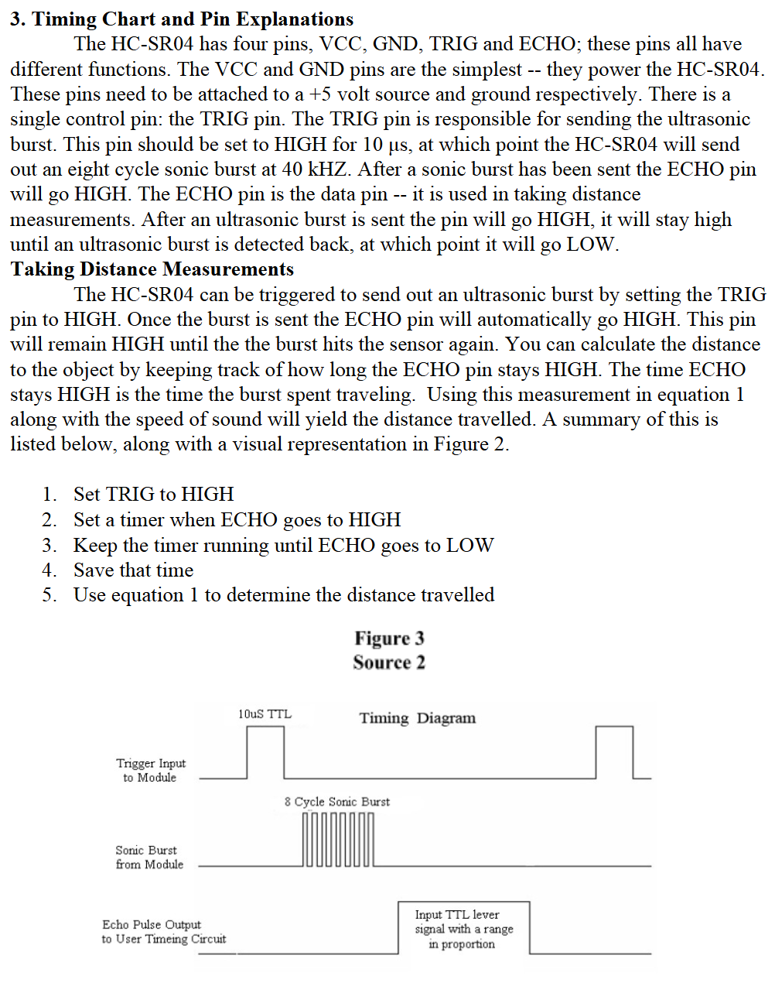
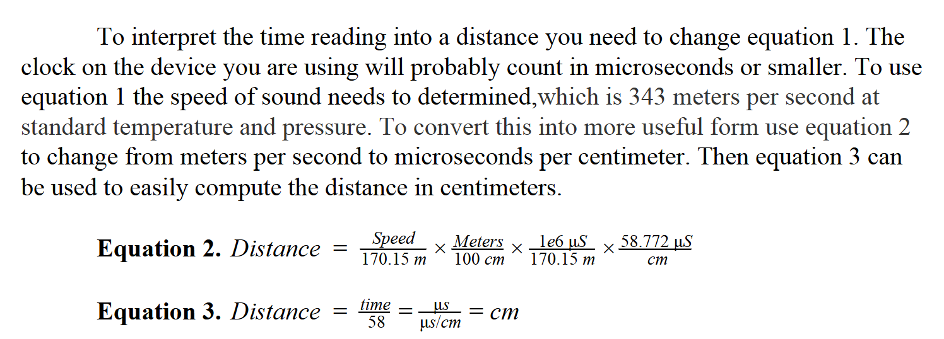
To calculate the time, it takes:
we use the timer, you interact with three specific types of registers:
- The Count Registers (TCNT1H & TCNT1L): This is the "Stopwatch." It holds the current count. Because it is a 16-bit timer, it is split into two 8-bit pieces: High (H) and Low (L).
- The Control Register (TCCR1B): This is the "Dashboard." It contains the knobs that turn the timer on/off and decide how fast it counts (the Prescaler).
- The Interrupt/Status Registers (TIMSK & TIFR): These are the "Alarm" settings
LDI R16, 0x02 ; Prescaler 8
OUT TCCR1B, R16
By loading 0x02 (Binary 0000 0010), we are turning on the CS11 bit, which tells the hardware: "Connect the clock, but divide the speed by 8."
Since assembly doesn't have a simple DIVIDE instruction for complex numbers, we use Repeated Subtraction.
I though what if we never receive the signal back like if something is too far from way.

Temp Sensor (DS18B20):

Bit Banging:
The bus must be pulled low for at least 480µs to signal a reset. Then, we release the bus (set it to input mode) to let it float high. The sensor will then pull it low to acknowledge its presence
HANDSHAKE:
SBI DDRC, TEMP_PIN
CBI PORTC, TEMP_PIN
CALL DELAY_480us
CBI DDRC, TEMP_PIN
RCALL DELAY_60us
RCALL DELAY_420us
RET

WRITE_BYTE:
LDI R17, 8
WB_LOOP:
LSR R16
BRCC WRITE_0
WRITE_1:
SBI DDRC, TEMP_PIN
CBI PORTC, TEMP_PIN
CALL DELAY_10us
CBI DDRC, TEMP_PIN
CALL DELAY_60us
RJMP WB_NEXT
WRITE_0:
SBI DDRC, TEMP_PIN
CBI PORTC, TEMP_PIN
CALL DELAY_60us
CBI DDRC, TEMP_PIN
CALL DELAY_10us
WB_NEXT:
DEC R17
BRNE WB_LOOP
RET

READ_BYTE:

READ_TEMP:
The code uses specific hexadecimal values to issue commands to the sensor. These are defined by the manufacturer:
- 0xCC (Skip ROM): Since your circuit likely has only one temperature sensor, you don't need to address it by its unique serial number. This code effectively tells the sensor, "I am talking to the only device on the line, just listen to me."
- 0x44 (Convert T): This command tells the sensor to start measuring the temperature and converting it to digital data. This takes time, which is why your code has a DELAY_1s.
- 0xBE (Read Scratchpad): Once the conversion is done, this command tells the sensor, "Okay, stop measuring, move your data to the scratchpad memory, and let me read it."

LEVEL 3:

Extra Features:
- Made the schematic look like a gun .
- Added a RELOAD as for testing I had to turn the simulation on and off frequently.
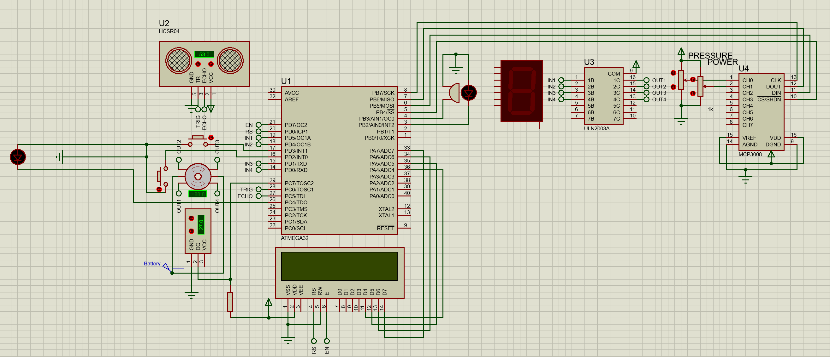
I TRIED TO DO IT WITH MY FLAGS REGISTER BUT IT WAS BECOMIMG COMPLICATED

