DIGITAL
AIM:
You are tasked with designing the control and data path logic for a simple custom 8-bit processor in Logisiim. The processor executes instructions encoded in either one or two bytes and supports arithmetic, logical, memory, and control-flow operations.
The instruction set architecture (ISA) is defined below. Your goal is to implement a processor capable of correctly decoding and executing all instructions according to their specified behavior.
PROCESSOR SPECIFICATIONS:
- 8 General-Purpose 8-bit Registers, R0 - R7 (R0 is a zero register)
- R7 acts as memory address register for load/store operations
- 8-bit addressable memory. Processor contains separate Instruction Memory and Data Memory.
- Processor has a 3 bit Flag register with a Zero Flag, Carry Flag and Negative Flag. Further flags can be added as per your choice.
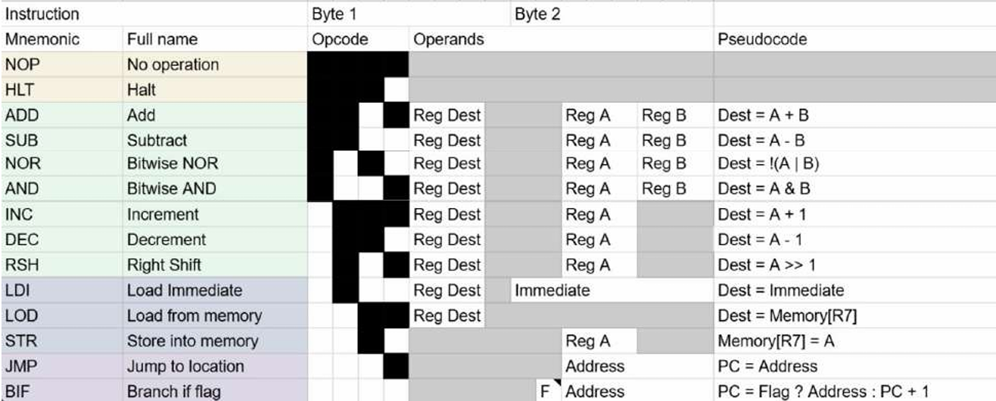
The length of every instruction is 16 bits.
OBJECTIVES:
- Correctly fetch instructions from memory.
- Decode instruction opcodes and operands.
- Execute all instructions according to the ISA specification.
- Properly update registers, memory, program counter, and flags.
- Halt execution when a HLT instruction is encountered.
Bonus task: Write a program for the processor to compute the first five numbers in the Fibonacci sequence and store all of them in memory.
Decoding the 16-bit ISA
Before placing a single wire in Logisim, you must understand how your processor reads a 16-bit instruction. Based on the provided specification table, your instructions are divided into two bytes (16 bits total).
Let's break down the bit fields. Looking at the black and white grid (assuming Black = 0, White = 1):
- Opcode (4 bits): The first 4 bits of Byte 1 tell the Control Unit what operation to perform.
  - NOP = 0000
  - HLT = 0001
  - ADD = 0010
  - SUB = 0011
  - LDI = 1001
- Register Destination (3 bits): The next 3 bits specify which of the 8 general-purpose registers (R0-R7) will receive the result.
- Source Registers / Immediate (Varies): Byte 2 contains the operands. For an ADD instruction, it holds the 3-bit addresses for Reg A and Reg B. For an LDI (Load Immediate) instruction, Byte 2 holds an 8-bit immediate numerical value.

Memory cell:
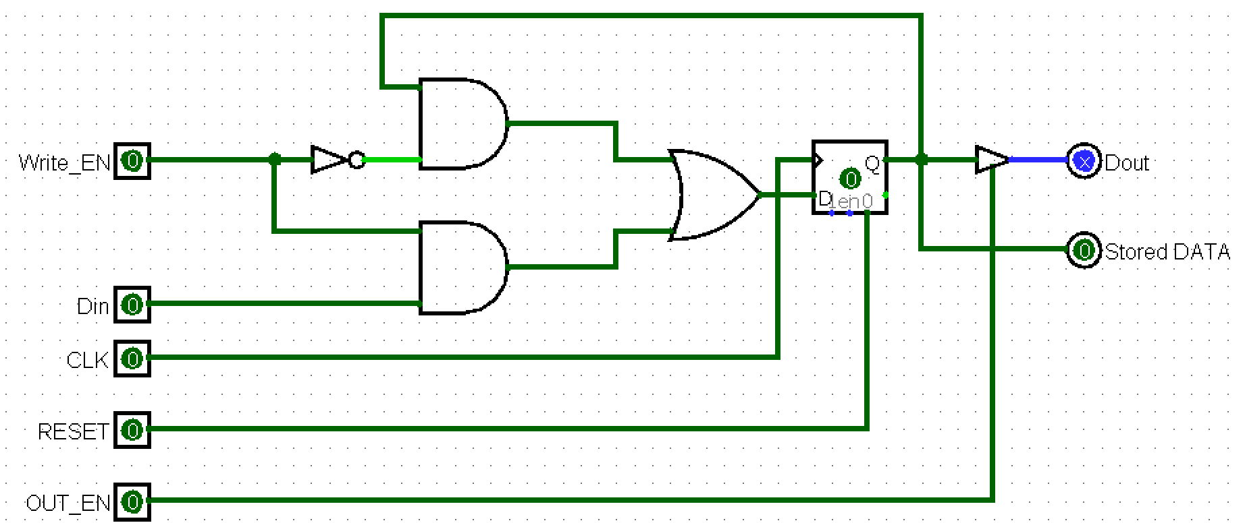
Its basically a D flip flop with more features.

Register:
Combining 8 memory cells to make a 8 bit Register
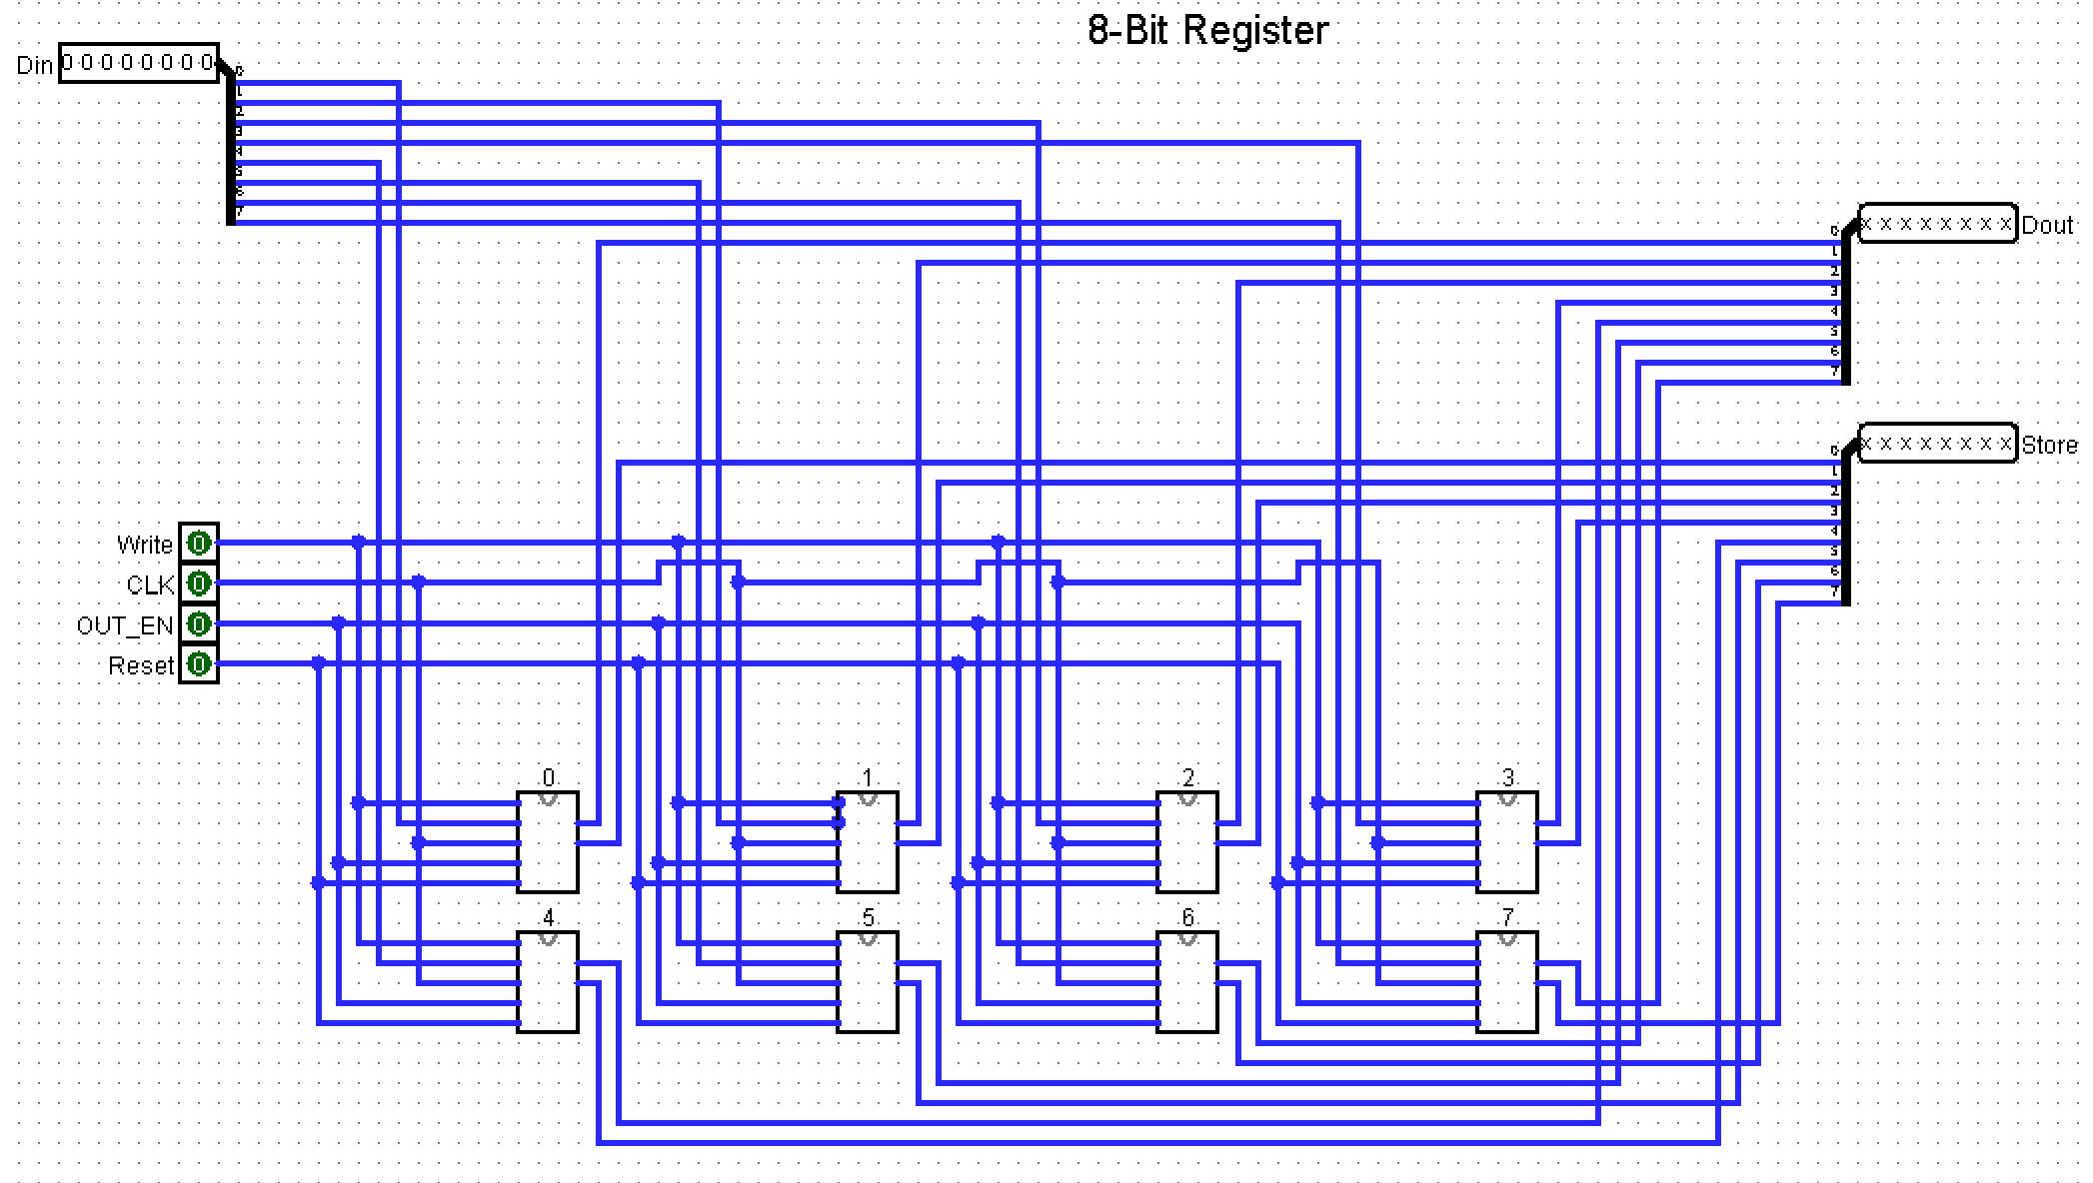

Program Counter:
The Program Counter stores the address of the next instruction.
Think of it like a bookmark in the instruction memory.
PC = 00000000 - fetch instruction at address 0
PC = 00000001 - fetch instruction at address 1
PC = 00000010 -fetch instruction at address 2
After most instructions, PC should increase by 1:
PC = PC + 1
But for jump instructions:
JMP address
PC should become the address directly:
PC = address
For halt:
PC should stop changing.

Half Adder:
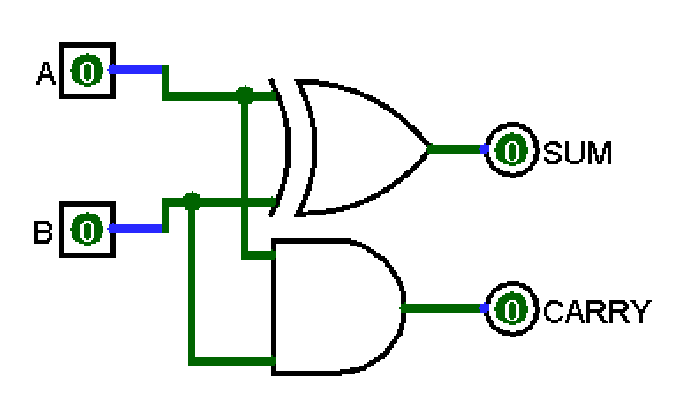

8Bit Adder for PC + 1:
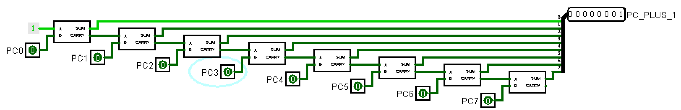

MUX:

(1BIT) 2 to 1 MUX:
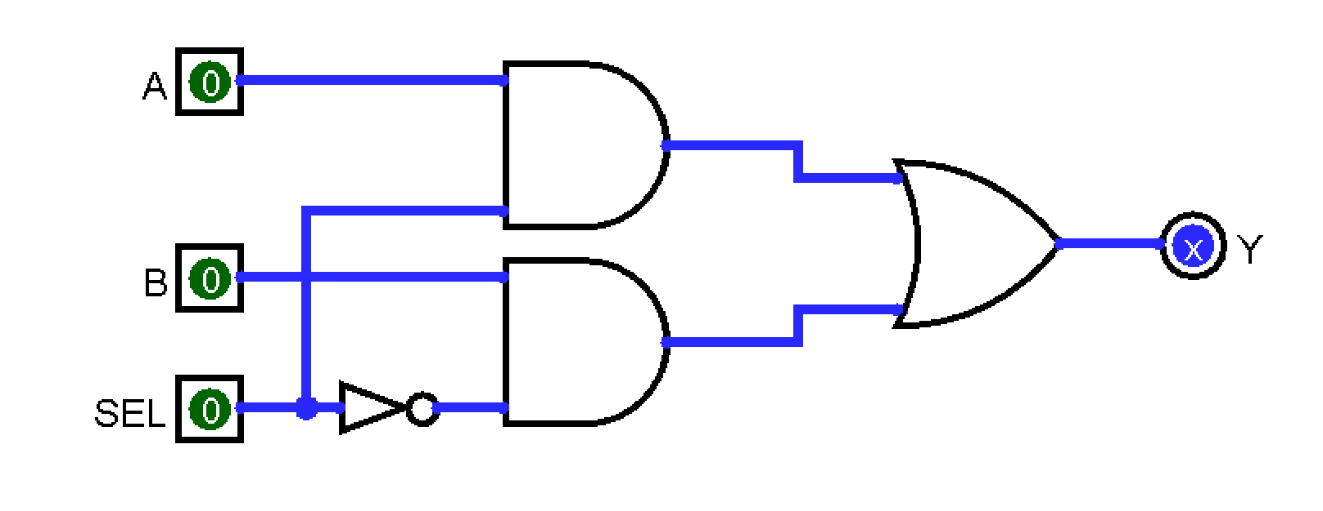

8BIT-2 to 1 MUX:
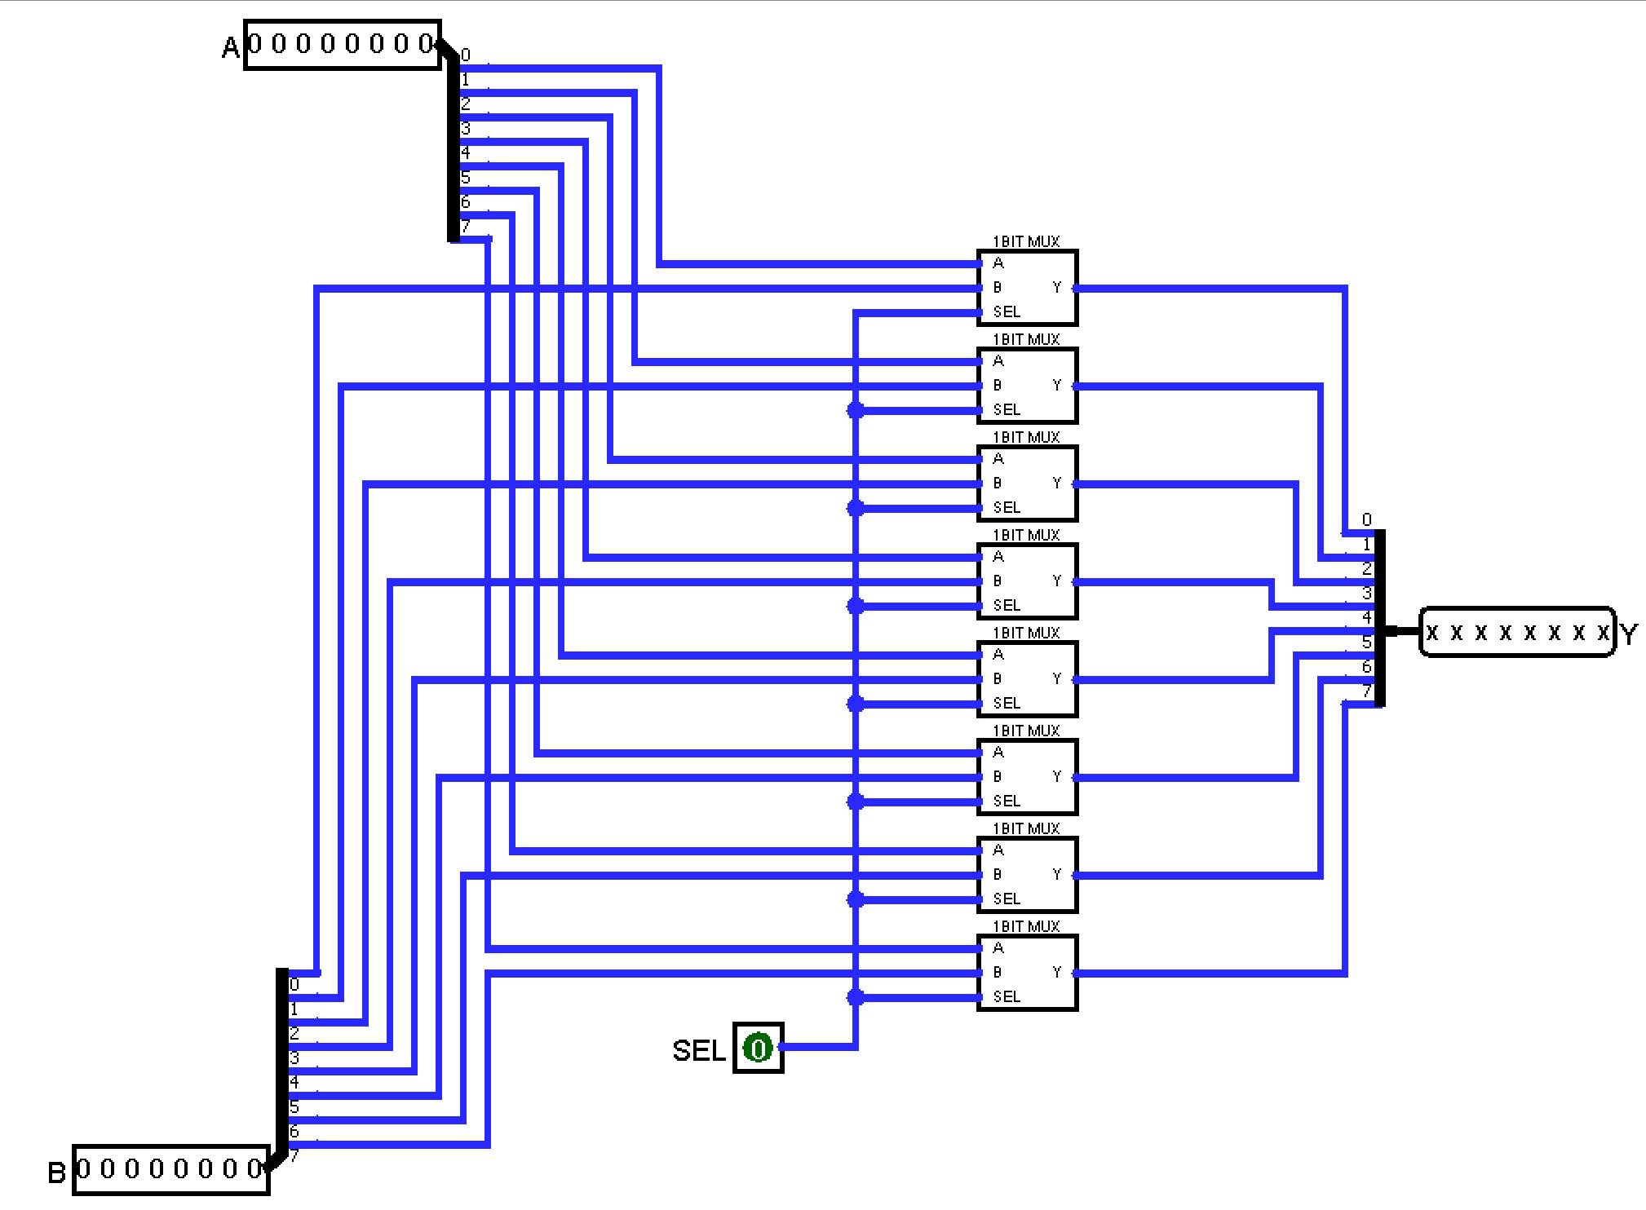

Program Counter:
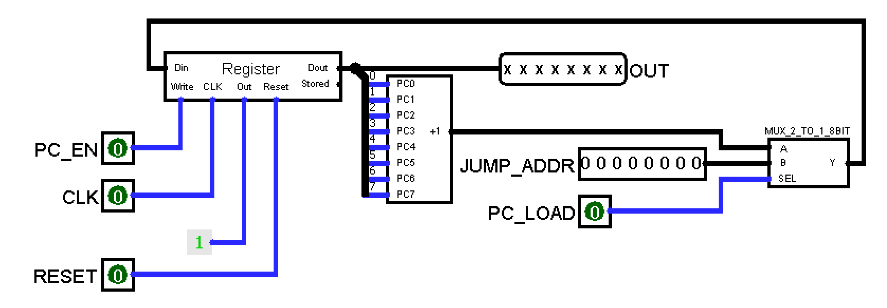
Normal instruction
PC_LOAD = 0
PC_EN = 1
MUX chooses:
PC + 1
So on clock:
PC = PC + 1
Jump instruction
PC_LOAD = 1
PC_EN = 1
MUX chooses:
JUMP ADDR
So on clock:
PC = JUMP ADDR
Halt instruction
PC_EN = 0
Register write is disabled, so PC holds the same value

Instruction Memory:
Instruction memory is a dedicated section of a computer's memory that stores the compiled machine code (the "recipe" or steps) of a program. It acts as a read-only repository providing the processor with the exact operations it needs to perform to execute a task.
It works in a continuous, three-step loop driven by the CPU's clock:
- Fetch: The Program Counter (PC) sends the memory address of the next required instruction to the instruction memory. The instruction memory then retrieves the binary code stored at that address and sends it to the Instruction Register.
- Decode: The Control Unit interprets the fetched binary sequence (breaking it down into the operation to execute and the registers involved) so the computer understands what to do.
- Execute: The processor performs the instructed task (adding numbers using the ALU or shifting data).
Once executed, the Program Counter automatically increments to point to the next instruction
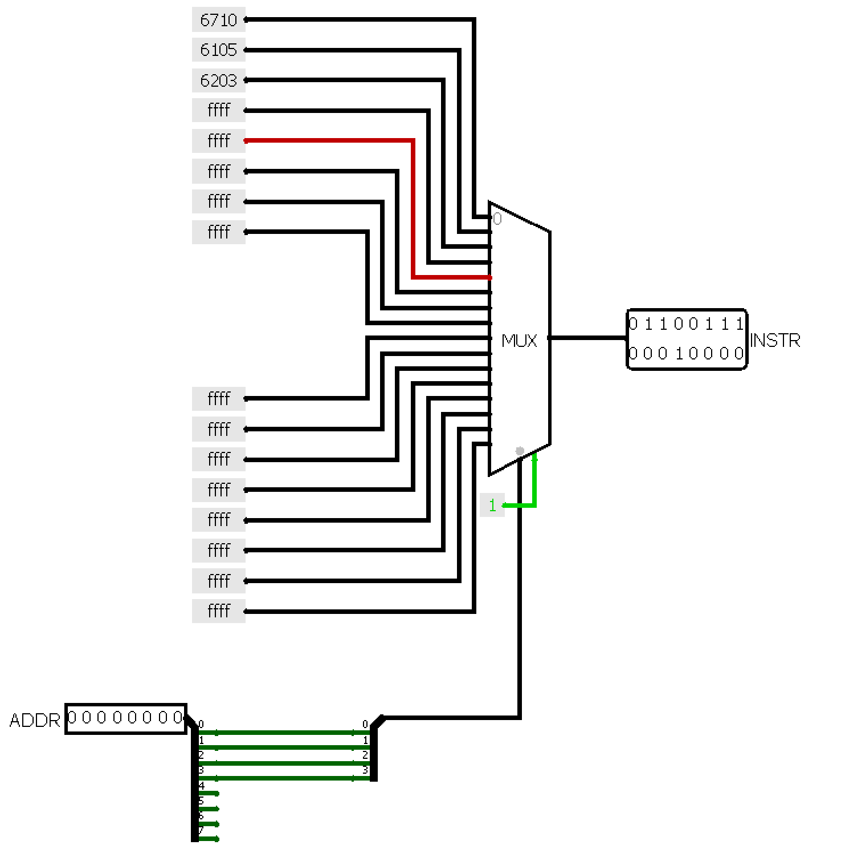

Instruction Splitter:
16-bit instruction is:
INSTR [15:12] = OPCODE
INSTR [11:8] = Byte-1 operand: Reg Dest / Flag select / unused
INSTR [7:4] = Byte-2 high nibble: Reg A / immediate upper nibble / address upper nibble
INSTR [3:0] = Byte-2 low nibble: Reg B / immediate lower nibble / address lower nibble
Instruction | Opcode | Uses [11:8] | Uses [7:4] | Uses [3:0] | Meaning
NOP | 0 | ignored | ignored | ignored | no operation
HLT | 1 | ignored | ignored | ignored | halt
ADD | 2 | Reg Dest | Reg A | Reg B | Dest = A + B
SUB | 3 | Reg Dest | Reg A | Reg B | Dest = A - B
NOR | 5 | Reg Dest | Reg A | Reg B | Dest = !(A | B)
AND | 6 | Reg Dest | Reg A | Reg B | Dest = A & B
INC | 8 | Reg Dest | Reg A | ignored | Dest = A + 1
DEC | 9 | Reg Dest | Reg A | ignored | Dest = A - 1
RSH | A | Reg Dest | Reg A | ignored | Dest = A >> 1
LDI | B | Reg Dest | immediate upper | immediate lower | Dest = immediate
LOD | C | Reg Dest | ignored | ignored | Dest = Memory[R7]
STR | D | ignored | Reg A | ignored | Memory[R7] = A
JMP | E | ignored | address upper | address lower | PC = address
BIF | F | Flag select | address upper | address lower | if flag then PC = address

Decoder:

REGISTER FILE:
An 8-bit register file is a small, ultra-fast storage array inside a CPU that holds temporary data bytes currently being processed. It acts like a scratchpad.
- Reading Data: The CPU provides the binary address of the register it wants to read. Internal circuits called multiplexers (MUX) act as digital switches, routing the 8-bit data from that specific register to the output lines.
- Writing Data: The CPU provides a destination register address, the new 8-bit data, and a Write Enable signal. Internal circuits called decoders activate only the chosen register, allowing it to capture and save the new data when the clock ticks.

The Memory address register(R7) acts as a gateway for the CPU to interact with the outside world:
- The CPU Needs Data: When the CPU needs to fetch an instruction or read a variable from RAM, it places that data's specific binary memory address into the MAR.
- Driving the Address Bus: The MAR is physically connected to the Address Bus (a set of parallel wires running to the RAM). It forces these wires high or low to transmit the address to the memory chip.
- Memory Activation: The RAM detects the address on the bus, locates the physical hardware cell, and prepares to either send data out or accept new data in.

Inputs:
- Read Address A: Binary code specifying which register to read for the first output.
- Read Address B: Binary code specifying which register to read for the second output.
- Write Address: Binary code specifying which register will receive new data.
- Write Data (8-bits): The actual 8-bit byte of data to be saved into the register file.
- Write Enable (WE): A 1-bit control signal (Yes/No) that permits or blocks writing.
- Clock: The timing signal that synchronizes when data gets saved.

Outputs:
- Read Data A
- Read Data B
- Memory address register (MAR)
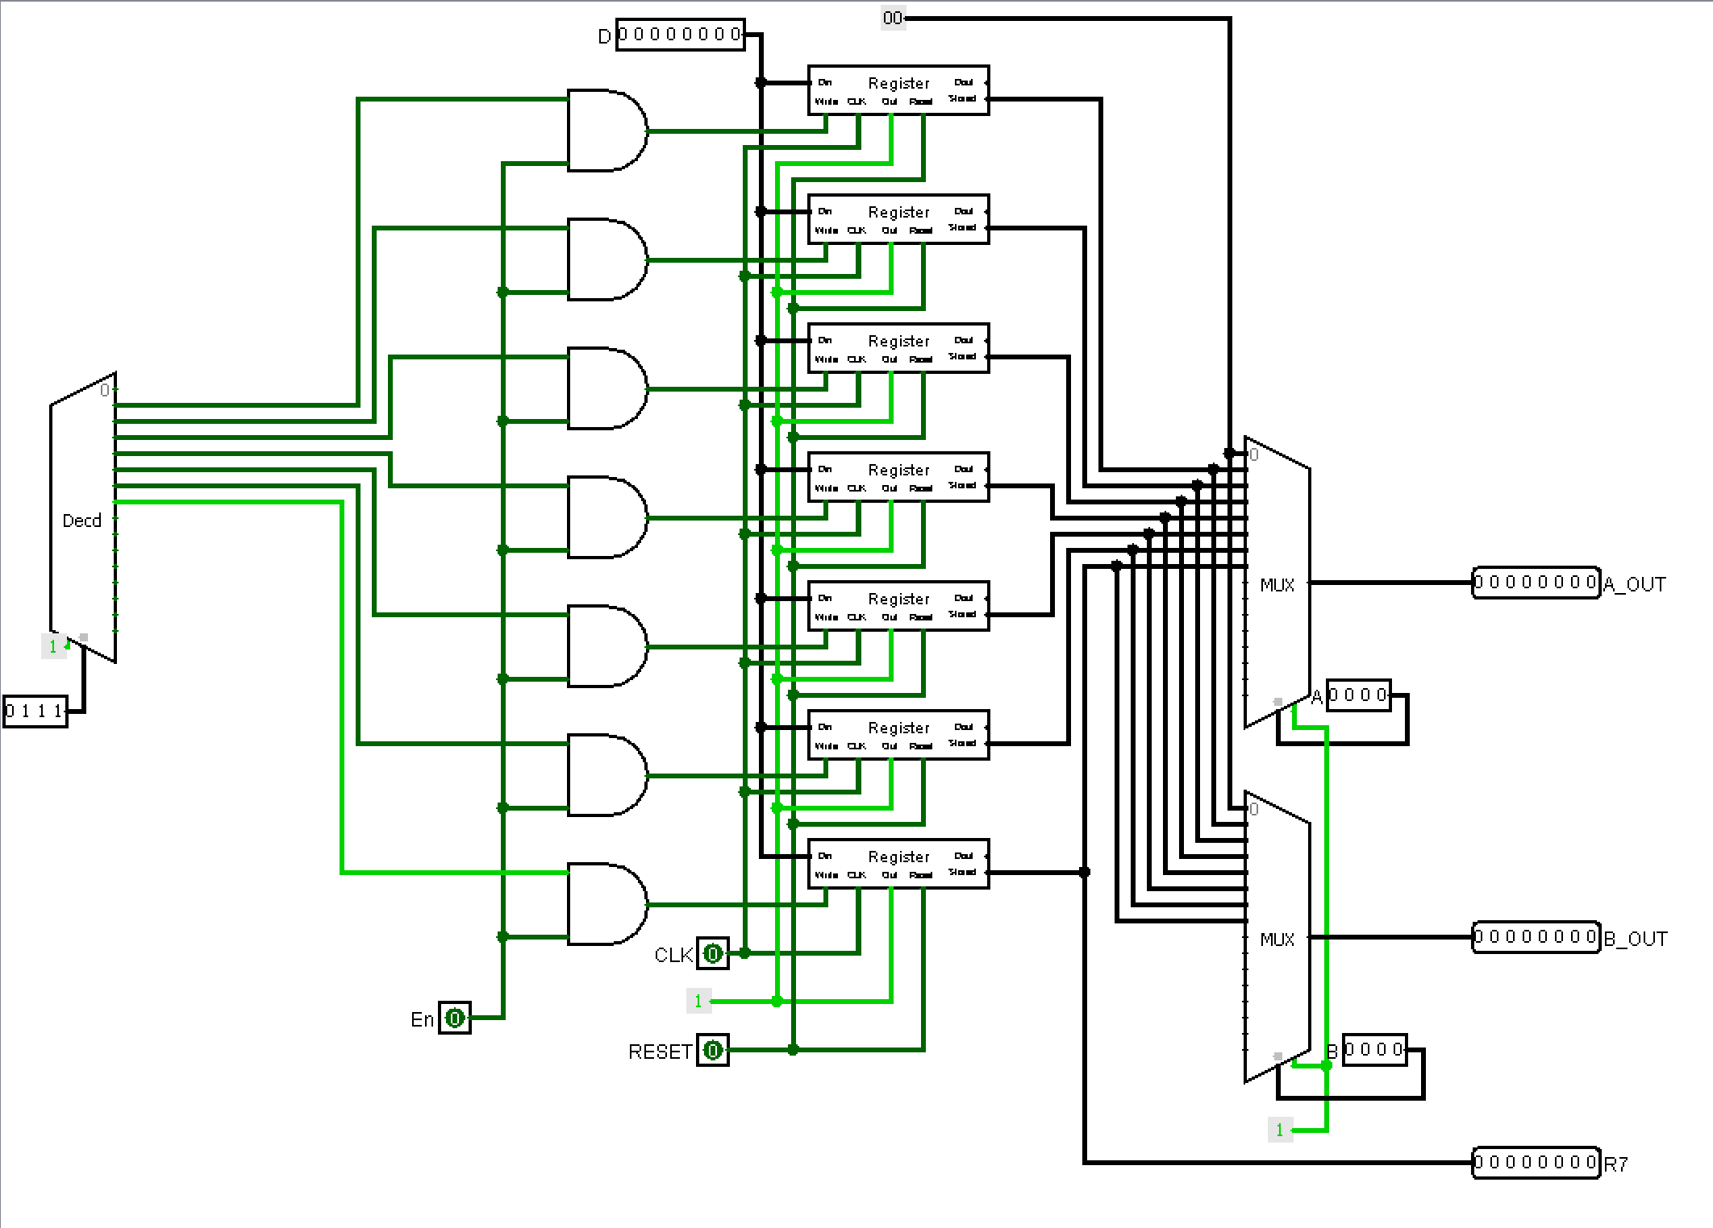

ALU:

ALU DECODER:
B3 | B2 | B1 | B0 | ADD | SUB | NOR | AND | INC | DEC | RSH
0 | 0 | 1 | 0 | 1
0 | 0 | 1 | 1 |  | 1
0 | 1 | 0 | 1 |  |  | 1
0 | 1 | 1 | 0 |  |  |  | 1
1 | 0 | 0 | 0 |  |  |  |  | 1
1 | 0 | 0 | 1 |  |  |  |  |  | 1
1 | 0 | 1 | 0 |  |  |  |  |  |  | 1
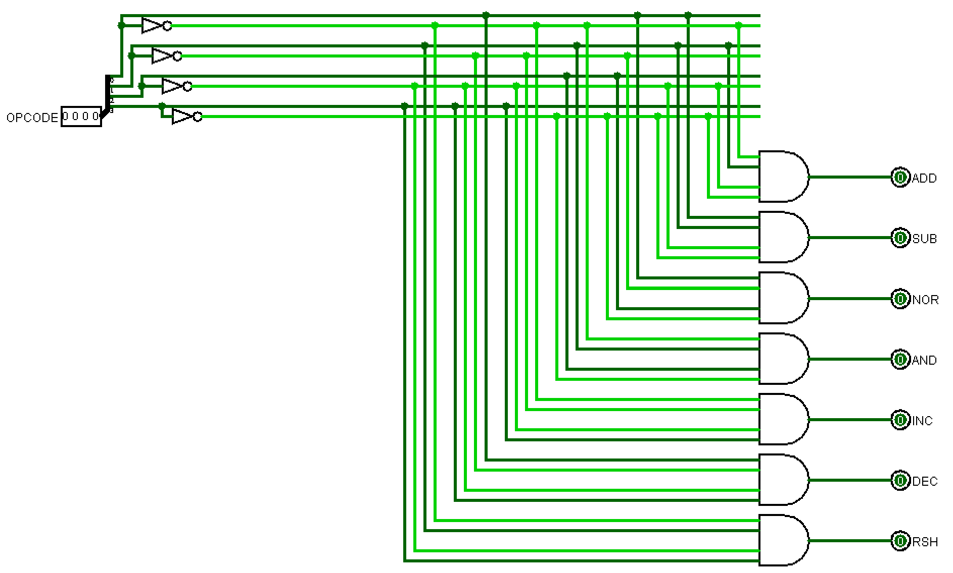

ADDER:

1BITFULLADDER:
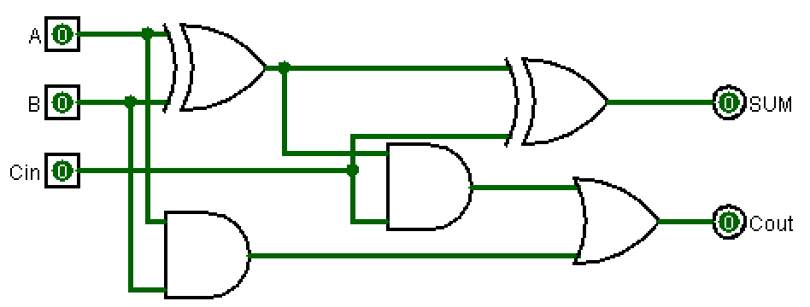

8BITFULLADDER:
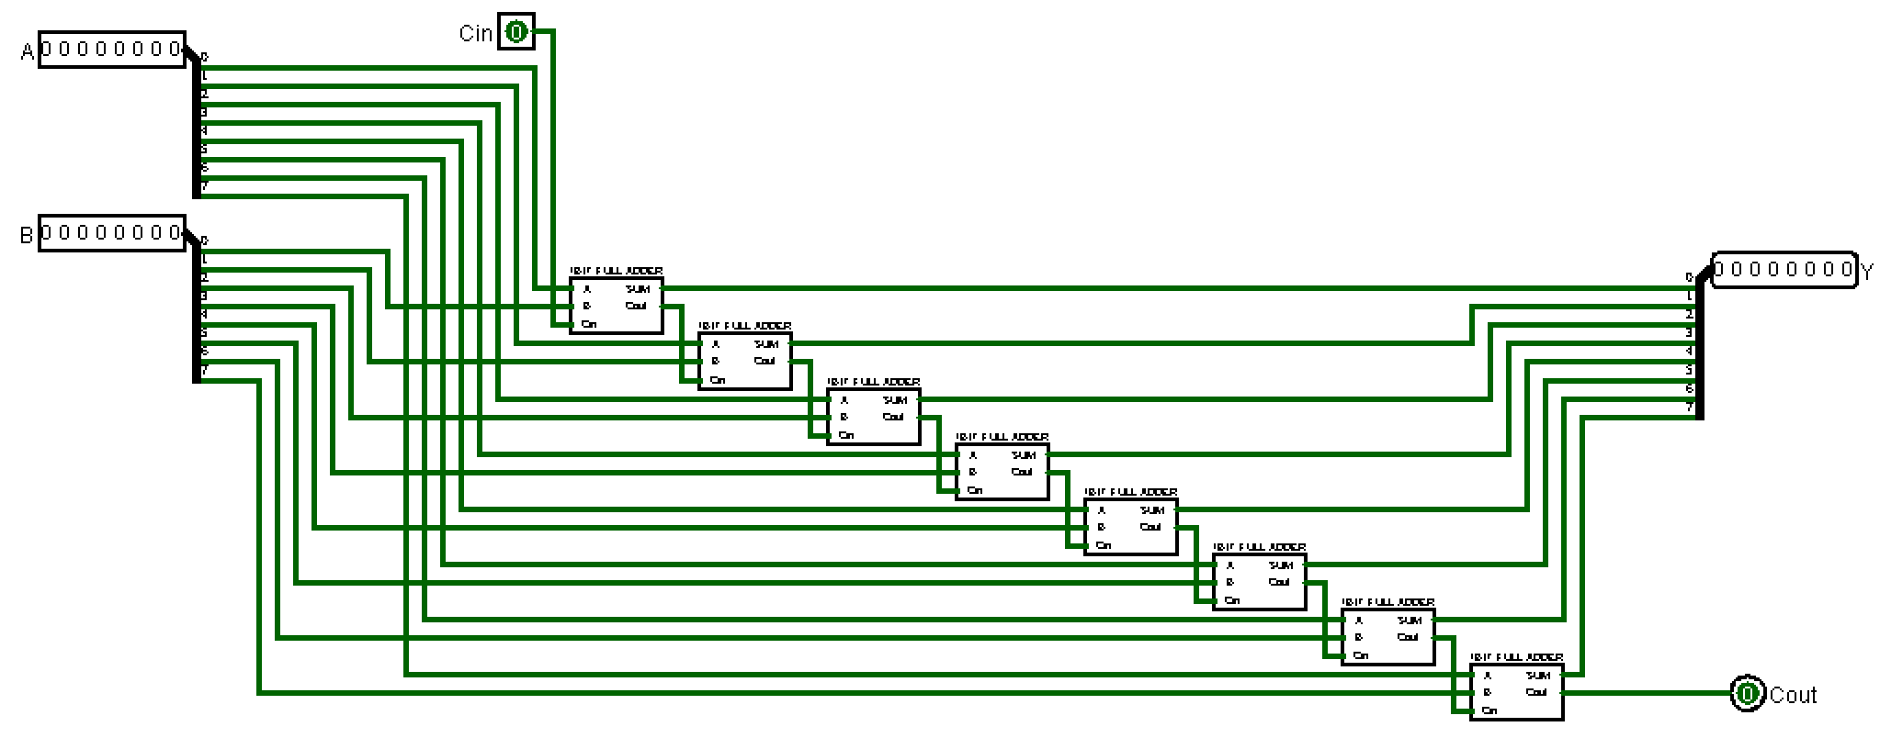

SUBRACTION:
Subtraction uses 2’s complement:
A - B = A + (B’) + 1
CPU does not know negative like humans do. It only checks whether the most significant bit is 1.
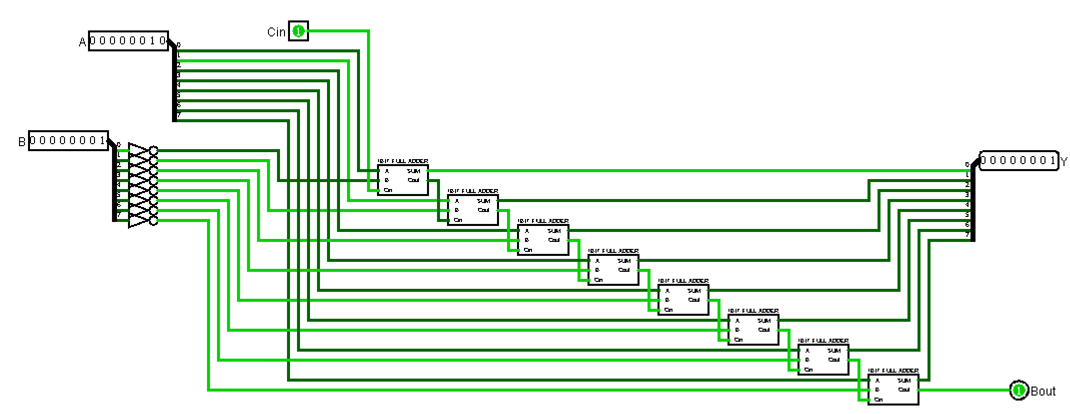

ADDER+SUBRACTER:
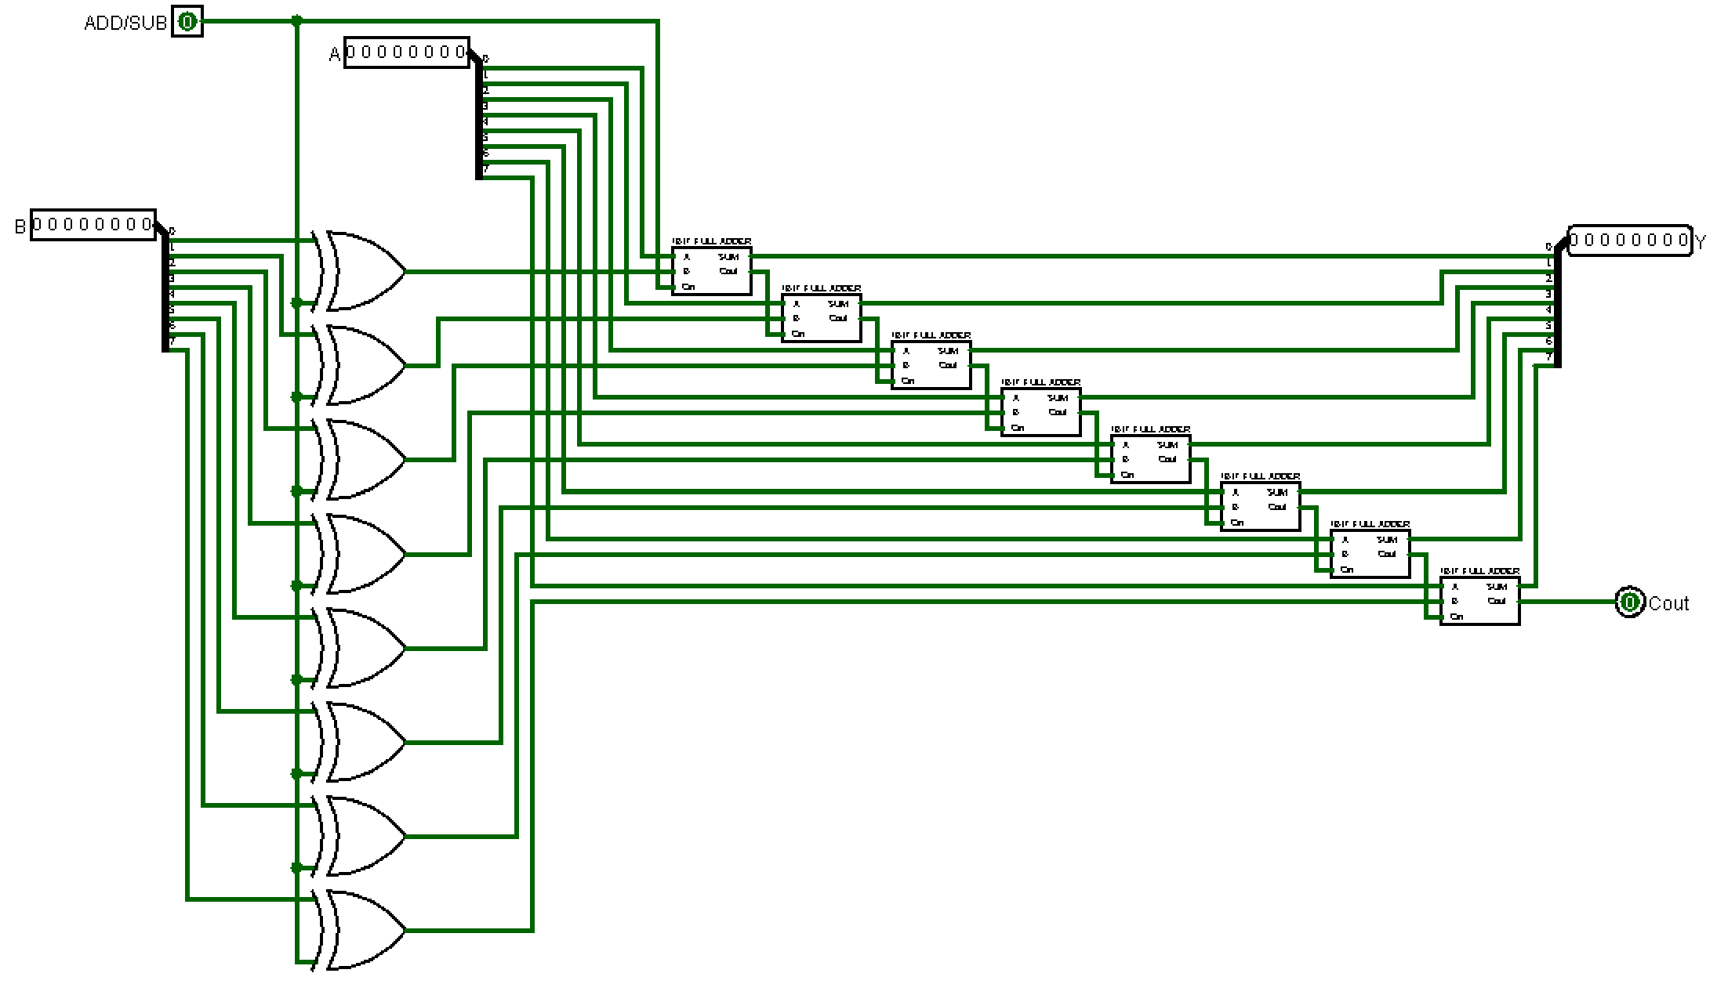
The XOR gates make it so that I can switch between ADD and SUB.

BITWISE NOR:
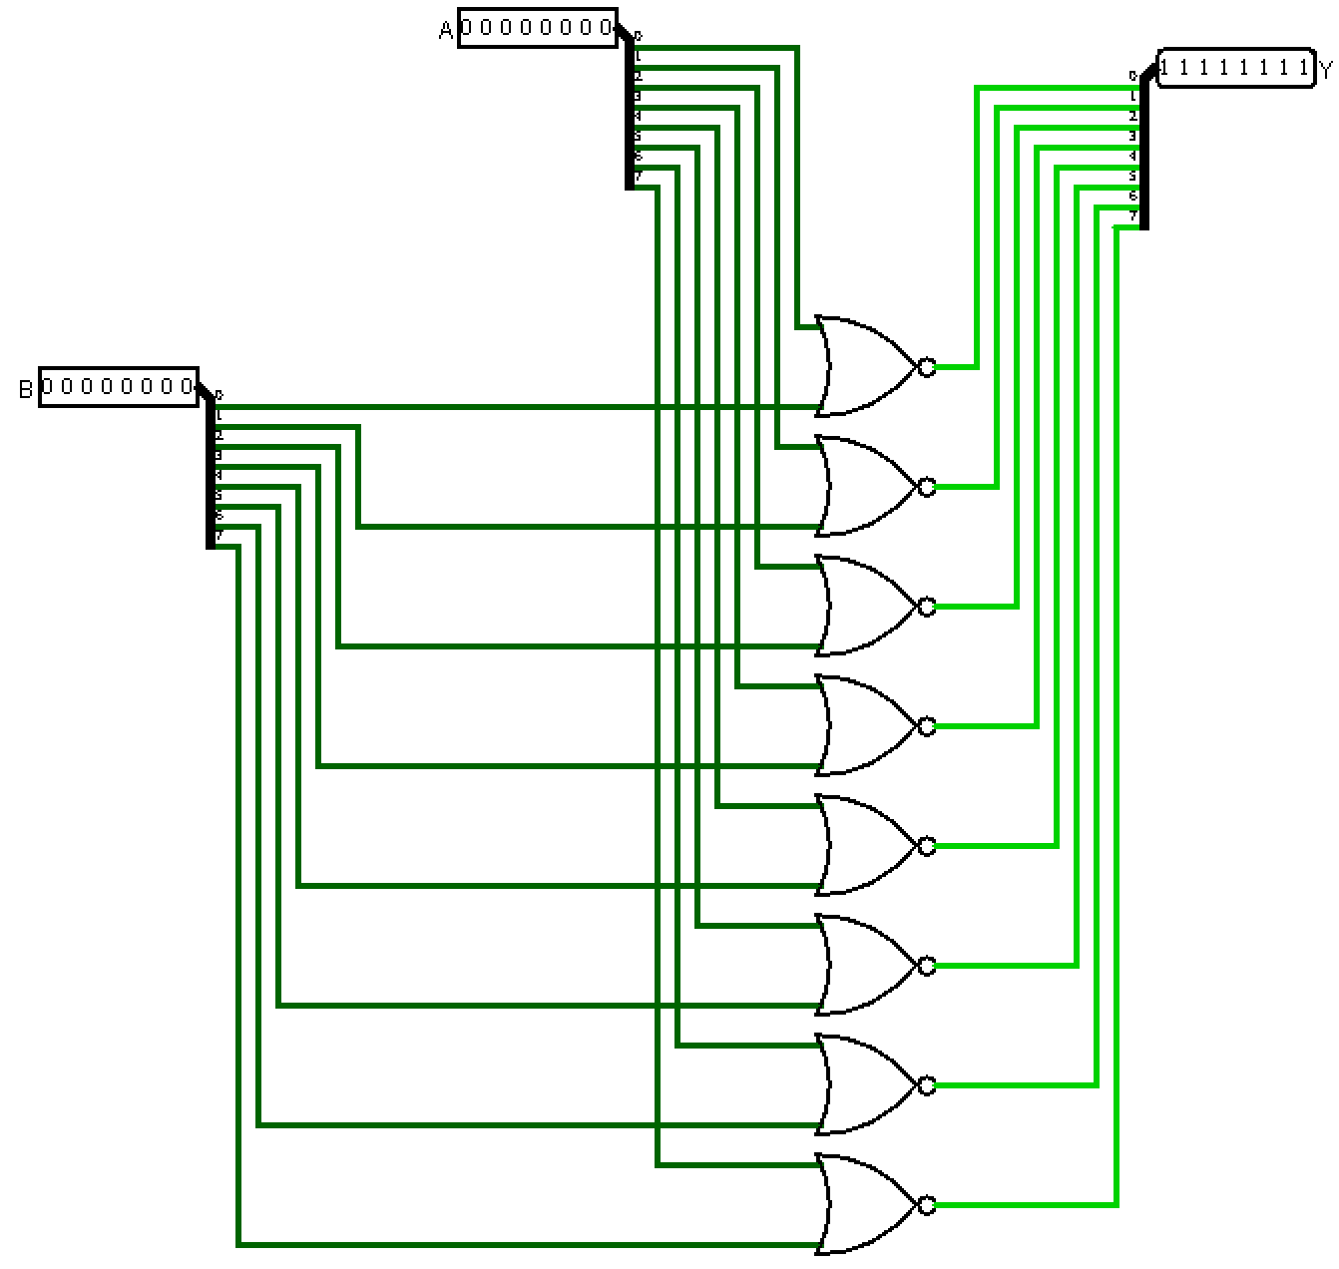

BITWISE AND:
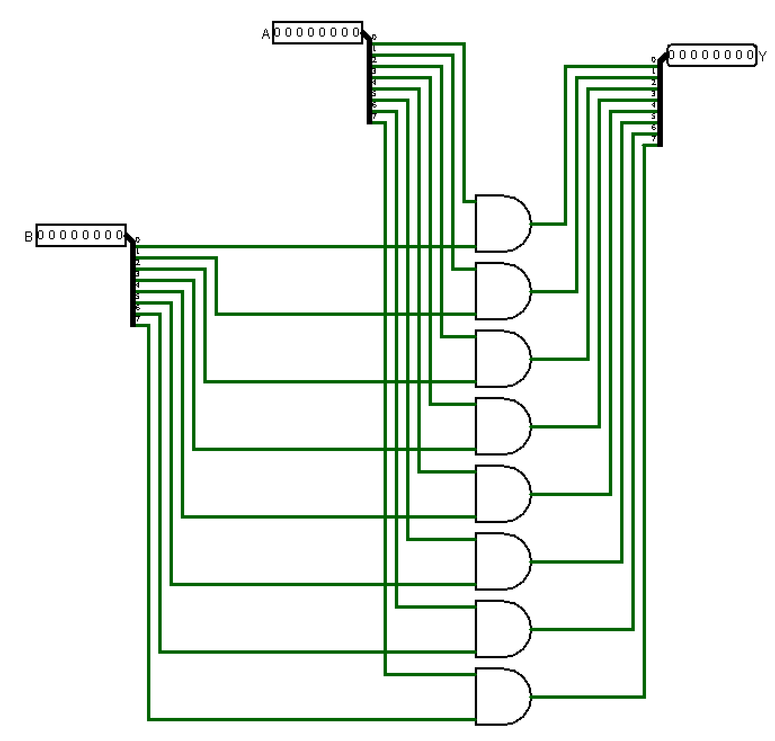

RIGHT SHIFT:
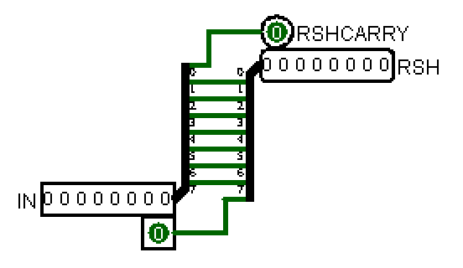

ALU:

DATA MEMORY:
As we have a 8-bit address we can have 2^8 memory registers, but for the task im only gonna implement 16 registers.
The AND gates are used to toggle between Write and Read mode
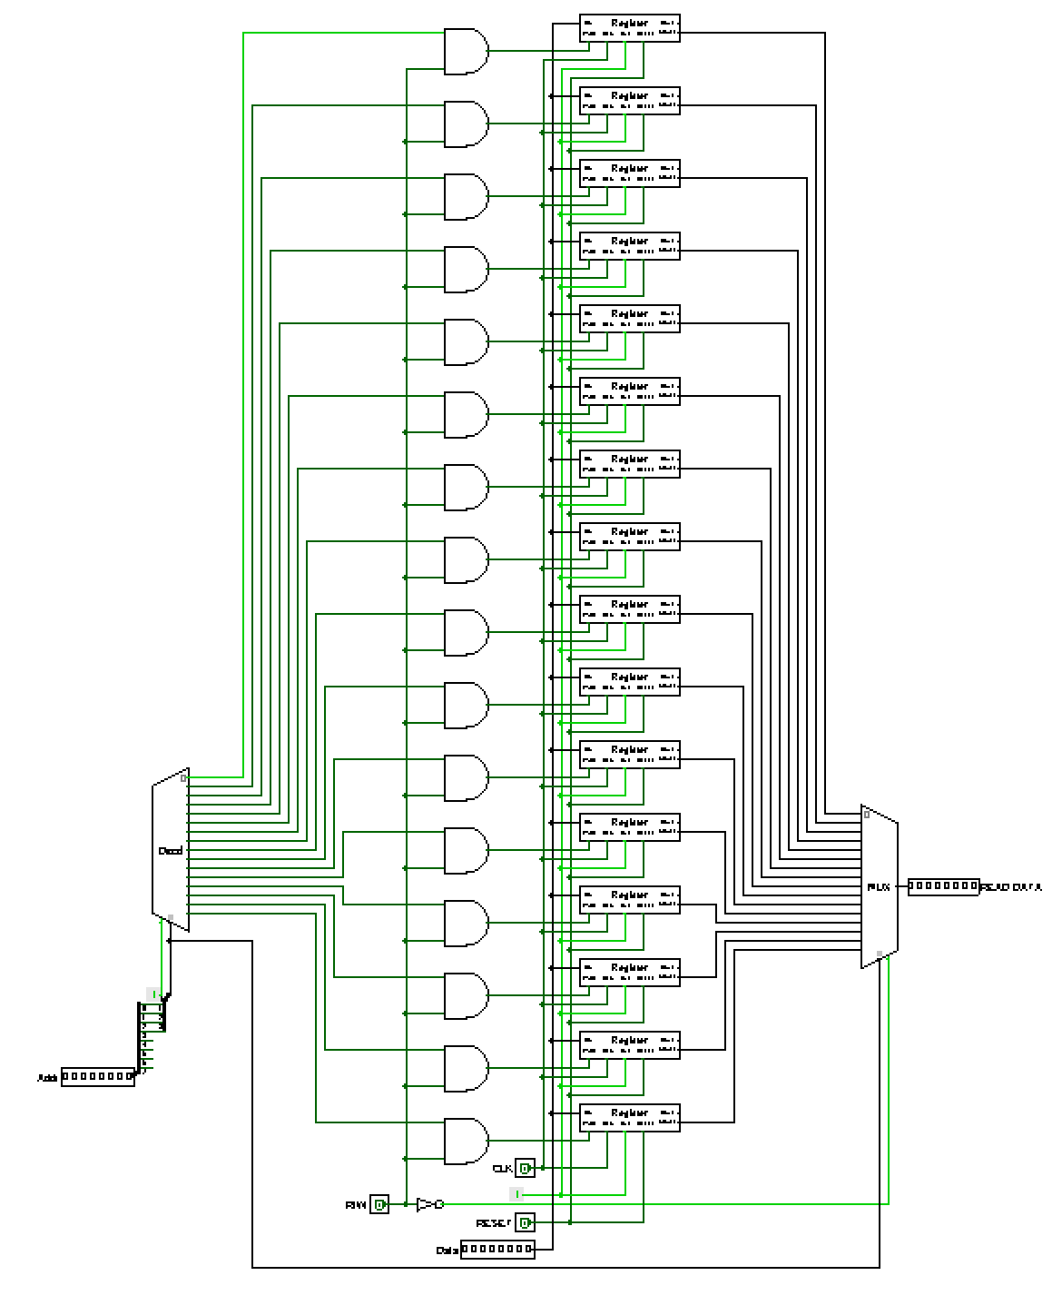

Call Stack:

FLAGS:
Every time the Arithmetic Logic Unit (ALU) performs a calculation, it automatically updates the bits inside the flag register based on the result.
The CPU's control unit then reads these flags to make decisions. This is how a computer handles conditional logic (like if/else statements in code). If a flag is 1 (Set), the condition is true; if it is 0 (Cleared), the condition is false.

When an ALU instruction happens:
ADD, SUB, NOR, AND, INC, DEC, RSH
then:
FLAG_WRITE = 1

For non-ALU instructions:
LDI, LOD, STR, JMP, BIF, NOP, HLT
keep:
FLAG_WRITE = 0

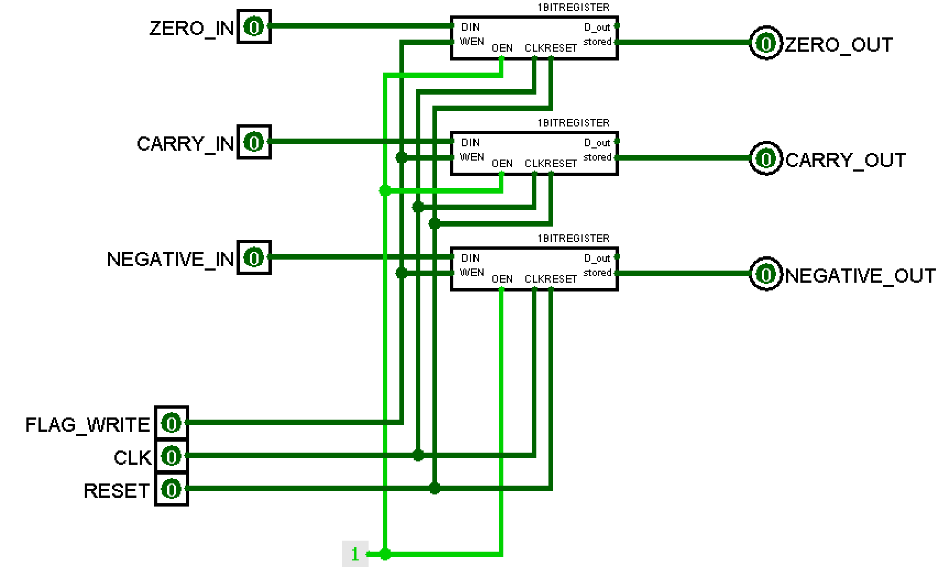

CONTROL UNIT:

