CSD 310-T301: Database Development and Use | Group B

Module 9.1 Milestone #2: Revised ERD, MySQL Table Creation, and Data Display
Team Members: Rakesh Shrestha, Josh Herrick
Case Study: Bacchus Winery
Date: August 8, 2026
Instructor: Vianelis Martinez

Overview
This milestone builds directly on our Milestone #1 business rules and initial ERD. We finalized attributes for all eight entities, confirmed every table is in Third Normal Form (3NF), wrote a MySQL script to create and populate the schema, and wrote a Python script to display the contents of every table. Screenshots of the script output are included below.

Revised Entity Relationship Diagram
The diagram below adds full attribute lists to the eight entities from Milestone #1 (WINE, DISTRIBUTOR, WINE_SHIPMENT, SUPPLIER, SUPPLY_SHIPMENT, DEPARTMENT, EMPLOYEE, EMPLOYEE_HOURS), with primary keys bolded and foreign keys italicized. Relationship cardinalities are shown in crow's-foot notation, consistent with our Milestone #1 diagram.
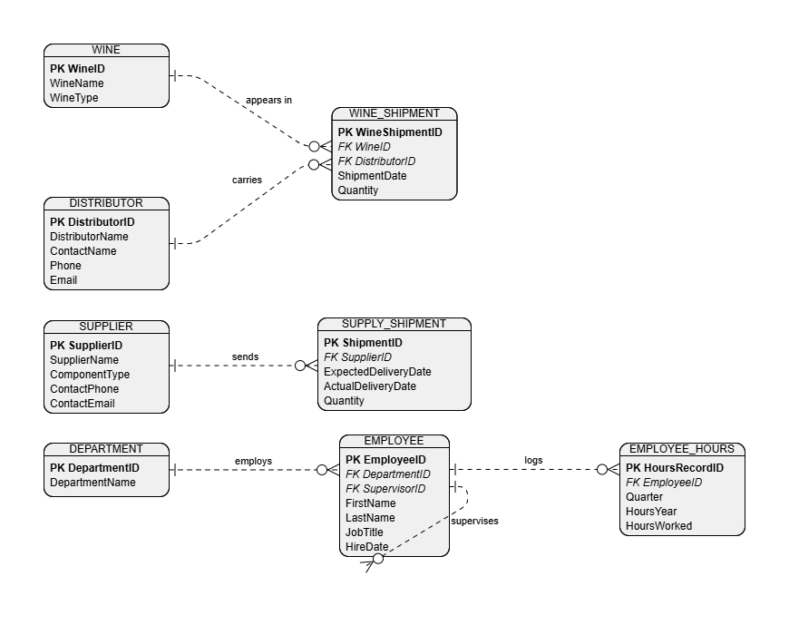

3NF Verification
Each table stores attributes that depend only on that table's primary key, with no repeating groups and no transitive dependencies:
- 1NF: every column holds a single atomic value; there are no repeating groups (e.g., quarterly hours live in their own EMPLOYEE_HOURS rows rather than four columns on EMPLOYEE).
- 2NF: every table uses a single-column surrogate primary key, so there are no partial dependencies on a composite key.
- 3NF: no non-key column depends on another non-key column. For example, DistributorName lives only in DISTRIBUTOR, not repeated in WINE_SHIPMENT; ComponentType lives only in SUPPLIER, not repeated in SUPPLY_SHIPMENT.

Finalized Table Attributes
DEPARTMENT
Column | Key | Notes
DepartmentID | PK | Surrogate key, auto-increment
DepartmentName |  | Finance/Payroll, Marketing, Production, or Distribution
EMPLOYEE
Column | Key | Notes
EmployeeID | PK | Surrogate key, auto-increment
FirstName
LastName
JobTitle
HireDate
DepartmentID | FK | References DEPARTMENT
SupervisorID | FK | Self-references EMPLOYEE; NULL if no supervisor
EMPLOYEE_HOURS
Column | Key | Notes
HoursRecordID | PK | Surrogate key, auto-increment
EmployeeID | FK | References EMPLOYEE
Quarter |  | 1-4
HoursYear |  | Reporting year
HoursWorked |  | Decimal hours for that quarter
WINE
Column | Key | Notes
WineID | PK | Surrogate key, auto-increment
WineName |  | Merlot, Cabernet, Chablis, Chardonnay
WineType |  | Red or White
DISTRIBUTOR
Column | Key | Notes
DistributorID | PK | Surrogate key, auto-increment
DistributorName
ContactName
Phone
Email
WINE_SHIPMENT
Column | Key | Notes
WineShipmentID | PK | Surrogate key, auto-increment
WineID | FK | References WINE
DistributorID | FK | References DISTRIBUTOR
ShipmentDate
Quantity |  | Units shipped
SUPPLIER
Column | Key | Notes
SupplierID | PK | Surrogate key, auto-increment
SupplierName
ComponentType |  | Bottles/Corks, Labels/Boxes, or Vats/Tubing
ContactPhone
ContactEmail
SUPPLY_SHIPMENT
Column | Key | Notes
ShipmentID | PK | Surrogate key, auto-increment
SupplierID | FK | References SUPPLIER
ExpectedDeliveryDate
ActualDeliveryDate |  | Used to calculate delivery gaps
Quantity |  | Units received

Record Counts
Every table was populated with at least 6 records, except where the case study itself specifies a smaller, fixed set: DEPARTMENT (4 departments named in the case study), WINE (4 wines named in the case study), and SUPPLIER (3 suppliers named in the case study).
- DEPARTMENT: 4 records
- EMPLOYEE: 8 records
- EMPLOYEE_HOURS: 32 records (8 employees x 4 quarters)
- WINE: 4 records
- DISTRIBUTOR: 6 records
- WINE_SHIPMENT: 10 records
- SUPPLIER: 3 records
- SUPPLY_SHIPMENT: 9 records

Python Script Output
The Python script Shrestha_Herrick_Module9_1_DisplayData.py connects to the bacchus_winery MySQL database using credentials stored in a local .env file, then runs SELECT * against each of the eight tables in turn. The screenshots below show the terminal output.
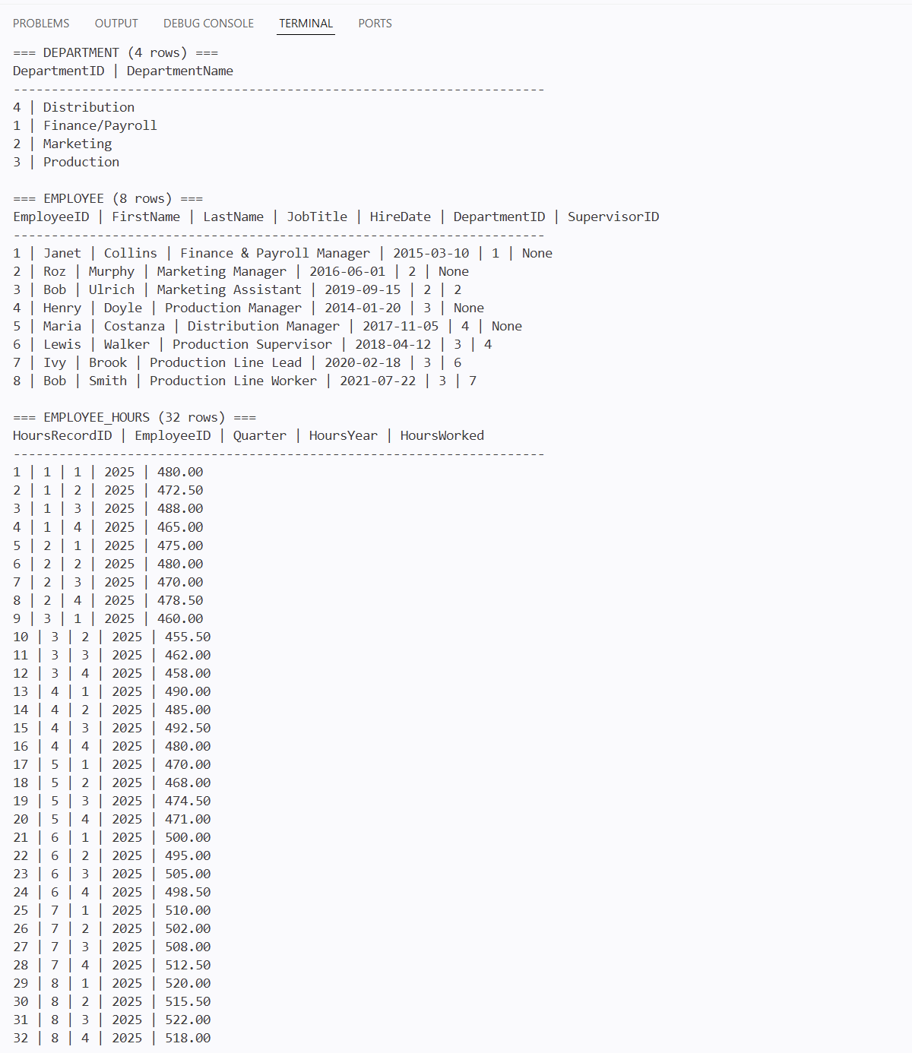
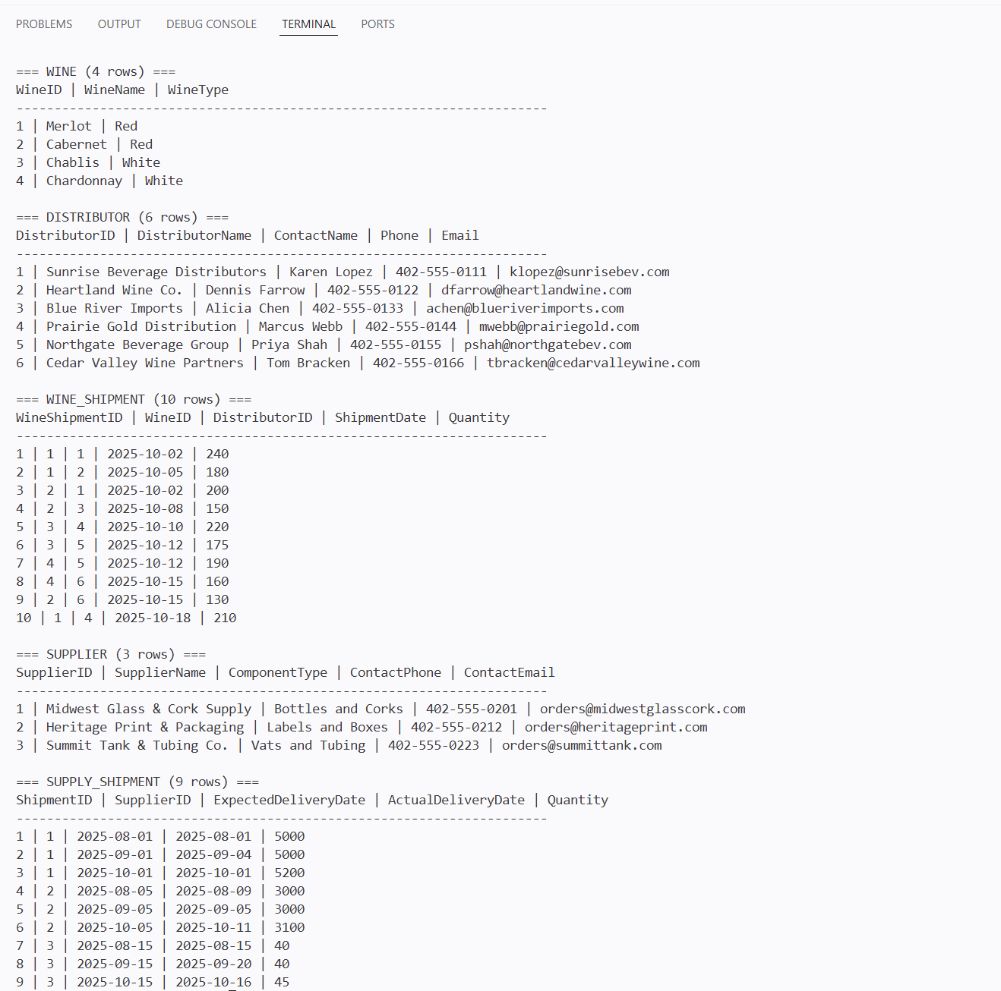

Files Submitted
- bacchus_winery.sql - creates and populates all 8 tables
- Shrestha_Herrick_Module9_1_DisplayData.py - displays the contents of all 8 tables
- GroupB_Milestone2_BacchusWinery.docx - this document

