CSD 310-T301: Database Development and Use | Group B
Module 10.1 Milestone #3: Generate Requested Reports
Team Members: Rakesh Shrestha, Josh Herrick
Case Study: Bacchus Winery
Date: August 16, 2026
Instructor: Vianelis Martinez


Prepared By
Rakesh Shrestha, Josh Herrick

Overview
This milestone builds on the Milestone #2 schema and instructor feedback. The feedback noted that while the submitted schema executed correctly, it did not yet represent all of the business processes described in the case study - specifically inventory tracking, purchase orders, and product sales. For this milestone, the Milestone #2 schema was revised to add four new tables (PURCHASE_ORDER, SUPPLY_INVENTORY, WINE_INVENTORY, and SALES), and two new reports were added on top of the three built for Milestone #2. These additions address the inventory tracking, purchase order, and product sales requirements identified in the Milestone #2 feedback and allow those business processes to be stored and queried.

Revised Entity Relationship Diagram
The diagram below carries forward all eight entities from Milestone #2 unchanged and adds four new entities: PURCHASE_ORDER and SUPPLY_INVENTORY (both tied to SUPPLIER), WINE_INVENTORY (tied to WINE), and SALES (tied to both WINE and DISTRIBUTOR). Relationship cardinalities are shown in crow's-foot notation, consistent with the Milestone #1 and #2 diagrams.

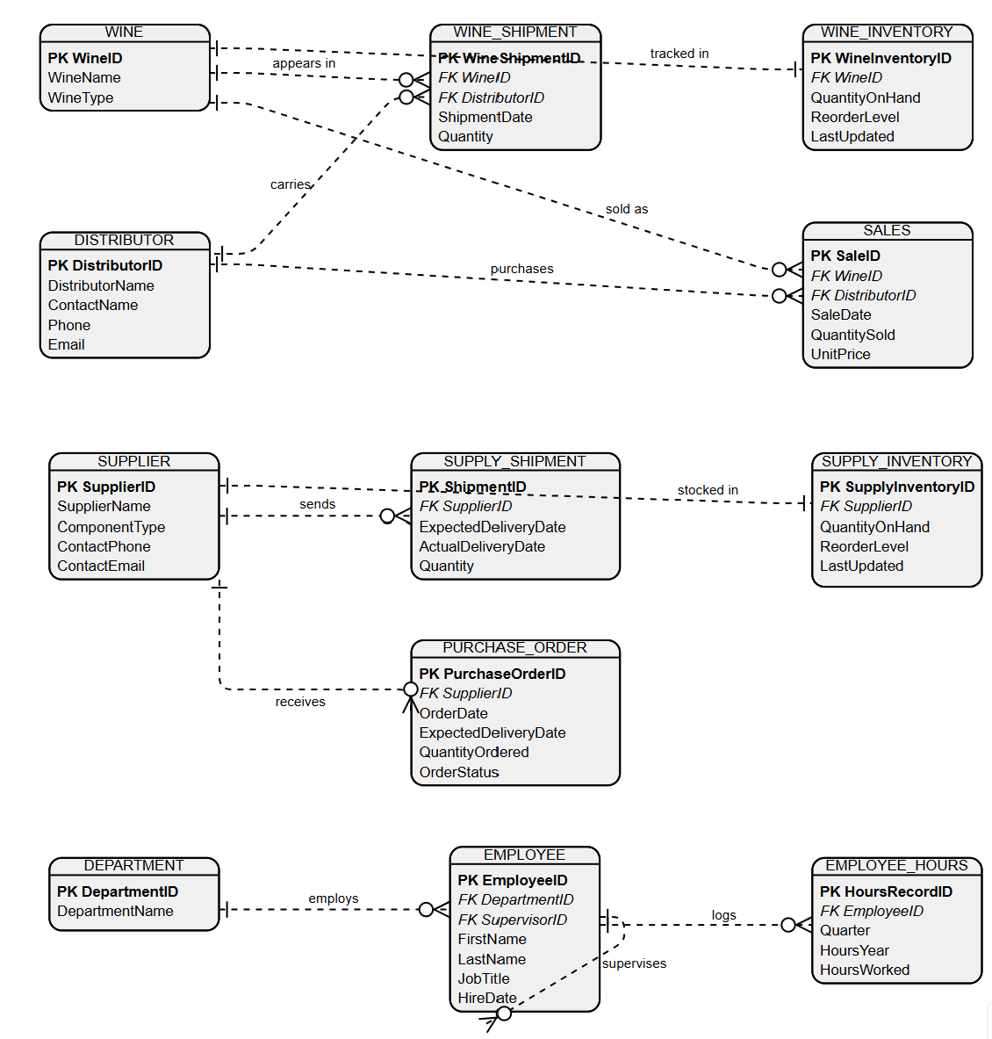
Figure 1: Revised ERD with Milestone #3 additions

New Tables Added for Milestone #3
PURCHASE_ORDER tracks each order placed with a supplier for raw materials (bottles/corks, labels/boxes, vats/tubing), including an OrderStatus so open orders can be distinguished from ones already received.
SUPPLY_INVENTORY tracks current on-hand stock of those raw materials, with a reorder level so low stock can be flagged before it affects production.
WINE_INVENTORY tracks current on-hand stock of each finished, bottled wine, also with a reorder level.
SALES tracks each wine sale to a distributor, including the unit price at the time of sale. This is distinct from the existing WINE_SHIPMENT table, which tracks shipping logistics (what shipped and when) but not what it sold for — SALES is what makes revenue reporting possible.
All four tables remain in Third Normal Form: each uses a single-column surrogate primary key (2NF), and every non-key column depends only on that key and not on any other non-key column (3NF). For example, SupplierName is not repeated in SUPPLY_INVENTORY or PURCHASE_ORDER; it is looked up through SupplierID.
Design note: PURCHASE_ORDER does not store a ComponentType or a direct link to SUPPLY_INVENTORY. This is intentional given the case study's data: each supplier in this database corresponds to exactly one component category (for example, Midwest Glass & Cork Supply always supplies bottles and corks), so the ordered component can be inferred through SupplierID. A larger, industry-scale system would typically split this into PURCHASE_ORDER and a PURCHASE_ORDER_LINE detail table to support multiple line items per order, but that level of decomposition is not required by the Bacchus Winery business rules and was left out to avoid adding complexity the case study does not call for.

Report Descriptions
Report 1: Supplier Delivery Performance
This report displays each supplier's expected and actual delivery dates, the number of days late, and whether the shipment was delivered on time. This information helps Bacchus Winery identify suppliers with recurring delivery delays and evaluate supplier delivery performance.
Report 2: Wine Distribution Performance
This report displays the wines distributed, the distributors receiving each wine, the quantity shipped to each distributor, and the total quantity shipped for each wine. This information helps Bacchus Winery evaluate wine distribution and identify which wines are being distributed most heavily.
Report 3: Employee Hours Report
This report displays the number of hours worked by each employee during each of the four quarters of 2025, along with the employee's department and total hours worked for the four-quarter period. This information allows Bacchus Winery management to review employee workload and compare total hours worked across employees and departments.
Report 4: Sales Revenue by Wine (New)
This report displays the total units sold and total sales revenue for each wine, calculated from the new SALES table. This information helps Bacchus Winery identify which wines generate the most revenue, rather than simply having the highest shipped volume, so pricing and production decisions can be based on actual sales performance.
Report 5: Inventory & Open Purchase Orders (New)
This report displays current on-hand inventory levels for both finished wine and raw materials, flagging any item at or below its reorder level, followed by a list of all purchase orders still open with suppliers. This information helps Bacchus Winery avoid production slowdowns by showing what needs to be reordered and what is already on order.

Report Screenshots
Report 1: Supplier Delivery Performance

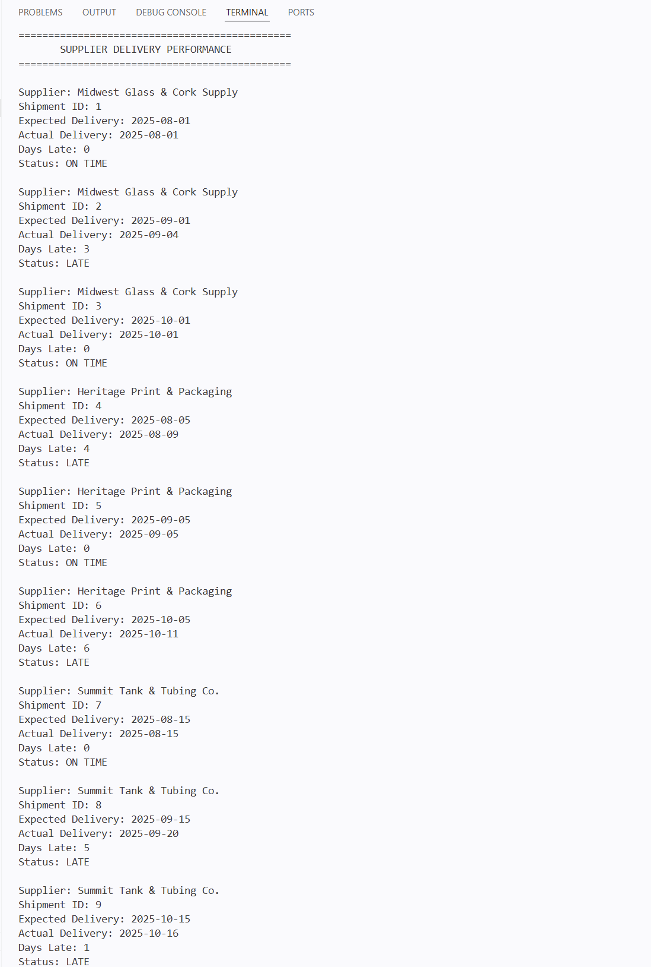
Report 2: Wine Distribution Performance

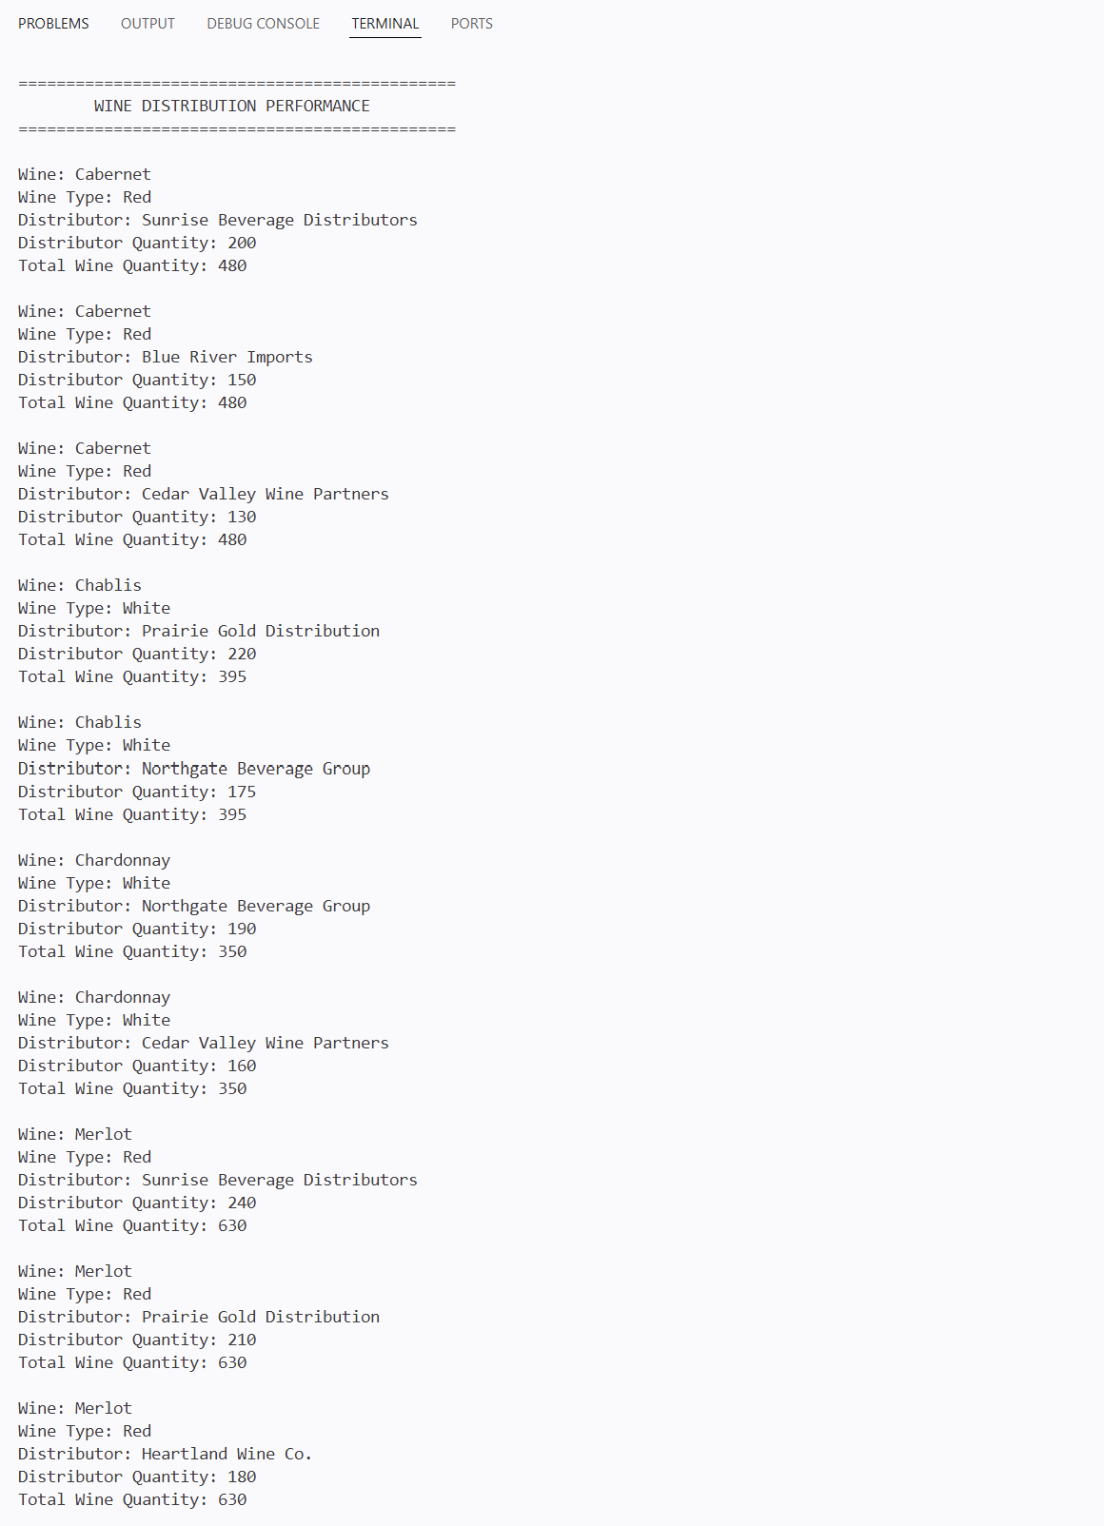
Report 3: Employee Hours Report

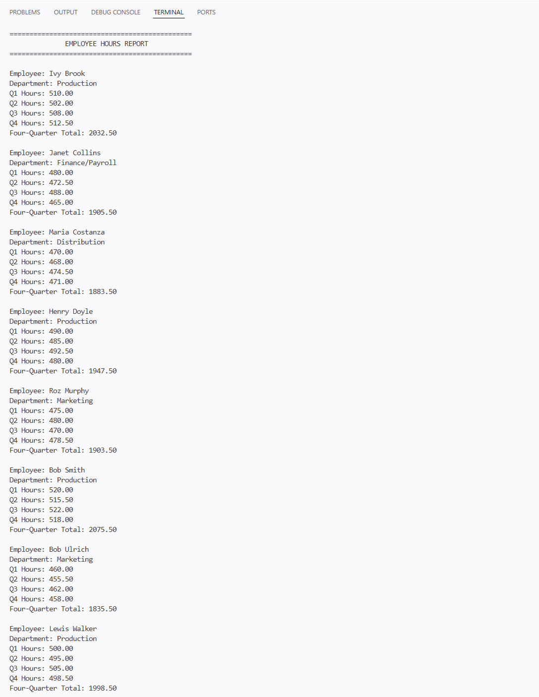
Report 4: Sales Revenue by Wine

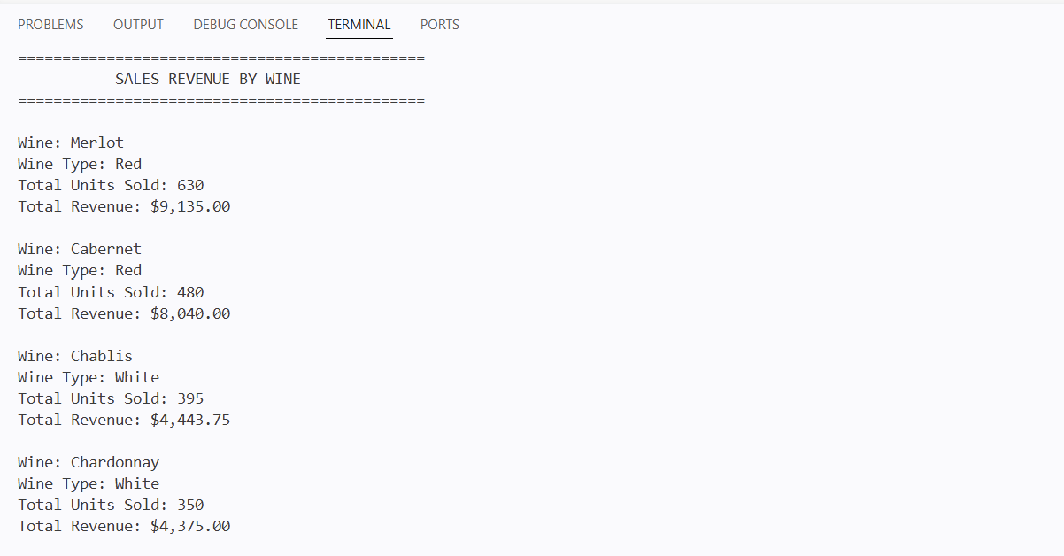

Report 5: Inventory & Open Purchase Orders
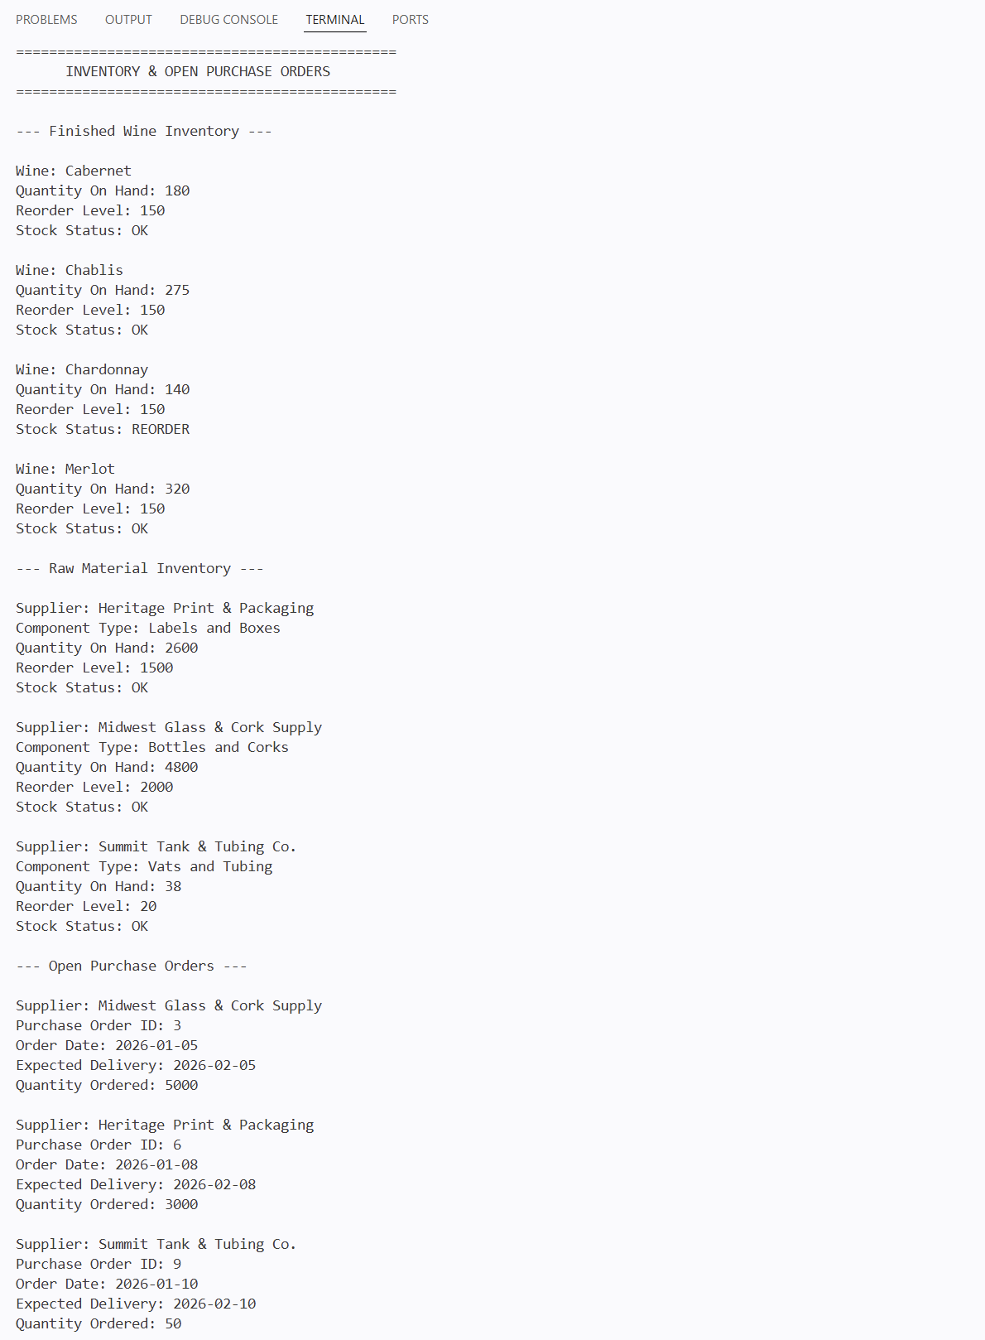

Files Submitted
bacchus_winery_v2.sql - creates and populates 12 tables (8 from Milestone #2, unchanged, plus 4 new for Milestone #3)
Herrick_Shrestha_Mod10_1_Reports.py - runs all 5 reports
GroupB_Milestone3_BacchusWinery.docx - this document

