Rakesh Shrestha
Module 1.2 Assignment
Date: June 12, 2026

- Git Configuration Verification

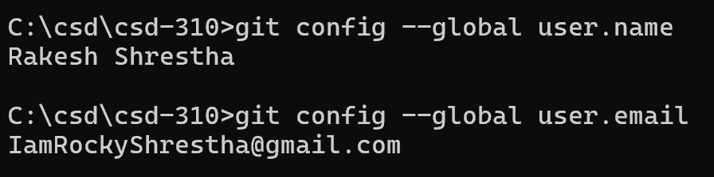
Figure 1: Verification of Git global username and email configuration.

- GitHub Repository Link
https://github.com/RockyShrestha/csd-310

- GitHub Repository Screenshot

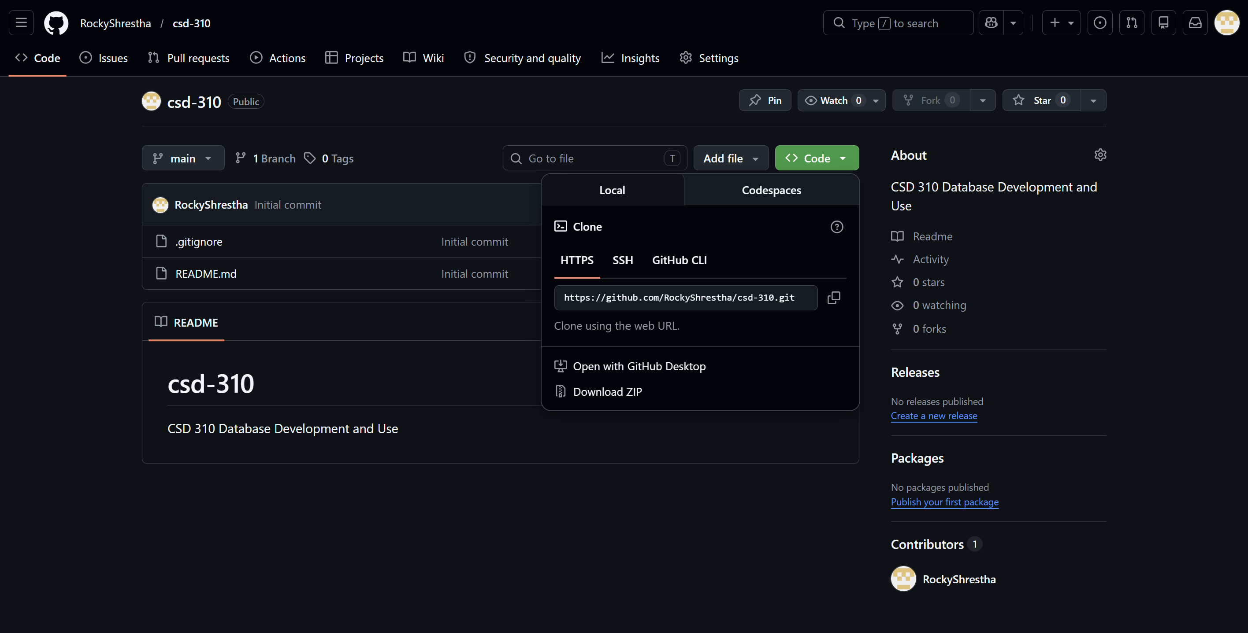Figure 2: CSD-310 GitHub repository.

- Local Directory Screenshot

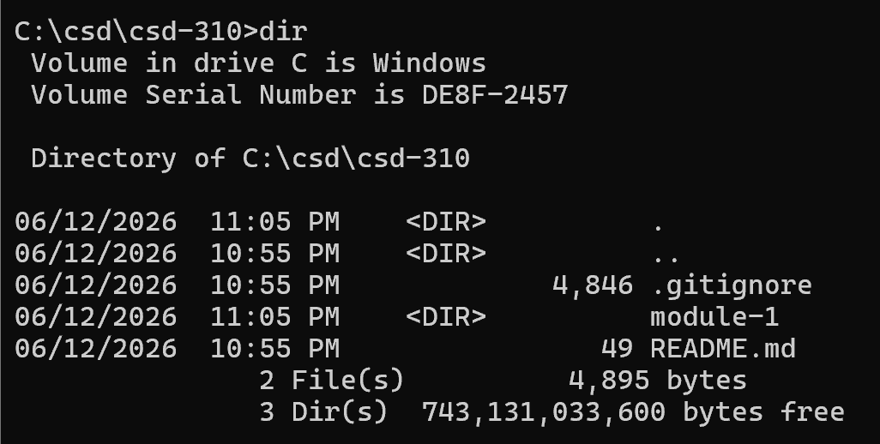
Figure 3: Local CSD-310 directory showing the module-1 folder

