Rakesh Shrestha
July 17, 2026
CSD-310: Module 6.2 Assignment - Movies: Table Queries

Overview
For this assignment I wrote a Python script (movies_queries.py) that connects to the movies database using the same connection pattern from the previous assignment, then runs four queries: selecting all studio records, selecting all genre records, selecting film names with a runtime under two hours, and listing film names with their directors ordered by director. Below is a screenshot of the script's output, followed by a link to my GitHub repository.

Query Results
The screenshot below shows the terminal output after running movies_queries.py, displaying the studio, genre, short film, and director records.

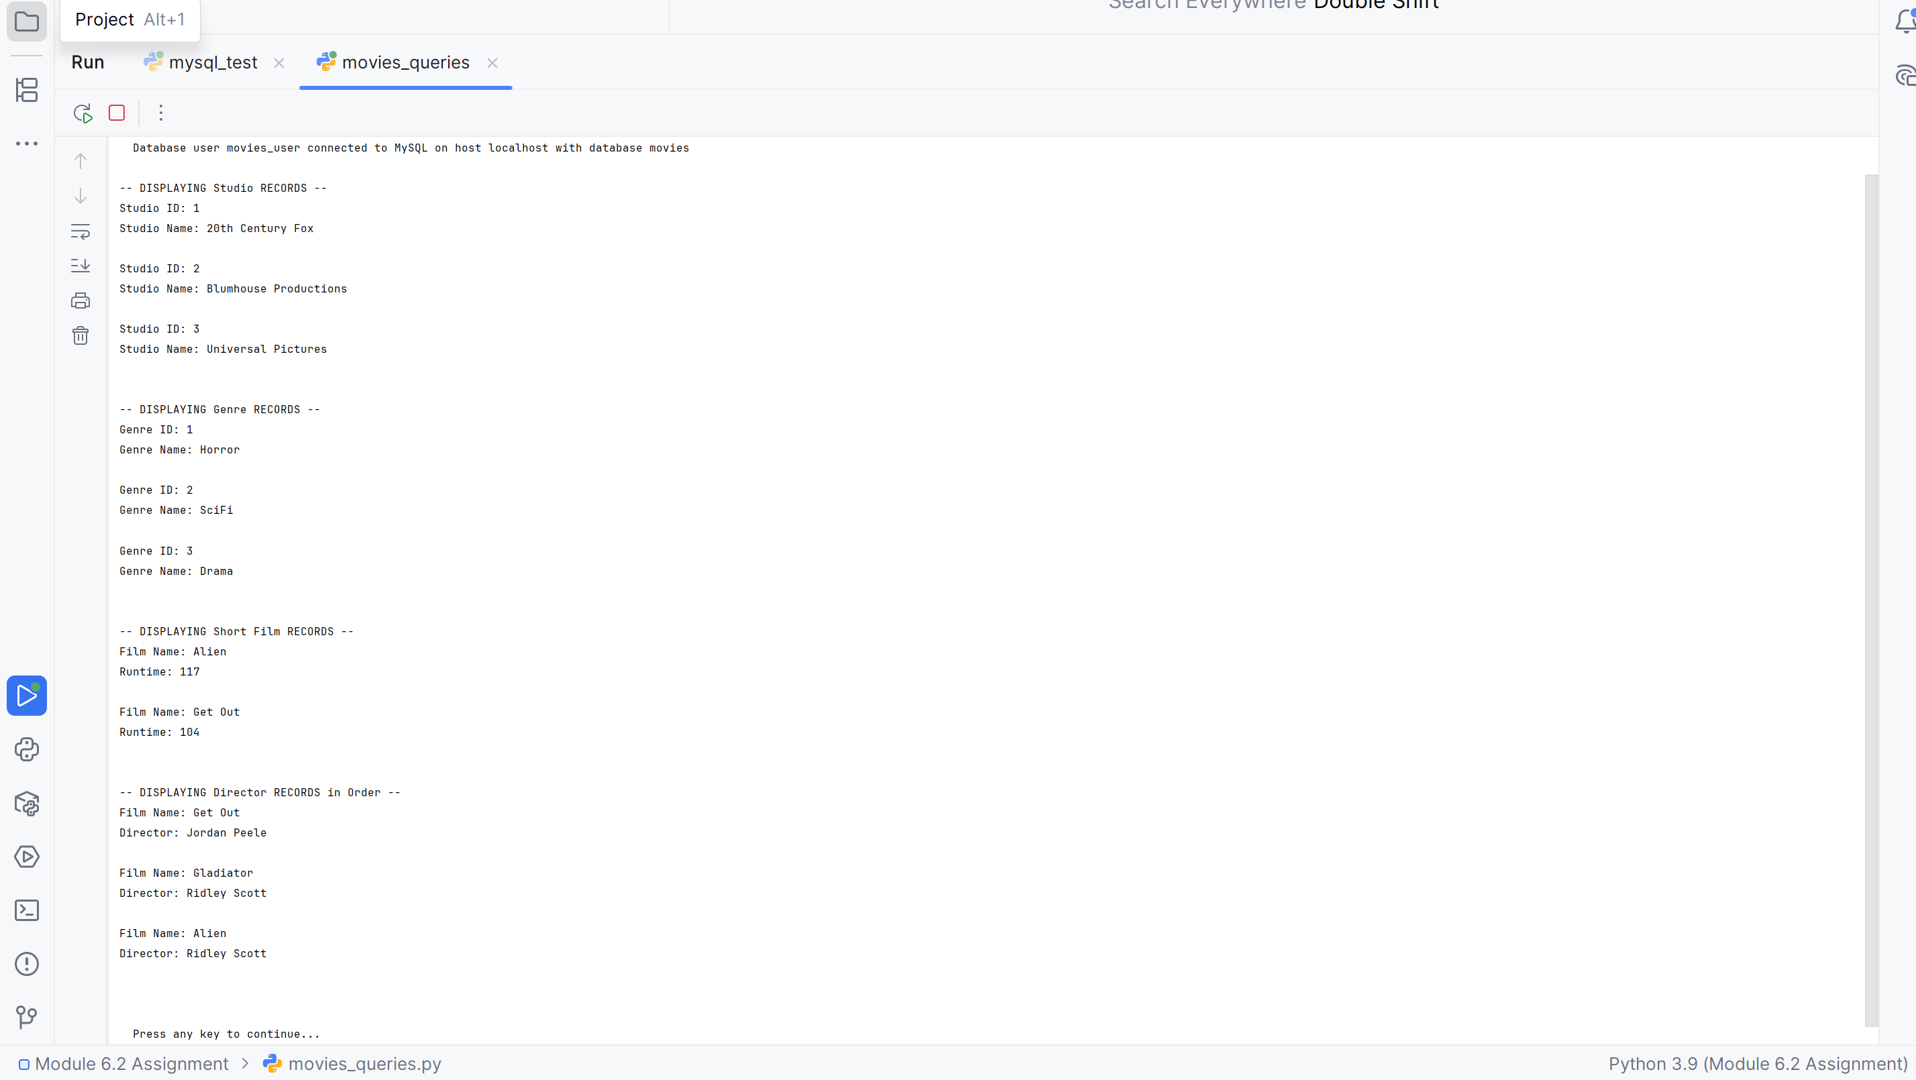

GitHub Repository
The movies_queries.py file is included in my project. My GitHub repository is:
https://github.com/RockyShrestha/csd-310

