Rakesh Shrestha

CSD310-T301 Database Development and Use | Module 2.2 Assignment: Visual Paradigm Bellevue University | June 19, 2026

Entity Relationship Diagram (ERD) - Publisher / Books / Authors

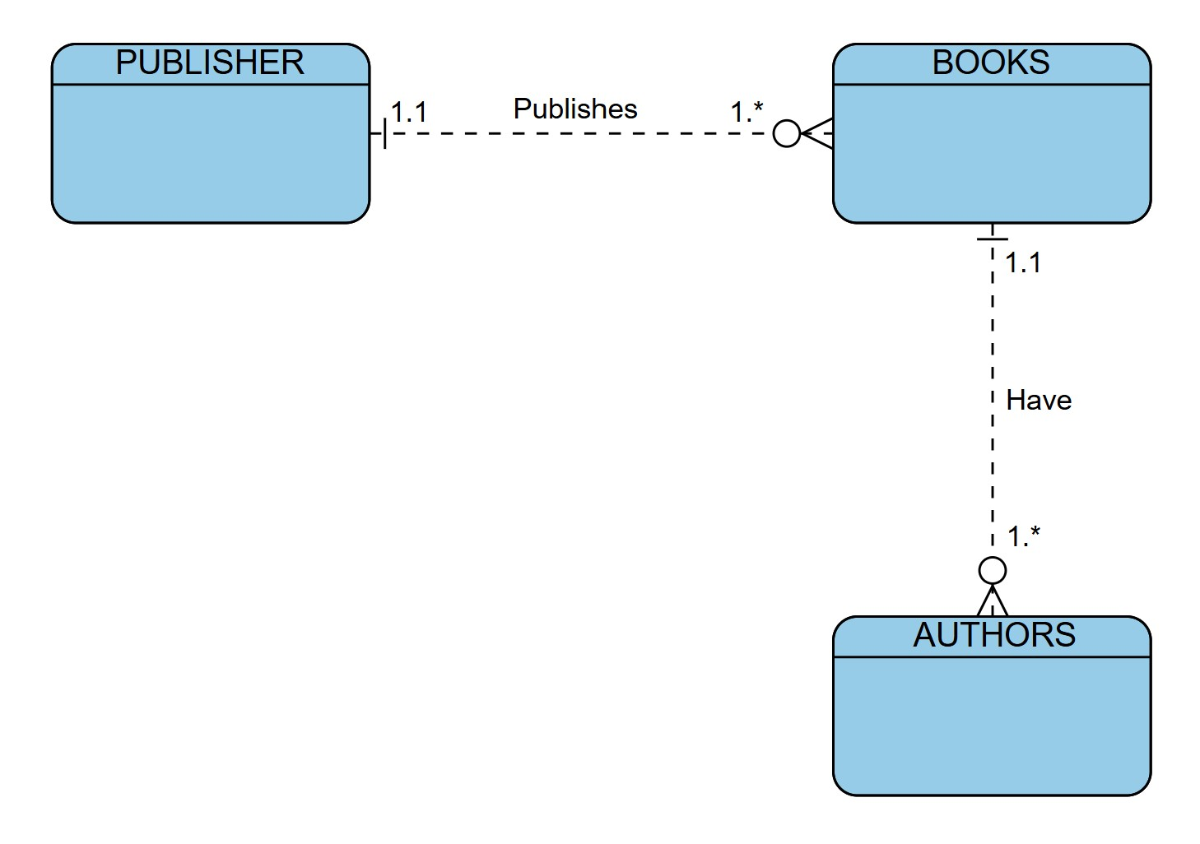

ERD Summary
This Entity Relationship Diagram models a publishing system. A PUBLISHER publishes one or more BOOKS (1.1 to 1.*), and each BOOK can have one or more AUTHORS (1.1 to 1.*). This ERD is recreated using the Visual Paradigm Online ERD tool as part of Module 2.2 practice with data modeling concepts.

