Rakesh Shrestha
CSD310-T301 Database Development and Use
Module 4.2 Assignment – MySQL Install
July 4, 2026

Screenshot 1: Initial MySQL Database Connection
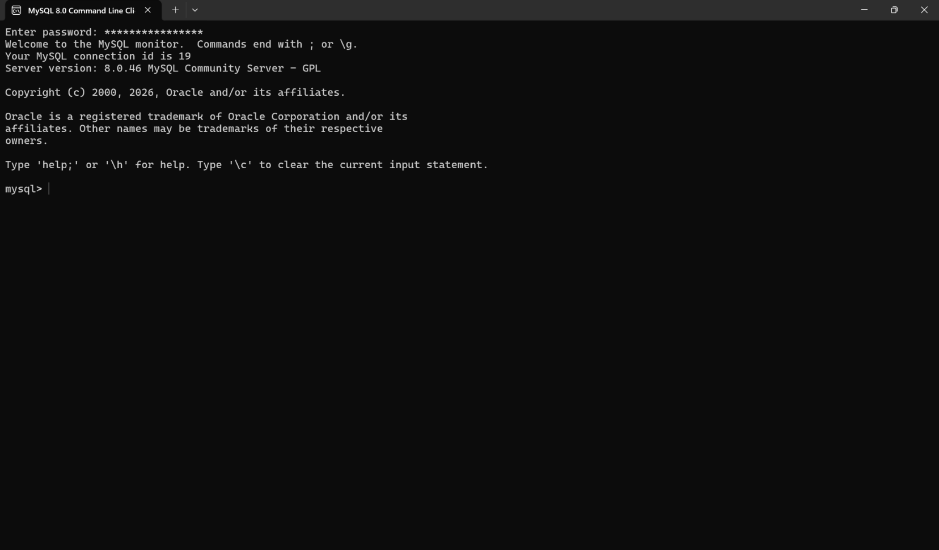
Screenshot 2: Creating the movies Database
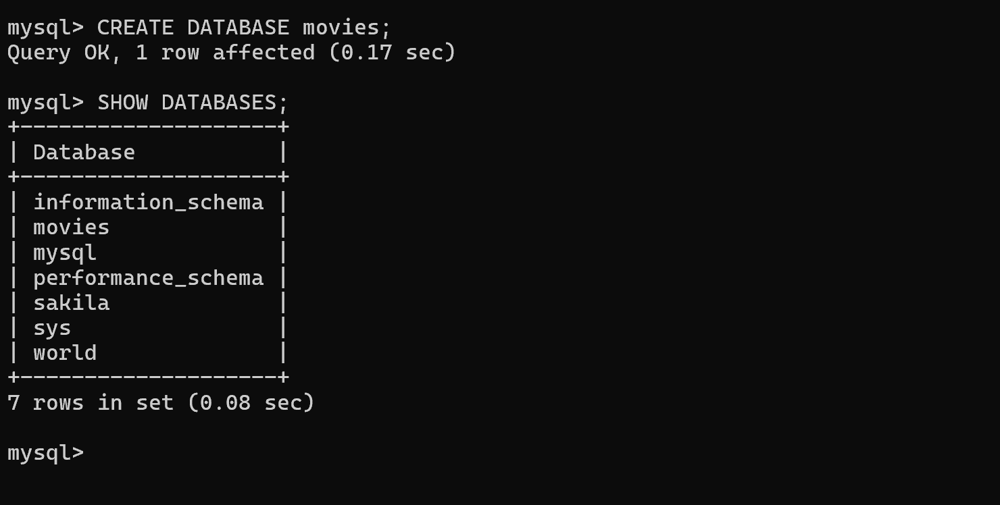
Function 1: UPPER()
Explanation:
The UPPER() function converts all characters in a string to uppercase. It is commonly used to display text consistently or to standardize text before performing comparisons.
Alias:
Database_Name
SQL Statement:
SELECT UPPER('movies') AS Database_Name;
Result: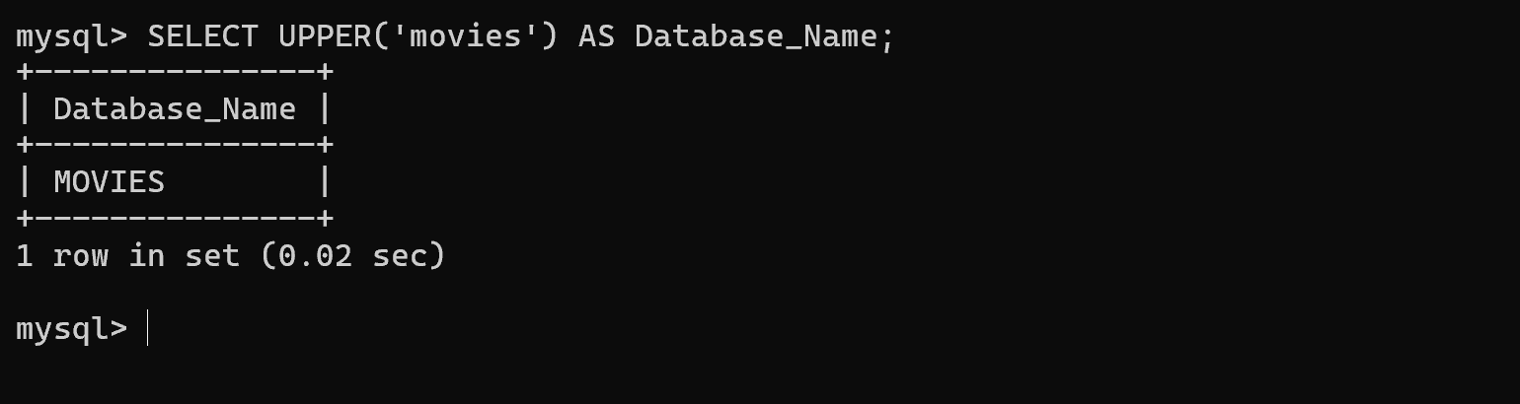
Function 2: LENGTH()
Explanation:
The LENGTH() function returns the length of a string. It is useful when checking how many characters are in text such as names, titles, or user input.
Alias:
Character_Count
SQL Statement:
SELECT LENGTH('Database Development') AS Character_Count;

Result: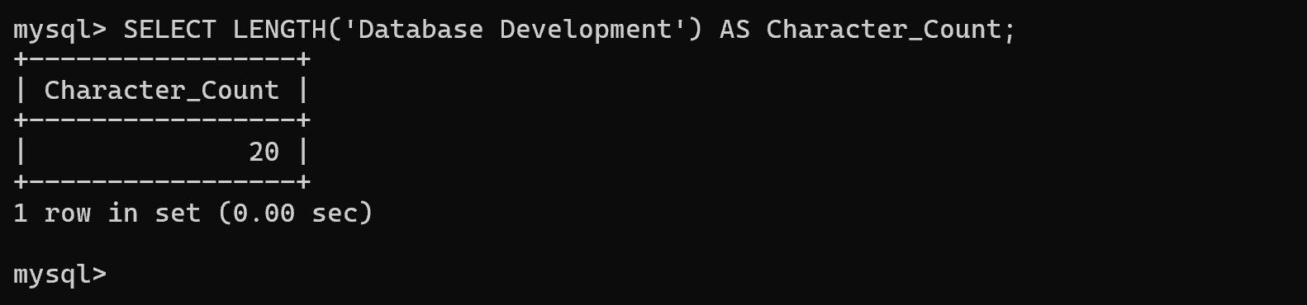
Function 3: NOW()
Explanation:
The NOW() function returns the current date and time. It is useful for recording when data is created, updated, or submitted.
Alias:
Current_Date_Time
SQL Statement:
SELECT NOW() AS Current_Date_Time;
Result:
