Rakesh Shrestha
Module 2.3 Assignment: Data Models
CSD310-T301 Database Development and Use

Module 2.3 Assignment: Data Models

Part 1: Entity Relationship Diagram (ERD)
Using Visual Paradigm Online, the following Entity Relationship Diagram was created to represent three business rules centered around a USER entity. The diagram uses Visual Paradigm’s notation style -- dashed relationship lines with a single perpendicular tick on the “one” side (1.1) and an open circle with a crow’s foot on the “many” side (1.*), with multiplicity labels placed near each entity end.

Business Rules Modeled:
• A USER has many ROLES — 1.1 (USER) to 1.* (ROLE)
• A USER has one BIRTHDATE — 1.1 (USER) to 1.1 (BIRTHDATE)
• A USER can have many DEPENDENTS — 1.1 (USER) to 1.* (DEPENDENT)

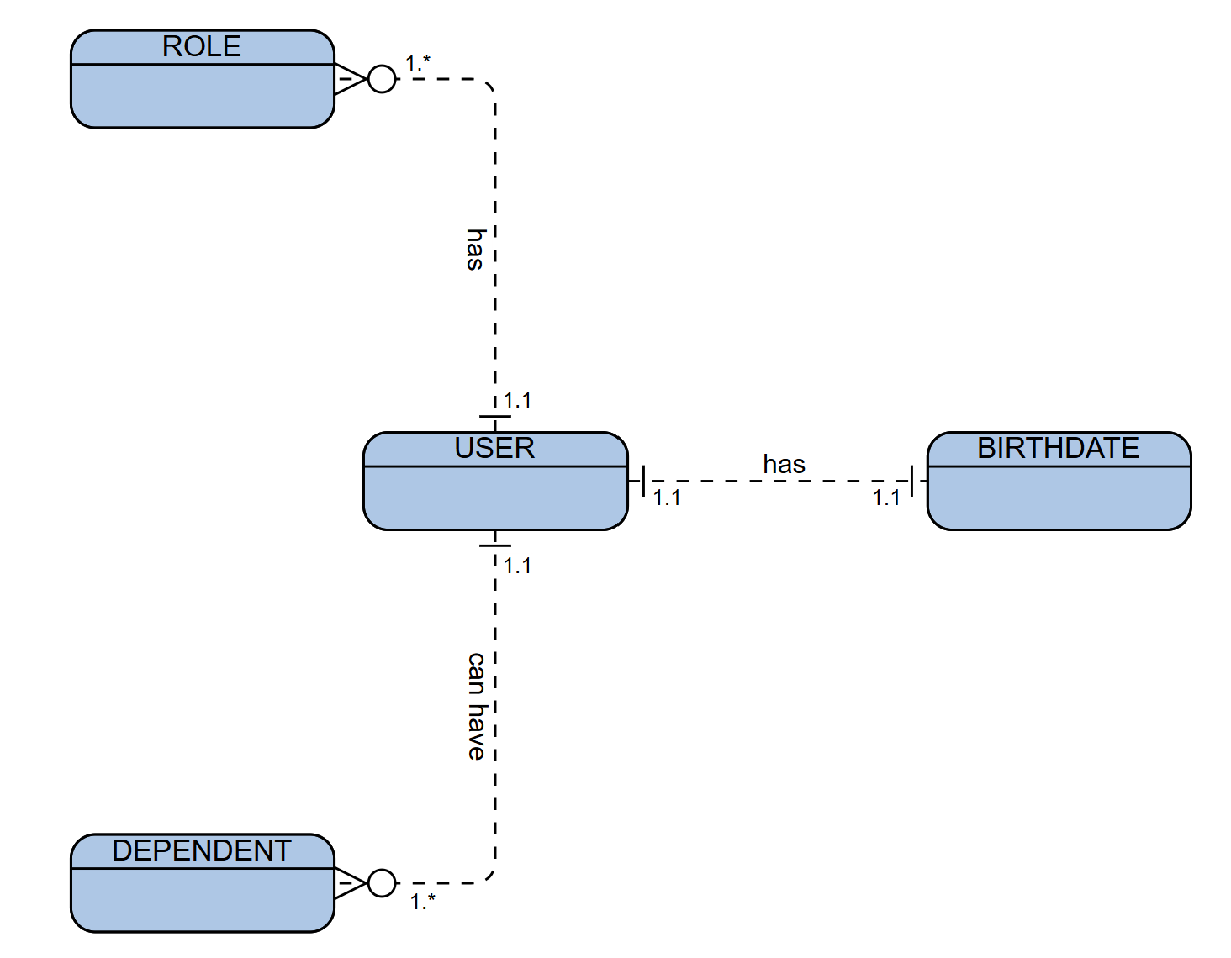

Figure 1: ERD created in Visual Paradigm Online — USER with ROLES, BIRTHDATE, and DEPENDENTS

In the diagram, each dashed relationship line carries multiplicity labels at both ends using Visual Paradigm’s notation. The label 1.1 with a single perpendicular tick means exactly one instance participates in the relationship, while 1.* with an open circle and crow’s foot means one or more instances. The USER–ROLE relationship is One-to-Many: one USER (1.1) must be assigned at least one ROLE, and can hold multiple ROLEs (1.*), such as Admin or Editor. The USER–BIRTHDATE relationship is One-to-One: each USER (1.1) has exactly one BIRTHDATE record (1.1), and that birthdate belongs to that user alone — no sharing, no duplicates. The USER–DEPENDENT relationship is One-to-Many: one USER (1.1) can be associated with one or more DEPENDENTs (1.*), meaning every user in this system is expected to have at least one dependent on record.

Part 2: NoSQL Data Structure
The same three business rules are translated below into a NoSQL document structure. Rather than splitting data across multiple joined tables, NoSQL embeds related data directly within the parent document. This makes the document self-contained and language agnostic, which is one of the core advantages driving the adoption of NoSQL technologies (Fowler & Sadalage, 2012).
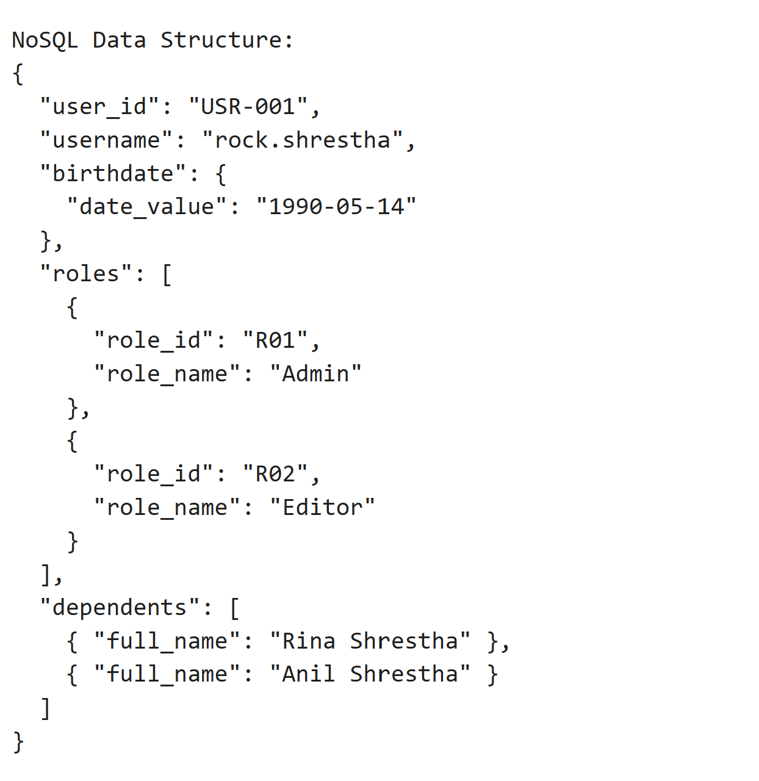
Figure 2: NoSQL Document Structure — USER with embedded ROLES, BIRTHDATE, and DEPENDENTS
The NoSQL document reflects all three ERD relationships in a denormalized format. The “birthdate” field is an embedded sub-document, matching the 1.1 relationship — exactly one birthdate object per user. The “roles” field is a nested array of objects, matching the 1.* relationship — one or more role entries per user. The “dependents” field is likewise an array, capturing the 1.* relationship between USER and DEPENDENT. Unlike the relational model, no JOIN operations are required; the complete user profile is retrieved in a single document read.

References

Fowler, M., & Sadalage, P. J. (2012). NoSQL distilled: A brief guide to the emerging world of polyglot persistence. Addison-Wesley.

