Group B
CSD 310-T301: Database Development and Use
Module 8.1 Milestone #1: Case Study Selection, Business Rules, and Initial ERD
Team Members: Rakesh Shrestha, Josh Herrick
Case Study Selected: Bacchus Winery
Date: August 02, 2026
Instructor: Vianelis Martinez

Group Introduction and Availability
Hi, I am Rakesh Shrestha. I am currently balancing this course with two other CSD courses this term, so my main working hours are evenings on weekdays (after 6 PM CST) and most of the day on weekends. I'll be checking the group discussion board and GitHub daily and can hop on a call or Discord if we need to sync up in real time.
Hi, I am Joshua Herrick. I work full-time while completing my degree online, so I typically work on coursework during the evenings after work and throughout the weekends. I will check the Blackboard discussion board regularly and will respond as quickly as I can so we can stay on schedule and meet each milestone.
For this project, we'll use Blackboard's group discussion board as our primary channel, with Discord as a backup for quick back-and-forth during the week.

Case Study Selected
Our group selected the Bacchus Winery case study. We chose this scenario over Outland Adventures and Willson Financial because it gives us the richest set of entities and relationships to design around: employees spread across four departments, a many-to-many relationship between wines and distributors, a supplier/shipment chain with delivery-date tracking, and a quarterly employee-hours requirement. It also maps cleanly to the three required reports for Milestone 3 (supplier delivery performance, wine distribution/sales trends, and employee hours by quarter), which made it the strongest fit for a two-person team working through all five milestones.

Business Rules

Employees and Departments
- Each employee belongs to exactly one department (Finance/Payroll, Marketing, Production, or Distribution). Each department has one or more employees assigned to it.
- Some employees supervise other employees within their department (for example, Ivy Brook supervises Bob Smith, and Lewis Walker oversees the production staff). An employee may report to zero or one supervisor, and a supervisor may oversee zero or more employees.
- The winery must track how many hours each employee worked during each of the last four quarters, since Stan and Davis need this for the yearly snapshot report.

Wine and Distribution
- Bacchus Winery produces four wines: Merlot, Cabernet, Chablis, and Chardonnay.
- Each wine may be carried by one or more distributors, and each distributor may carry one or more wines. This many-to-many relationship exists because the owners specifically need to know which distributor carries which wine.
- Each wine shipped to a distributor must have a recorded quantity and date, so sales trends can be tracked per wine and per distributor over time.

Suppliers and Inventory
- The winery orders supplies from three suppliers: one for bottles and corks, one for labels and boxes, and one for vats and tubing.
- Each supplier is responsible for exactly one component category and ships that component to the winery on a recurring, roughly monthly basis.
- Each shipment from a supplier has both an expected delivery date and an actual delivery date, so the system can calculate delivery gaps and flag suppliers that are consistently late.

Assumptions
- We assume each employee works full-time for the winery and belongs to only one department at a time; no employee is split across multiple departments.
- We assume the three supply "components" (bottles/corks, labels/boxes, vats/tubing) are each provided by a single, dedicated supplier, exactly as described in the case study, rather than any supplier providing multiple component types.
- We assume distributor orders are tracked at the wine level rather than at the individual bottle or case level, since the case study only asks which distributor carries which wine and how sales trends look overall.
- We assume employee hours are logged and reported quarterly rather than daily or weekly, since the case study specifically asks for hours worked "during the last four quarters."
- We assume Stan and Davis, as the owners, are not tracked in the Employee table since they are not staff; this can be revisited in Milestone 2 if the group decides ownership records are needed.

Initial Entity Relationship Diagram
The diagram below shows our initial entity set and relationships, built directly from the business rules above. At this stage we've focused on entities, primary keys, foreign keys, and relationship cardinality; full attribute lists will be added for each table in Milestone 2 once we finalize the design and move into MySQL table creation.
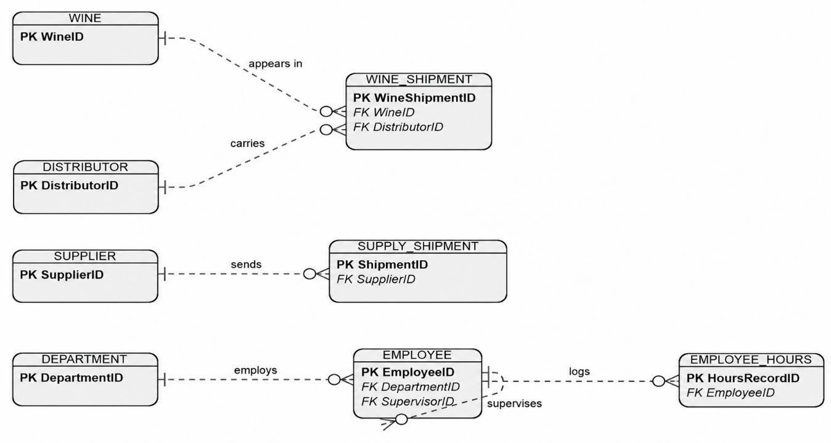

EMPLOYEE_HOURS and WINE_SHIPMENT are junction/tracking tables: EMPLOYEE_HOURS resolves the need to store multiple quarterly hour records per employee, and WINE_SHIPMENT resolves the many-to-many relationship between WINE and DISTRIBUTOR, since a relational table can only directly express one-to-one or one-to-many relationships. WINE_SHIPMENT will also carry the ShipmentDate and Quantity attributes once we build out the full attribute list in Milestone 2, since it tracks recurring shipment events rather than a static association. EMPLOYEE also has a self-referencing relationship through the SupervisorID foreign key, which captures that a supervisor is itself an employee: each employee reports to zero or one supervisor, while a supervisor may oversee zero or more employees.

