Rakesh Shrestha
July 12, 2026
CSD-310: Module 5.2 Assignment - Movies: Setup

Overview
For this assignment I created the movies database schema by running the db_init_2022.sql script from the MySQL command line client, verified the tables that were created with SHOW TABLES, and then built a Python script (mysql_test.py) that connects to the database using credentials stored in a hidden .env file. Below are the screenshots documenting each step, followed by a link to my GitHub repository.

Step 1: Running db_init_2022.sql
I logged into the MySQL command line client, switched to the movies database with USE movies; and ran the script with source db_init_2022.sql;. This dropped and recreated the movies_user account, granted privileges, and dropped/recreated the studio, genre, and film tables, then inserted the sample records. The screenshot below shows the last lines of output after the script finished running.
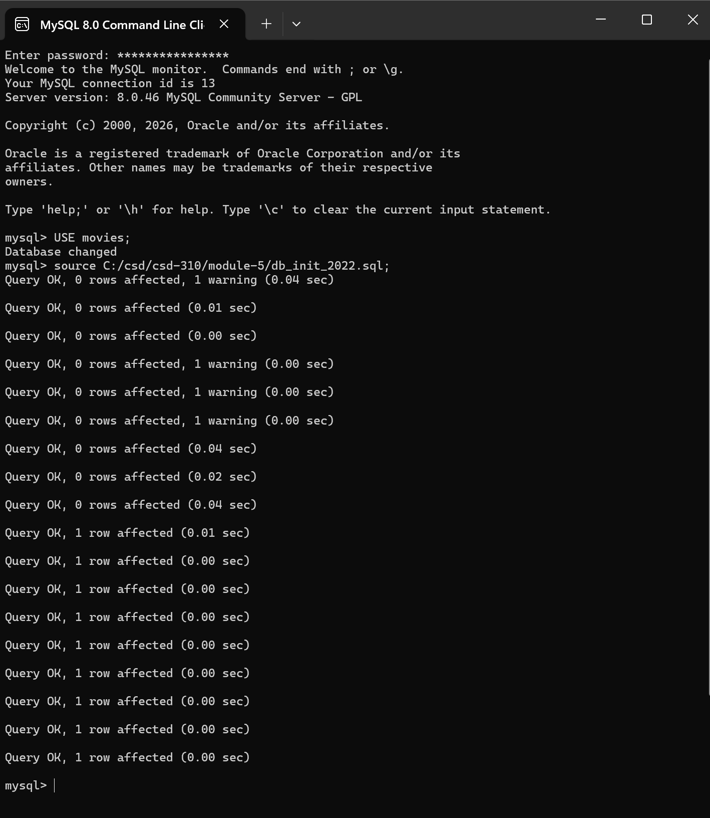

Step 2: SHOW TABLES
After the script ran successfully, I confirmed the tables were created by running USE movies; followed by SHOW TABLES;. The screenshot below shows the film, genre, and studio tables listed in the movies database.

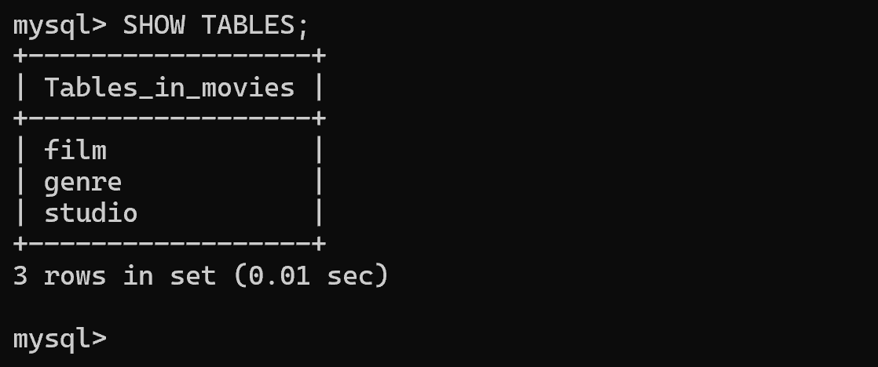

Step 3: Python Connection Test
I installed the mysql-connector-python and python-dotenv packages, created a .env file in my module-5 directory containing the movies_user credentials, and wrote mysql_test.py to connect to the database using those credentials. The .env file is excluded from Git using the .gitignore file, ensuring that database credentials are not uploaded to the public GitHub repository. The screenshot below shows the script running successfully and confirming the connection to MySQL.

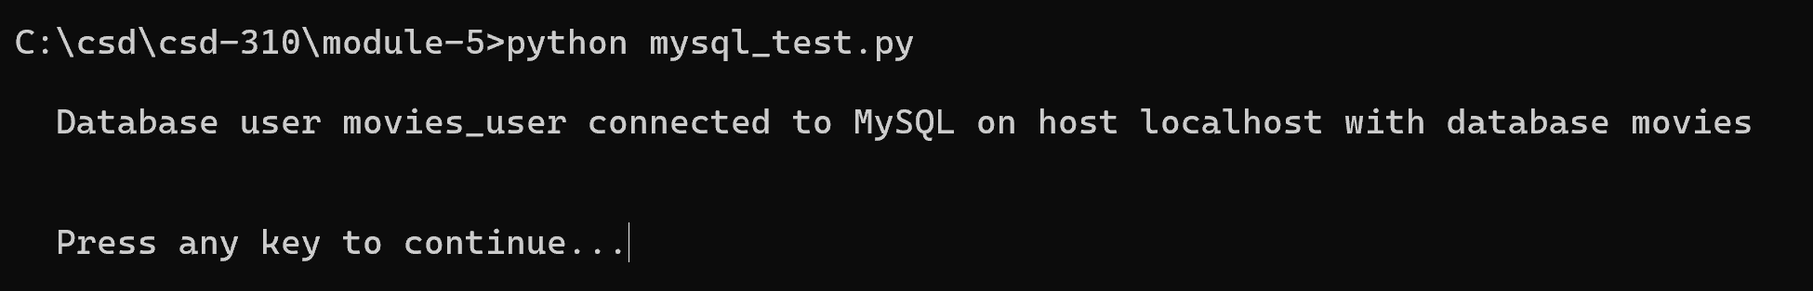

GitHub Repository
The db_init_2022.sql script and mysql_test.py file are included in my project. The .env file is excluded via the .gitignore file to protect the database credentials. My GitHub repository is:
https://github.com/RockyShrestha/csd-310

