Rakesh Shrestha
Module 4.3 Assignment: Movies!
Date: July 5, 2026

Movies ERD

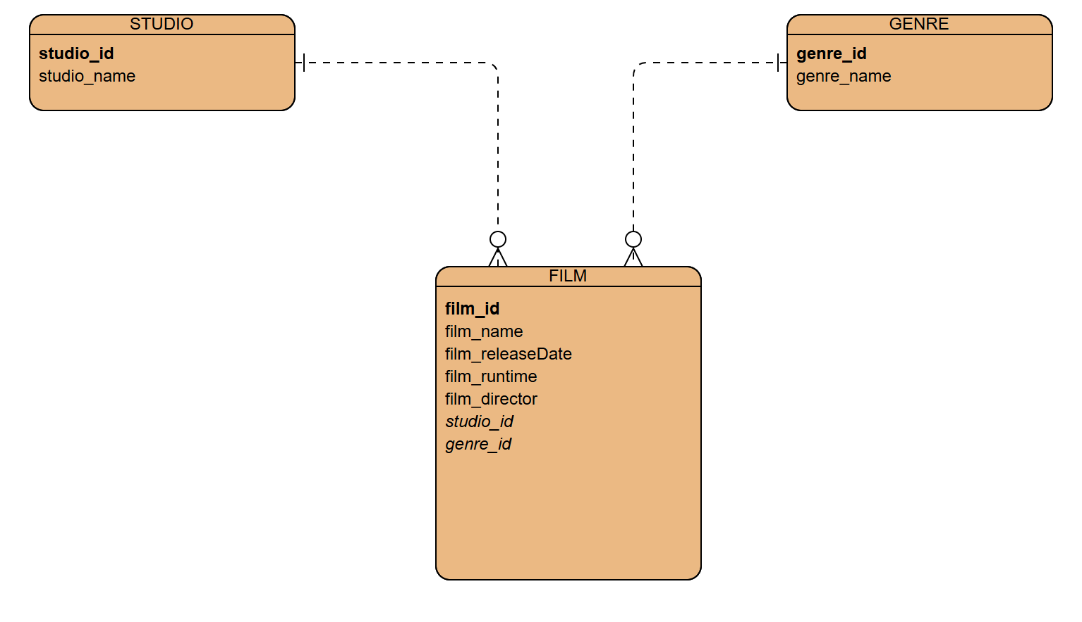
Bold attributes represent primary keys. Italicized attributes in FILM represent foreign keys.

