Rakesh Shrestha
Module 1.2 Assignment
June 13, 2026

- Git Configuration Verification

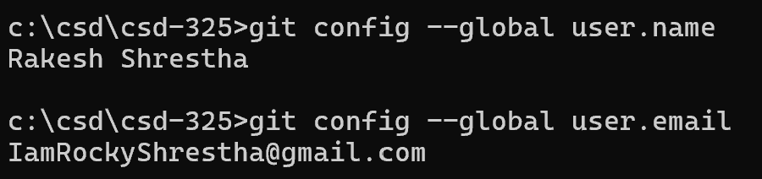
Figure 1: Verification of Git global username and email configuration.

- GitHub Repository Link
https://github.com/RockyShrestha/csd-325.git

- GitHub Repository Screenshot

Figure 2: CSD-325 GitHub repository.
- Local Directory Screenshot

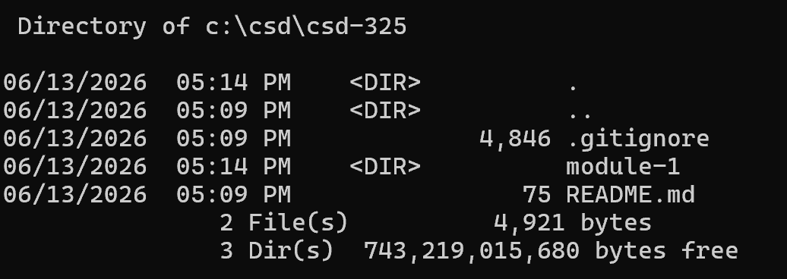
Figure 3: Local CSD-325 directory showing the module-1 folder

