CSD-325 Advanced Python
Module 2.2 Assignment – Debugging Documentation
Rakesh Shrestha | June 21, 2026
Bellevue University
Introduction
For this module, I chose a Grade Calculator program that I wrote in Python. The program contains four functions: calculate_average(), get_letter_grade(), display_results(), and main(). The program iterates through a hardcoded list of student records, computes each student's numeric average, converts it to a letter grade, and prints the results. I used Visual Studio Code's built-in Python debugger to step through the program and document the debugging process.
Debugging Setup
Before starting, I opened grade_calculator.py in Visual Studio Code and verified that the Python debugger was working correctly. I reviewed the Debugging Guide from this module, which covered six core debugger commands: Continue, Step Over, Step Into, Step Out, Restart, and Stop. I also referenced the TestGorilla, Python Debugging Interview Questions article and the profsuesam YouTube tutorial to reinforce my understanding of why a structured debugging workflow matters, especially setting breakpoints rather than relying solely on print() statements.
Screenshot 1 – Breakpoint Set and Debugging Started
I set a breakpoint on line 4, which is the def calculate_average(grades): line. This is the entry point of the first function in the program. Setting the breakpoint here lets me pause execution right before any function logic runs, so I can inspect the program state before any variables are assigned. I then launched the debugger using Run > Start Debugging. The red breakpoint marker confirms that the breakpoint is active, and the highlighted line shows the current execution point in the program.
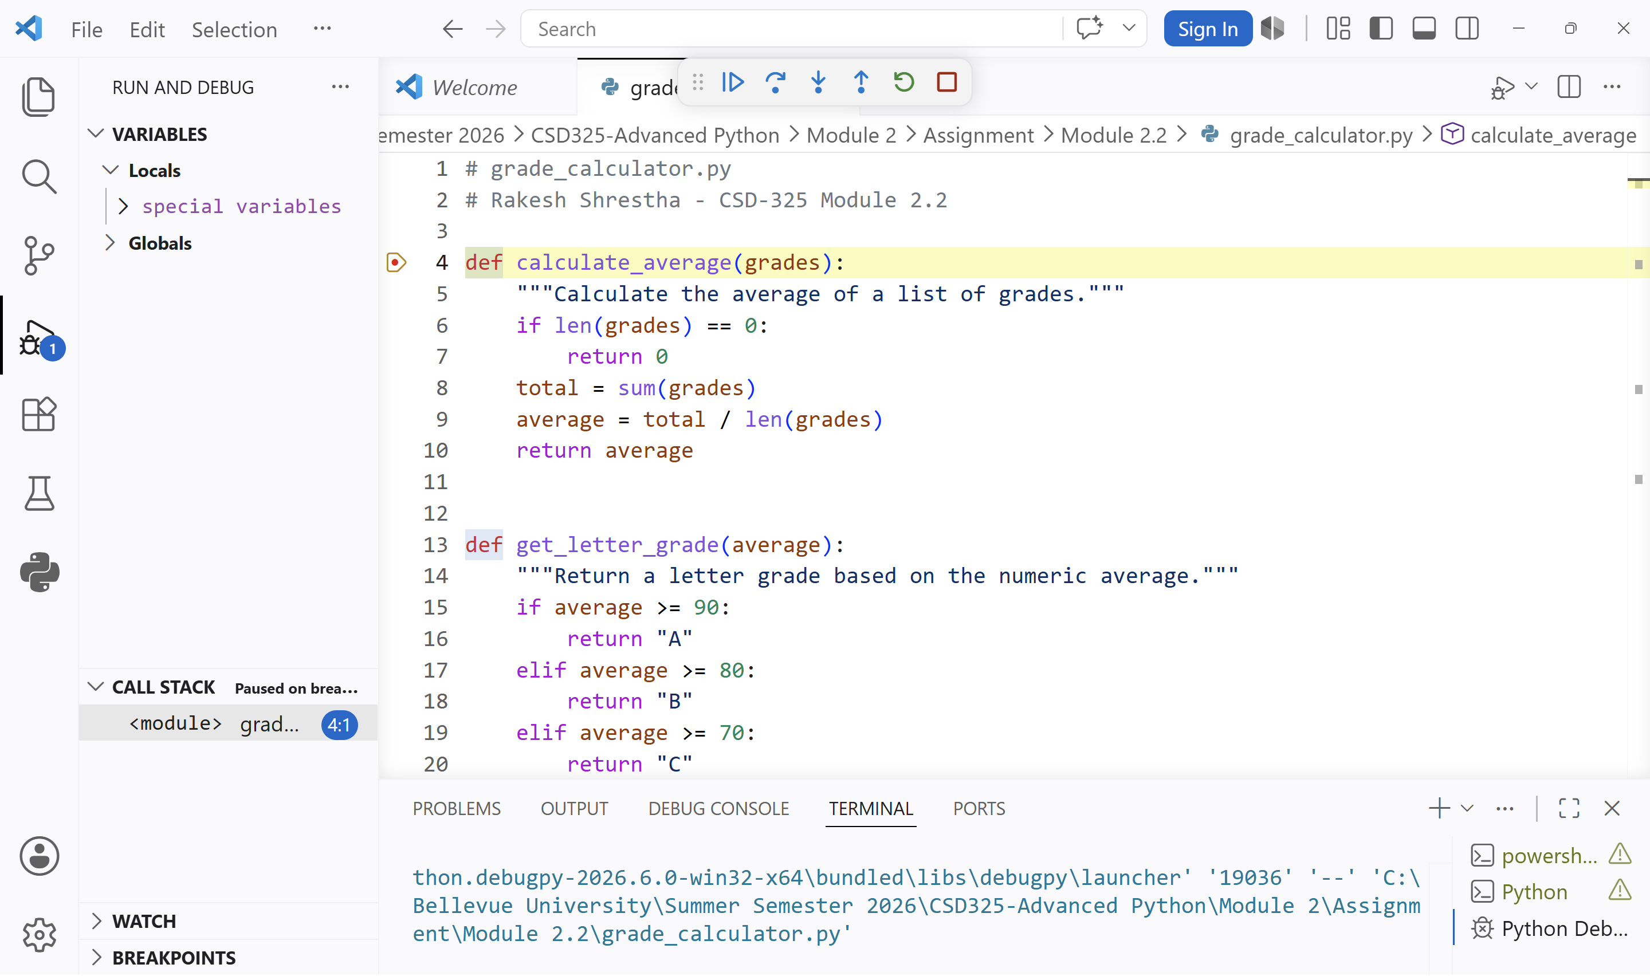
Screenshot 1: Breakpoint on line 4 (def calculate_average). Debugger paused at program entry into the function.
Screenshot 2 – Stepped Into the Function
After the program reached the calculate_average(grades) function call, I used ‘Step Into’ to enter the function. The debugger paused at line 8 (total = sum(grades)), allowing me to inspect the grades parameter before the calculation was performed. The Variables panel shows the current values being passed into the function, and the Call Stack confirms that calculate_average() was called from display_results(), which was called from main().

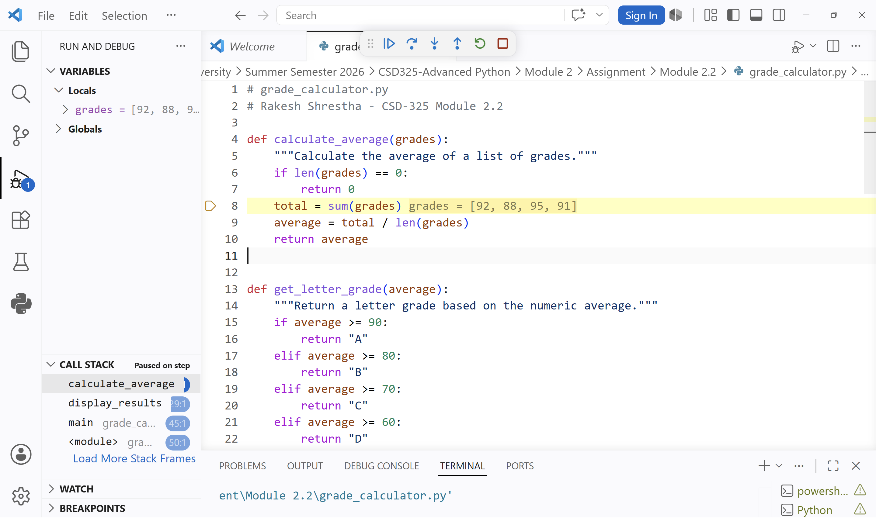
Screenshot 2: Stepped into calculate_average(). Paused at line 8 (total = sum(grades)). The Variables panel shows the grades parameter, and the Call Stack confirms the function call sequence.

Screenshot 3 – Inspecting the Return Value
I continued stepping through the program using Step Over. When execution reached line 10 (return average), the Variables panel showed that total was 366 and average was 91.5. The inline debugger values also displayed the current contents of these variables directly in the editor. This allowed me to verify the calculation before the value was returned to the calling function. Being able to inspect variable values during execution is a useful debugging technique because it confirms program logic without adding temporary print() statements. This step verified that the average was calculated correctly before being returned.

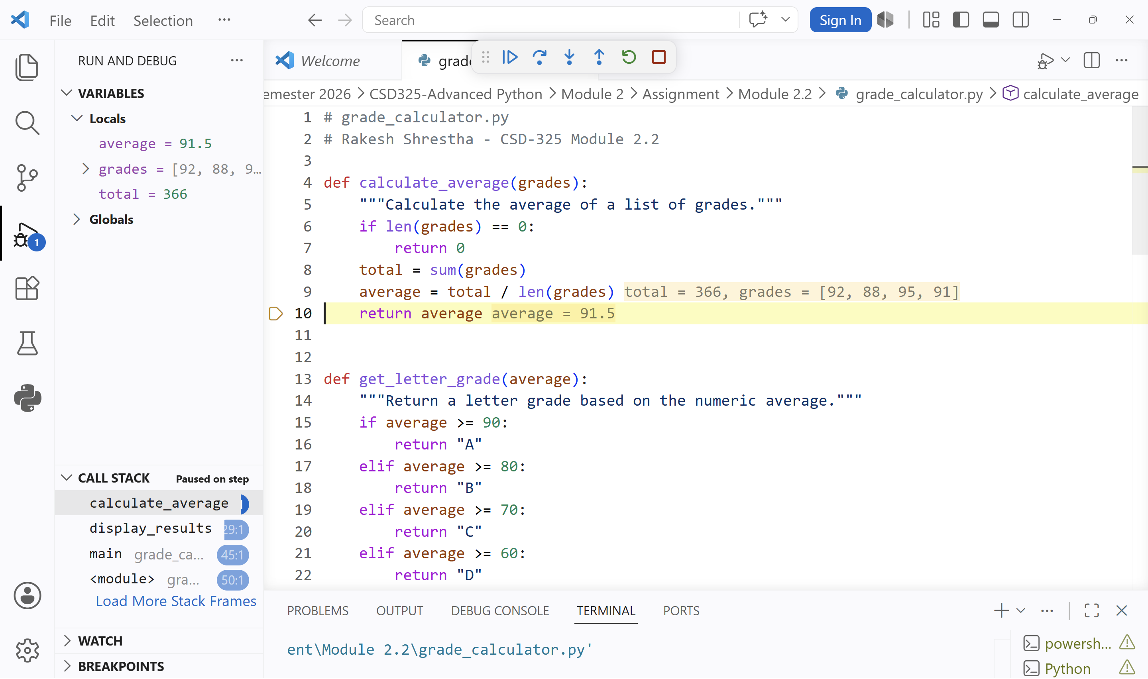
Screenshot 3: Paused at line 10 (return average). Variables show total = 366 and average = 91.5. Inline debugger values confirm the calculated average before it is returned.
Reflection
This debugging exercise reinforced what the Debugging Guide emphasized: debugging is not guessing, but it is systematically observing how a program executes. Before this assignment, I relied heavily on print() statements to troubleshoot Python programs. Working through the debugging process in VS Code showed me how much more effective it is to use breakpoints along with the ‘Step Into’ and ‘Step Over’ commands. Being able to inspect variables such as grades, total, and average in real time helped me verify the program's logic and calculations without modifying the code. The Variables panel, Call Stack, and inline debugger values provided a clear view of what the program was doing at each stage of execution. This experience increased my confidence in using debugging tools and demonstrated how they can help identify issues more efficiently than relying solely on printed output. Going forward, I plan to make the debugger a regular part of my development process rather than using it only when a program fails to run correctly.
References
Abiola, G. (2017). Debugging in Python. Codementor.
https://www.codementor.io/@gbozee/debugging-in-python-9ia7lof32
CSE 232. (n.d.). Debugging guide. Michigan State University.
https://cse232-msu.github.io/CSE232/debugging_guide.html
TestGorilla. (n.d.). 25 Python debugging interview questions.
https://www.testgorilla.com/blog/python-debugging-interview-questions/
profsuesam. (n.d.). Debug [Video]. YouTube.
https://www.youtube.com/watch?v=2sS5xIZeF5k

