CSD-325 Advanced Python
Module 2.2 Assignment – Flowchart Documentation
Rakesh Shrestha | June 21, 2026
Bellevue University
Program Overview
The program selected for this assignment is a Grade Calculator written in Python. It contains four functions: calculate_average(), get_letter_grade(), display_results(), and main(). The program iterates through a list of student records, computes each student's average grade, maps it to a letter grade using conditional logic, and prints a formatted summary for each student. This program was chosen because it demonstrates clear use of functions, loops, conditional branching, and formatted output, which makes it ideal for flowchart modeling and debugging practice.
Program Flowchart
The flowchart below models the complete execution flow of the Grade Calculator program, from program start through the student processing loop to program end. Arrows are placed at the end of each flow line as per standard flowchart convention.

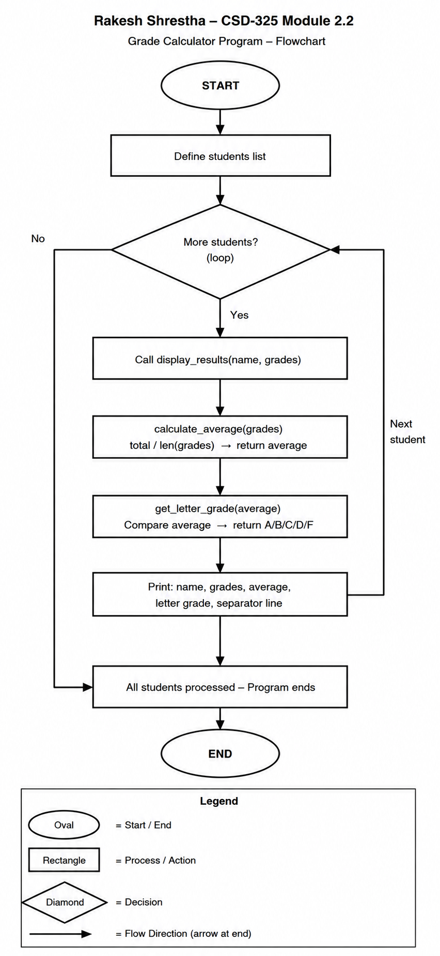
Flowchart Symbols Used
Oval – Represents the Start and End terminal points of the program. Rectangle – Represents a process or action step (e.g., calling a function, performing calculations, assigning values, or defining data). Diamond – Represents a decision point with a Yes/No branch (e.g., checking whether more students remain in the loop). Arrows with arrowheads at the end of each line indicate the direction of program flow.

Function Descriptions
calculate_average(grades) – Accepts a list of numeric grades, sums them, divides by count, and returns the average as a float. Returns 0 if the list is empty.
get_letter_grade(average) – Uses conditional if/elif/else logic to map a numeric average to a letter grade (A through F).
display_results(name, grades) – Orchestrates the output by calling calculate_average() and get_letter_grade(), then printing a formatted report for one student.
main() – Defines the student dataset and iterates through each student, calling display_results() for each one.

