Rakesh Shrestha
CSD-325 Advanced Python | Module 3.2 | Brownfield + Flowchart
June 2026 | Bellevue University

1. Program Overview
Cho-Han is a traditional Japanese dice game in which two dice are rolled inside a bamboo cup and the player bets whether the total will be even (CHO) or odd (HAN). For this assignment I examined Al Sweigart’s original chohan.py to understand how the program worked before making any changes. This is a brownfield task because I started with existing code and added specific modifications rather than writing a new program from the beginning.

The original program keeps a dictionary of Japanese number names, runs a main loop that handles betting and dice rolling, and exits when the player quits or runs out of money. I kept all of that logic intact and only changed the four things listed in the assignment requirements.

2. Documented Changes
The table below describes each required change, what I implemented, and where it appears in the code.

# | Requirement | What I Changed
1 | Input prompt | Changed from '> ' to 'rs:' at both the wager entry and the CHO/HAN entry prompts.
2 | House fee | Changed from 10 percent to 12 percent house fee.
3 | Bonus notice | Added a BONUS line in the program introduction telling the player that totals of 2 or 7 earn 10 mon.
4 | Bonus behavior | After revealing the dice, the program checks whether the total is 2 or 7. If so, it announces the bonus and adds 10 mon to the purse before determining win or loss.

3. Flowchart Conventions
The three flowcharts below follow standard symbols and plain language algorithm steps. Parallelograms represent input and output steps. Rectangles represent processing steps. Diamonds represent decisions. Rounded rectangles (terminals) mark the start and end. Circles labeled A, B, R, S, and W are connectors that link the flowcharts and return paths together. Each input and output step has exactly one outgoing arrow.

4. Program Flowcharts
The three flowcharts on the following page cover the complete flow of the Cho-Han program:

- Flowchart 1: Start the game and validate the wager amount.

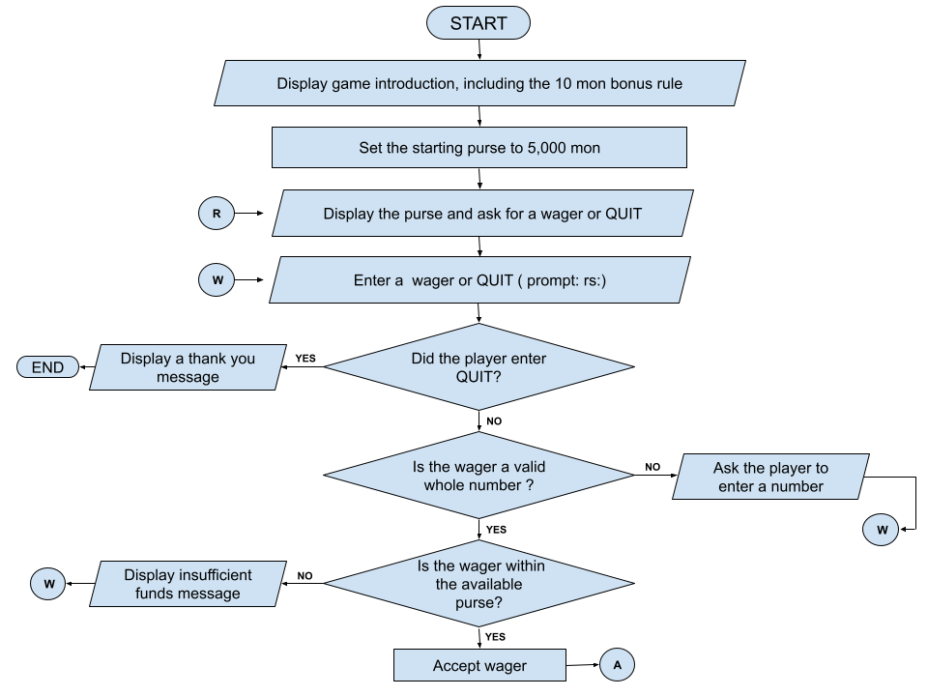

Note: Connector R receives the next-round flow from Flowchart 3 and continues at the purse display. Connector
W returns to wager entry after an invalid wager. Connector A continues to Flowchart 2.

4. Program Flowcharts (continued)

- Flowchart 2: Roll the dice, accept the CHO/HAN guess, and apply the 10 mon bonus.

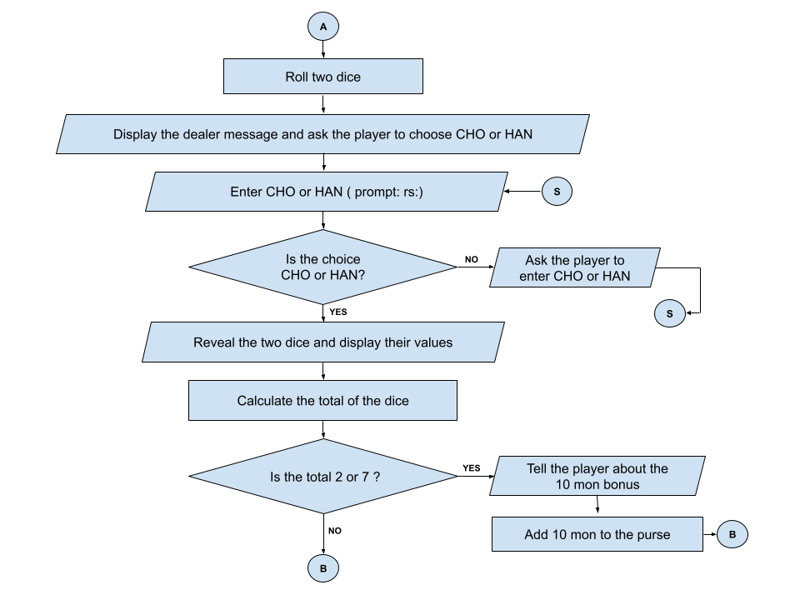

Note : Connector S returns to the choice entry. Connector B continues to Flowchart 3.

4. Program Flowcharts (continued)

- Flowchart 3: Determine the result, collect 12% of the wager as the house fee, and either loop or end.

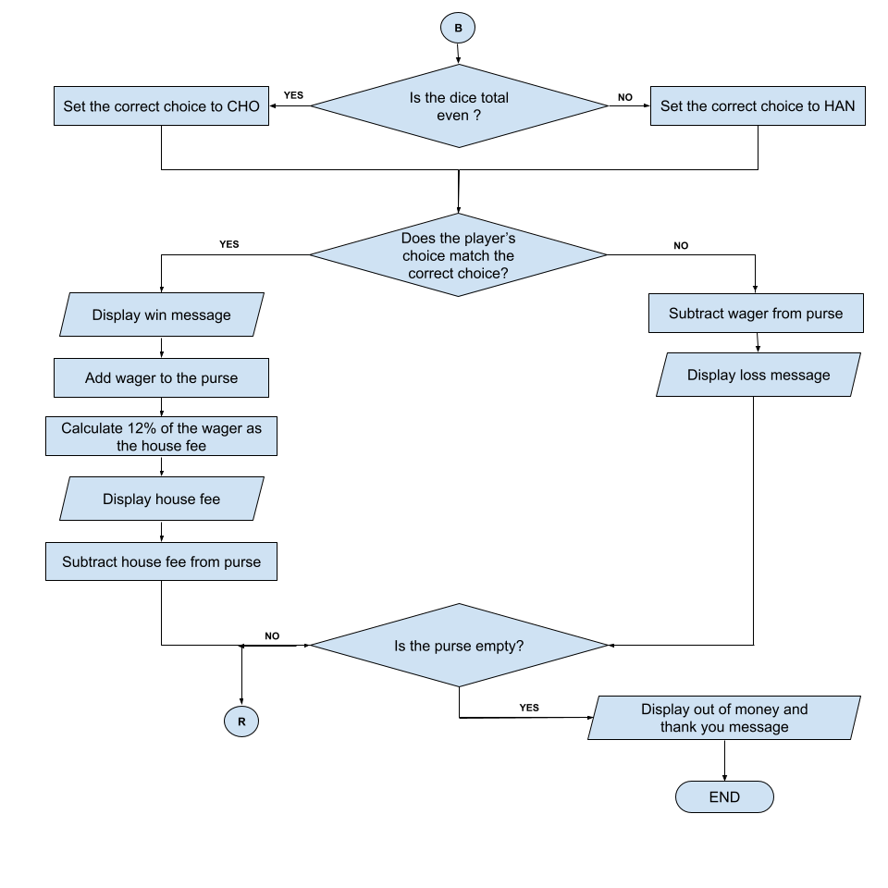
Note: Connector R returns to “Display the purse and ask for a wager or QUIT” in Flowchart 1. A full round repeats until the player quits or the purse is empty.

5. Verification
I ran the modified program and tested the following cases:

- Typing a non-numeric wager shows the “please enter a whole number” message and loops back.
- Typing a wager larger than the current purse shows the “not enough” message and loops back.
- Typing an invalid bet (not CHO or HAN) shows an error and loops back.
- A dice roll totaling 2 prints the bonus announcement and adds exactly 10 mon to the purse.
- A dice roll totaling 7 also triggers the 10 mon bonus correctly.
- A winning bet deducts a 12 percent fee (e.g., a 100 mon bet costs 12 mon).
- Typing QUIT at the wager prompt exits the program cleanly.

6. References

Sweigart, A. (2021). The Big Book of Small Python Projects. No Starch Press. (Original Cho-Han source provided with the course materials.)

Wozniak, J. (2023, April 20). Brownfield vs. greenfield projects in IT: A comparison for sustainable growth. Netkodo.
https://netkodo.com/blog/understanding-brownfield-greenfield-projects-it-comprehensive-guide-sustainable-development

W3Schools. (2024). Python dictionaries.
https://www.w3schools.com/python/python_dictionaries.asp

