Rakesh Shrestha
CSD325-T301 Advanced Python – Module 8.2 Assignment: JSON Practice

Program Output
Below is the result of running Shrestha_Module8_2_JSONPractice.py, which loads student.json, prints the original student list, appends a new record of myself, prints the updated list, and writes the updated data back to the file.

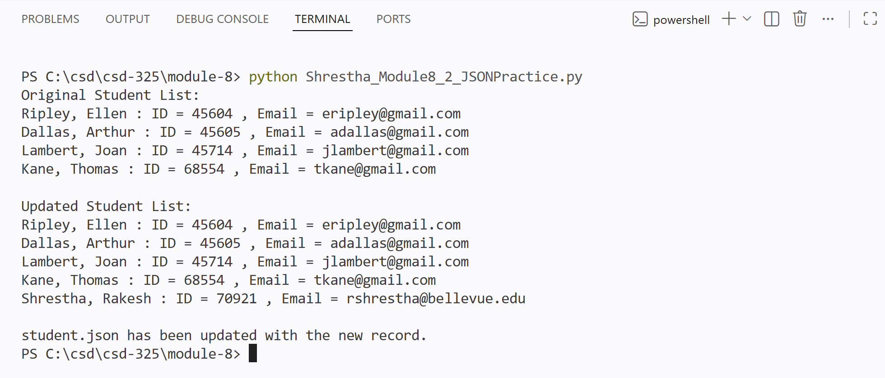

File-Change Notification
When Shrestha_Module8_2_JSONPractice.py runs, VS Code detects that student.json changed on disk (because the file is open in the editor while the script overwrites it) and prompts to reload the file.
Note: VS Code's file-conflict dialog differs in wording from the example shown in the assignment but reflects the same underlying behavior — detecting that student.json changed outside the editor.

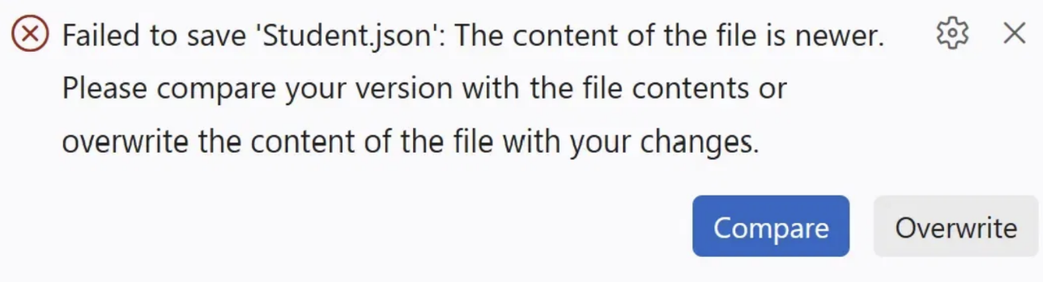

Updated student.json Contents
Contents of student.json after the program ran and json.dump() wrote the appended record:
[
{
"F_Name": "Ellen",
"L_Name": "Ripley",
"Student_ID": 45604,
"Email": "eripley@gmail.com"
},
{
"F_Name": "Arthur",
"L_Name": "Dallas",
"Student_ID": 45605,
"Email": "adallas@gmail.com"
},
{
"F_Name": "Joan",
"L_Name": "Lambert",
"Student_ID": 45714,
"Email": "jlambert@gmail.com"
},
{
"F_Name": "Thomas",
"L_Name": "Kane",
"Student_ID": 68554,
"Email": "tkane@gmail.com"
},
{
"F_Name": "Rakesh",
"L_Name": "Shrestha",
"Student_ID": 70921,
"Email": "rshrestha@bellevue.edu"
}
]

